In this assignment you will be performing several tasks against your database.

- Create a new database and import a table with data.
- Normalize the “usersNotNormalized” table.
- Create a normalized table for your project.
- Insert, Select, Update, & Delete data.
- Perform a SQL Dump (Export)

After completing this assignment, you will be submitting this document and a SQL Dump in the following naming convention.

All lowercase lastname_firstname_database.pdf
lastname_firstname_database.sql

Paste your answer in the marked areas below. To expand this area, highlight your answer, open your “Formatting Palette”, Styles section and select the “Answer” style.

Answers go here.

We suggest you watch the following videos before attempting this assignment.

- http://vimeo.com/24637589

Part 1
Create a new database and import a table with data.

The “.sql” file with this assignment is called SQL Dump. This file is an export of all objects and data from a database. You will use this file to import a table and sample data.

Start up Mamp and Sequel Pro. You will need to create a new database called “bdfYYMM” (replace YYMM with the current year and month). Once the database is created, open the query tab, and then drag the SQL file into the window. Once there, click “Run All” to execute the SQL and import the tables and data to your database.

If successful, you can click on the table to the left, then the “content” tab to view the imported data.

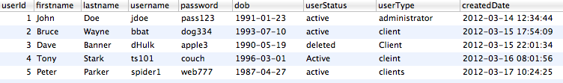

Part 2
Normalize the table “usersNotNormalized”.

Database normalization is the process of optimising the structure of data for several reasons including:
- Performance
- Consistancy
- Eliminate Duplicate Data
- Forward Compatibility

The table we imported, usersNotNormalized, is not normalized. If we review each column, we can see there are 2 columns, (userStatus & userType) which have repeating groups of data.

Every user should have a status of “active” or “deleted”. However, some of the columns have capital letters or misspellings. The same is true for type. Some types are “client” while another is “Clients”.

It may be clear to the human eye these values should have the same meaning, but your computer views them as different values.

Create 3 new tables to normalize this table. Separate the values for status and type to separate table. Create a new “users” table to utilize these new tables. Your tables should resemble the ER diagram below.

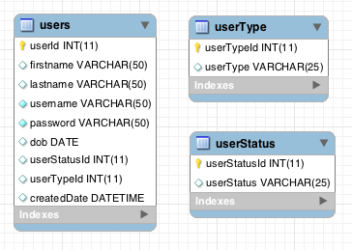

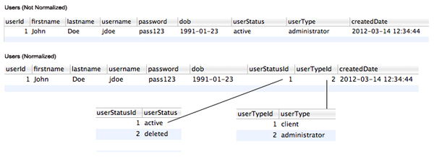

You may use Sequel Pro’s GUI to create these tables but you are required to paste your “create table” statements below. Make sure the tables are created with type = InnoDB.

Answers go here.

CREATE TABLE `bdf1302`.`users` ( `usersId` INT NOT NULL AUTO_INCREMENT , `firstname`
VARCHAR(45) NULL , `lastname` VARCHAR(45) NULL , `username` VARCHAR(45) NULL ,
`password` VARCHAR(45) NULL , `dob` DATE NULL , `userStatusId` INT(11) NULL ,
`userTypeId` INT(11) NULL , `createdDate` DATETIME NULL , PRIMARY KEY (`usersId`) )
ENGINE = InnoDB;

CREATE TABLE `bdf1302`.`userType` ( `userTypeId` INT(11) NOT NULL AUTO_INCREMENT ,
`userType` VARCHAR(25) NULL , PRIMARY KEY (`userTypeId`) )ENGINE = InnoDB;

CREATE TABLE `bdf1302`.`userStatus` ( `userStatusId` INT(11) NOT NULL AUTO_INCREMENT ,
`userStatus` VARCHAR(25) NULL , PRIMARY KEY (`userStatusId`) )ENGINE = InnoDB;

UPDATE `bdf1302`.`users` SET `lastname`='Wayne', `username`='bbat', `password`='dog334',
`dob`='1993-07-10', `userStatusId`=1, `userTypeId`=1, `createdDate`='2012-03-15
17:54:09' WHERE `userId`='2';UPDATE `bdf1302`.`users` SET `lastname`='Banner',
`username`='dHulk', `password`='apple3', `dob`='1990-05-19', `userStatusId`=2,
`userTypeId`=1, `createdDate`='2012-03-15 22:01:34' WHERE `userId`='3';UPDATE
`bdf1302`.`users` SET `lastname`='Stark', `username`='ts101', `password`='couch',
`dob`='1996-03-01', `userStatusId`=1, `userTypeId`=1, `createdDate`='2012-03-16
08:01:56' WHERE `userId`='4';UPDATE `bdf1302`.`users` SET `lastname`='Parker',
`username`='spider1', `password`='web777', `dob`='1987-04-27', `userStatusId`=1,
`userTypeId`=1, `createdDate`='2012-03-17 10:24:25' WHERE `userId`='5';UPDATE
`bdf1302`.`users` SET `userStatusId`=1, `userTypeId`=2 WHERE `userId`='1';

INSERT INTO `bdf1302`.`userstatus` (`userStatusId`, `userStatus`) VALUES (1,
'active');INSERT INTO `bdf1302`.`userstatus` (`userStatusId`, `userStatus`) VALUES (2,
'deleted');

INSERT INTO `bdf1302`.`usertype` (`userTypeId`, `userType`) VALUES (1, 'client');INSERT
INTO `bdf1302`.`usertype` (`userTypeId`, `userType`) VALUES (2, 'administrator');

-- drop table `bdf1302`.`usersnotnormalized`;
Part 3
Create a normalized table for your project.

Create a few related tables (minimum of 2) that will be needed for your project that you created in the preproduction assignment. For example, if your project were an address book, you would need to store information about your contacts, their phones and email addresses. You would create a contacts table, contactEmail table and contactPhone table to store your data. Foreign Keys are not required for this assignment.

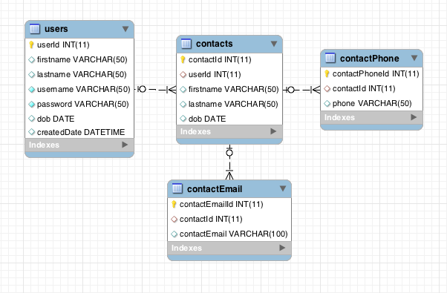

You may use Sequel Pro’s GUI to create these tables but you are required to paste your “create table” statements below. Make sure the tables are created with type = InnoDB.

Answers go here.

delimiter $$
CREATE TABLE `contactemail` (
`contactEmailId` int(11) NOT NULL AUTO_INCREMENT,
`contactId` int(11) DEFAULT NULL,
`contactEmail` varchar(100) DEFAULT NULL,
PRIMARY KEY (`contactEmailId`),
KEY `contactId` (`contactId`),
CONSTRAINT `contactId` FOREIGN KEY (`contactId`) REFERENCES `contacts` (`contactId`) ON DELETE NO ACTION ON UPDATE NO ACTION
) ENGINE=InnoDB AUTO_INCREMENT=2 DEFAULT CHARSET=latin1$$
delimiter $$

CREATE TABLE `contactphone` (
`contactPhoneId` int(11) NOT NULL AUTO_INCREMENT,
`contactId` int(11) DEFAULT NULL,
`phoneNumber` varchar(50) DEFAULT NULL,
PRIMARY KEY (`contactPhoneId`),
KEY `contactsIdFK` (`contactId`),
CONSTRAINT `contactsIdFK` FOREIGN KEY (`contactId`) REFERENCES `contacts` (`contactId`) ON DELETE NO ACTION ON UPDATE NO ACTION
) ENGINE=InnoDB AUTO_INCREMENT=2 DEFAULT CHARSET=latin1$$
delimiter $$
CREATE TABLE `contacts` (
`contactId` int(11) NOT NULL AUTO_INCREMENT,
`userId` int(11) DEFAULT NULL,
`firstname` varchar(45) DEFAULT NULL,
`lastname` varchar(45) DEFAULT NULL,
`dob` date DEFAULT NULL,
PRIMARY KEY (`contactId`),
KEY `userId` (`userId`),
CONSTRAINT `userId` FOREIGN KEY (`userId`) REFERENCES `users` (`userId`) ON DELETE NO ACTION ON UPDATE NO ACTION
) ENGINE=InnoDB AUTO_INCREMENT=2 DEFAULT CHARSET=latin1$$

Part 4
CRUD - Insert, Select, Update, & Delete data.

Write 6 SQL statements:
- Insert 3 rows into your new table from part 3, Use 3 separate SQL statements.
- Update only one of the rows you just inserted. (Hint: Reference the primary key of the table in your where condition)
- Select all of the rows from your table.
- Finally, delete one row from your database. (Hint: Reference the primary key of the table in your where condition)

Paste 6 SQL statements here.
-- these are the three inserts
INSERT INTO contacts(contactId,userId,firstname,lastname,dob)
VALUES (2,2,"Bruce","Wayne","1993-07-10");
INSERT INTO contactEmail(contactEmailId,contactId,contactEmail)
VALUES (2,2,"test2@test2.com");
INSERT INTO contactPhone(contactPhoneId,contactId,phoneNumber)
VALUES (2,2,"555-555-5555");
-- update
UPDATE contactPhone SET phoneNumber = "555-555-5553"
WHERE contactPhoneId = 2;
-- selecting all the rows from contactEmail
SELECT *
FROM contactEmail;
-- deleting one row
DELETE
FROM contactEmail
WHERE contactEmailId = 2;

Part 5
Perform a SQL Dump of your database.

Make sure when you export your database, you choose “SQL Dump”. This will produce a “.sql” file. If you open this file, you will see SQL such as “Create table…” and “Insert into…”.

