LAB 4-1
Compression Techniques
______________________________________________________________________

Walkthrough

We’re going to practice compressing files using Terminal. First create a new directory on your Desktop called lab_4. Copy all the pdf files for the first four lectures to this new directory. Feel free to do this in the GUI. As you’ll see, these aren’t the best examples compression-wise but it will work fine for our purposes. Now open Terminal. Navigate to the newly created lab_4 directory. Perform a long-format list of the directory:

ls -l

You should see output similar to the following:

-rw-r--r-- 1 jrobertknight2 staff 32088484 Jan 30 23:39 nss_day1.pdf
-rw-r--r-- 1 jrobertknight2 staff 3135145 Feb 2 11:15 nss_day2.pdf
-rw-r--r-- 1 jrobertknight2 staff 7119996 Feb 4 13:02 nss_day3.pdf
-rw-r--r-- 1 jrobertknight2 staff 7707235 Feb 7 21:54 nss_day4.pdf

As you know from lab 2, the 5th column is the size of the files in bytes. So nss_day1.pdf is 32,088,484 bytes large. Dividing this number by 1024 we can find the size of the file in kilobytes, 31,340KB. If we divide that number by 1024 we can find the size of the file in megabytes, 31MB. If you dislike doing math like I do you can easily find the file size by using the du command. To find the size of each file and the sum total in kilobytes type:

du -ak

You’ll see output similar to the following:

MacBook-Pro:lab_4 jrobertknight2$ du -ak
31340 ./nss_day1.pdf
3064 ./nss_day2.pdf
6956 ./nss_day3.pdf
7528 ./nss_day4.pdf
48888 .
MacBook-Pro:lab_4 jrobertknight2$

For the size in megabytes type:

du –am

You’ll see that the sum total of all the pdf files is about 48MB. Now that we have the total size of the files we can effectively compare various compression methods. You’ll need to get the size of each compressed file after you make it. Before proceeding, make sure you understand the difference between the three different compression formats. If you can’t answer that question go back to the notes and figure it out. Do not proceed until you fully understand the purpose of each compression format (archive, format, and combined.)

First we’re going to tar all the pdf files so that we have one single file. The format for doing this is:

tar -cvf file.tar input1 input2 input3

…where the inputs are the different files you are compressing.

tar –cvf lab4.tar nss_day1.pdf nss_day2.pdf nss_day3.pdf nss_day4.pdf

This will create a new file called lab4.tar comprised of the pdf files. Now get the size of the .tar file using the methods we used earlier. Next we’re going to gzip the tar file. There are a couple ways to do this. First off we’re going to just use the gzip command.

gzip lab4.tar

This creates a new file called lab4.tar.gz. Looking at the size we can see that the gzipped file is about the same size as the .tar file by itself. In fact it’s a few bytes larger. The explanation for this can be found in the manual for gzip.

“Compression is always performed, even if the compressed file is slightly larger than the original. The worst case expansion is a few bytes for the gzip file header, plus 5 bytes every 32K block, or an expansion ratio of 0.015% for large files. Note that the actual number of used disk blocks almost never increases.”

Basically, while the size looks the same because of the header info, it is actually using less space on the disk. It’s just one of those weird things you have to deal with sometimes.

Because gzip is used in conjunction with tar so often, support for gzip was built into the tar program. We could have added the “z” option in the tar command to gzip the file immediately after tar-ing it. Also note that once the tar file is gzipped we no longer have the tar file by itself. Now we need to decompress lab4.tar.gz.

gunzip lab4.tar.gz

Now we’re going to bzip the tar file using the following format:

bzip2 file

bzip2 lab4.tar

This gives us lab4.tar.bz2. Once again it appears that the file is slightly larger than the tar by itself. The same explanation applies.

Now let’s zip the files:

zip file.zip input1 input2 input3

zip lab4.zip nss_day1.pdf nss_day2.pdf nss_day3.pdf nss_day4.pdf

Pretty straightforward, right? You can zip folders but it requires a little more in the command. See the note on that below in the next section.

Now for the dmg file. This one is a little tricky but not too bad.

hdiutil create file.dmg -srcfolder /path/to/folder/

The hdiutil command wants a folder as an input so we’re going to point it to the lab_4 directory on your desktop. Before we do it though we need to take out any other compressed files that might be in that folder so we’re only working with the original pdf files. Otherwise we’d end up compressing everything and it would give us incorrect size results.

hdiutil create lab4.dmg –srcfolder ~/Desktop/lab_4

Remember that “~” represents your home directory, /Users/username.

Now we can finish filling out the chart:

 | Filename | Bytes | Kilobytes | Megabytes
Sum Total | All the pdf files together | 50,061,312 | 48,888 | 48
.tar | lab4.tar | 45,794,510 | 44,724 | 44
.tar.gz | lab4.tar.gz | 45,799,295 | 44,728 | 44
.tar.bz2 | lab4.tar.bz2 | 45,996,425 | 44,920 | 44
.zip | lab4.zip | 45,776,655 | 44,704 | 44
.dmg | lab4.dmg | 46,112,779 | 45,040 | 44

Now that you’ve been walked through it I want you to complete the next task on your own.

Instructions

Create a number of different compressed/archived files from the same source files and compare them.

* Tar - .tar
* Tar Gzip - .tar.gz
* Tar Bzip2 - .tar.bz2
* Zip - .zip
* DMG - .dmg

You may use any files you like, but the sum total uncompressed size must be a minimum of 15 MB. You also must have a minimum of 4 unique uncompressed files that will be used for each archived/compressed file. Perform the activity just like we did above.

Fill in the information in the table below

 | Filename | Bytes | Kilobytes | Megabytes
Sum Total | All the files together
.tar
.tar.gz
.tar.bz2
.zip
.dmg

Tar

create

tar -cvf file.tar input1 input2 input3

Note: Inputs can be files or folders.

extract

tar -xvf file.tar

Tar Gzipped
create
note the z option is used to both gzip and tar at the same time
tar -cvzf file.tar.gz input1 input2 input3

Note: Inputs can be files or folders.

extract

tar -xzpvf file.tar.gz

*COMMON OPTIONS

-x, --extract, --get
extract files from an archive

-c, --create
create a new archive

-f, --file [HOSTNAME:]F
use archive file or device F

-j, --bzip2
filter archive through bzip2, use to decompress .bz2 files

-p, --preserve-permissions
extract all protection information

-v, --verbose
verbosely list files processed

-z, --gzip, --ungzip
filter the archive through gzip

Bzip2

create

bzip2 file

Note: Input must be single file.

extract

bzip2 -d file.bz2

Zip

create

zip file.zip input1 input2 input3

Note: Inputs can be files or folders, but folders will not be searched recursively unless you specify input1/* as the input, where input1 is the folder in question.

extract

unzip file.zip

unzip file.zip

DMG

create

hdiutil create file.dmg -srcfolder /path/to/folder/

- put the files into the new folder then do these steps

- note: hdiutil create theFileToCreate.dmg -srcfolder /path/to/the/folder/one/makes/can/be/random

mount a disk image

hdiutil mount file.dmg

unmount

hdiutil unmount /Volumes/mountpoint

Lab 4-2
IP Addressing Activity
________________________________________________________________________

Learning Objectives

Upon completion of this activity you will be able to determine network information for a given IP address and network mask.

When you are given an IP address and subnet mask, you can determine other information about the IP address such as:

- Network address
- Network broadcast address
- Total number of host bits
- Number of hosts

Example:

For a given IP address, determine network information

Given:

Class B
Host IP Address | 172.27.96.150
Subnet Mask | 255.255.0.0 (/16)

Find:

- note: this is just and example, the answers are below this – starting at step 1

Network Address
Network Broadcast Address
Total Number of Host Bits
Number of Hosts

Step 1: Translate host IP address and network mask into binary notation.

 | 172 | 27 | 96 | 150
IP Address | 10101100 | 00011011 | 01100000 | 10010110
Network Mask | 11111111 | 11111111 | 00000000 | 00000000
 | 255 | 255 | 0 | 0

Step 2: Determine the network address.

- Draw a line under the mask.
- Perform a binary AND-ing operation on the IP address and the subnet mask.
(1 AND 1 results in a 1; 0 AND anything results in a 0)
- Express the result in dotted decimal notation.
- The result is the network address for this host IP address, which is 172.27.0.0.

 | 172 | 27 | 96 | 150
IP Address | 10101100 | 00011011 | 01100000 | 10010110
Subnet Mask | 11111111 | 11111111 | 00000000 | 00000000
Network Address | 10101100 | 00011011 | 00000000 | 00000000
 | 172 | 27 | 0 | 0

Step 3: Determine the broadcast address for the network address.

The subnet mask separates the network portion of the address from the host portion. The network address has all 0s in the host portion of the address and the broadcast address has all 1s in the host portion of the address.

 | 172 | 27 | 96 | 150
IP Address | 10101100 | 00011011 | 01100000 | 10010110
Subnet Mask | 11111111 | 11111111 | 00000000 | 00000000
Broadcast Add. | 10101100 | 00011011 | 11111111 | 11111111  – note: compare virticaly, 0, 1 = 0
 | 172 | 27 | 255 | 255

By counting the number of host bits (bits in the host portion of the address) we can determine the total number of usable hosts for this network.

Host Bits: 16

Total number of usable hosts:

2¹⁶ = 65,536

65,536 - 2 = 65,534 (we subtract the network address and the network broadcast address because those addresses can never be assigned to any nodes on the network.)

Now we add this information to the table:

Host IP Address | 172.27.96.150
Network Mask | 255.255.0.0 ( /16)
Network Address | 172.27.0.0
Network Broadcast Address | 172.27.255.255
Total Number of Host Bits | 16
Number of Usable Hosts | 65,534

Challenge 1:

Fill in the missing information in the tables below.

Problem 1

Class A
Host IP Address | 10.5.85.128
Network Mask | 255.0.0.0 ( /8)
Network Address | 10.0.0.0
Network Broadcast Address | 10.255.255.255
Total Number of Host Bits | 24
Number of Usable Hosts | 16777214

- note: 10.255.255.255
24,16, 8

Problem 2

class B
Host IP Address | 172.16.123.1
Network Mask | 255.255.0.0 ( /16)
Network Address | 172.16.0.0
Network Broadcast Address | 172.16.255.255
Total Number of Host Bits | 16
Number of Usable Hosts | 65534

Problem 3

class B
Host IP Address | 172.21.37.15
Network Mask | 255.255.0.0 ( /16)
Network Address | 172.21.0.0
Network Broadcast Address | 172.21.255.255
Total Number of Host Bits | 16
Number of Usable Hosts | 65534

Problem 4

class c
Host IP Address | 192.168.1.1
Network Mask | 255.255.255.0 (/24)
Network Address | 192.168.1.0
Network Broadcast Address | 192.168.1.255
Total Number of Host Bits | 8
Number of Usable Hosts | 254

Problem 5

class C
Host IP Address | 192.168.3.33
Network Mask | 255.255.255.0 (/24)
Network Address | 192.168.3.0
Network Broadcast Address | 192.168.3.255
Total Number of Host Bits | 8
Number of Usable Hosts | 254

Problem 6

class A
Host IP Address | 10.50.128.254
Network Mask | 255.0.0.0 (/8) – note: sider notaion is 8
Network Address | 10.0.0.0
Network Broadcast Address | 10.255.255.255
Total Number of Host Bits | 24
Number of Usable Hosts | 16777214 – note: nodes

Challenge 2:

Now that you understand the structure of IP addresses and the different types of addresses, answer the questions based on the following scenario.

Scenario

Given the information in the network map below match the computer name with the appropriate description.

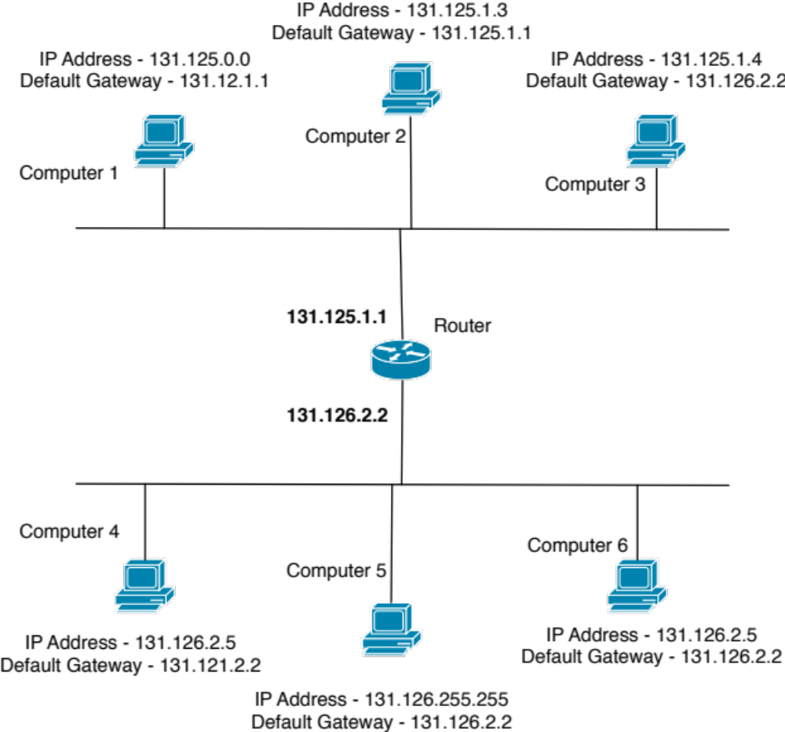

Match the computer name with the appropriate description

__c____ Computer 1 | a. You can’t use a broadcast address for a host address.
___e___ Computer 2 | b. This address is duplicated on the network, and the default gateway is incorrect.
___f___ Computer 3 | c. You can’t use a network address for a host address, and the default gateway is incorrect.
___b___ Computer 4 | d. This address is duplicated on the network.
___a___ Computer 5 | e. No changes are needed.
___d___ Computer 6 | f. The default gateway is incorrect.

Once you have filled in the required information save the document as a pdf. To save the Word doc to pdf click on "File" > "Print" and then in the bottom left corner of the print dialogue window click on "PDF" > "Save as PDF..." Name the pdf file using our standard naming convention and upload it to the dropbox.

