- 请概述单片机嵌入式系统中外部扩展资源的种类。
单片机外部扩展资源包括外部RAM/ROM、键盘、显示器、A/D、D/A、I/O扩展、中断扩展、串通信、总线驱动、电源驱动、看门狗等一些最基本的模块。

- 对于行列矩阵式非编码键盘中按键的识别通常采用两步扫描判别法。以图7.17所示的4 × 4键盘为例，画出两步扫描判别法识别按键流程图。
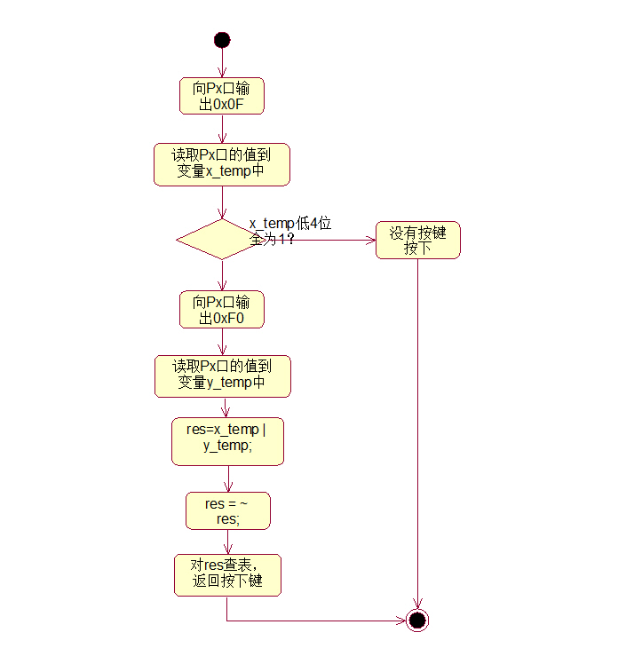

- 编写一个程序，单片机外接4 × 4阵列式按键键盘和蜂鸣器，根据按键键值的不同使蜂鸣器响相应的次数。
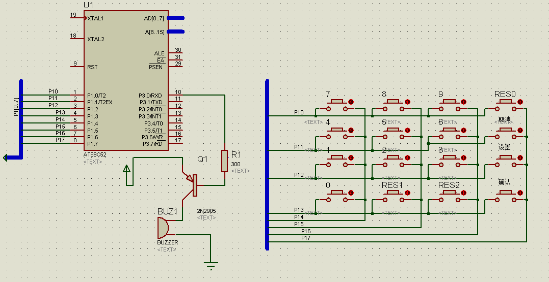//其中 延时函数 未给出
#include<REG52.H>
#include"IMSutil.h"

#define KEY_PORT P1

sbit bibber= P3^0;

enum BUTTON_TYPE { B0 , B1 , B2 , B3 , B4 , B5 , B6 , B7 , B8 , B9 , CANCEL , CONFIRM , SET , RES0 , RES1 , RES2 , NON };

//This function acts like a factory, it map the raw input value into the enum type and return it
enum BUTTON_TYPE convertButton( unsigned char raw );

//This function read the keyboad and return the key typed, NON when no key is pressed
enum BUTTON_TYPE getKeyPressed( void );

int main( void )
{
enum BUTTON_TYPE press;
unsigned char cnt;

while( 1 )
{
press = getKeyPressed();

if( press >= B1 && press <= B9 )
{
for( cnt = 0 ; cnt < press ; cnt ++ )
{
bibber = 0; //trun on the bibber
delay_ms( 1000 );
bibber = 1;
delay_ms( 1000 );
}
}

}

return 0;
}

enum BUTTON_TYPE convertButton( unsigned char raw )
{
//use the simple if else stuff( switch case are essentially the same)
//can i figure out a classifier to compute and get raw to correct type more efficient?
switch( raw )
{
case 0x11: return B7;break;
case 0x21: return B8;break;
case 0x41: return B9;break;
case 0x81: return RES0;break;
case 0x12: return B4;break;
case 0x22: return B5;break;
case 0x42: return B6;break;
case 0x82: return CANCEL;break;
case 0x14: return B1;break;
case 0x24: return B2;break;
case 0x44: return B3;break;
case 0x84: return SET;break;
case 0x18: return B0;break;
case 0x28: return RES1;break;
case 0x48: return RES2;break;
case 0x88: return CONFIRM;break;
default: return NON;
}

return RES0;
}

//This is a bad implementation
//They have a bette approach
//First read the key into firstKey ( if first read faild, give up immediately)
//Second reread the key into secondKey
//if they are the same so it is pressed
//if not return NON
enum BUTTON_TYPE getKeyPressed( void )
{
#ifndef KEY_PORT
#error "No KEY_PORT defined function getKeyPressed() can't work!!"
#endif

unsigned char x_temp,y_temp;

KEY_PORT = 0x0F;

x_temp = KEY_PORT;

KEY_PORT = 0xF0;

y_temp = KEY_PORT;

x_temp = x_temp | y_temp;

x_temp = ~x_temp;

//wait for user to release the key
do
{
KEY_PORT = 0xF0; //can/should I use delay here?? If I have an operating system , it will be very easy, set a wait and let other run. when timeout check the value if fail..continue wait...
}
while( KEY_PORT != 0xF0 );

return ( convertButton(x_temp) );
}

- 图7.19中“串行口扩展8位LED显示器静态驱动电路”使用单片机的RXD和TXD引脚发送移位时钟和移位数据给74HC164，如果单片机的RXD和TXD被占用，改用P1.6和P1.7发送移位时钟和移位数据给74HC164，请编程实现。

16．编写一个写I²C总线接口E²PROM的程序，并提供校验功能，当校验失败的时候提供报警。可用串口精灵发送要写入的数据给单片机。
20．设计一个单片机程序，接收计算机通过串口发送的数据流，将其中的小写字符转换为大写字符，并回送给计算机。

