09计科2班 冯少泳 200930583134 DT report

Table of contents
Decision Tree classifier
Train method:
- None Normalize ; No Feature Selection ; No Discretization ;
- None Normalize ; No Feature Selection ; With Discretization ;
- None Normalize ; Feature Selection ; With Discretization ;

Introduction
We choose the yeast dataset in
http://archive.ics.uci.edu/ml/datasets/Yeast
We thought it is an easy one, but it never is.

Pre-processing
Because there are 10 attributes in dataset yeast.data. The first one is the sequence number, which has no thing to do with te prediction. Then the 2 to 9 is attributes that used to predict. Finally, the 10th is class label, but it's a string type. So, we need to get rid of the first attribute and convert the 10th attribute to number.

Convert was implement in c. So we first use the mex -setup to find a proper c compiler. And mex changleLabel.c to compile the c source file. Finally, call the function.

In this dataset, we do not normalize the data because the original data seems to fall into [0 1] region. And we have test it with K-NN, normalize vs. non-normalize does not differ a lot. So we focus more on how to discrete the dataset and choose the right features. Feature selection is the PCA method use the MatLab build-in function princomp. The discretization include CACC and the aequilatus(等宽的).

Classification Method
Decision Tree( TREEC )

Experimental Result

None Normalize

No Feature Selection

No Discretization

- Use the Information Gain without Pruning
20% training
80% testing
(??? Maximum recursion limit of 500 reached. Use set(0,'RecursionLimit',N)
to change the limit. Be aware that exceeding your available stack space can
crash MATLAB and/or your computer.
)

It seems that decision tree can't stop within 500 recursion,may need pre-pruning.

Well, it seems that even pessimistic pruning (-3), 1000 recursion still reached.

- Use the Information Gain with early pruning( level 1 )
20% training
80% testing
测试准确率 0.310606060606061
训练准确率 0.317567567567568
决策树训练用时 0.400711353826492
每个测试样品耗时 2.276822061877163e-04

- Use the Information Gain with early pruning( level 3 )
20% training
80% testing
测试准确率 0.310810810810811
训练准确率 0.312289562289562
决策树训练用时 0.352825813381842
每个测试样品耗时 0.000210460810348295

- Use the Information Gain with early pruning( level 5 )
20% training
80% testing
测试准确率 0.284511784511785
训练准确率 0.307432432432432
决策树训练用时 0.443252429658495
每个测试样品耗时 2.166965487109993e-04

- Use the Information Gain with early pruning( level 10 )
20% training
80% testing
测试准确率 0.260942760942761
训练准确率 0.400673400673401
决策树训练用时 0.581344554781497
每个测试样品耗时 2.192907511693604e-04

Decision Tree without discretization work poorly. It often fails to stop within 1000 recursion. The training process is very unstable, the training time and the accuracy vary.
And the accuracy is very low.

None Normalize

No Feature Selection

With Discretization
- discrete method :
Each attribute is (等宽) put into 4 discrete levels.

With heavy prune ( level 10 )
20% training
80% testing
Taccuracy for training accuracy
Xaccuracy for testing accuracy
tTTimeElasped for training time
Time2classifeOneSample for time to classify one sample
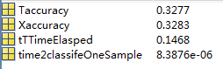

20% 80% prune graph
Accuracy is too low and we can see that prune = 1 or 2 may not have a result within 1000 recursions
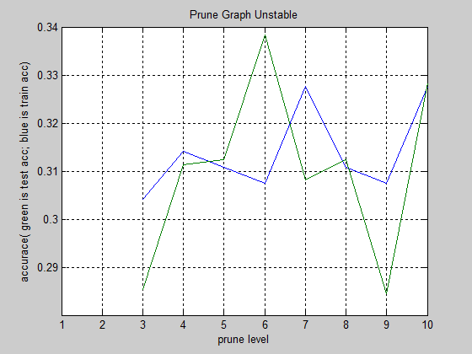

2) Each attribute is (等宽) put into 8 discrete levels.
With heavy prune ( level 10 )
20% training
80% testing
Taccuracy for training accuracy
Xaccuracy for testing accuracy
tTTimeElasped for training time
Time2classifeOneSample for time to classify one sample
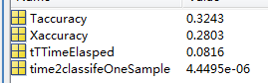

20% 80% prune graph
Accuracy is still too low. And when the training samples(or percentage) become larger and larger,
We even fail to train a decision tree.
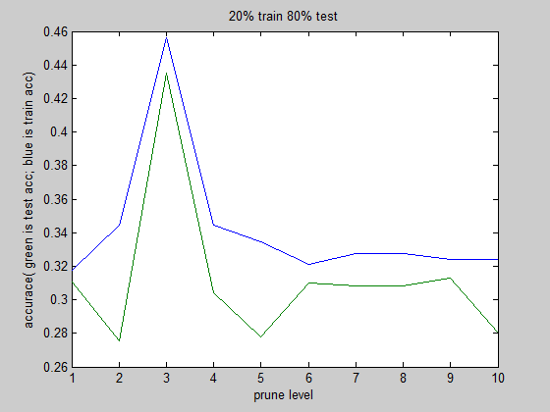

- use CACC package download from the net
We still get a very slow accuracy. This time the training process is smooth. It can stop within 1000 recursions. Well it seems we fail in preprocessing the data.

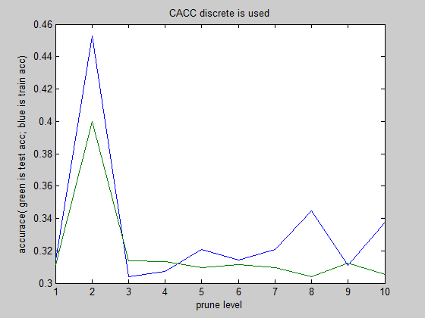

With different kind of discretization, training the decision becomes easier, but it sometimes fails to finish within 1000 recursion too. Even thought we discrete the data, it's accuracy still stays around 30% which is quite weird. Decision Tree is supposed have a good performance (at least it is close to the KNN). But during the experiment, it is much worse than the KNN classifier.

None Normalize

Feature Selection

With Discretization
Feature selection PCA, select the feature that accumulated over 85%.
After the score is created, use the (等宽) put into 8 levle

Here is the graph:
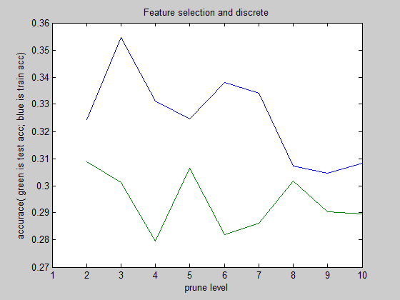
We can see that when prune level becomes bigger, the training accuracy and the testing accuracy become lower. It makes sense. But we have choose a major features and discrete them. We get a worse result. It is not even better the K-NN classifier.

Conclusion
We got a big problem int pre-processing the dataset and feature selecting. Follow the Lab2 experiment, training a Decision Tree is quite easy. But processing the real attribute is tough.

