09计科2班 冯少泳 200930583134 KNN classifier report

Table of contents
K Nearest Neighbour classifier
- feature selection
The following report falls in to two category:
A. All the features are in used
B. a. Feature selection with observation
b. Feature selection with PCA

Introduction
We have chosen the yeast dataset in
http://archive.ics.uci.edu/ml/datasets/Yeast
We thought it is an easy funny one, but it never is.

Pre-processing
Because there are 10 attributes in dataset yeast.data. The first one is the sequence number, which has no thing to do with te prediction. Then the 2 to 9 is attributes that used to predict. Finally, the 10th is class label, but it's a string type. So, we need to get rid of the first attribute and convert the 10th attribute to number.

Convert was implement in c. So we first use the mex -setup to find a proper c compiler. And mex changleLabel.c to compile the c source file. Finally, call the function.

In this experiment we try both the non-normalized and the normalized method to train the classifier

Classification Method
K Nearest Neighbour( knnc )

Experimental Result

1 None Normalized; Full Feature
a. Independent Run
b. cross validation

K = 1 : 15;

Independent Run
In every figure, the training time is given and the testing on training testing set time is given.
20% training
80% testing
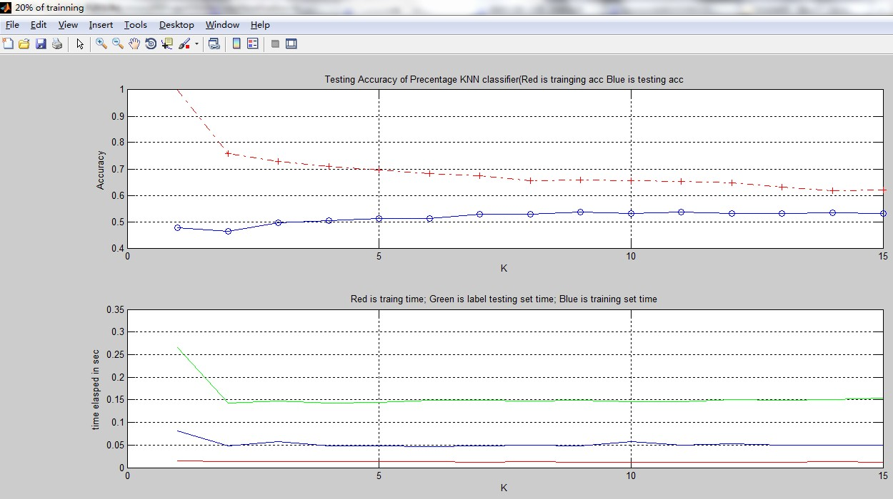
Time for classifying one sample
K TimePerSample(sec)
1 0.000195423181055951
2 0.000117409833030018
3 0.000121042706467892
4 0.000136943694918346
5 0.000127520168894930
6 0.000161968735551418
7 0.000196440814616895
8 0.000232327350707291
9 0.000196105453415011
10 0.000172515907225426
11 0.000233474096268468
12 0.000127801492805982
13 0.000125687025990660
14 0.000126091686924298
15 0.000126674134669760
30% training
70% testing
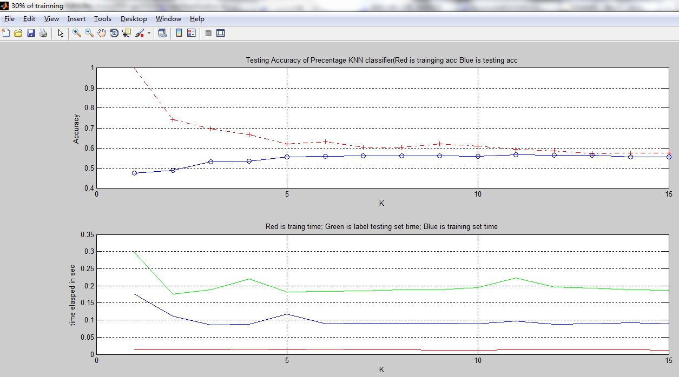
K TimePerSample(sec)
1 0.000292718136484655
2 0.000170578245404265
3 0.000177748323617602
4 0.000172025278686630
5 0.000214007166712493
6 0.000182378547129004
7 0.000175256105930503
8 0.000172715307921344
9 0.000182189885684107
10 0.000174639183005688
11 0.000183674179601839
12 0.000180462218502456
13 0.000172892178025935
14 0.000182612015667065
15 0.000235340059594302

40% training
60% testing
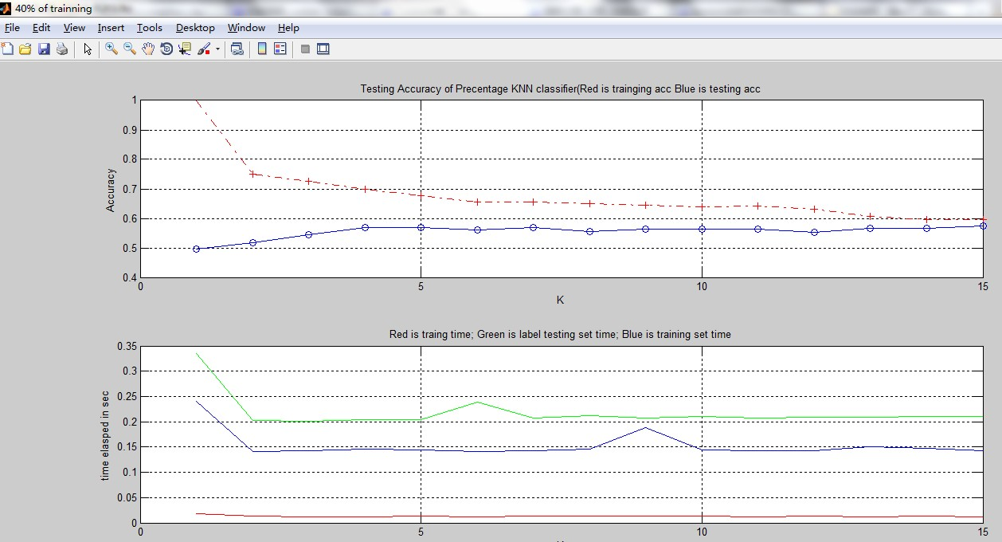
K TimePerSample(sec)
1 0.000381218924377788
2 0.000244540603432232
3 0.000227474719490856
4 0.000227249770361589
5 0.000236199335719611
6 0.000257985301390495
7 0.000229080713274375
8 0.000230942456067941
9 0.000229954109893631
10 0.000235344639027971
11 0.000239943721225844
12 0.000268661310065801
13 0.000239283723780562
14 0.000236562334314516
15 0.000235383138878946

50% training
50% testing
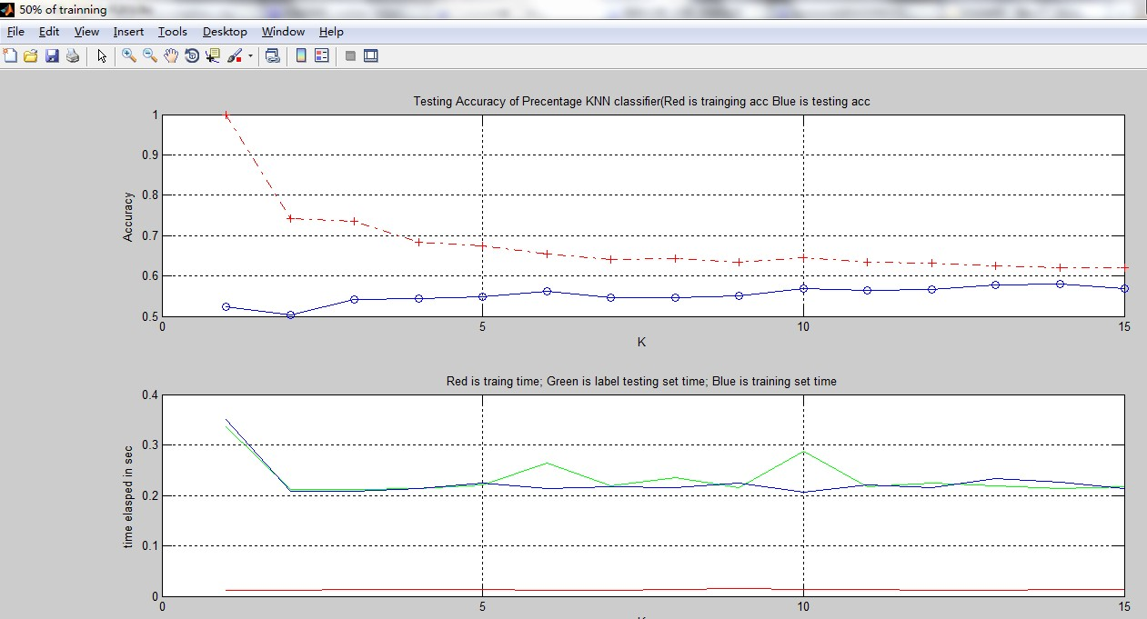
K TimePerSample(sec)
1 0.000463691176303224
2 0.000292885636446526
3 0.000287298955982500
4 0.000294683360080890
5 0.000285651152724699
6 0.000280609997507544
7 0.000302709053543337
8 0.000291340862169974
9 0.000289461904146549
10 0.000293974045171519
11 0.000290849493182477
12 0.000294211143916830
13 0.000292857237432464
14 0.000293222461962149
15 0.000297987552344931

60% training
40% testing
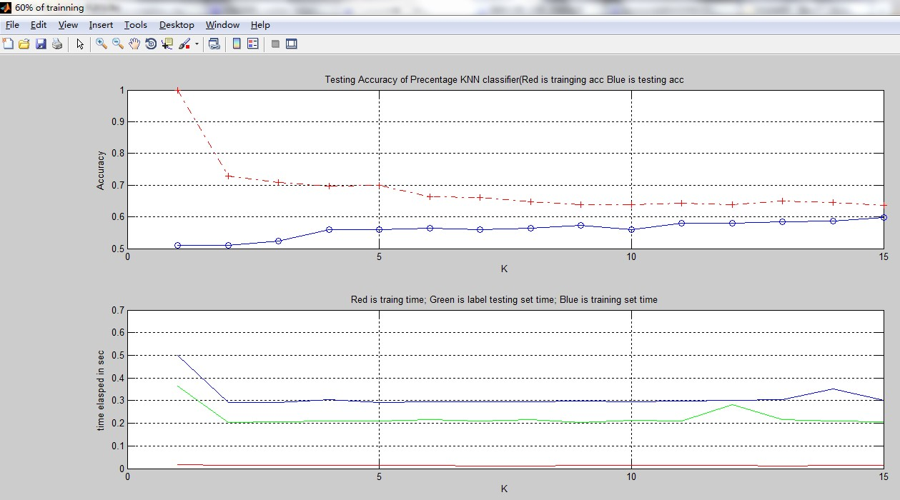
K TimePerSample(sec)
1 0.000572494983986416
2 0.000340579306685620
3 0.000473463192318675
4 0.000670974852790540
5 0.000520099436799100
6 0.000494653235296257
7 0.000367514627424380
8 0.000488740483183338
9 0.000433068873677004
10 0.000527822231905705
11 0.000409641439359917
12 0.000397287937177853
13 0.000431534379616723
14 0.000393973925005731
15 0.000413772198370575

70% training
30% testing
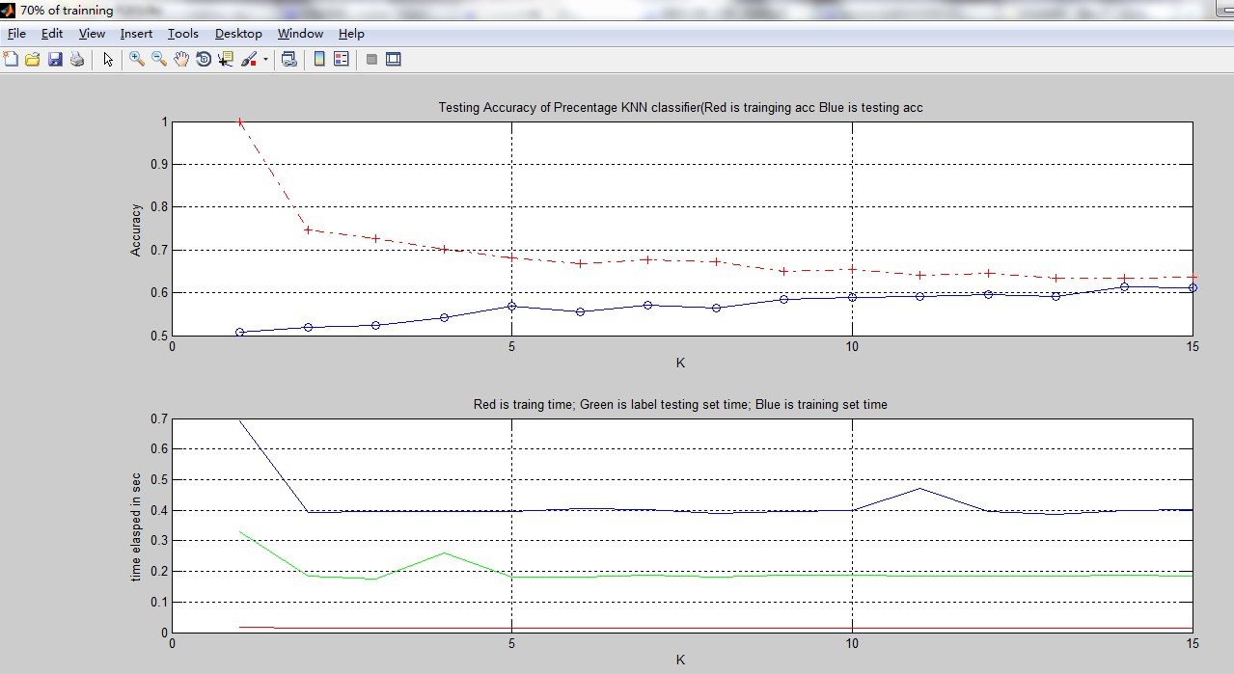
K TimePerSample(sec)
1 0.000692922524001413
2 0.000410018633079247
3 0.000423059845940128
4 0.000412053541346022
5 0.000406023532399985
6 0.000410549335397202
7 0.000413384142809880
8 0.000399660598397343
9 0.000414438954870411
10 0.000496634085924744
11 0.000412057936396274
12 0.000470737351076140
13 0.000417767106673900
14 0.000419347127239570
15 0.000423443314074633

All the data above is not normalized, no feature selection. K-NN is lazy learning, we can find out that under any percentage the training time is almost zero. But It need to calculate the distance for each unseen sample. To this dataset, when K is quite small( 1 ~ 5 ) the accuracy is quite low. When K is bigger like( 6 ~ 15 ) the situation gets better, but over all the accuracy of the testing is not really high.

b. Cross validation
5-fold validation
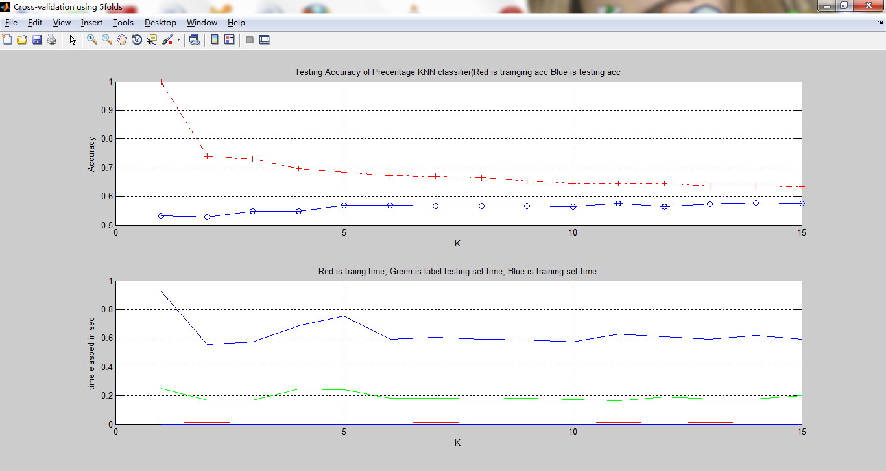
K TimePerSample(sec)
1 0.000846133764037448
2 0.000567384892614267
3 0.000571312212082210
4 0.000829483356048494
5 0.000817764139652477
6 0.000619393724216271
7 0.000613113909676468
8 0.000596350896294546
9 0.000612480545618660
10 0.000586786042314140
11 0.000556758377817461
12 0.000647012425834060
13 0.000606445755130418
14 0.000592579441182852
15 0.000672788823969829

10-fold validation
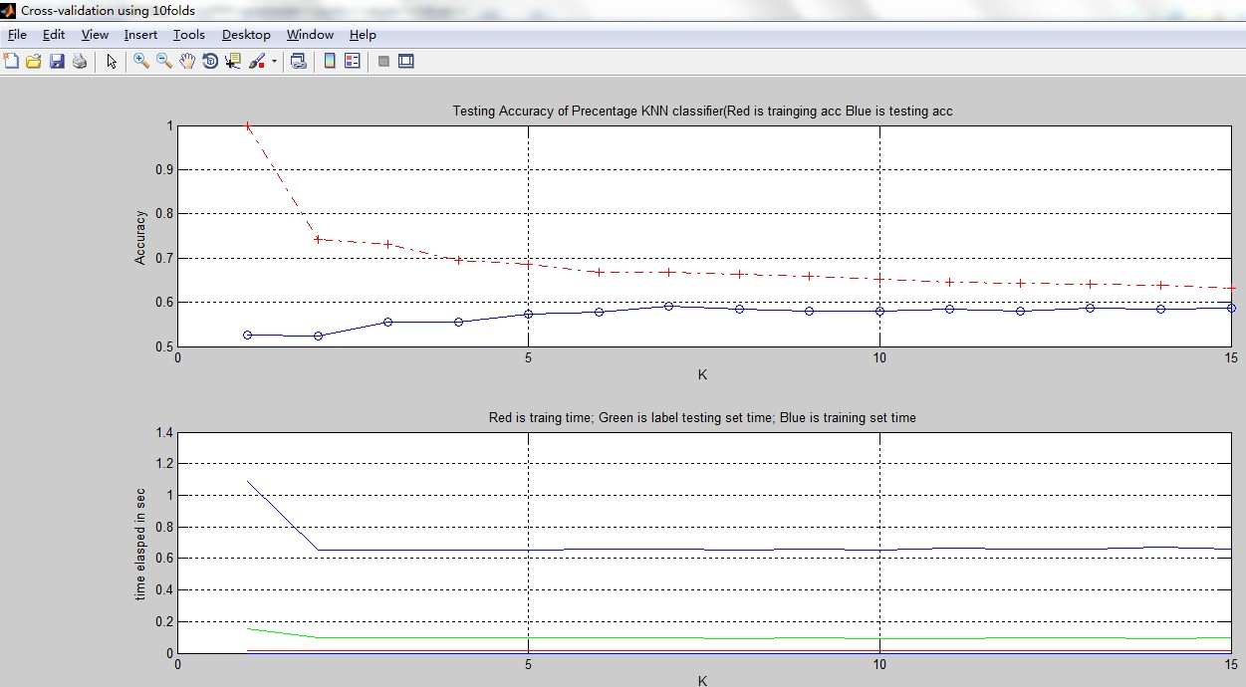
K TimePerSample(sec)
1 0.00105062020435096
2 0.000666822059026899
3 0.000639031312219268
4 0.000640446309605977
5 0.000657690785342584
6 0.000649683914482480
7 0.000667888673159705
8 0.000630728233038072
9 0.000656989395739463
10 0.000618690023065494
11 0.000630390086638074
12 0.000641876166941906
13 0.000654616426959791
14 0.000625166319156077
15 0.000655270925167599

Use the K-fold cross-validation, the running time and the accuracy is average.

Normalized
K = 1 : 15;
a.
20% training
80% testing
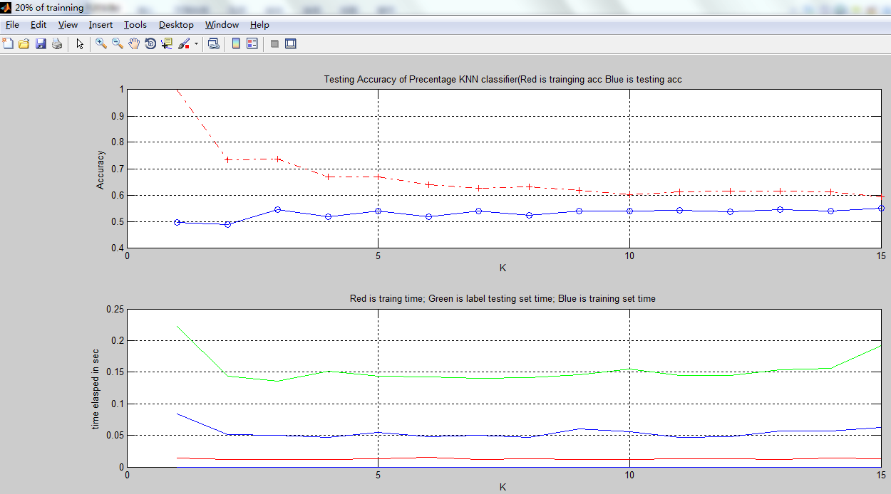
K TimePerSample(sec)
1 0.000187567148965080
2 0.000120918131950095
3 0.000114149033151922
4 0.000127584106147442
5 0.000120447471271928
6 0.000120037035360644
7 0.000117803356506768
8 0.000119166663729678
9 0.000122308664067623
10 0.000129900284681978
11 0.000122244726815111
12 0.000121980727836999
13 0.000129684548017052
14 0.000131693002742725
15 0.000161797548714048

30% training
70% testing
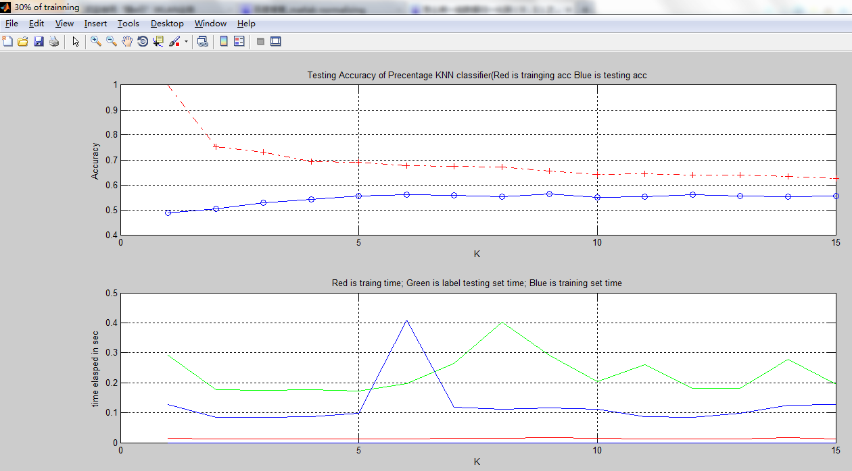
K TimePerSample(sec)
1 0.000280109420468528
2 0.000171020656492550
3 0.000168497309667043
4 0.000170492404446836
5 0.000165917364408067
6 0.000189672198588750
7 0.000253972263892400
8 0.000386961131361632
9 0.000280774923715405
10 0.000195432032501477
11 0.000250068858597466
12 0.000174185452230709
13 0.000175224505138483
14 0.000268785960545768
15 0.000187886989666405

40%
60%
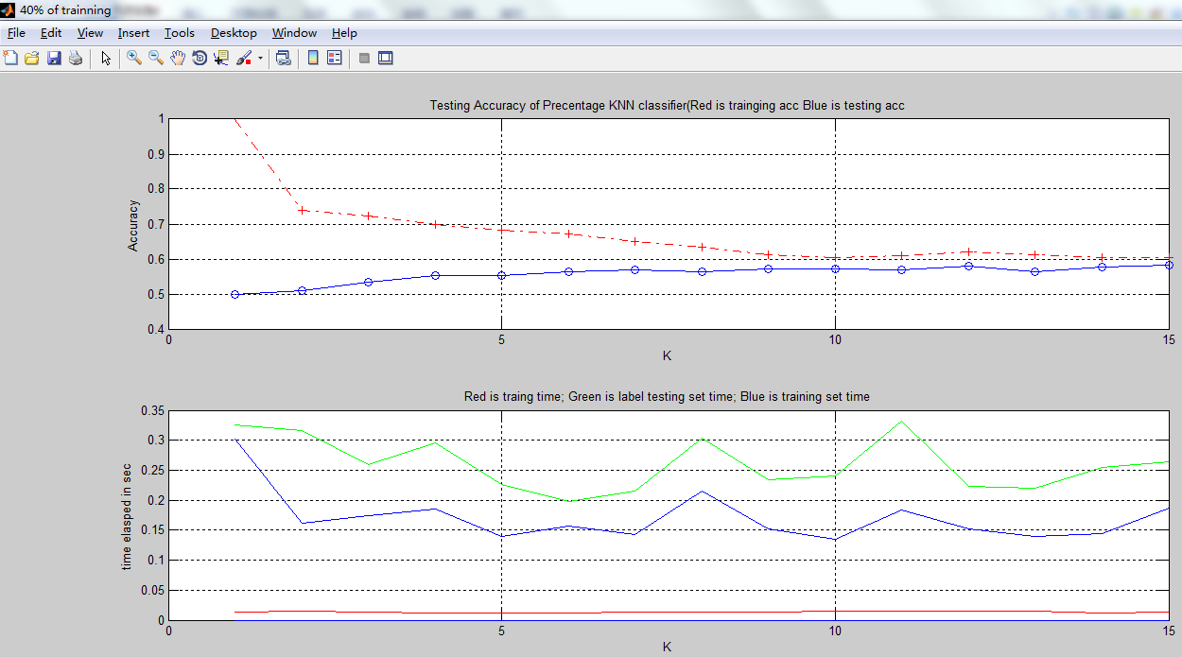
K TimePerSample(sec)
1 0.000364753638111618
2 0.000353920880043058
3 0.000291626471172255
4 0.000331785665724045
5 0.000253203069901557
6 0.000221647492046888
7 0.000240845717734396
8 0.000339887134364880
9 0.000262336334548516
10 0.000270165554243173
11 0.000372829806850384
12 0.000250916178753655
13 0.000246829144573747
14 0.000285772293832605
15 0.000296005004223830

50%
50%
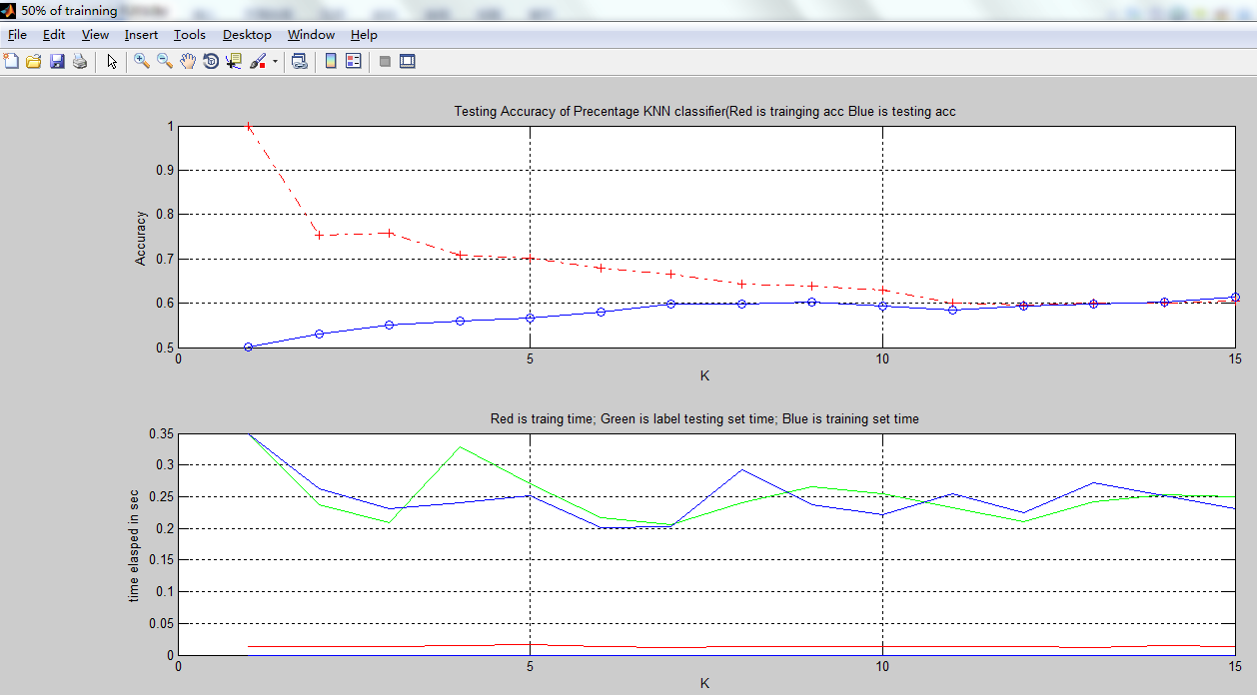
K TimePerSample(sec)
1 0.000470777060532866
2 0.000319883852629163
3 0.000280662172440356
4 0.000443333706315857
5 0.000363591916597628
6 0.000291204150637162
7 0.000276271552777885
8 0.000323617992757263
9 0.000358371121105474
10 0.000344205296625879
11 0.000312669842615147
12 0.000283421499899713
13 0.000326412323652558
14 0.000340951958410275
15 0.000337275276752487

60%
40%
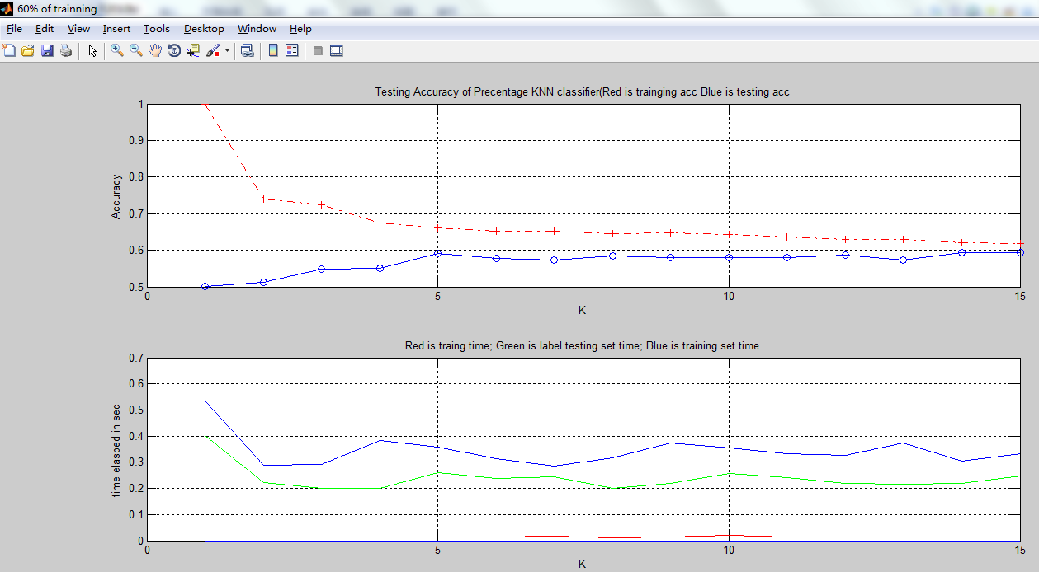
K TimePerSample(sec)
1 0.000674868012720896
2 0.000371834310703750
3 0.000334606329805819
4 0.000337836192303667
5 0.000437499931525265
6 0.000399838002307061
7 0.000409816338682916
8 0.000337573018322361
9 0.000366294457147415
10 0.000433208298137320
11 0.000405152631735193
12 0.000369960742955956
13 0.000366042833121402
14 0.000369765218712791
15 0.000416426213097414

70%
30%
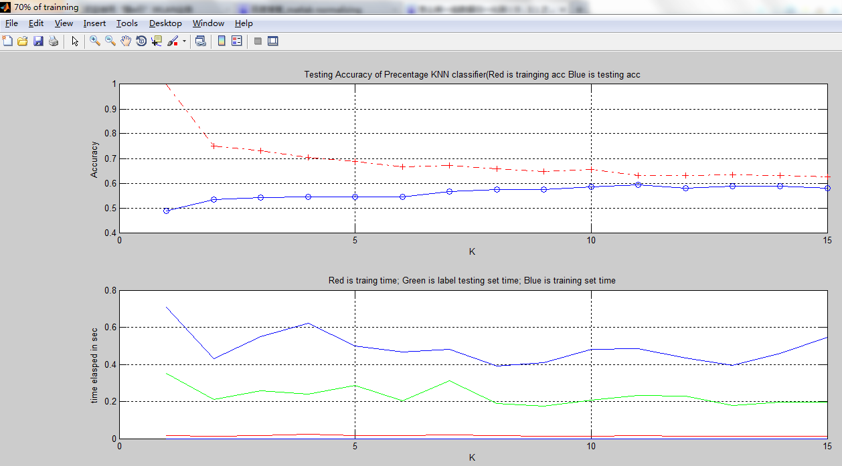
K TimePerSample(sec)
1 0.000784289026169553
2 0.000470560450303488
3 0.000574781375696789
4 0.000536321389702232
5 0.000644189108042307
6 0.000453510951612589
7 0.000696897846954541
8 0.000426048480111633
9 0.000390115648012099
10 0.000466835645214737
11 0.000518770855282581
12 0.000510177433276940
13 0.000399885844722769
14 0.000442947448331394
15 0.000437384413474655

b.
5-fold validation
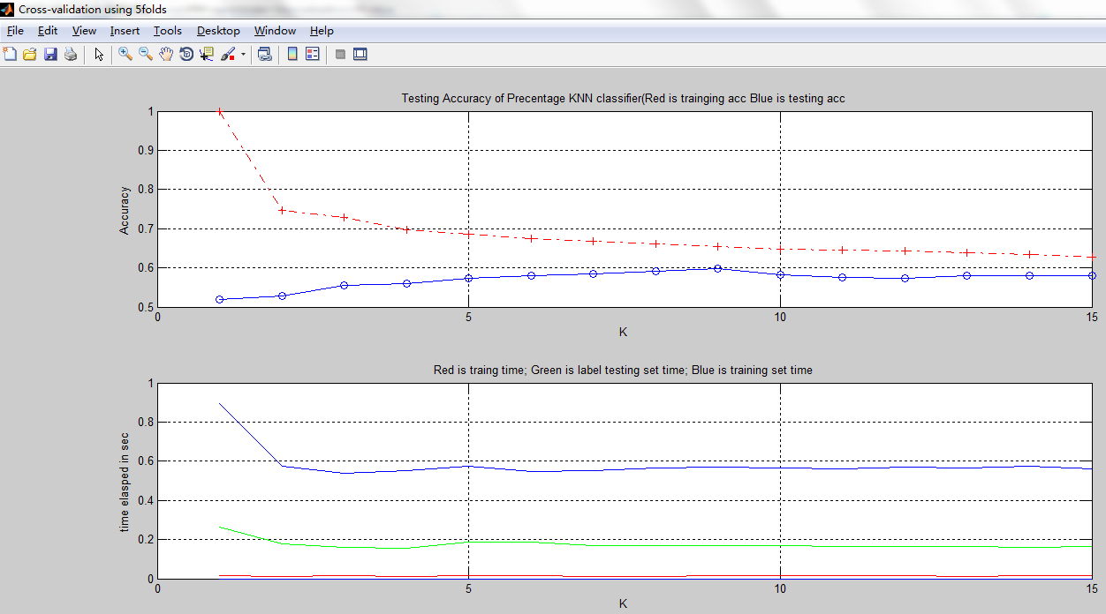
K TimePerSample(sec)
1 0.00106024846078136
2 0.000750613019796665
3 0.000601862946791385
4 0.000730146246627267
5 0.000652043013976214
6 0.000681962035733050
7 0.000591266482114111
8 0.000532848719524648
9 0.000590586887103178
10 0.000530243935537165
11 0.000576694155468112
12 0.000598558754527344
13 0.000596296740035172
14 0.000563443373639292
15 0.000545099591881599

10-fold validation
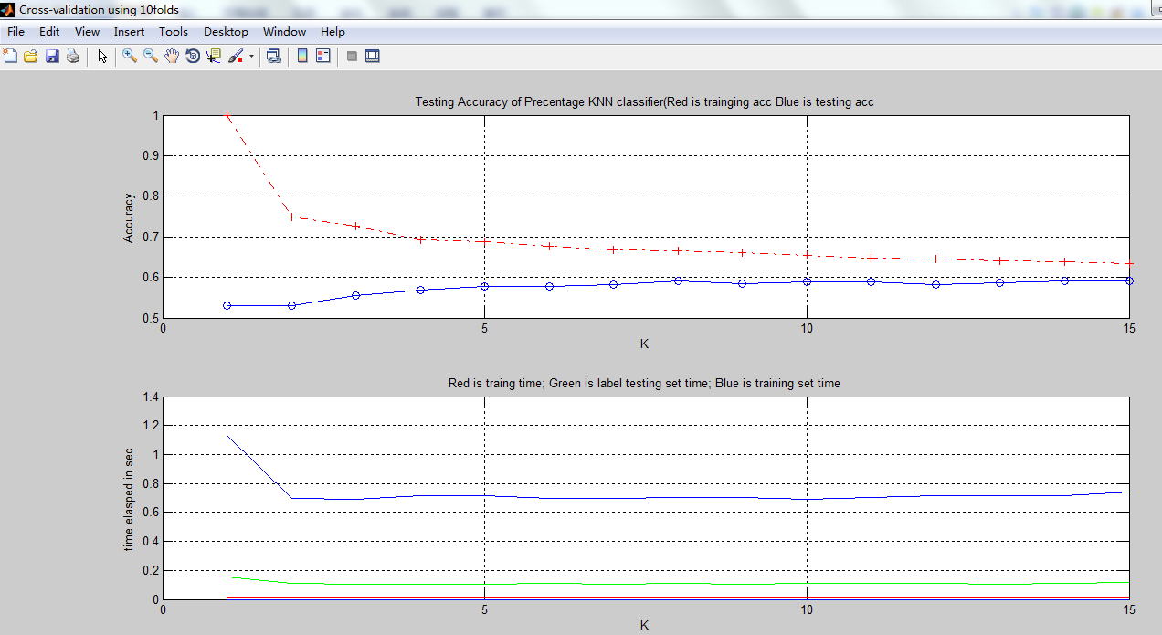
K TimePerSample(sec)
1 0.00103656929681199
2 0.000738277610839714
3 0.000685799865284588
4 0.000712732697690662
5 0.000683543464551009
6 0.000753537457802896
7 0.000709644139800838
8 0.000742894101730309
9 0.000716974057418759
10 0.000741600295485005
11 0.000732176776132723
12 0.000745998510232633
13 0.000689613258475188
14 0.000747833218629495
15 0.000783387133130045

After normalizing the data, it does not have much improvement. Because the original data does not have a large scale. They all falls within 0 and 1. But overall, compared to the non normalize records, it works a little better.

Feature selection:
- After CACC choose feature by observation
- Use PCA method

After using the CACC to discrete
We can find out that some features seems to be useless, they seldom change.
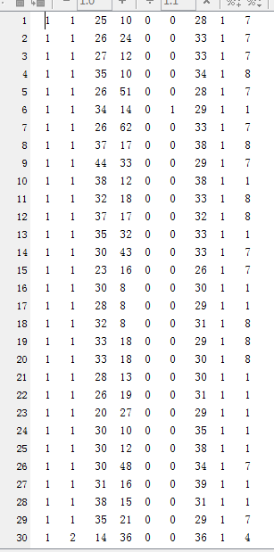

So, let's try feature 3 4 7 to classify samples
20% training
80% testing
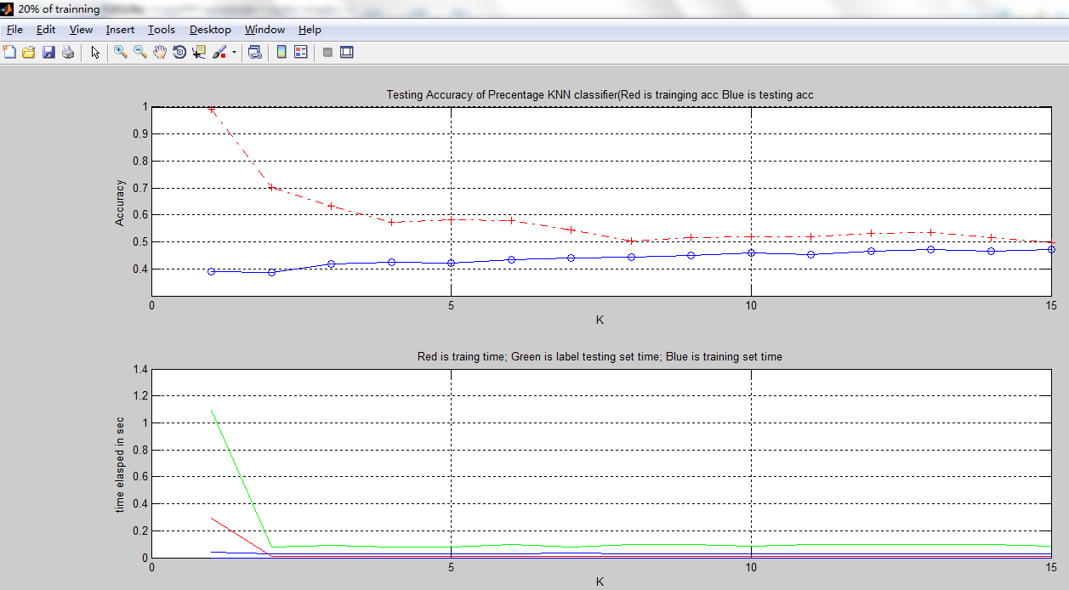
Compared to the full features one, the accuracy is much lower. Maybe we have chosen wrong features. Meanwhile the calculate process is much faster.

50% training
50% testing
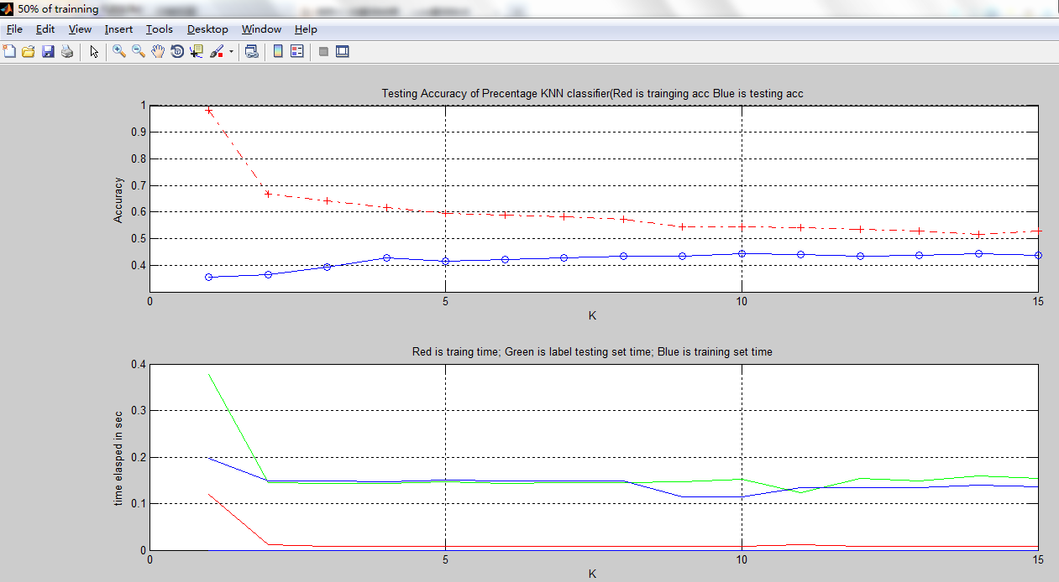
We still get a low accuracy result. It is obvious features 3 4 7 is wrongly chosen.

PCA:
princomp function in matlab.
3 main component:
50% training
50% testing
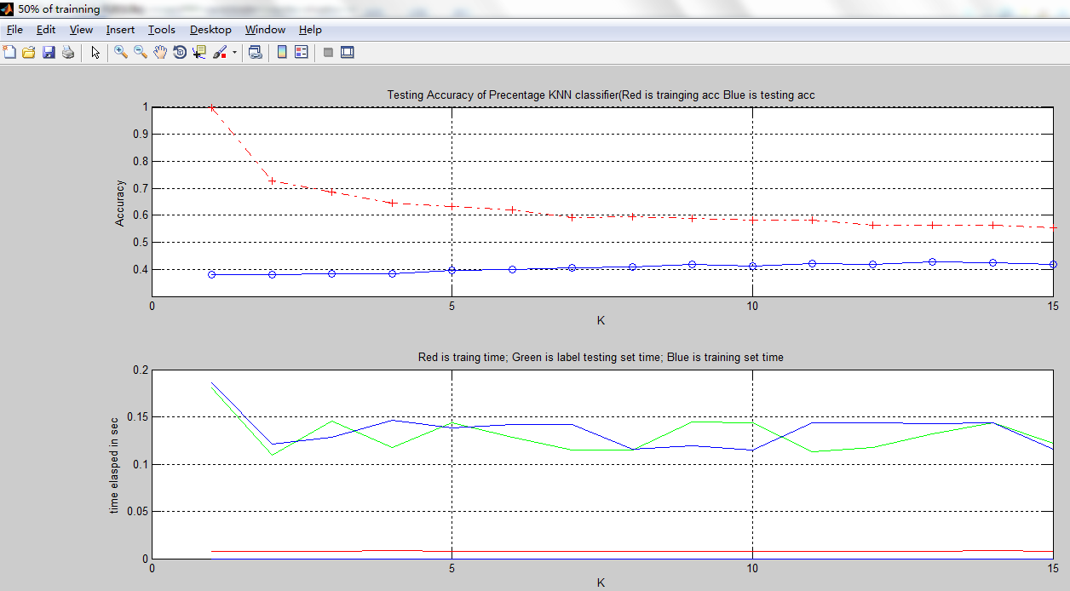
It seems 3 main component is not enough.

5 main component:
50% training
50% testing
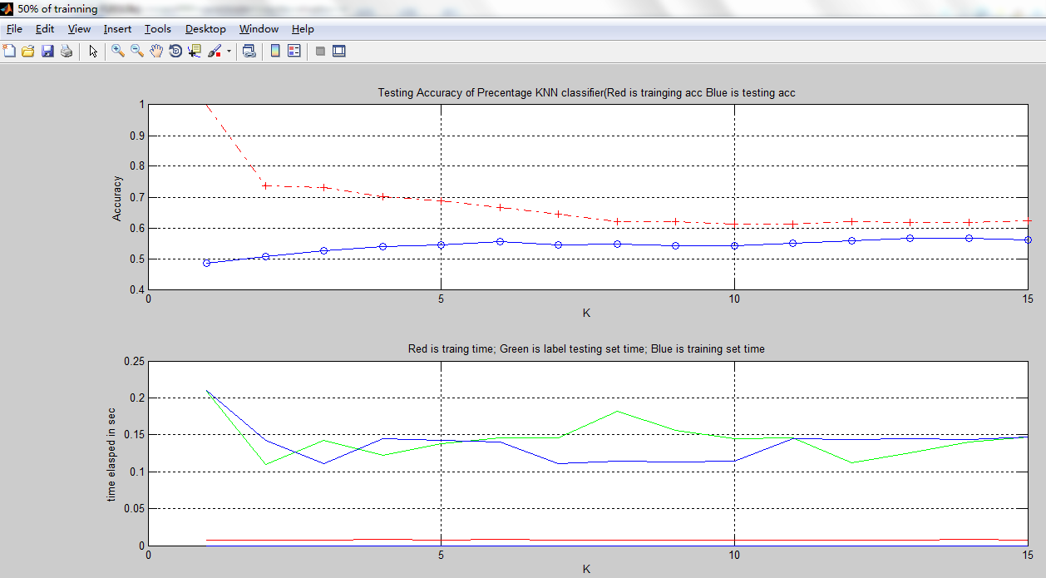
When component is 5, it's quite good.
(When component is 5, the accumulated latent is above 85%)

7 main component
50% training
50% testing
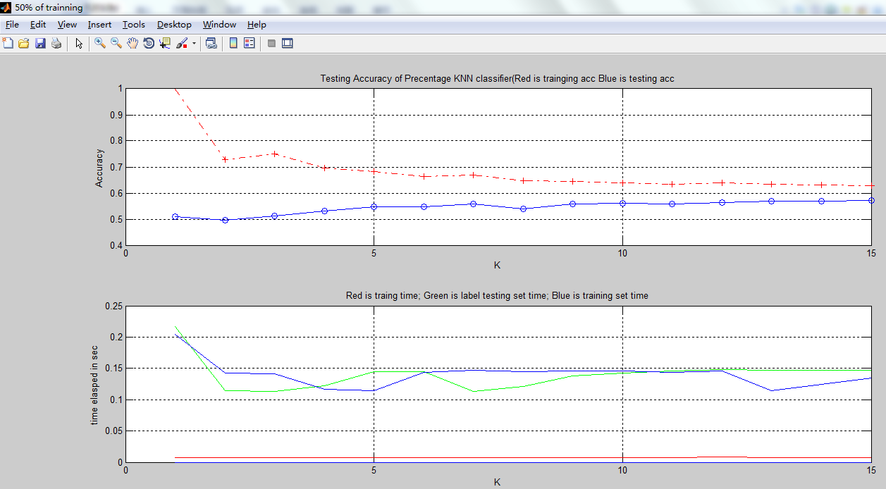
Compared to the 5 main component, 7 component does not have much improvement.

