Manual – ELAN Analysis Companion (EAC)

Dependencies
Python 2.7; Matplotlib 1.4.3; Numpy 1.9.2.
For Windows, a scientific Python distribution like Python-xy contains all dependencies:
http://code.google.com/p/pythonxy/wiki/Downloads

Tested Platforms
Windows 7 64-bit; Ubuntu 12.04 32-bit; ELAN 2.6.

License and legal matters
This software package is released under GNU Public License v3. Users are kindly asked to reference this software package with the following reference:
Andersson, R & Sandgren, O. (2013). “EAC – A Software Tool for Time-Course Analysis of ELAN Annotated Data” [Journal Title].
The software authors do not claim responsibility for any damages caused by this software. Use it at your own risk and make sure you have backed up the original files before using this software.

Motivation for software
This software was developed with ELAN users who do not code in mind. All information extracted by this software is possible to extract on your own, using script from your favorite programming language. However, not all researchers doing observational studies (ethologists, linguists, anthropologists) do this. This is often reflected in the data analysis stage of their research as well, focusing more on count data and heavily down-sampled time. This means they are also missing out on a lot of interesting information in the data which is best visualized as responses over time following some key event.
Furthermore, we found a small bias in the “Compare annotators”-functionality of ELAN, where the durations of events are not taken into account. Sometimes, this is an important consideration and we corrected the calculation to do precisely this.

Description of user interface and functionality
This section will go through each interface element of the software tool, first for the time-course analysis tab, and then for the inter-rater reliability tab.

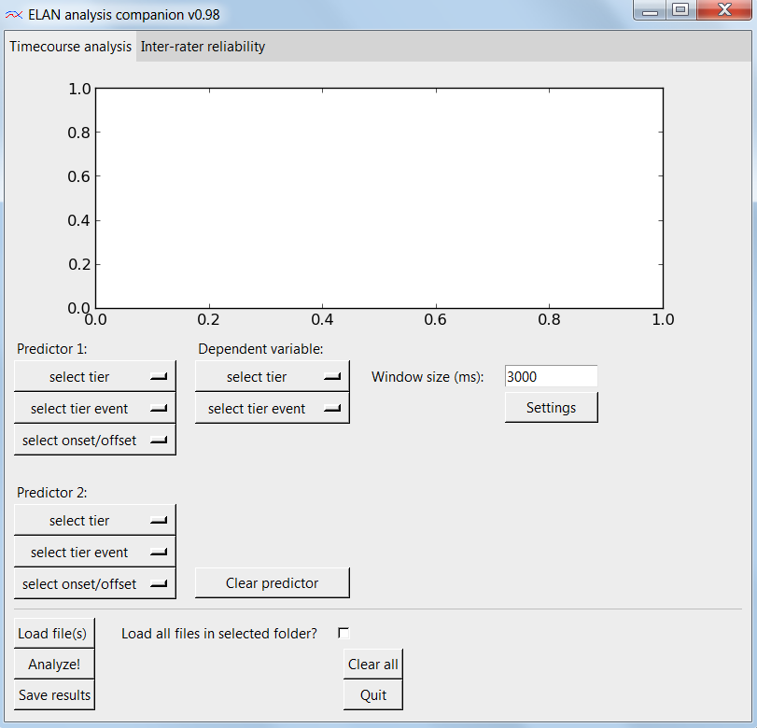Figure 1: Interface tab for the time-course analysis.

Dialog for the time-course analysis
The time-course analysis tab consists of three parts. Top-most, below the tabs, is the plot area, where the analysis results are drawn. Below this area there are the widgets for specifying the predictors, dependent variable and settings for the analysis. Finally, at the bottom, there are general file input and output handling, clear and exit buttons. This last section is identical for both the time-course analysis tab and the inter-rater reliability tab, and works in the same way.
The predictors buttons to the left in the middle area consist of two groups of three buttons. The first group is for the first and mandatory predictors, whereas the second group is optional. These specify the tiers, events and time points in ELAN's .eaf-files where the program should look for triggers for an analysis window. When at least one file is loaded, the dropdown widget with the test “select tier” will be populated by the names of all the tiers in the .eaf file(s). Upon selection of a particular tier, the next widget, the one with the text “select tier event”, is then populated by all the names of the different events in the selected tier. Selecting an event is mandatory and specifies what events trigger analysis windows. Finally, the last button in a group is the button for selecting either the onset of the offset as the trigger point of an analysis window.
The center column of the middle area holds the dropdown widgets for the dependent tier and event. The selection of first a tier and then an event is mandatory. This specifies what event you are actually counting inside the triggered analysis windows. At the bottom of this layout column is also a button with the text “Clear predictor”, which refers to Predictors 2, which can be cleared without clearing anything else.
Finally, the right-most layout column of the middle area is the settings for the analysis window. The text field holding a number is the size of the analysis windows in milliseconds, and can be changed at any point by the user. Click the button with the text “Settings” triggers a settings dialog with more choices.
The settings dialog has four different fields and widgets that can be changed by the user. The first one is the resolution in milliseconds. This is simply to what degree data should be downsampled in order to save memory. If you are analyzing conversations lasting up to 30 minutes, it does not make sense to treat the data as events occurring with millisecond precision. A resolution of 10 ms makes sense for most experiments, but the limits are set by the memory of your computer and your own patience in waiting for the analysis results. The second widget is a dropdown menu specifying what to do about analysis windows that overlap, due to trigger events occurring in rapid succession or analysis windows being very large. The two alternatives are “double-dipping” and “first come first serve”. The first alternative allows the same data to be used for more than one analysis windows, which may be questionable statistically. The second alternative is to only use the data for the first occurring analysis window. The third widget in the settings dialog is how to bin the resulting data. Sometimes you don't want to analyze the data at maximal resolution, but you are happy to simplify it. The difference between the resolution and the bin size is that your output will be numbering according to your bins and that bins don't simply use each n:th sample, but aggregates values in a more sophisticated way, as specified in the final widget. The fourth and last dropdown widget specifies how to aggregate bin values, and this can either be done by taking the mean or using a value rounded up. The mean is simply the mean of all values (0, 1, NaN) of a bin, whereas “round up” when that values are rounded up to 1 if there is at least a single 1 in the data constituting the bin. The output value “NaN” is only used if no other values are present in the binned data. When clicking the “OK” button, your selected settings are saved to a file in the program folder, to be loaded when you start the program next time.
Finally, we will describe the file-handling button in the very end of the GUI. The button “Load file(s)” triggers a dialog for navigating your computer and locating an .eaf file to read. Upon ticking the tick box for “Load all files in selected folder?”, all .eaf files in the same folder as the file you just loaded will be loaded as well. They will also be unloaded if you untick the box. The “Analyze!” button is the button to press after having loaded files and specified all you predictors, dependent variable and settings. EAC will then process all your data and draw it in the plot area at the top. The button “Clear all” restores all widgets to their default values and also reloads all settings to defaults saved on your computer. Finally, the “Quit” button closes the program.
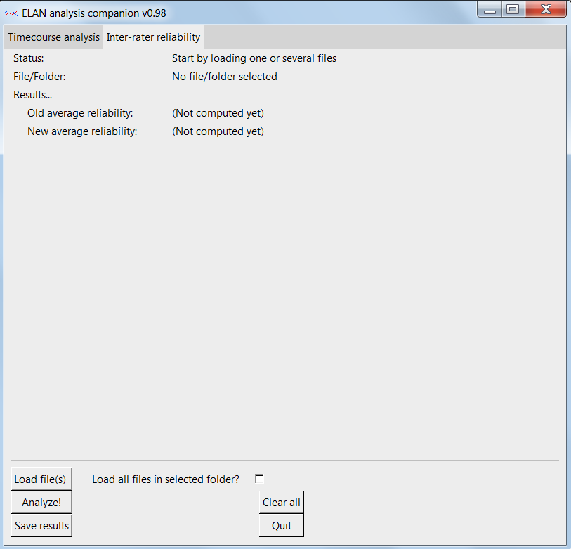Figure 2: Interface tab for the inter-rater reliability calculation.

Dialog for the inter-rater reliability tab
For this tab, the first thing to conclude is that the bottom input/output widgets are the same for this tab, and they work in the same manner, except for a few small details. When loading all files in the selected folder, the mode of this tab ignores files ending with “_corrected.txt” to avoid loading already corrected files. The explanation for this is that when saving the results, the resulting files have the names of the original files but with a “_corrected” suffix to them.
Moving on the text fields above, the first one is the status field. This is a simple indicator of what you need to do next. The field with the text “File/Folder:” specifies what file(s) you have just loaded. This will update when you load a file or click the tick box to load all files in the folder. The results text has two fields under it. These fields will receive values when you click “Analyze!”. The first field (Old average reliability) will show the reliability according to ELAN's calculation. The second field (New average reliability) will show the reliability statistic according to EAC's calculation.

Data examples and tutorial

Example 1 – verifying the options for overlap handling
The aim of this first example is simply to demonstrate the two options for handling the case when two triggered analysis windows are so near or large that they overlap. Either you could allow “double-dipping” and let some time points of the dependent event be counted twice (statistically dubious), or you could only let the first analysis window use the contested time points (“first come – first serve”).
Let's start with using a simplified .eaf file where we have purposefully constructed annotations that will overlap. You may find this file in: /Examples/1/overlap.eaf
Then, let's manually calculate the problematic events and the expected results for the two overlap options:
SETTINGS
Predictor tier "%spa@Speaker #1"
Predictor event "$BACH"
Predictor point "onset"
Dependent tier"Speaker #1 Task"
Dependent event "Task"
Resolution: 1 ms
Bin size: 1 ms
Window size: 3000 ms

Pred-event 1: 00:05.750 -- 00:06.845
Pred-event 2: 00:07.085 -- 00:07.935
Dep-event 1: 00:04.043 -- 00:11.541

Pred-event 3 (no overlap): 00:18.148 -- 00:19.628
Dep-event 2: (non-existent)

EXPECTED OUTPUT 1 (NO OVERLAP HANDLING - "DOUBLE-DIPPING")
First triggered event: window becomes 4250--7250
→ Dep event covers window completely: all ones.
Second triggered event: window becomes 5585--8585
→ Dep event covers window completely: all ones
Last triggered event (no dep event): all zeros
Result: a flat line with height (1+1+0)/3 = 0.67

EXPECTED OUTPUT 2 (OVERLAP HANDLING - "FIRST COME FIRST SERVE")
First triggered event: window becomes 4250--7250
→ Dep event covers window completely: all ones
Second triggered event: window becomes 5585--8585
→ 5585--7250 are blocked by first-come-first-serve (null value)
→ Unblocked window is: 7251--8585
→ Dep event covers window completely: all ones for unblocked window
Last triggered event (no dep event): all zeros
Result: 0.5 ((1+NaN+0)/2) u ntil time (7250-7085)) 165, then 0.67 (1+1+0)/3.

These are our two expected results. Now, we proceed to enter the same information into EAC, click “Analyze” and finally compare the graph(s) with the expected output.

Example 2 – verifying the options for rounding results
The aim of this example is to showcase the two rounding functions for the resulting data. When binning data, it is often desirable to use the mean of the binomial values inside the bin to calculate a gradual change for each case in the statistical analysis. However, sometimes we want to employ an analysis that expect binomial data (zeros and ones). For that scenario, it is possible to select “Round up” to have the bin value be rounded up to one if there is any one (i.e. hit) at all during this time interval. Otherwise it returns a zero, or in the scenario where a bin is only nans, then a nan (not a number) is returned. A special .eaf file for testing this can be found in: /Examples/2/rounding.eaf
First, let's look that that .eaf file and then calculate the expected results from the two bin functions:
SETTINGS
Predictor tier "%spa@Speaker #1"
Predictor event "$BACH"
Predictor point "onset"
Dependent tier"Speaker #1 Task"
Dependent event "Task"
Resolution: 1 ms
Bin size: 500 ms
Window size: 3000 ms
Pred-event 1: 00:00.520 -- 00:01.240
Pred-event 2: 00:06.610 -- 00:07.530
Dep-event 1: 00:04.043 -- 00:07.085
Dep-event 2: 00:12.419 -- 00:13.150

EXPECTED OUTPUT 1 (“MEAN”)
First predictive event onset is >1500 ms away from dep event, thus ignored.
Second predictive event coincides with dependent event 1.
Bin 1: 05.110 – 05:610 (analysis window start 05.110) = 1
Bin 2: 05.610 – 06.110 = 1
Bin 3: 06.110 – 06.610 = 1
Bin 4: 06.610 – 07.110 (trigger onset 06.610, dep offset 07.085) = .952
Bin 5: 07.110 – 07.610 = 0
Bin 6: 07.610 – 08.110 = 0

EXPECTED OUTPUT 2 (“ROUND UP”)
First predictive event onset is >1500 ms away from dep event, thus ignored.
Second predictive event coincides with dependent event 1.
Bin 1: 05.110 – 05:610 (analysis window start 05.110) = 1
Bin 2: 05.610 – 06.110 = 1
Bin 3: 06.110 – 06.610 = 1
Bin 4: 06.610 – 07.110 (trigger onset 06.610, dep offset 07.085) = 1
Bin 5: 07.110 – 07.610 = 0
Bin 6: 07.610 – 08.110 = 0

Then, to verify these expected results, select the same values and settings in EAC and click “Analyze”. Verify that the graph corresponds to this, but also blick “Save results” and verify the actual number.

Example 3 – a slightly larger and more natural example
This example will show a slightly larger example as a better showcase for this software tool. We will not manually calculate the correctness of the results this time. Instead, we will focus on a plausible example of a real analysis and some motivations for different choices of the settings. The background of this material is a study on the conversational functions of utterances and how they interact with the gaze of the speakers. For example, do you look up more at a person's face when asking a question compared to making statement?
First of all, click on the “Settings” button and modify the values. Resolution should be set to 10 ms, because 1 ms is way too high for a transcription that lasts about 20 minutes per conversation. Too high resolution consumes a lot of memory and everything takes much longer time. Set overlap-handling to “first come first serve”. This will take longer time than the “double-dipping” solution, but is a bit more correct in terms of statistics and you don't allow a measurement value to be repeatedly sampled. Set bin size to 10 ms and “Bin function” to use the mean. At this stage, we want to look at the graph at detail, so we avoid binning it and we are using the same size as the resolution. We are also using the mean of the bin, which will probably not matter too much for these small bins. For a proper analysis, we may consider binning the data in 250 ms bins, as we are looking at fairly slow effects. Now click “Ok” to save the new settings. We are going to set the “Window size” to 3,000 ms, in order to capture the first 1.5 seconds before the onset of our event and 1.5 seconds after this event.
Now, let's load up some files. Start by clicking “Load file(s)” and select any file in the following folder: /Examples/3/
Now, click on the tick box for loading all files in the folder. Now, we are ready to start selecting predictors and dependent variables. This is a study about communicational functions and gaze, so let's briefly motivate the selection of predictors and dependent variable from this perspective. In our ELAN-annotated data, the utterances are coded for their communicative function. These functions are “$BACH” for backchannelling ('mhmm', 'mmh', et c.), “$STATEMENT” for statements (“She's wearing a blue sweater.”, “$REQUEST” for requests for information (“Is she wearing ear rings?” and “$NONE“ for other types of utterances (“Oops” when dropping a game piece, e.g.). These codes are all stored in the ELAN tier for communicative functions and the tier name is “%SPA@Speaker #1”. Furthermore, the material also contains codes for where the two speakers direct their gaze during this conversation. These gaze locations are either “Face” for the other speaker' s face, “Task” for the game board, and “Off” for anywhere else. These codes are all stored in their own tiers and divided up by speaker, so a tier name for this information would be “Speaker #2 Face” for the code “Face”, which indicates when Speaker #2 direct his gaze to Speaker #1's face.
For this analysis, we are interested in when a request for information triggers the other person to look up to the speaker. Is it the onset of the question, which typically is initiated by a question word (“wh-” word) or is it the offset of the question, which is likely to end with a rising tone to signal its function as a question. Which of these two signals is the best predictor for gaze look-up of the listener? One expectation is that the question word in the beginning of a sentence is a signal to look up and listen carefully, as this is a real request and not just some backchannelling or less informative utterance. However, another expectation is that the rising tone in the end of the question is the definite signal that this is a question and this compels the listener to look up and visually signal that she/he has understood the request.
So, let us select the following predictors and dependent variable:
Predictor 1
Tier: %spa@Speaker #1
Event: $REQUEST
Point: onset

Predictor 2
Tier: %spa@Speaker #1
Event: $REQUEST
Point: offset

Dependent
Tier: Speaker #2 Face
Event: Face

So, we are looking at exactly the same event as a predictors, just that we are looking at different point of the event: first the onset of that event and then the offset. Now click “Analyze!” and inspect the graph. This analysis should produce a graph looking like below:
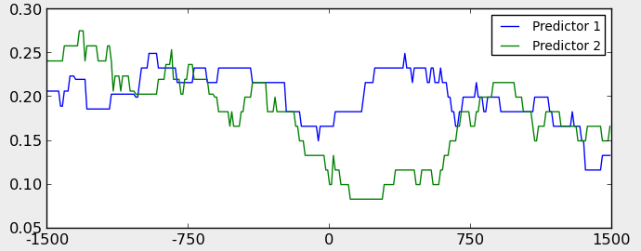Figure 3: Output plot from example 3.
From an exploratory perspective, this graph is very interesting, but for deciding between our hypothesis, it is a bit more difficult to use. What we can see is that for our first predictor (the onset of the question), the gaze of the other already seems to have dropped and now grows as the question is articulated. However, it does not reach a height that surpasses previous levels. This could be that either this is noise, i.e. natural fluctuations of looking and not looking at the speaker. Or, it could be that the previous peaks represent other distinct events and is not noise, something backed up by the fact that we did indeed select a very large analysis window so we have no control over what is happening before. The second predictor, the offset of the question, shows that as the exact end of the question, the listener's gaze has already started to shift away, but later refixates the speaker's face and peaks at about 900 ms. Perhaps the listener looked away to search for an answer to the question as soon he/she understood what the question was about, and then returns about 900 ms later to the initial speakers face to give the answer.
To generate the proper analysis output, go into the settings dialog and set bin size to 200 ms and bin function to round up. Then click “Analyze!” again, and then “Save results”. A pop-up dialog should now have informed you that the data has been saved in the file “results.txt” in the same folder as the EAC program. Find this file and open it in a text editor to have a look. The file should look like this:

Table 1: First 20 lines from the output data of example 3.

The different headers refer to, in order: the name of the eaf-file; the predictive event, which is a combination of its tier name and event name; the dependent event name; the bin size in milliseconds, the predictive event number in order of occurrence; the bin number in order of occurrence (bin 1 is here 0-200, e.g.); and finally value is the dependent variable output. For this example, we selected that the output value should be rounded up inside the bins. That means that if there is only one single occurrence of the dependent event in the predictive window, then the whole bin get the value 1. This is desirable, e.g., when you are want to perform some type of logistic regression.

Example 4 – inter-rater reliability correction
This example will showcase the correction to ELAN's inter-rater reliability calculation. This correction is especially important if you have event of varying lengths of time, and where you want longer events to have a proportionally greater influence on the results. First, we need to export an annotation comparison from ELAN. You can find the example annotation file for doing this in the folder:
/examples/04/irr1.eaf

Open up this file in ELAN and have a look at it. We will focus on the coding of the event for gazing on another's face, coded in two tiers as the event “FACE”. The first tier we consider is the “Rater #2 FACE” tier, which indicates the coding of events by Rater 2. The second relevant tier is, expectedly, the “RATER #1 FACE”, which is the same data coded by Rater 1. If you look carefully at the times of the different annotations for the event FACE, you can manually calculate the expected reliability results by ELAN and by EAC. Let's do this as a verification:
Manual calculation:
Event 1: Rater #2 FACE: 09.010 – 09.723
Event 1: Rater #1 FACE: 09.010 – 09.794
Event 2: Rater #2 FACE: 11.163 – 11.963
Event 2: Rater #1 FACE: 11.196 – 12.033
Event 1 prediction= (9723-9010)/(9794-9010) = .9094
Event 2 prediction = (11963-11196)/(12033-11163) = .8816
Expected ELAN agreement = (.9094 + .8816)/2 = 8955
Expected EAC agreement = ((9723-9010) + (11963-11196)) / ((9794-9010) + (12033-11163)) = (716 + 767)/(784 + 870)= .8948

This minimal example predicts a very small difference between the calculations. Let us verify these results anyway. In ELAN's menu, select “Tier” → “Compare Annotators...”. In the pop-up window, select the tiers “Rater #2 Face” and “Rater #1 Face”. Click “Compare” to see the ELAN calculation (as “Average agreement”). Now click “Save” and save this .txt-file.
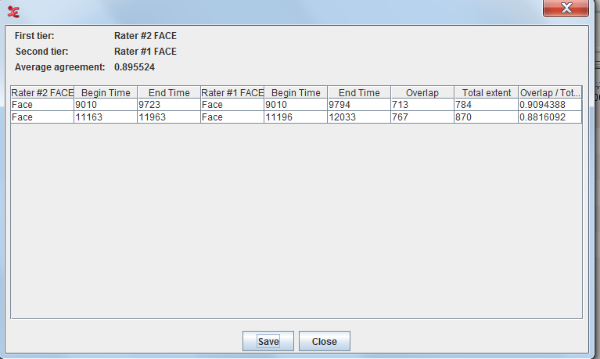Figure 4: ELAN's results dialog when comparing annotators.
Now, start up EAC and click the tab indicating “Inter-rater reliability”. Load the file you just saved from ELAN (do NOT tick the box for “Load all files...”) and press “Analyze!”. You should now get both the old reliability (ELAN's original calculation) and the new reliability (EAC's calculation).
The results should match the expectations. The small differences are due to the fact that the events are very similar in overlap and extent. Event 2 has a slightly longer extent (870 vs 784), biasing the final statistic more in the direction of of the overlap ratio of Event 2, which is lower than Event 1.
However, let's consider an example where EAC's reliability calculation really makes a difference. In this scenario, Rater #1 only focuses on clear and major events, but Rater #2 is really picky and also codes for small fragments of perceived events. This example file can be found in:
/examples/04/irr2.eaf

Again, let us do a manual calculation for this file. As you can see, Rater #2 has code for gaze to the face on three occasions: one long event and two short events. Rater #1 however, does not recognize these short events as proper ones, and only codes the first event.
Manual calculation:
Event 1: Rater #2 FACE: 09.010 – 09.723
Event 1: Rater #1 FACE: 09.010 – 09.794
Event 2: Rater #2 FACE: 12.499 – 12.579
Event 2: Rater #1 FACE: N/A
Event 3: Rater #2 FACE: 12.739 – 12.859
Event 3: Rater #1 FACE: N/A
Event 1 prediction= (9723-9010)/(9794-9010) = .9094
Event 2 prediction = 0/(12579-12499) = 0
Event 3 prediction = 0/(12859-12579) = 0
Expected ELAN agreement = (.9094 + 0 + 0)/3 = 0.3031
Expected EAC agreement = ((9723-9010) + 0 + 0) / ((9794-9010) + (12579-12499) + (12859-12739)) = .7246

Here, the expected results from the two calculations differ substantially. Thus, if we want all events to be equally important, then the calculation from ELAN makes more sense. However, if you believe that events should matter in terms of their duration, so not all events carry equal weight, then the calculation from EAC makes from sense.

Example 5 – real data file
This example contains an unabridged data file (HI3-HIP3strukt2.eaf) from a research publication: Sandgren, O., Andersson, R., van de Weijer, J., Hansson, K., & Sahlén, B. (2014). Coordination of gaze and speech in communication between children with hearing impairment and normal-hearing peers. Journal of Speech, Language, and Hearing Research, 57(3), 942-951.

Trouble-shooting
Error message: “Did not find predictive tier!” (dumped to console – if any): you have batch loaded a number of data files and some of these files do not have the predictive tier that you selected for.

Error message: “Empty vector. Selected non-existent tier/event?” (pop-up): you have batch loaded a number of data files which do not share all tiers or events. You happened to select a particular predictor tier/event that is not matched with the selected dependent tier/event in the same data file. That is, the predictor and the dependent variable does not exist within the same file(s) and are thus unanalyzable.

Odd peaks/troughs at the beginning/end of the results graph: any analysis windows extending beyond the beginning or the end of the annotation file will be filled with null values, which may cause a slight change in the curve. This is the least biased solution however, and the problem should go away with longer and more annotation files. Also the end of the annotation file is calculated, for a lack of a better solution, based on the latest point of time in the annotation file. This is typically the end point of some annotation. To force the detection of a longer time line, you could create a dummy annotation in the very end of your file. This seems to be the only way if you want to be able to analyze annotation files without having to provide the source media file(s) for the annotations.

When I click “Analyze” the program freezes or becomes very slow: The program can be very slow for a number of reasons. First of all, the program is not optimized for speed, so there is room for huge improvement in future versions. Secondly, have you set your “resolution” value to something realistic? Having 1 ms resolutions for data spanning over many minutes seldom make sense and just produces a lot of number for the program to go through. Most behaviors should be analyzable with a 10 ms resolution. Thirdly, the “first come – first serve” overlap handling solution is slower than the “double-dipping” one. Consider using the double-dipping for your exploratory analysis unless you know that there are a lot of trigger events close to each other. Finally, until a more efficient future version comes out, consider this slowness a “feature” that punishes researchers that do post-hoc analyses rather than generating true predictive hypotheses and testing those once.

The graphs look off: this will likely be caused by the bin size you have selected. Note that the range of values within a bin is aggregated to a single value, which is placed as the first value in the current time line. So all values from 1401 ms to 1500 ms, for example, are aggregated to a single value which is placed at 1401 ms. Therefore, the graph looks shifted 100 ms to the left. If you a analyzing quick behaviors where this shifting of the curve is problematic, then you are probably using a too large bin size for your analysis.

