Ivrit HaOr
The Complete Aleph Track
An illustrated beginning to every Hebrew letter and vowel
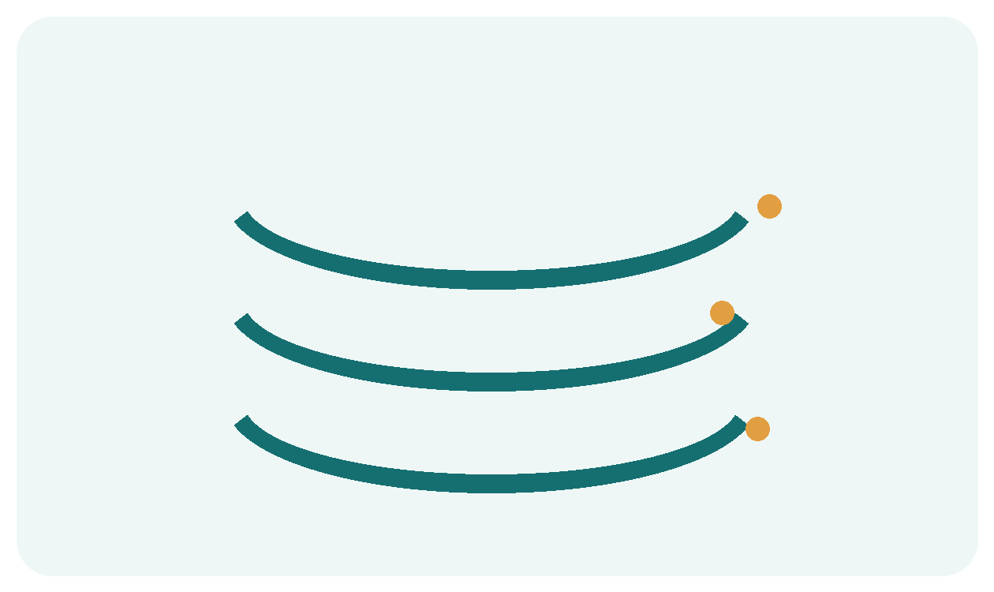 | 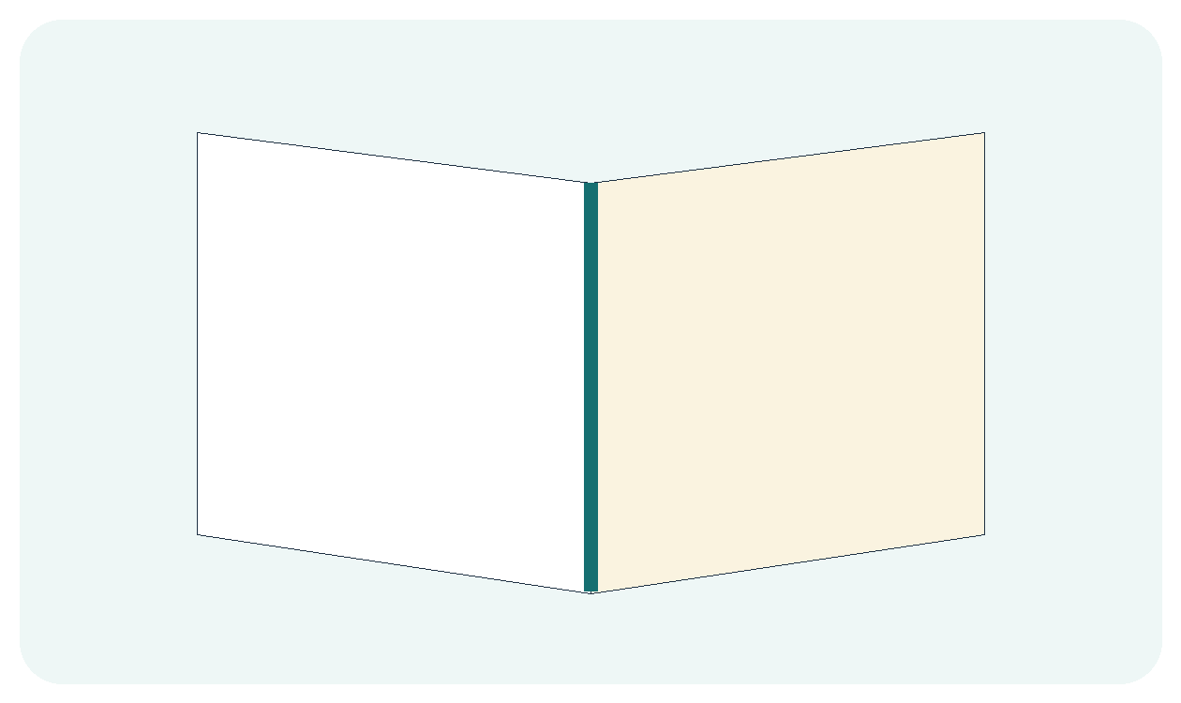 | 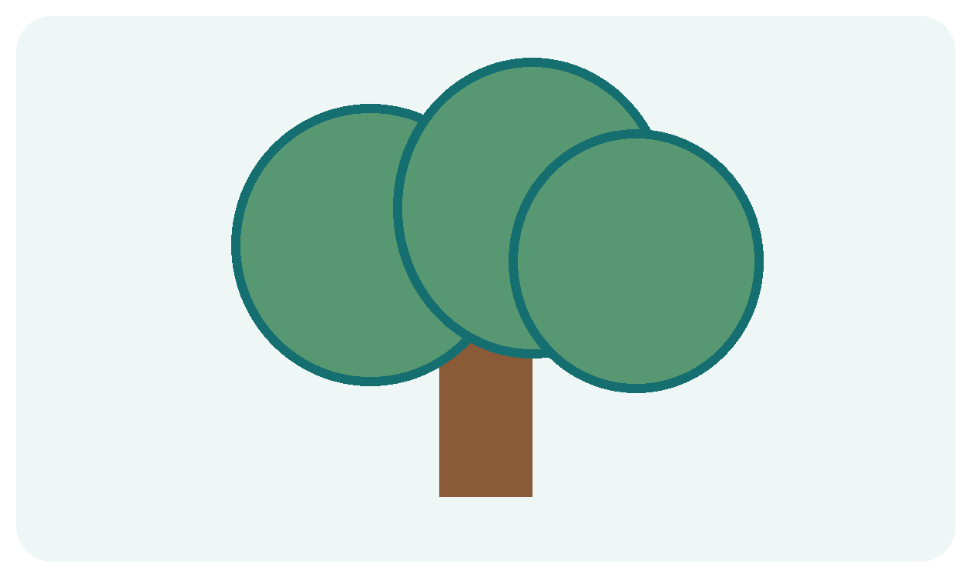
א בּ ג ד ה ו ז ח ט י
כּ ל מ נ ס ע פּ צ ק ר שׁ ת
Twelve lessons • classroom practice • reference charts • teacher key
Name __________________________________________
Hebrew name ___________________________________
Read Hebrew from the right toward the left. A little progress in every lesson is enough.

For Teachers and Families
IVRIT HAOR • ALEPH TRACK
This book follows the established Aleph Track sequence. Each lesson has a letter page and a reading page. Picture clues support recognition; the printed Hebrew letters and vowel marks are the source to read.
A simple 30 minute lesson
5 minutes Review earlier letters and one familiar vowel.
8 minutes Meet the new letter shapes and make their sounds.
7 minutes Study the new vowel or practice the sound lab.
7 minutes Read, point, circle, and write.
3 minutes Ask the quick check aloud and end with success.
Reading rules that matter
• Hebrew runs from right to left. Point to one letter at a time.
• A dot inside בּ, כּ, or פּ changes the consonant sound. A vowel dot beneath or above belongs to the vowel system.
• שׁ has its dot on the upper right and says sh; שׂ has its dot on the upper left and says s.
• At the end of a word, מ נ כ פ צ become ם ן ך ף ץ.
• Vowel names and sounds vary a little by reading tradition. This book uses common beginner Israeli pronunciations and flags the most important variation.
Instruction and assessment
Read a model aloud before asking students to decode independently. Let students name the picture, point to the letter, and say the sound. The quick checks are oral and low pressure. Aim for fluent reading with common vowels; sheva, the three hataf marks, and qamats qatan are recognition and teacher-modeling goals. The last pages provide letter and vowel charts and a teacher key.
Niqqud is printed with each Hebrew example. Print at actual size so the small marks remain clear.

Lesson 1 Aleph and Ayin
MEET THE LETTERS • QUIET LETTERS AND THE STICK VOWELS
Look at each picture, then point to the Hebrew form above it. Say the sound before tracing the shape.
א  Aleph  Quiet carrier; let the vowel speak. | ע  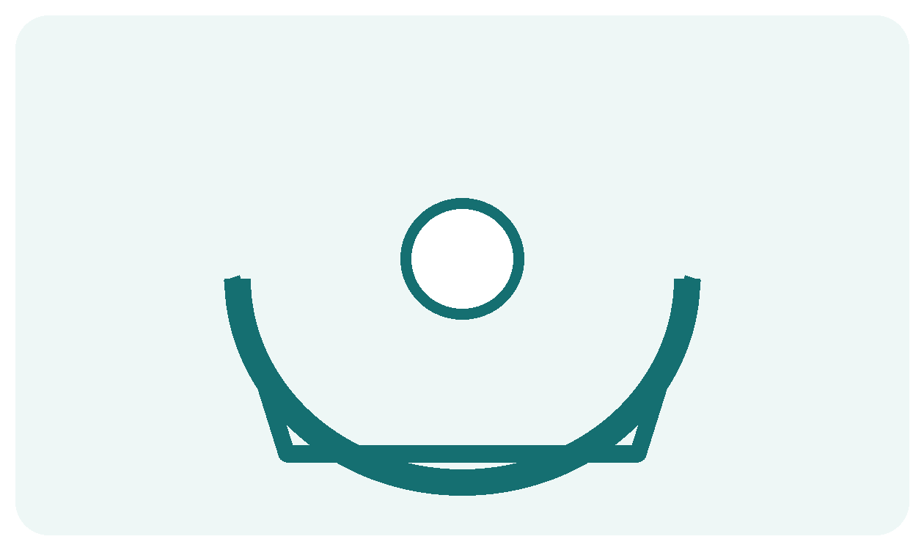  Ayin  Another quiet carrier in beginner reading.
Notice and remember
Begin at the right. Point to the letter, then look beneath it for the vowel.
Find it
Point from the right and find א and ע.
ע א ב ע ד א ע א
Make the shape
Trace each new form once with your finger. Copy the form in the space below.
____________________________________________________________________
Teacher quick check • Name each new letter, say its sound, and spot it in the hunt.

Lesson 1 Read and Practice
SOUND LAB • BEGIN ON THE RIGHT
Meet the vowel mark or reading feature. Look carefully at its place above, below, or inside the letter.
אַ  Patach  AH  A short stick below | אָ  Qamats gadol  AH  A stick with a handle below
Read from right to left
עָ | עַ | אָ | אַ
ah | ah | ah | ah
Point and tell
Cover the English sounds. Read the Hebrew row aloud. Uncover the sounds and check yourself.
Try it
Write one א and one ע. Add a patach to one and a qamats to the other.
My practice space
____________________________________________________________________
____________________________________________________________________
Say it one more time
Find א and ע in this row, then name one vowel mark you can read.
ע א ב ע ד א ע א

Lesson 2 Bet and Vet
MEET THE LETTERS • THE DOT INSIDE CHANGES THE SOUND
Look at each picture, then point to the Hebrew form above it. Say the sound before tracing the shape.
בּ ב
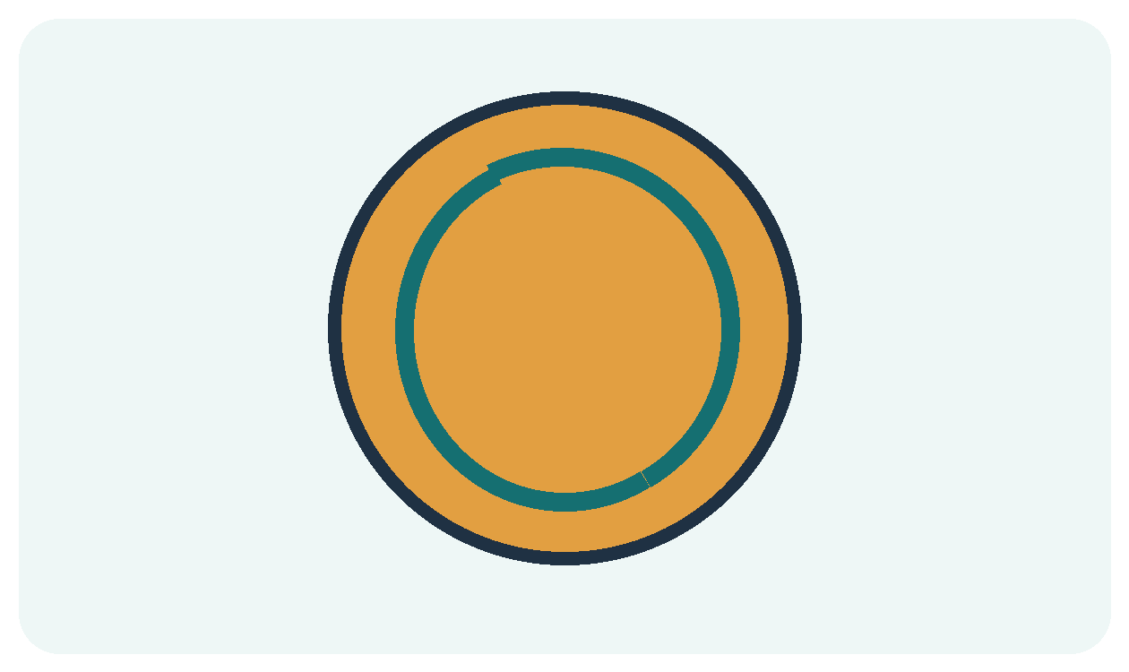
Bet and Vet
Dot inside: b. Empty inside: v.
Notice and remember
Point inside first. A dot inside ב makes b; the dot beneath is the vowel.
Find it
Point from the right and find every dotted בּ.
ב בּ א בּ ע ב בּ
Make the shape
Trace each new form once with your finger. Copy the form in the space below.
____________________________________________________________________
Teacher quick check • Name each new letter, say its sound, and spot it in the hunt.

Lesson 2 Read and Practice
SOUND LAB • BEGIN ON THE RIGHT
Meet the vowel mark or reading feature. Look carefully at its place above, below, or inside the letter.
בִּ
Hiriq
EE
One pea sized dot below
Read from right to left
בָּ | אִ | בִ | בִּ
bah | ee | vee | bee
Point and tell
Cover the English sounds. Read the Hebrew row aloud. Uncover the sounds and check yourself.
Try it
Say bee and vee while pointing to the dot inside or its absence.
My practice space
____________________________________________________________________
____________________________________________________________________
Say it one more time
Find every dotted בּ in this row, then name one vowel mark you can read.
ב בּ א בּ ע ב בּ

Lesson 3 Mem and Tet
MEET THE LETTERS • MOUND ON TOP OR TEAR ON TOP
Look at each picture, then point to the Hebrew form above it. Say the sound before tracing the shape.
מ  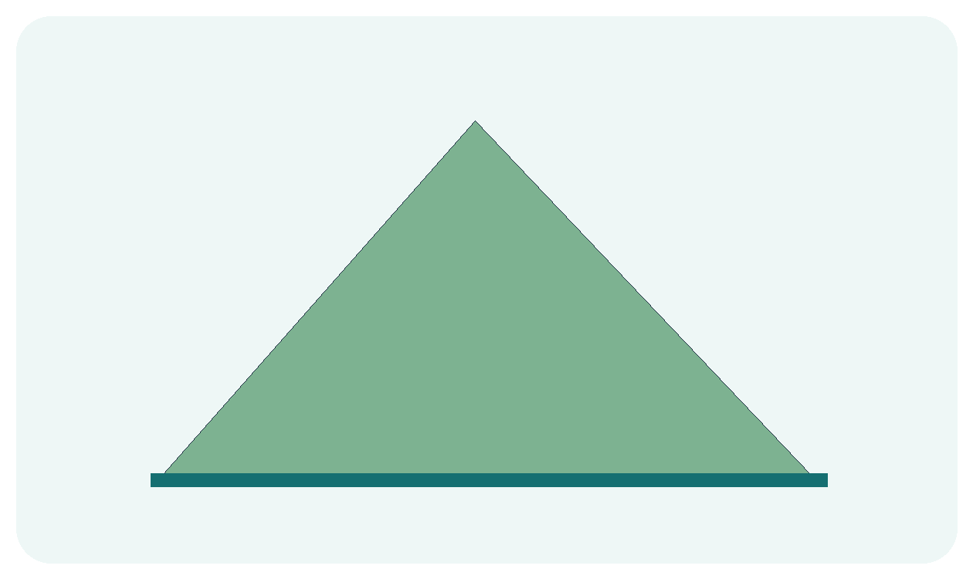  Mem  A mound on top; mmm. | ט  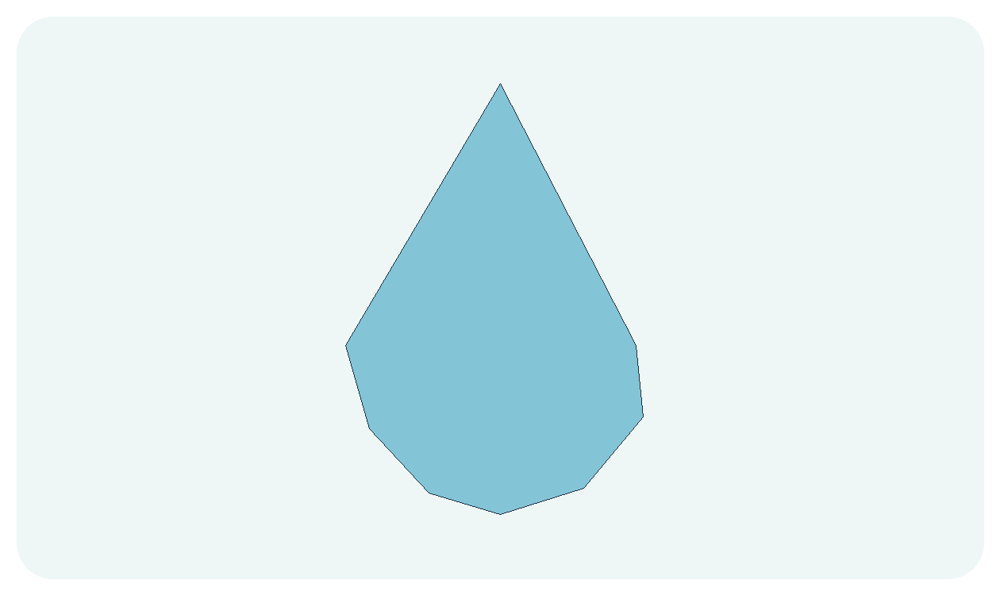  Tet  A tear shaped opening; t.
Notice and remember
Trace the top shape in the air: Mem has a mound and Tet has a tear.
Find it
Point from the right and find every Mem, then every Tet.
ט מ ב מ ע ט מ ט
Make the shape
Trace each new form once with your finger. Copy the form in the space below.
____________________________________________________________________
Teacher quick check • Name each new letter, say its sound, and spot it in the hunt.

Lesson 3 Read and Practice
SOUND LAB • MEET THE THREE EGGS
New today: Segol is three dots beneath a letter and says eh. Point to each dot, listen to the teacher, then try the reading row.
מַ  Patach  AH  Stick below | מִ  Hiriq  EE  Dot below | מֶ  Segol  EH  Three dots below | מָ  Qamats gadol  AH  Stick with a handle below
Read from right to left
טִ | טָ | מִ | מָ
tee | tah | mee | mah
Point and tell
Cover the English sounds. Read the Hebrew row aloud. Uncover the sounds and check yourself.
Try it
Make four syllables: מָ, מִ, טָ, טִ. Say each from the right.
My practice space
____________________________________________________________________
____________________________________________________________________
Say it one more time
Find every Mem, then every Tet in this row, then name one vowel mark you can read.
ט מ ב מ ע ט מ ט

Lesson 4 Resh and Dalet
MEET THE LETTERS • ROUNDED CORNER OR DENTED CORNER
Look at each picture, then point to the Hebrew form above it. Say the sound before tracing the shape.
ר  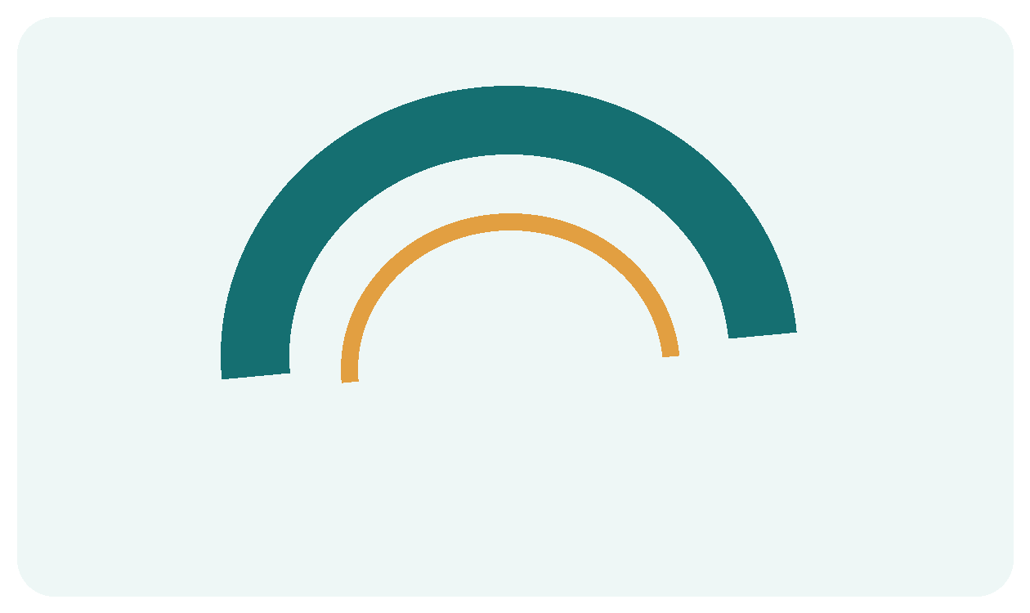  Resh  Round at the top; r. | ד  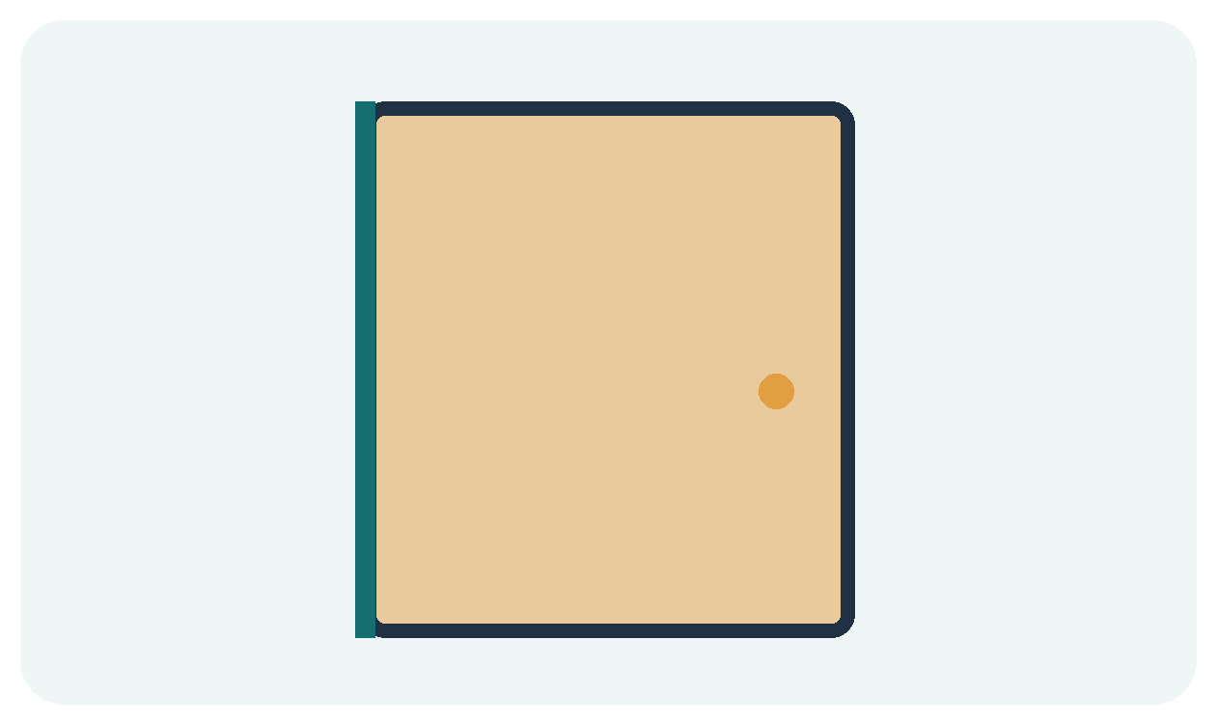  Dalet  A small dent or overhang; d.
Notice and remember
Compare the top right corner carefully before reading the vowel.
Find it
Point from the right and find every rounded Resh.
ר ד ר ד ד ר ר ד
Make the shape
Trace each new form once with your finger. Copy the form in the space below.
____________________________________________________________________
Teacher quick check • Name each new letter, say its sound, and spot it in the hunt.

Lesson 4 Read and Practice
SOUND LAB • PRACTICE THE THREE EGGS
Review Segol. Find its three dots beneath Resh, say eh, and then blend it with the consonant.
רֶ
Segol
EH
Three little eggs below
Read from right to left
מֶ | בֶּ | דֶ | רֶ
meh | beh | deh | reh
Point and tell
Cover the English sounds. Read the Hebrew row aloud. Uncover the sounds and check yourself.
Try it
Draw three tiny eggs under ד and read the result aloud.
My practice space
____________________________________________________________________
____________________________________________________________________
Say it one more time
Find every rounded Resh in this row, then name one vowel mark you can read.
ר ד ר ד ד ר ר ד

Lesson 5 Chet Hei and Vav
MEET THE LETTERS • A ROOF A HOLE AND A TALL LINE
Look at each picture, then point to the Hebrew form above it. Say the sound before tracing the shape.
ח  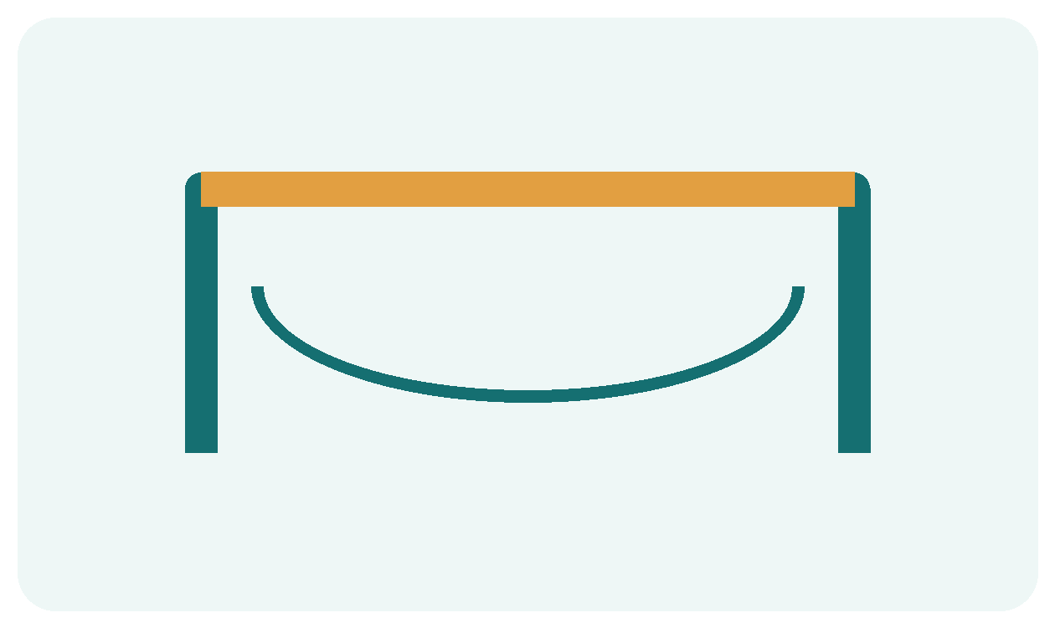  Chet  Closed like a chuppah; kh. | ה  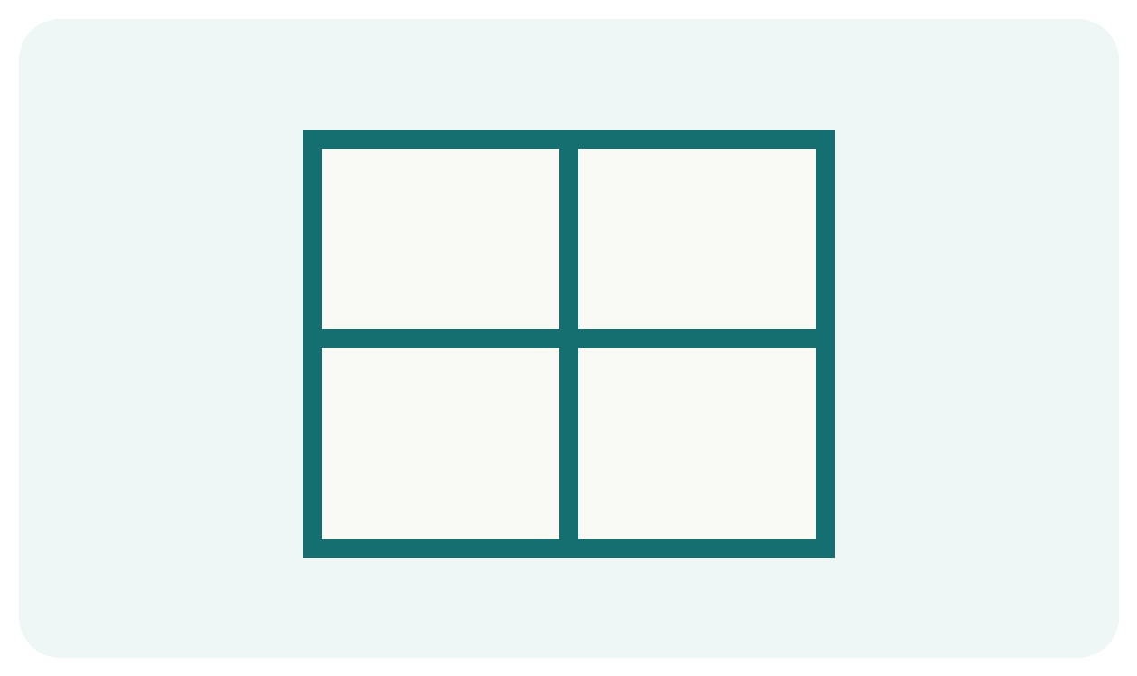  Hei  An opening halfway down; h. | ו  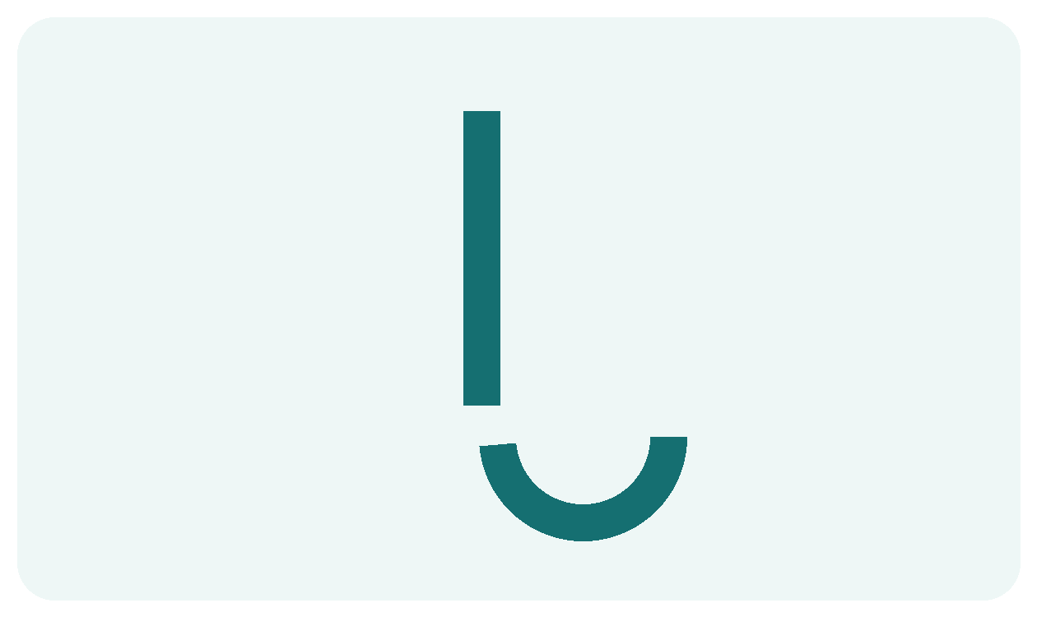  Vav  Tall and straight; v.
Notice and remember
Chet is closed, Hei has a hole, and Tav later gains a toe.
Find it
Point from the right and find every Hei with its opening.
ת ה ח ה ו ח ה ו
Make the shape
Trace each new form once with your finger. Copy the form in the space below.
____________________________________________________________________
Teacher quick check • Name each new letter, say its sound, and spot it in the hunt.

Lesson 5 Read and Practice
SOUND LAB • BEGIN ON THE RIGHT
Meet the vowel mark or reading feature. Look carefully at its place above, below, or inside the letter.
חֹ  Holam chaser  OH  One dot above | וֹ  Holam male  OH  The dot sits above Vav
Read from right to left
וֹ | מֹ | הֹ | חֹ
oh | mo | ho | kho
Point and tell
Cover the English sounds. Read the Hebrew row aloud. Uncover the sounds and check yourself.
Try it
Read ו as v, then וֹ as oh. Point to the dot above.
My practice space
____________________________________________________________________
____________________________________________________________________
Say it one more time
Find every Hei with its opening in this row, then name one vowel mark you can read.
ת ה ח ה ו ח ה ו

Lesson 6 Shin Lamed and Yud
MEET THE LETTERS • THREE TEETH TALL LADDER TINY LETTER
Look at each picture, then point to the Hebrew form above it. Say the sound before tracing the shape.
שׁ  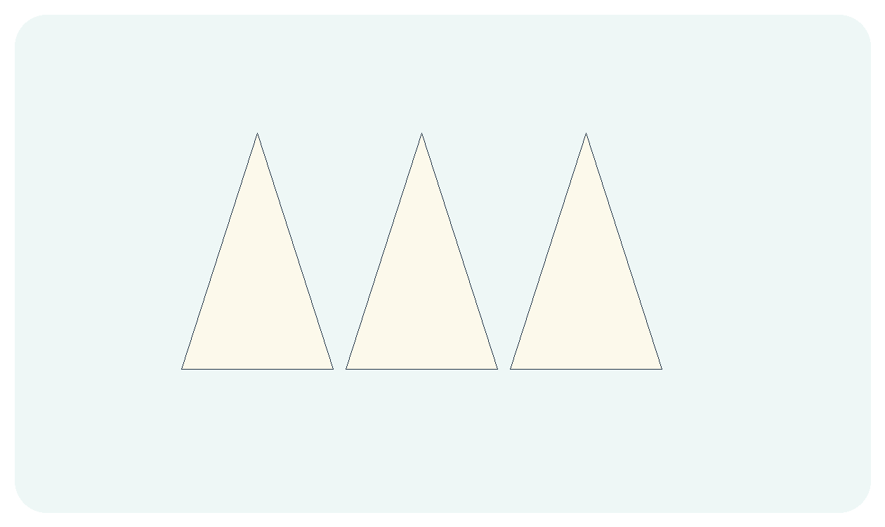  Shin  Dot on the upper right; sh. | ל  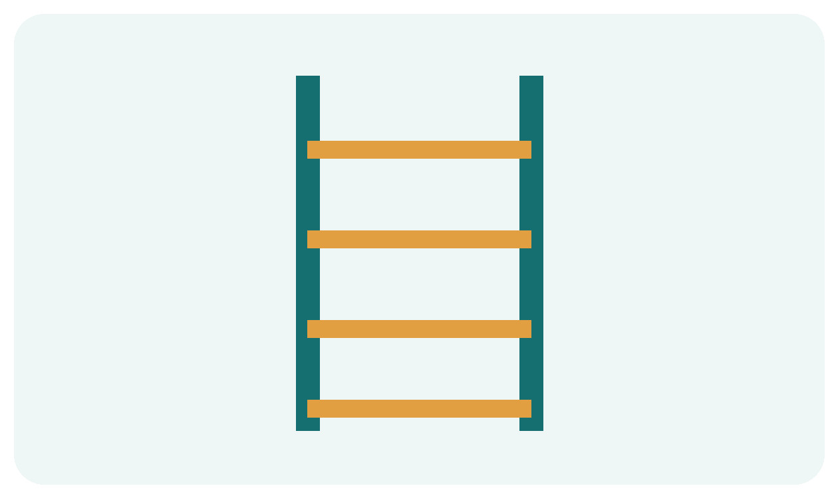  Lamed  The tallest letter; l. | י  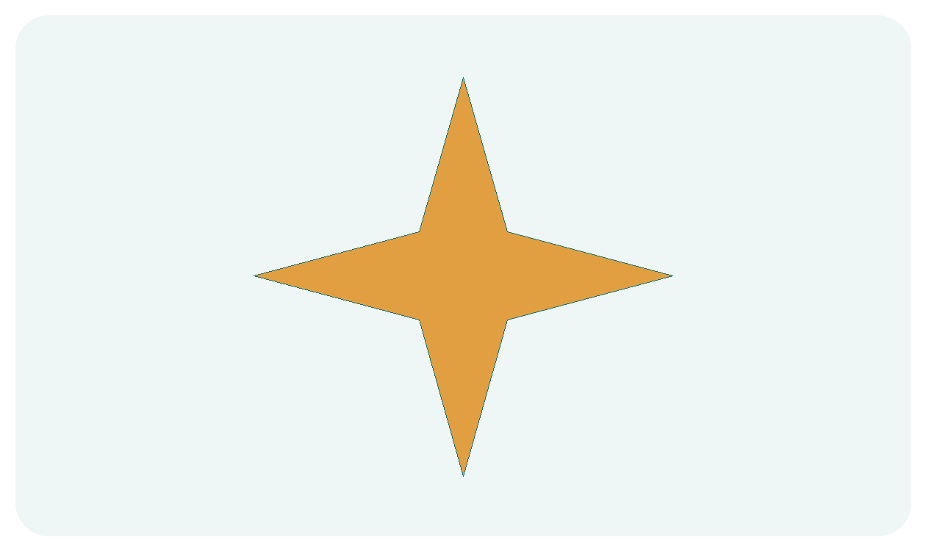  Yud  Small and quick; y.
Notice and remember
The dot above the right branch makes Shin say sh.
Find it
Point from the right and find every Shin with a right dot.
שׁ י ל שׁ ל י שׁ
Make the shape
Trace each new form once with your finger. Copy the form in the space below.
____________________________________________________________________
Teacher quick check • Name each new letter, say its sound, and spot it in the hunt.

Lesson 6 Read and Practice
SOUND LAB • BEGIN ON THE RIGHT
No new vowel today. Review the sounds you already know, then blend each letter with a vowel.
מַ  Patach  AH  Stick below | מִ  Hiriq  EE  Dot below | מֶ  Segol  EH  Three dots below | מוֹ  Holam  OH  Dot above
Read from right to left
יֹ | לֶ | שִׁ | שָׁ
yo | leh | shee | shah
Point and tell
Cover the English sounds. Read the Hebrew row aloud. Uncover the sounds and check yourself.
Try it
Read שָׁ, שִׁ, שֶׁ, שׁוֹ from right to left.
My practice space
____________________________________________________________________
____________________________________________________________________
Say it one more time
Find every Shin with a right dot in this row, then name one vowel mark you can read.
שׁ י ל שׁ ל י שׁ

Lesson 7 Nun and Gimel
MEET THE LETTERS • NARROW NUN AND A GOING FOOT
Look at each picture, then point to the Hebrew form above it. Say the sound before tracing the shape.
נ  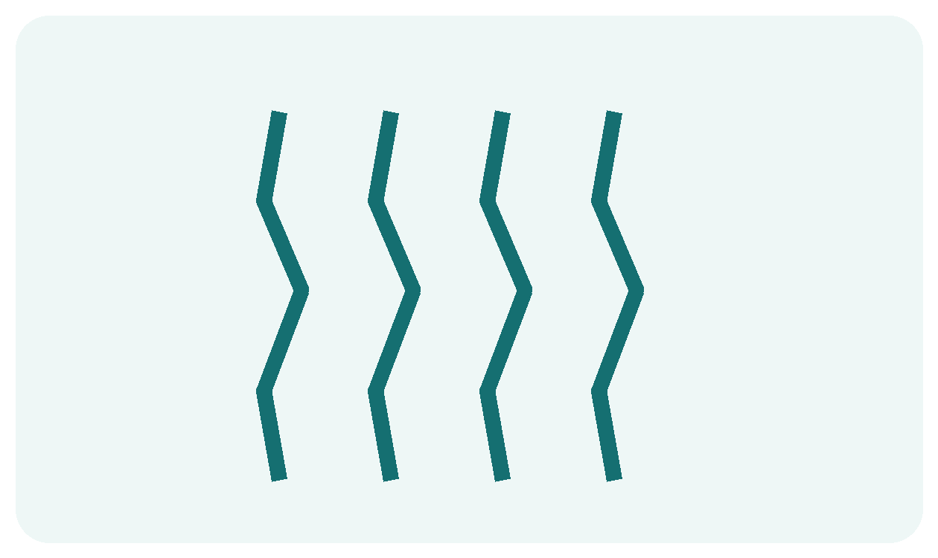  Nun  Narrow and upright; n. | ג  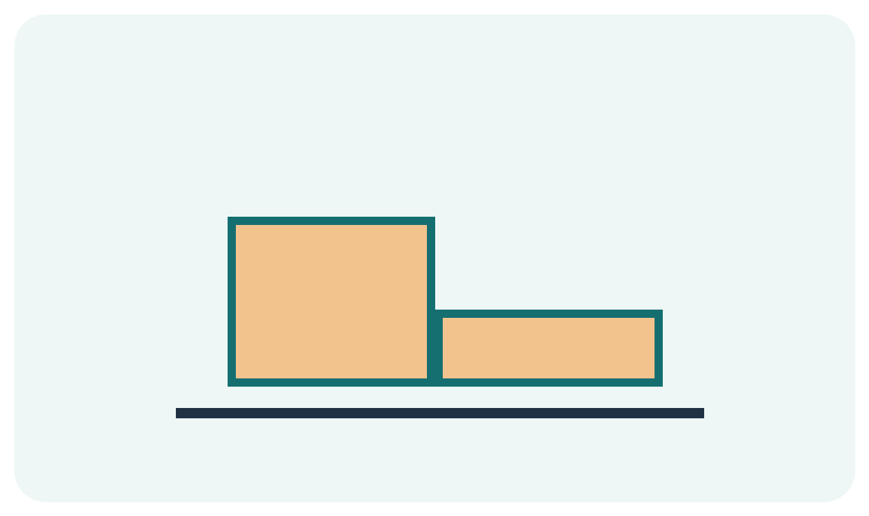  Gimel  Its foot goes out; g.
Notice and remember
A dreidel carries נ ג ה שׁ outside Israel. The four letters begin “A great miracle happened there.”
Find it
Point from the right and find every Gimel with a going foot.
ג נ ג נ נ ג ג נ
Make the shape
Trace each new form once with your finger. Copy the form in the space below.
____________________________________________________________________
Teacher quick check • Name each new letter, say its sound, and spot it in the hunt.

Lesson 7 Read and Practice
SOUND LAB • BEGIN ON THE RIGHT
No new vowel today. Review the sounds you already know, then blend each letter with a vowel.
מַ  Patach  AH  Stick below | מִ  Hiriq  EE  Dot below | מֶ  Segol  EH  Three dots below | מוֹ  Holam  OH  Dot above
Read from right to left
גּוֹ | גֶ | נִ | נָ
go | geh | nee | nah
Point and tell
Cover the English sounds. Read the Hebrew row aloud. Uncover the sounds and check yourself.
Try it
Point to נ and ג on a dreidel picture or draw a four sided top.
My practice space
____________________________________________________________________
____________________________________________________________________
Say it one more time
Find every Gimel with a going foot in this row, then name one vowel mark you can read.
ג נ ג נ נ ג ג נ

Lesson 8 Samech Sin and Tav
MEET THE LETTERS • TWO WAYS TO SAY S AND ONE TOE
Look at each picture, then point to the Hebrew form above it. Say the sound before tracing the shape.
ס  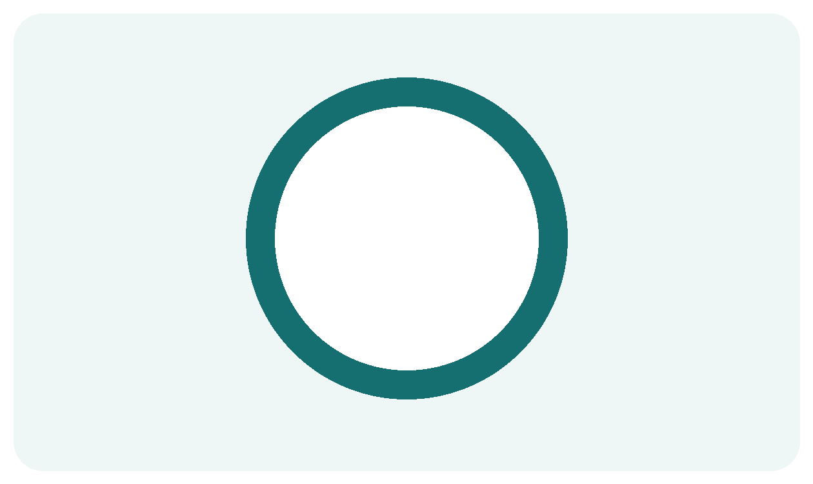  Samech  A closed circle; s. | שׂ  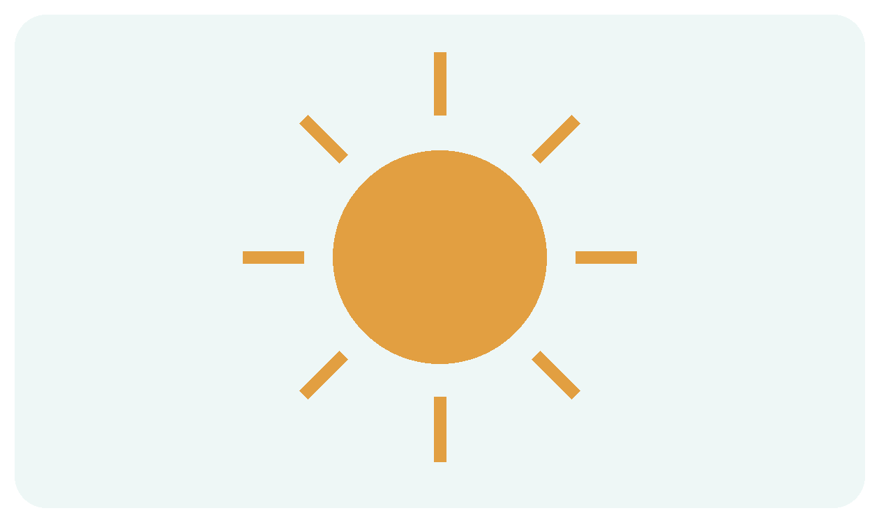  Sin  Dot on the upper left; s. | ת  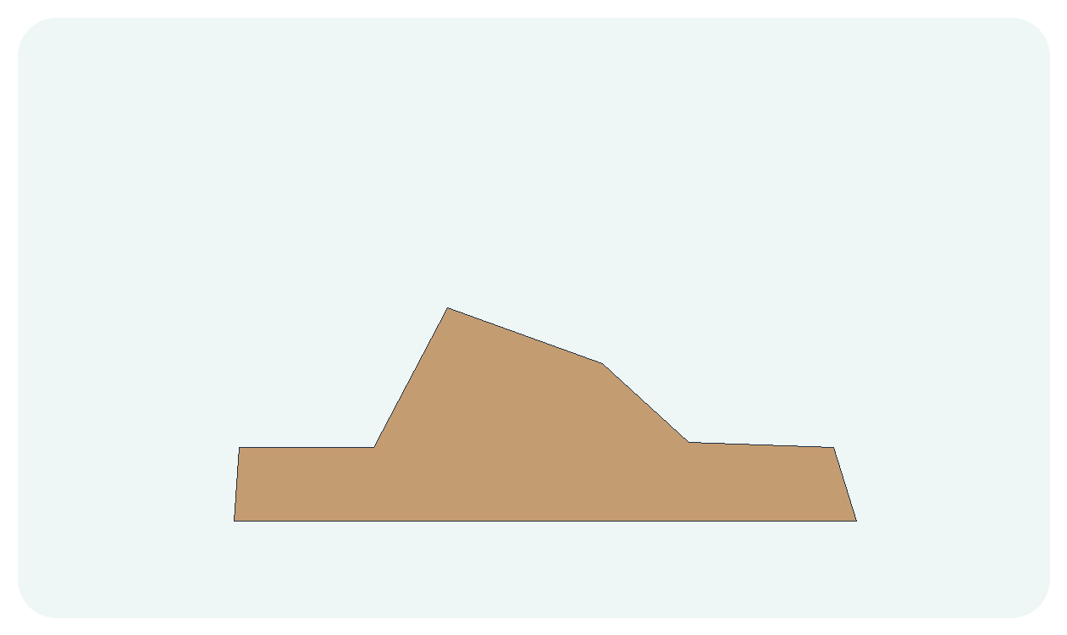  Tav  A toe at the lower left; t.
Notice and remember
Shin has its dot on the right; Sin has its dot on the left. Both Samech and Sin say s.
Find it
Point from the right and find every Samech and every left dot Sin.
ס שׂ ת ס שׁ שׂ ת
Make the shape
Trace each new form once with your finger. Copy the form in the space below.
____________________________________________________________________
Teacher quick check • Name each new letter, say its sound, and spot it in the hunt.

Lesson 8 Read and Practice
SOUND LAB • BEGIN ON THE RIGHT
Meet the vowel mark or reading feature. Look carefully at its place above, below, or inside the letter.
סֻ  Qubuts  OO  Three staircase dots below | סוּ  Shuruq  OO  A dot in the center of Vav
Read from right to left
תּוּ | תֻ | סוּ | סֻ
too | too | soo | soo
Point and tell
Cover the English sounds. Read the Hebrew row aloud. Uncover the sounds and check yourself.
Try it
Compare ה, ח, and ת: hole, closed roof, and toe.
My practice space
____________________________________________________________________
____________________________________________________________________
Say it one more time
Find every Samech and every left dot Sin in this row, then name one vowel mark you can read.
ס שׂ ת ס שׁ שׂ ת

Lesson 9 Zayin and Kaf
MEET THE LETTERS • ZIPPER ZAYIN AND A CUPPED KAF
Look at each picture, then point to the Hebrew form above it. Say the sound before tracing the shape.
ז  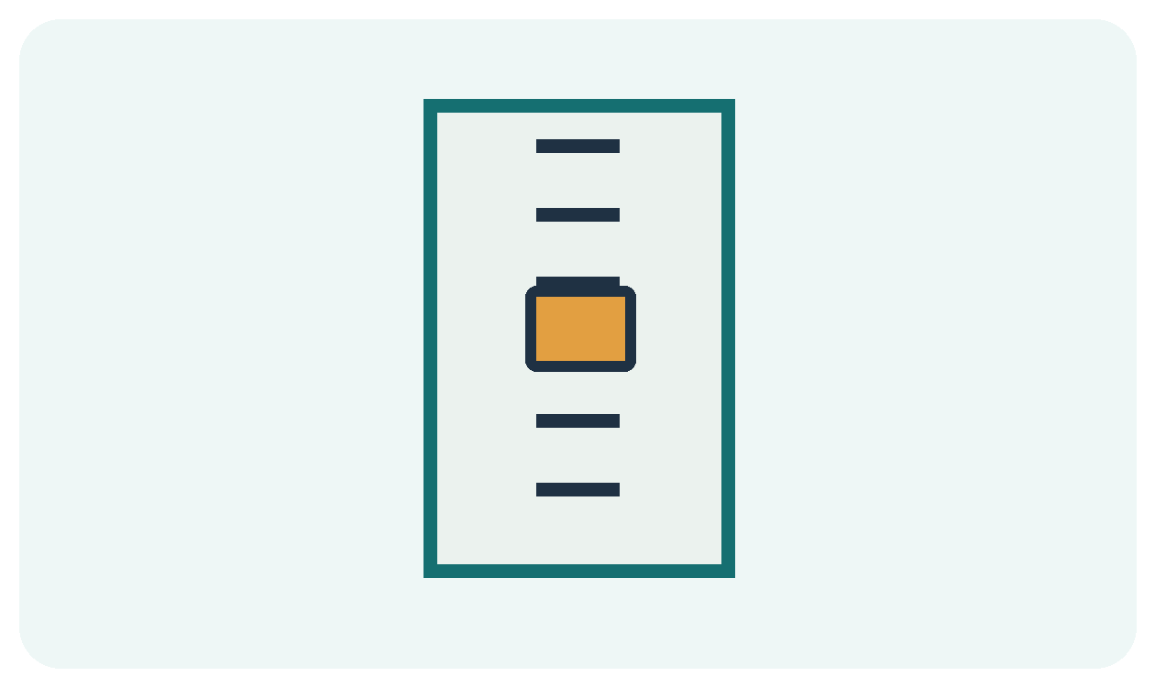  Zayin  Think zipper for z. | כּ כ ך  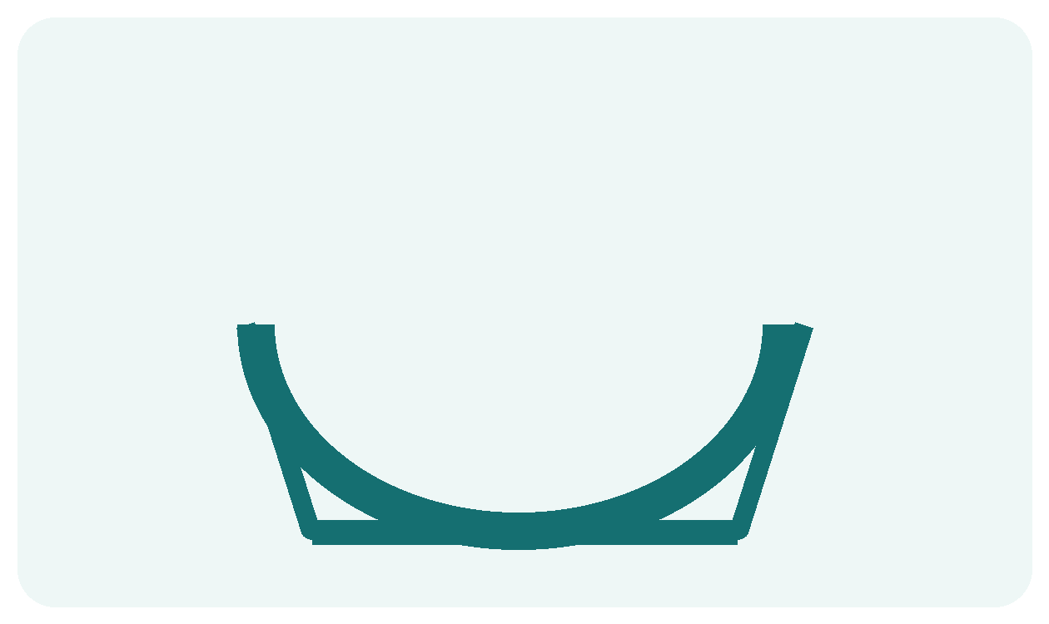  Kaf Khaf and final Khaf  Dot inside: k. No dot: kh. Final ך: kh.
Notice and remember
Tsere may sound like eh or ay in different reading traditions. Use eh here and listen to the teacher for words.
Find it
Point from the right and find every Zayin and the final Khaf.
ז כ כּ ך ז כ ך
Make the shape
Trace each new form once with your finger. Copy the form in the space below.
____________________________________________________________________
Teacher quick check • Name each new letter, say its sound, and spot it in the hunt.

Lesson 9 Read and Practice
SOUND LAB • BEGIN ON THE RIGHT
Meet the vowel mark or reading feature. Look carefully at its place above, below, or inside the letter.
זֵ
Tsere
EH or AY
Two level dots below; often long e
Read from right to left
לֵ | כֵ | כֵּ | זֵ
leh | kheh | keh | zeh
Point and tell
Cover the English sounds. Read the Hebrew row aloud. Uncover the sounds and check yourself.
Try it
Find the inside dot in כּ. Say k for כּ and kh for כ and ך.
My practice space
____________________________________________________________________
____________________________________________________________________
Say it one more time
Find every Zayin and the final Khaf in this row, then name one vowel mark you can read.
ז כ כּ ך ז כ ך

Lesson 10 Peh and Tzadi
MEET THE LETTERS • A MOUTH A PIZZA AND TWO FINAL FORMS
Look at each picture, then point to the Hebrew form above it. Say the sound before tracing the shape.
פּ פ ף  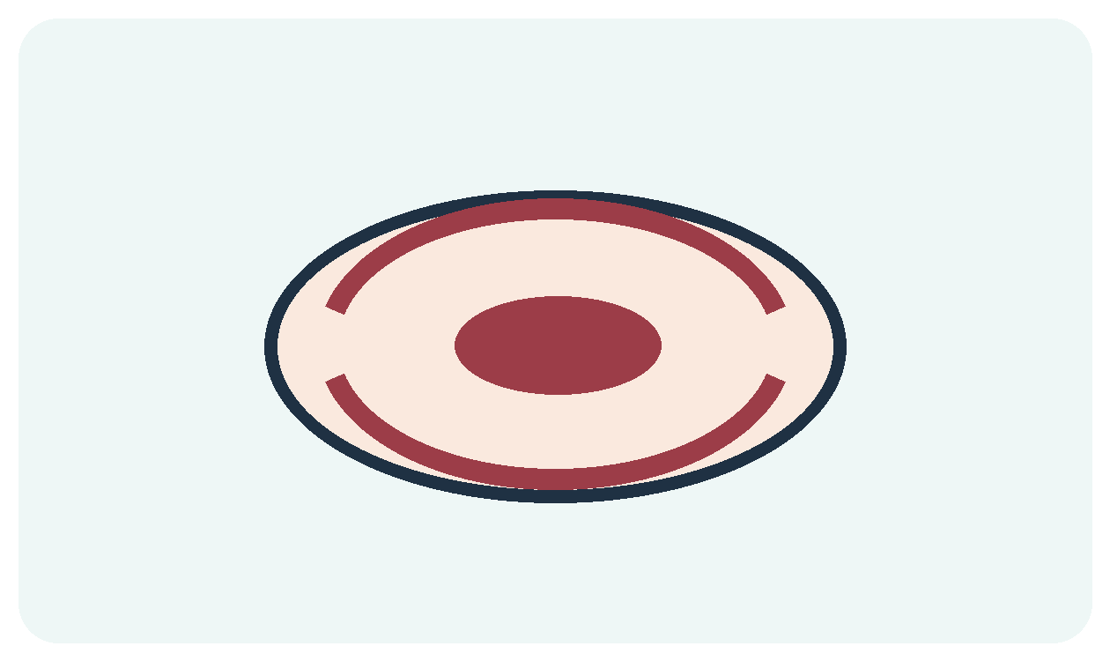  Peh Feh and final Feh  Dot inside: p. No dot: f. Final ף: f. | צ ץ    Tzadi and final Tzadi  The ts in pizza. Final ץ ends a word.
Notice and remember
Say pizza slowly: pee-tsah. Hear ts in the middle? Find צ in פִּצָּה and ץ at the end of עֵץ. The picture is a clue; read the printed letter.
Find it
Point from the right and find every final Feh and final Tzadi.
פּ פ ף צ ץ פּ צ ף
Make the shape
Trace each new form once with your finger. Copy the form in the space below.
____________________________________________________________________
Teacher quick check • Name each new letter, say its sound, and spot it in the hunt.

Lesson 10 Read and Practice
SOUND LAB • BEGIN ON THE RIGHT
Meet the vowel mark or reading feature. Look carefully at its place above, below, or inside the letter.
שְׁ
Sheva
QUICK or QUIET
Two vertical dots below
Read from right to left
עֵץ | פִּצָּה | סֵפֶר | פֶּה
etz | pizza | sefer | peh
Point and tell
Cover the English sounds. Read the Hebrew row aloud. Uncover the sounds and check yourself.
Try it
Find sheva in שְׁמִי. It can be very brief in some reading traditions. In מַלְכָּה it is quiet.
My practice space
____________________________________________________________________
____________________________________________________________________
Say it one more time
Find every final Feh and final Tzadi in this row, then name one vowel mark you can read.
פּ פ ף צ ץ פּ צ ף
Pizza clue: say “pee-tsah.” The middle ts is צ; עֵץ shows ץ at a word ending. Cover the pizza picture and find צ again.

Lesson 11 Qof and the Final Five
MEET THE LETTERS • FINISH THE ALPHABET AND CHANGE WORD ENDINGS
Look at each picture, then point to the Hebrew form above it. Say the sound before tracing the shape.
ק  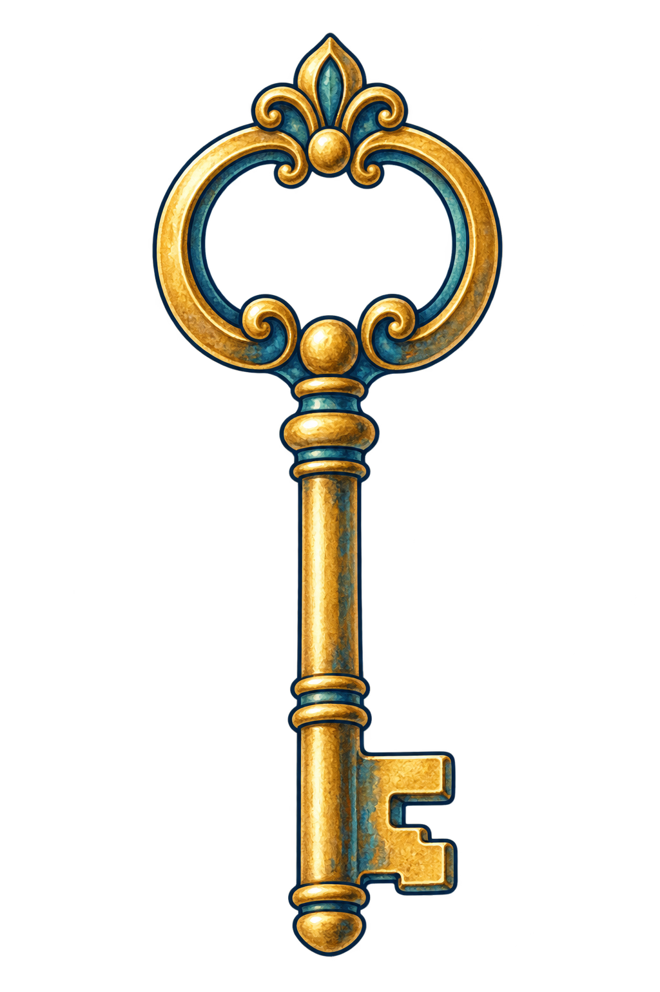  Qof  Key begins with /k/. Qof says /k/. Look at the plain ק beside the key. | ם ן ך ף ץ  Five final forms  At a word ending, these replace מ נ כ פ צ.
Notice and remember
Say key, then only /k/. Point to the plain ק. Hebrew קַר (kar) means cold and begins with Qof. Dotted כּ also says /k/ in modern Hebrew.
Find it
Find each Qof, then the five final forms. Qof has a long stroke below its top.
ק מ ם ק נ ן כ ך פ ף צ ץ ק
Make the shape
Trace each new form once with your finger. Copy the form in the space below.
____________________________________________________________________
Teacher quick check • Name each new letter, say its sound, and spot it in the hunt.

Lesson 11 Read and Practice
SOUND LAB • BEGIN ON THE RIGHT
Meet qamats qatan in כָּל (kol, “all”). It looks like the ah qamats, but this word is pronounced with o. Learn it as a teacher-modeled word.
כָּל
Qamats qatan
O
Looks like qamats; context changes it
Read from right to left
עֵץ | כָּל | קִ | קַר
etz | kol | kee | kar
Point and tell
Cover the English sounds. Read the Hebrew row aloud. Uncover the sounds and check yourself.
Try it
Match מ→ם, נ→ן, כ→ך, פ→ף, צ→ץ.
My practice space
____________________________________________________________________
____________________________________________________________________
Say it one more time
Find the five final forms in this row, then name one vowel mark you can read.
מ ם נ ן כ ך פ ף צ ץ

Lesson 12 Read the Whole Track
MEET THE LETTERS • RECOGNIZE EVERY LETTER AND EVERY VOWEL
Look at each picture, then point to the Hebrew form above it. Say the sound before tracing the shape.
א ב ג  Start at the right  Read each Hebrew row from right to left. | נ ס ע  Look for the shape  Check inside dots, top dots, and final forms. | ק ר שׁ ת  End with confidence  A careful reader checks the vowel marks too.
Notice and remember
The three hataf marks are uncommon in early words. Recognize them first; fluent reading grows with practice.
Find it
Point from the right and find all 22 base letters.
א בּ ג ד ה ו ז ח ט י כּ ל מ נ ס ע פּ צ ק ר שׁ ת
Make the shape
Trace each new form once with your finger. Copy the form in the space below.
____________________________________________________________________
Teacher quick check • Name each new letter, say its sound, and spot it in the hunt.

Lesson 12 Read and Practice
SOUND LAB • BEGIN ON THE RIGHT
Meet the vowel mark or reading feature. Look carefully at its place above, below, or inside the letter.
חֲ  Hataf patach  short AH  Reduced patach, usually under a guttural | אֱ  Hataf segol  short EH  Reduced segol | אֳ  Hataf qamats  short O  Reduced qamats
Read from right to left
עֵץ | סוּ | בִּ | אַ
etz | soo | bee | ah
Point and tell
Cover the English sounds. Read the Hebrew row aloud. Uncover the sounds and check yourself.
Try it
Choose a name. Find its sounds, then ask a teacher to help write it in Hebrew.
My practice space
____________________________________________________________________
____________________________________________________________________
Say it one more time
Find all 22 base letters in this row, then name one vowel mark you can read.
א בּ ג ד ה ו ז ח ט י כּ ל מ נ ס ע פּ צ ק ר שׁ ת

The Whole Alphabet
REFERENCE • POINT FROM RIGHT TO LEFT
These are the 22 base letters in alphabetical order. The marked forms show sounds that change with a dot.
א | Aleph | quiet
בּ / ב | Bet / Vet | b / v
ג | Gimel | g
ד | Dalet | d
ה | Hei | h
ו | Vav | v
ז | Zayin | z
ח | Chet | kh
ט | Tet | t
י | Yud | y
כּ / כ | Kaf / Khaf | k / kh
The final forms appear on the next page. Some beginning words include dots and vowel signs that unpointed everyday Hebrew omits.

The Whole Alphabet Continued
REFERENCE • POINT FROM RIGHT TO LEFT
ל | Lamed | l
מ | Mem | m
נ | Nun | n
ס | Samech | s
ע | Ayin | quiet
פּ / פ | Peh / Feh | p / f
צ | Tzadi | ts
ק | Qof | k
ר | Resh | r
שׁ / שׂ | Shin / Sin | sh / s
ת | Tav | t
The final forms appear on the next page. Some beginning words include dots and vowel signs that unpointed everyday Hebrew omits.

Five Final Forms
REFERENCE • AT THE END OF A WORD
These five letters change shape at the end of a word. Their basic consonant sounds stay the same.
מ | ם | End sound m  מַיִם water
נ | ן | End sound n  גַּן garden
כ | ך | End sound kh  מֶלֶךְ king
פ | ף | End sound f  כַּף palm
צ | ץ | End sound ts  עֵץ tree
Read the change
Find an ending form in each example above. Copy ם, ן, ך, ף, and ץ below.
____________________________________________________________________
Teacher note: ask the student to find the ending in an actual word before copying it.

The Vowel Signs
REFERENCE • NIQQUD
Point to the Hebrew example. The mark can sit below, above, or in a Vav. A dot inside a consonant is a different feature.
Patach  stick below | אַ | ah
Qamats gadol  stick with handle | אָ | ah
Hiriq  one dot below | אִ | ee
Hiriq male  Hiriq followed by Yud | אִי | ee
Segol  three dots below | אֶ | eh
Tsere  two level dots | אֵ | eh or ay
Holam chaser  dot above | אֹ | oh
Holam male  Vav plus dot above | אוֹ | oh
Qubuts  three staircase dots | אֻ | oo
Shuruq  Vav plus center dot | אוּ | oo

The Quiet and Reduced Marks
REFERENCE • ADDITIONAL VOWEL READING
These marks are part of the complete pointed system. Beginners can recognize them before mastering every word pattern.
Sheva שְׁ a very short vowel or no vowel
Two vertical dots. Pronunciation varies by position and tradition; in מַלְכָּה it is quiet.
Hataf patach חֲ short ah
Reduced patach, common under guttural letters.
Hataf segol אֱ short eh
Reduced segol.
Hataf qamats אֳ short oh
Reduced qamats.
Qamats qatan כָּל oh in this word
Same mark as qamats gadol; context determines the sound.
Three kinds of dots
Inside בּ, כּ, פּ: the dagesh changes the consonant. Above שׁ or שׂ: the side chooses sh or s. Below a letter, above a letter, or within vowel Vav: the mark may tell us a vowel sound.
A reading tradition can differ in how tsere and a spoken sheva sound. Pronounce a word with your teacher or community as you learn it.

Aleph Track Check 1
GENTLE END OF TRACK PRACTICE
1 Name the letters
א בּ ג ד ה ו ז ח ט י כּ
ל מ נ ס ע פּ צ ק ר שׁ ת
Start at the right edge of each row. Say the sound of each letter.
2 Change the sound
בּ has a dot and says ______. ב without the dot says ______.
כּ has a dot and says ______. כ without the dot says ______.
פּ has a dot and says ______. פ without the dot says ______.
שׁ has its dot on the ______. שׂ has its dot on the ______.
3 Write the ending forms
ending form __________________ | מ
ending form __________________ | נ
ending form __________________ | כ
ending form __________________ | פ
ending form __________________ | צ

Aleph Track Check 2
GENTLE END OF TRACK PRACTICE
4 Read new sound combinations
רוֹ | לֶ | פּוּ | זִ | קַ
____________ | ____________ | ____________ | ____________ | ____________
Start at the right. Say each syllable aloud without an English answer beneath it.
כָּל | חֲ | שְׁ | סוּ | סֻ
____________ | ____________ | ____________ | ____________ | ____________
These are recognition challenges. The teacher can model sheva, hataf patach, and qamats qatan.
5 Read familiar picture words
פֶּה  ________________ | פִּצָּה  ________________ | עֵץ  ________________
6 My Hebrew name
Write your Hebrew name with teacher help. Point to one letter you know and say its sound.
____________________________________________________________________

Teacher Key and Teaching Notes
USE WITH THE 12 LESSONS
• Lessons 1–2: א and ע carry the vowel in these beginner examples. בּ = b; ב = v. Patach and qamats gadol = ah; hiriq = ee.
• Lessons 3–4: מ = m, ט = t, ר = r, ד = d. Introduce Segol on the Lesson 3 sound page before independent practice; Lesson 4 reviews it. Contrast the top corner of Resh and Dalet.
• Lessons 5–6: ח = kh, ה = h, ו = v, שׁ = sh, ל = l, י = y. Holam = oh; וֹ can represent oh.
• Lessons 7–8: נ = n, ג = g, ס and שׂ = s, ת = t. Qubuts and shuruq = oo. Shin dot right; Sin dot left.
• Lessons 9–10: ז = z; כּ = k, כ and ך = kh; פּ = p, פ and ף = f; צ and ץ = ts. Tsere is commonly eh, and some traditions use ay. Sheva can be brief or silent.
• Lesson 11: ק = k, remembered by key; קַר (kar) means cold. The five final pairs are מ–ם, נ–ן, כ–ך, פ–ף, צ–ץ. Qamats qatan in כָּל sounds oh and is modeled by the teacher.
• Lesson 12: the three reduced marks are recognition goals: hataf patach (short ah), hataf segol (short eh), and hataf qamats (short oh).
Check answers
Part 1: b/v; k/kh; p/f; right/left. Final forms: ם ן ך ף ץ. Part 2 new syllables, reading from right: ka, zi, pu, le, ro. Recognition row: su, su, sh + sheva, short kha, kol. Picture words: peh (mouth), pitsa (pizza), etz (tree). Accept the local pronunciation of tsere.
The short syllable charts are practice approximations. Keep lexical words and names in a consistent spoken Hebrew tradition.

