
A conference
Covering developments
in Deaf Health Research

Tuesday 25th March 2014 10am to 4.30pm

Aldersgate Room, Central Hall Westminster, Storeys Gate, London SW1H 9NH www.c-h-w.com

DELEGATE BOOKING FORM

Your Details:
Name:
Address to which invoice should be sent:

 |  |  |  | Post Code:
Telephone: |  |  |  | Email:

Organisation name:

Special Requirements:
[ ] I have special dietary requirements - details:

[ ] I will be using a wheelchair

[ ] I have Usher

[ ] Other:
Delegate Fees:
£95.00 this includes refreshments and lunch
Payment:
[ ] Please invoice (provide address details as above)
[ ] I enclose a cheque for £ made payable to BSMHD
[ ] I will pay be BACS (Please clearly state the name of Organisation/Originator)
Sort Code: 40-52-40 Account Number: 00013141
[ ] Other method of payment i.e. cash (we do not have Credit Card facilities)
Cancellation Policy:
Whether payment has been received or not you will be liable for the full fee unless we receive written notification at least 21 days before the event, in which case you will only be charged a £25 administration fee. No refund will be made for bookings cancelled less than 21 days before the event, or for non-attendance on the day.
In the case of events beyond our control which results in the cancellation of the event, every effort will be made to hold the event at a later date, if you are unable to attend the new date, a full refund will be permitted.
Please return by Email or post to;
BSMHD, C/o Deaf Access, Community House, South Street, Bromley, BR1 1RH
SMS 07766913449 Fax 0208 466 9396 Email info.bsmhd@gmail.com

A SignHealth Conference facilitated by The British Society for Mental Health and Deafness
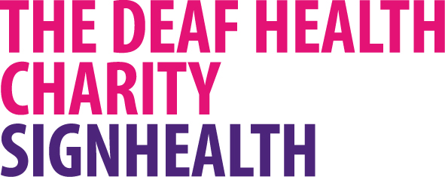
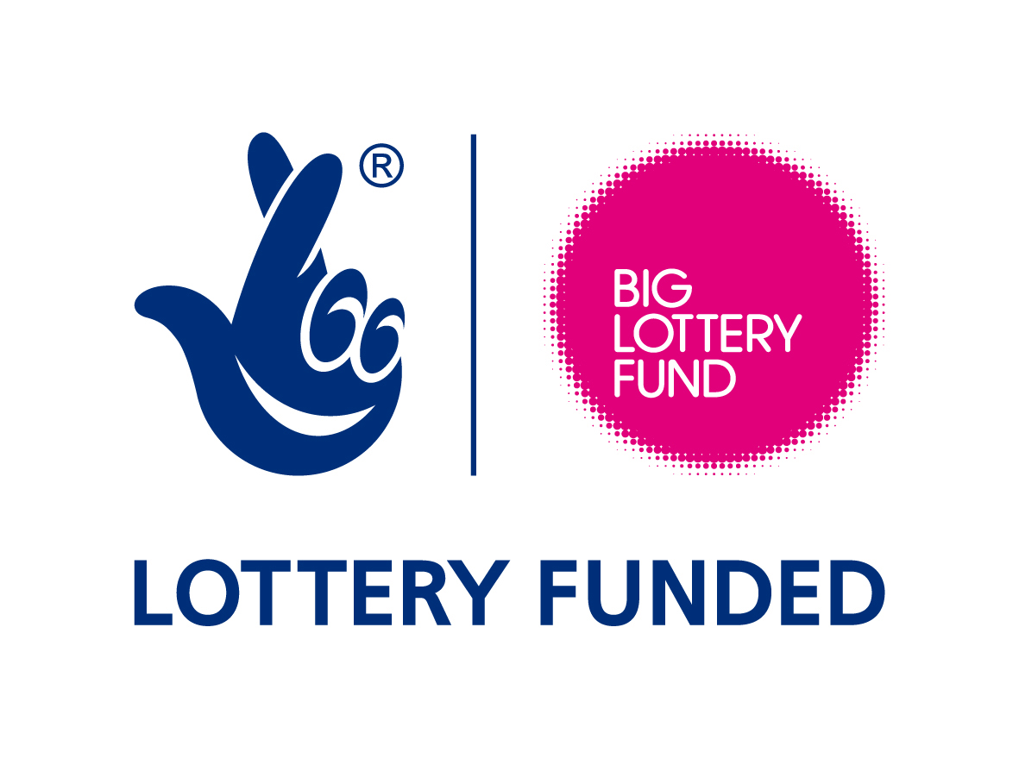
British Society
for Mental Health
and Deafness

The Deaf Health Charity SignHealth
Registered Charity No. 1011056 www.signhealth.org.uk

British Society for Mental Health and Deafness
Registered Charity No. 1057135 www.bsmhd.org.uk

