

Paper 1

Name of Meeting: Leicestershire Interim Leadership Group

Date of Meeting: 4 December 2013

Subject: Issue, Signposting and Safeguarding process

Author: Micheal Smith and Fiona Barber

Status: For approval

Summary Overview

This paper sets out the following:

- The suggested process of reporting information, which is, captured either face to face or through our telephone helpline service.

- A referral process for signposting members of the public to the NHS Independent Complaints Advocacy Service delivered by POhWER.

Recommendations

The meeting is asked to:

- To note the process of information handling through the Healthwatch helpline and through Outreach activity.

- To signoff the suggested reporting process and reporting frequency.

- To signoff the suggested referral process to NHS Independent Complaints Advocacy services.

Introduction

- In the Reference Group meeting of the 28th of August, it was raised by members that the process of capturing information from the public would benefit from review, looking at how the information gathered, was reported to the Reference Group and Lead Member Representatives. It was agreed the Team Leader, Micheal Smith would complete this in discussion with Fiona Barber, ILG member.

Contact from a member of the public

- Healthwatch has many points of contact with the public, primarily this would be through the Healthwatch Helpline but it is important to remember our contact can also be at events and at Community meetings.

- Any issue raised to Healthwatch during a meeting or an event, would be recorded on an Issue form (Appendix 1) by the member of staff present. The completed form would be passed to the Healthwatch Advisor to log onto the Healthwatch Database. The Advisor would then action the issue through the same process set out in Figure 1.

Reporting issues process

- When looking at how issues are captured and reported, is how to inform key member representatives and staff leads. Previously it had been agreed that, should issues from members of the public be about a specific Trust or work programme topic, this would be flagged to the relevant member lead and staff lead. This needed to be reflected in the agreed process. Once an issue has been recorded the information will be sent to the member representative using the template set out in Appendix 2.

- It is important to distinguish any complaints, which are received by Healthwatch. All complaints will be referred to either the relevant Patient Advice and Liaison Service/Patient Information and Liaison Service service or an independent Advocacy Service, whichever the member of public chooses. The information of the complaint will be captured, to allow inclusion into future trend analysis.

- After recently meeting with the NHS Independent Advocacy service, they have provided their standard protocol with Healthwatch, which includes a proposed referral process.

- Using this referral process (Appendix 2 – Section 5.4), Healthwatch would be able to better track referrals to POWhER.

- To ensure the Healthwatch board is kept informed of the issues captured, Fiona and Micheal agreed that the information needed to come through regularly and in the first instance this would be aligned to the Healthwatch Leicestershire Board meetings. This would better inform the board members of public issues, in a timely manner. A monthly reporting frequency was agreed.

- As Healthwatch Leicestershire, has a responsibility to feed intelligence into the central Healthwatch England Hub, this monthly report will be loaded up to the Healthwatch Hub by the Healthwatch advisor.

Reporting safeguarding process

- As per the Safeguarding process, we will be encouraging members to report any concerns directly to the relevant Safeguarding team, but any intelligence captured, on safeguarding, will be logged into the Healthwatch Database.

- A regular report produced by the Healthwatch Advisor, on any safeguarding issues will be sent to the Enter and View and Safeguarding Work Group for review. Information reported to the Group will be anonymised.

- Healthwatch Leicestershire has an obligation to report, on a quarterly basis, to Healthwatch England on all safeguarding concerns captured. The Healthwatch Advisor will prepare the report.

- The Safeguarding Policy is contained in a separate paper.

Reporting signposting process

- When reporting on the information gathered through the Healthwatch Helpline, the reporting frequency needs to allow a sufficient time for analysable data to be collected. A quarterly reporting period is recommended to align with other timelines.

- The quarterly report will look into and highlight any trends in the calls received and requests for information. The information will be anonymised. This report will be prepared by the VAL Research Team

- If any trends are identified for Trust or organisation specific, this will be shared with the agreed contact under protocol arrangements.

- Should any signposting calls be complicated or complex, and they relate to a specific Work Group or stakeholder, the call will be flagged to the specific Member and staff led. All complex and complicated calls handled will be captured as an anonymous case study and referred to our Comms team to highlight good examples of Healthwatch, to promote the helpline service and encourage take up.

- To support Healthwatch England, in understanding the local picture, the Quarterly Trend report will be uploaded to the Healthwatch Hub by the Healthwatch Advisor.

Next steps

- Once agreed this process will be put into place immediately with the first issue report going to the Healthwatch Leicestershire Board meeting in January 2014.

- The first quarterly trend report will go to the Healthwatch Leicestershire in January 2014 and the following cycle

  - 1st April 2014 – 30th June 2014
  - 1st July 2014– 30th September 2014
  - 1st October 2014 – 31st December 2014

Summary/Conclusion

- Through this process we can establish the routes and frequency of reporting. This will ensure the right members and staff are kept aware of issues and trends identified through contact with members of the public.

- The process also establishes where external reporting is required. To ensure Healthwatch is sharing its intelligence where it can make the most impact.

- By agreeing a referral process with POhWER, this will offer a better recording process to demonstrate how Healthwatch and POhWER are working together.

- The process will be cascaded to all staff in the next available Team meeting in December.

Figure 1. Issue, Signposting and Safeguarding Flowchart Process

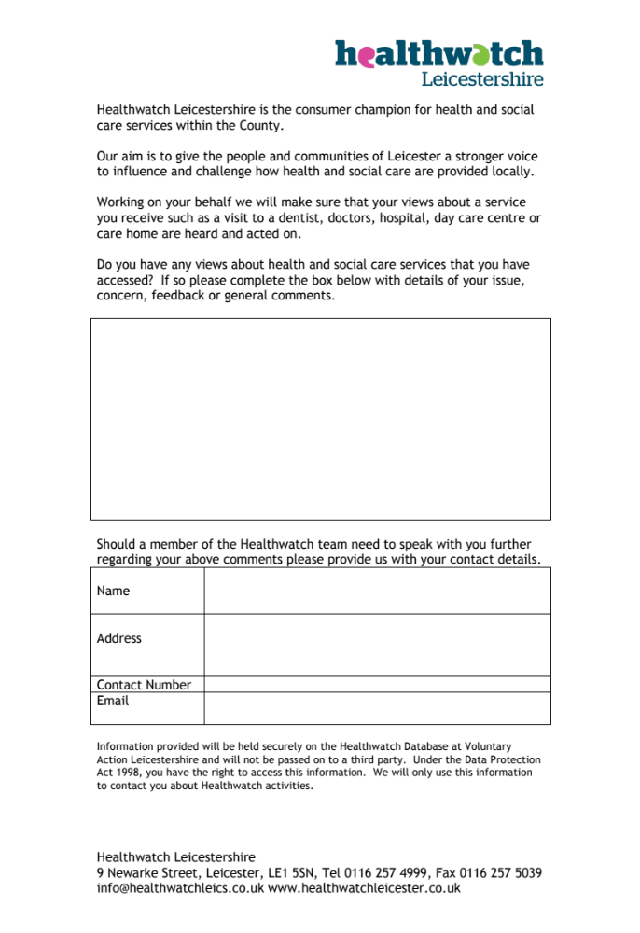
Appendix 1 – Issue capture form

Appendix 2. Template Email format

Member name,

Please find below the details of an issue received through the Helpline/at an event, which relates specifically to the …………trust/Local Authority

The details of the issue have been anonymised and passed to you for information only and you are not required to take any action to resolve the matter.

This issue has been sent to you as part of the issue recording process.

If you have any further questions about the issue please contact Gill/Cherelle/Hardip for more information.

Issue received on-

Insert Issue text into box below.

Appendix 3. Suggested Protocol between Healthwatch Leicestershire and POhWER Advocacy

Healthwatch Leicestershire

Protocol & Procedure for Working and Information Sharing Between Healthwatch Leicestershire & POhWER

1 Introduction

The aim of this document is to ensure that Healthwatch Leicestershire and POhWER develop a constructive working relationship with one another in an ever-changing health and social care landscape.

Each body has a distinctive role to play in improving health, social care and wellbeing outcomes for communities within Leicestershire and it is important to acknowledge their independent but complimentary roles and responsibilities so that they can “add value‟ to each other’s work.

2 Roles and Responsibilities

2.1 Healthwatch Leicestershire

Healthwatch is the new independent consumer champion for both health and social care. It exists in two distinct forms – local Healthwatch and Healthwatch England. Local Healthwatch to be known locally as Healthwatch Leicestershire and is a vital part of the Government’s plans to give people a stronger voice and drive improvements in health and social care services.

Healthwatch Leicestershire will represent the views and experiences of the diverse communities in the County, and will reach out to ensure that the voices of vulnerable people and hidden communities are heard. It will gather intelligence from people and use it to inform how decisions about services are made, including highlighting where there are problems and where things are working well.

Healthwatch Leicestershire will strengthen the collective voice of local people across both health and social care, influencing the Joint Strategic Needs Assessment and Joint Health and Wellbeing strategy – on which local commissioning decisions will be based – through its seat on the Health and Wellbeing Board.

Healthwatch Leicestershire will also refer or signpost people to the appointed independent advocacy services for Leicestershire if they need help to complain about NHS services or need advocacy help with other services.

The national vision for local Healthwatch is that it will:
- Act as local consumer champion representing the collective voice of patients, service users, carers and the public
- Support individuals to access information about services
- Provide or signpost people to independent advocacy if they need help to complain about NHS services
- Have real influence with commissioners, providers, regulators and Healthwatch England using their knowledge of what matters to local people

2.2 POhWER Leicestershire

POhWER Leicestershire provides the statutory NHS Complaints Advocacy and is here to help people who live in Leicestershire make a complaint about NHS care or treatment.
NHS Complaints Advocacy is free, confidential and independent of the NHS.
We can:
- Support people to make a complaint about the service, care or treatment provided by the NHS, including complaints about GP, dentist, local hospital, ambulance service or pharmacy,
- Support people with a complaint about health and social care,
- Support people to make an NHS complaint on someone else's behalf, including if someone has died,
- Listen to concerns,
- Signpost people to the right organisation if we think that someone else can be of more help than we can,
- Answer questions about the NHS complaints procedure and explain options,
- Provide a step by step guide to making an NHS complaint and offer some tips,
- Provide a POhWER advocate; a trained and experienced professional worker who can help and support people through the NHS complaints process,
- Support people to write a complaint letter, attend a complaint meeting, request access to medical records and refer complaints to the Parliamentary and Health Service Ombudsman (PHSO) if the local service is unable to resolve your complaint.

How the two bodies will work together:

Both bodies have a role to play in the way that local services are planned and delivered and how they interact with each other will directly influence and add value to outcomes for local people and communities.

Healthwatch Leicestershire and POhWER Leicestershire agree to adhere to the following key principles and actions:

3 Key Principles:
- Improved health and social care in the County is a common goal.
- Ensuring early and inclusive discussions.
- Developing relationships based on openness, honesty and accountability.

4 Actions:
- Information Sharing: When a qualifying complaint relating to an NHS service is received HW Leicestershire will seek to obtain permission under their data sharing protocol to forward the complainant and complaint details to POhWER.
- POhWER will contact the complainant within 5 working days and confirm this has been done back to HW Leicestershire.
- Regular and timely sharing of actions. POhWER will periodically update HW Leicestershire on the “top level” progress of each complainant within the scheduled update meetings or specifically on any issue between meetings if there is a benefit to the complainant to do so.
- Work Planning. Monthly planned & timetabled meetings / briefing sessions to take place between the two organisations to further develop the working relationship and improve outcomes and efficiency, further clarify each other’s roles and responsibilities, and to provide an opportunity to share knowledge and experience on specific topics, in the spirit of partnership working.

5 Data Sharing
Both organisations shall recognise the legal requirements of the Data Protection Act 1988 and commit to fully comply with the Act. The Act dictates that information should only be disclosed on a “need to know” basis. Records must be treated carefully and disposed of in a secure manner and staff must not disclose information outside their line of duty.

5.1 Consent
Healthwatch Leicestershire and POhWER will obtain informed consent where needed.

The Organisations accept that for consent to be valid, the data subject must be
informed of the purpose for which the information is being collected, how it will be
used and with whom it will be shared.

5.2.1 Sharing with Consent
Staff should ensure that consent to share personal sensitive information has been
given explicitly. Sensitive information will only be released if its disclosure is deemed critical appropriate and explicit consent has been given to release for that purpose.

5.2.2 Without Consent
In some cases it may not be practical to obtain consent, for instances if the individual is unable to give consent or there may be a risk to third party.

The Data Protection Act and the Common Duty of Confidentiality exempts partners
from compliance, if compliance may result in harm to an individual, including a work
colleague, or may prejudice the reduction of crime.
If an individual is unable to give consent, the decision should be made on the
individual’s behalf by the carer or professional responsible, taking into account the views of the individual (and carers if appropriate), with the individual’s best interests being paramount.
Recipients of personal information which has been shared without consent will be
informed of the consent status. They will also be informed on what basis the decision to share was made and will put in place agreed security procedures.

The individual will be informed of the disclosure made without consent, unless there are justifiable concerns for the safety of an individual or others. If there are concerns then the individual will not be informed of the relevant disclosure.
In all cases, when personal information is shared, either, with or without consent, a
record of the sharing event should be kept on file as soon as possible.

5.3 Restrictions on information shared:
The information will be destroyed by both organisations following the completion of the project.

5.4 How the information will be recorded and shared:

5.5 Transfer of Information In-Person or by Telephone
- The receiver of the information is properly identified
- The receiver of the information understands their responsibility
- Information is shared on a “need to know” basis only
- Conversation cannot be overheard

5.6 Transfer of Information by Post – Internal or External
Printed information, or other media, containing personal information will only be sent by special delivery post or via courier:
- Envelope is sealed and marked “Personal & Confidential – to be opened by addressee only”
- Full address details are used
- The addressee is informed the time, date and method that the information was sent and the addressee acknowledges receipt.

5.7 Transfer of Information by Email
Email is not always a secure method of sending personal sensitive information unless encryption is used. If using email:
- Ensure information is kept to a minimum
- Ensure it is in an attachment and that it is password protected
- Send password details in a separate e-mail or separate validated route such a text message to the information
- Only send on a “need to know” basis

6 Authorisation

This document is authorised by the board in accordance with Healthwatch Leicestershire’s Policy and procedures (to be updated)

Signed POHWER Leicestershire Signed Healthwatch Leicestershire

