Technical Exercise

Richard Barad

03/28/2025

This analysis explores the socio-economic vulnerabilities in Philadelphia County. The analysis uses the following variables:

1. Black, Indigenous, and People of Color (BIPOC) Population
2. People 25+ without a High School Diploma
3. Percent of Overcrowded Housing Units
4. Households with No Vehicle
5. Population below 150%
6. Heat Exposure Index

Variables one to five use data from the provided extract from the Center for Disease Social Vulnerability Index (SVI) dataset. The Heat Exposure data was downloaded from the Philadelphia Open Data Portal and was included to capture areas that are likely to experience the strongest impacts of extreme heat from climate change[1]. The six maps on page two show the maps of the six variables for the county. The maps demonstrate that there is a correlation between multiple variables. For example, areas with a large BIPOC population tend to also have a large population without a high school diploma, a large percentage of overcrowded housing units, and a larger population below the 150% poverty line.

To assess how the selected variables vary across the different parts of Philadelphia the average value for each variable by planning district was calculated. The charts on page two show the mean values for each planning district.

To determine if the variables are correlated with eachother a correlation matrix was created. The correlation matrix and the analysis of the matrix is visible on the page three.

All analysis was conducted using R and the code is available on github here:

|  |  |  |
| --- | --- | --- |
|  |  |  |
|  |  |  |

**Figure 1, Maps of Selected Variables for the City of Philadelphia**

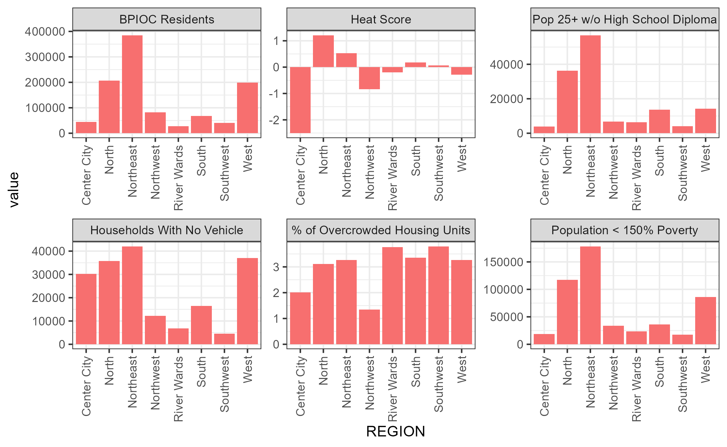

1. **Largest number of BPIC Residents:** North, Northeast and West Philadelphia.
2. **Highest Heat Exposure:** North, Northeast, and South Philadelphia.
3. **Largest Population 25+ Without Highschool Diploma:** North and Northeast Philadelphia
4. **Largest Number of Households with No Vehicle:** Center City, North, Northeast, West
5. **Highest Percent of Overcrowded Housing Units:** River Wards, South, Southwest, West
6. **Largest Population < 150% Poverty:** North and Northeast Philadelphia

**Analysis of Variables by Region**

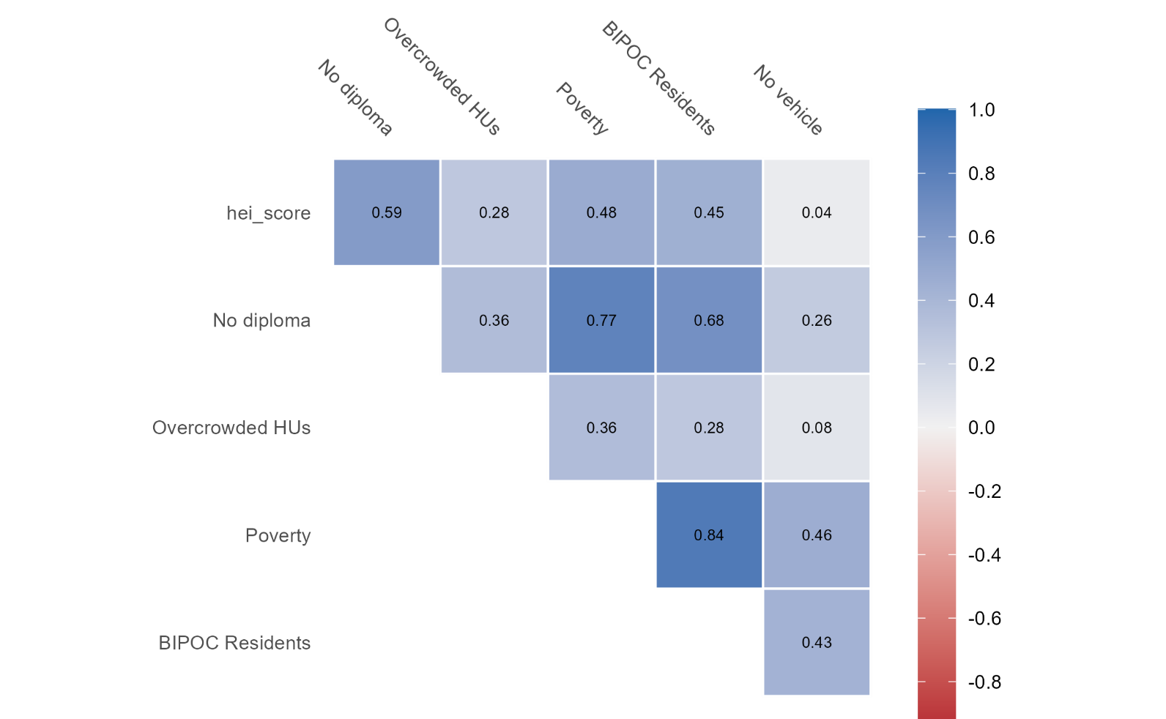**Correlation Matrix**

[Grab your reader’s attention with a great quote from the document or use this space to emphasize a key point. To place this text box anywhere on the page, just drag it.]

1. Heat Vulnerability by Census Tract, Philadelphia Department of Public Health, <https://opendataphilly.org/datasets/heat-vulnerability-by-census-tract/> July 21, 2022