Prelab 1b

The trajectory for x and y are defined as follows:

ytraj = [-2, -2, -2, -2, -2, -2, 0, 1, 2, 3, 4, 5, 6, 7 , 8, 9, 10, 11, 12, 13, 14, 15, 15, 15, 15, 15, 15, 15, 15, 15, 15, 15, 15, 14, 13, 12, 11, 10, 9, 8, 7, 6, 6, 6, 6, 6, 6, 6, 6, 7, 8, 9, 10, 11, 12, 12, 12, 12, 11.5, 11.25, 11, 11, 11, 11, 11, 11];

xtraj = [15.5, 15.5, 15.5, 15.5, 15.5, 15.5, 15.5, 15.5, 15.5, 15.5, 15.5, 15.5, 15.5, 15.5, 15.5, 15.5, 15.5, 15.5, 15.5, 15.5, 15.5, 15.5, 14.5, 13.5, 12.5, 11.5, 10.5, 9.5, 8.5, 7.5, 6.5, 5.5, 4.75, 4.75, 4.75, 4.75, 4.75, 4.75, 4.75, 4.75, 4.75, 4.75, 5.75, 7, 8, 9, 10, 11, 12.25, 12.25, 12.25, 12.25, 12.25, 12.25, 12.25, 11, 10, 9, 8, 7, 6, 6, 6, 6, 6, 6];

With the exceptions of the beginning and the end of the trajectory, this follows the center of the path through the maze. Some corrections are made at the beginning to place the arm at the outside of the maze, and some corrections are made at the end to get the arm to the finish line through a shorter path. The inverse kinematics are plotted below.

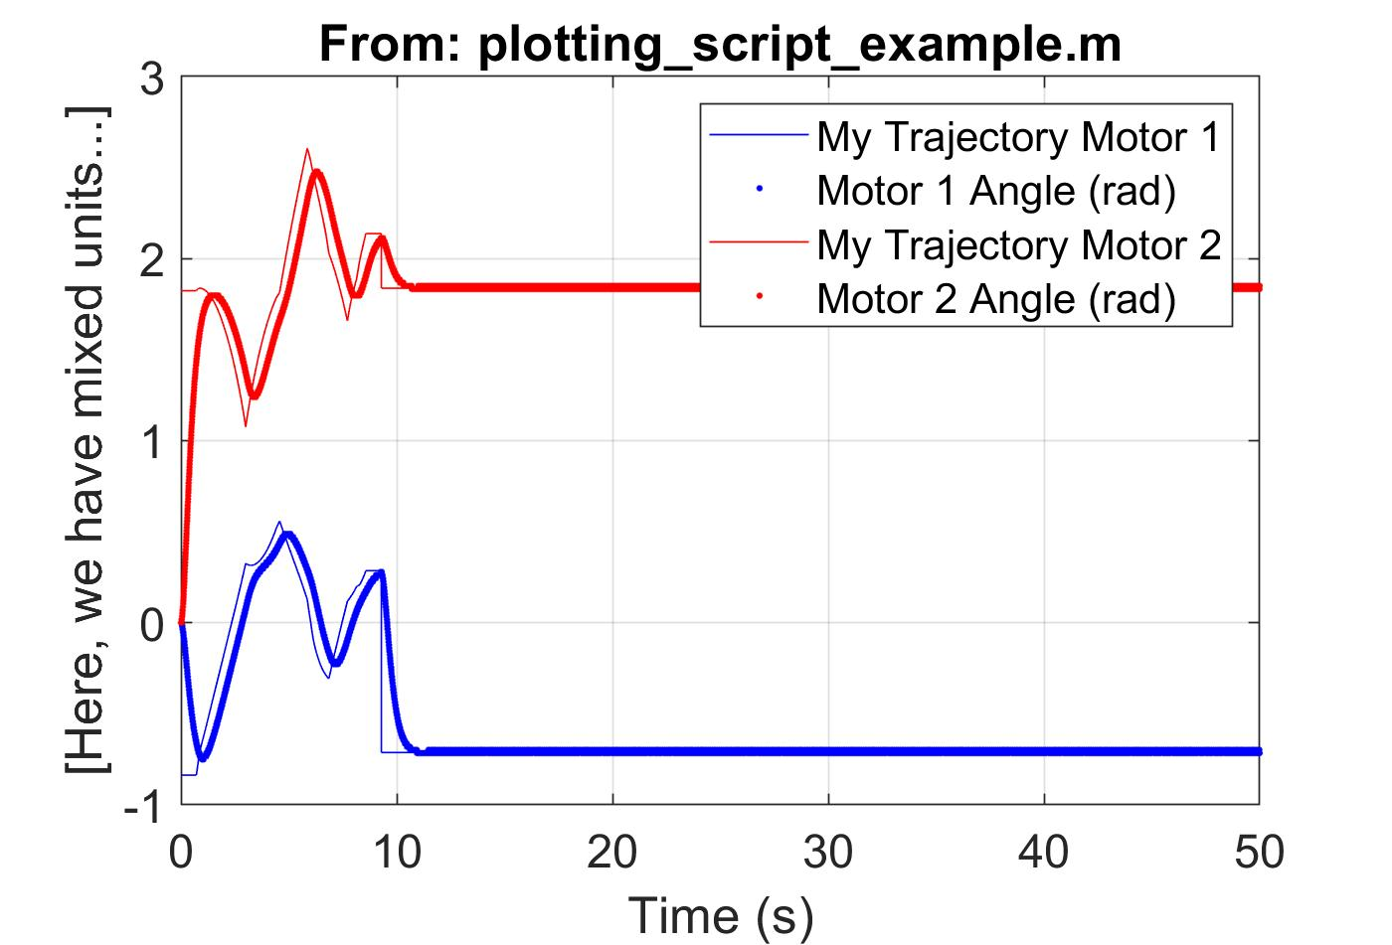

Plotting using the simulated arm, we can see that the simulated trajectory follows the given trajectory fairly well. At the end, the arm returns to its base position at the beginning of the maze.

The forward kinematics are then used to plot the following trajectory.

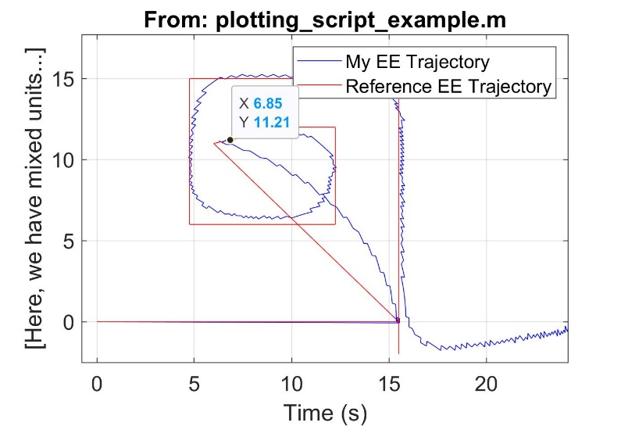

As you can see, the estimates show that the arm is generally following the trajectory, but curving at the corners as expected. The reference trajectory is following the middle of the given maze except at the end, where I curve it down a little to reach the finish line early. Below is the shown trajectory mapped onto the given maze.

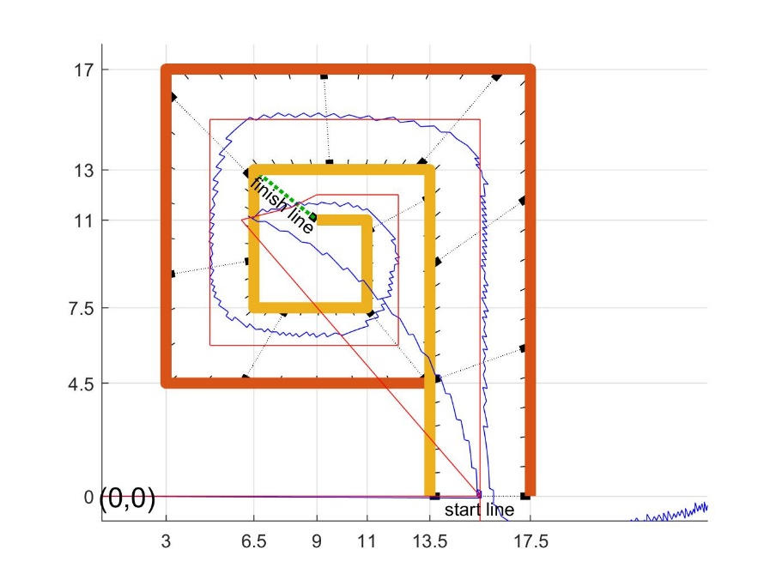

As you can see, the trajectory stays within the bounds of the maze