**package** com.example.myapplication;  
  
**import** android.content.Intent;  
**import** android.os.Bundle;  
**import** android.os.Handler;  
**import** android.view.View;  
**import** android.widget.Button;  
**import** android.widget.EditText;  
**import** android.widget.Toast;  
  
**import** androidx.appcompat.app.AppCompatActivity;  
  
**public class** Activity_MainLogin **extends** AppCompatActivity **implements** View.OnClickListener{  
  
 EditText **username**, **password**;  
 Button **logbutton**;  
  
 **protected void** onCreate(Bundle savedInstanceState){  
 **super**.onCreate(savedInstanceState);  
 setContentView(R.layout.***activity_mainlogin***);  
  
 **username** = findViewById(R.id.***username***);  
 **password** = findViewById(R.id.***password***);  
 **logbutton** = findViewById(R.id.***logb***);  
  
 **logbutton**.setOnClickListener(**this**);  
 }  
  
  
 @Override  
 **public void** onClick(View v) {  
 **switch** (v.getId()){  
 **case** R.id.***logb***:  
 String un = **username**.getText().toString();  
 String pw = **password**.getText().toString();  
 **if** (un.equals(**"richard"**)&&pw.equals(**"villete"**)){  
 Intent i = **new** Intent(Activity_MainLogin.**this**, Search_List.**class**);  
 startActivity(i);  
 } **else** {  
 Toast.*makeText*(**this**, **"incorrect username or password"**, Toast.***LENGTH_LONG***).show();  
 **username**.setText(**""**);**password**.setText(**""**);  
 }  
 **break**;  
 }  
 }  
}

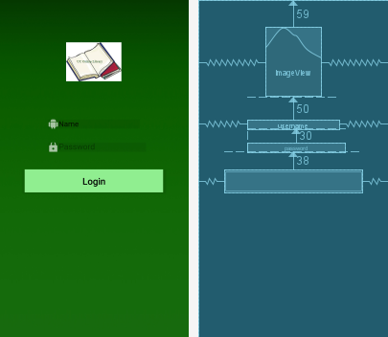

**package** com.example.myapplication;  
  
**import** android.content.Intent;  
**import** android.os.Bundle;  
**import** android.os.Handler;  
  
**import** androidx.appcompat.app.AppCompatActivity;  
  
**public class** SplashScreen **extends** AppCompatActivity {  
 @Override  
 **protected void** onCreate(Bundle savedInstanceState){  
 **super**.onCreate(savedInstanceState);  
 setContentView(R.layout.***splashscreen***);  
 **new** Handler().postDelayed(**new** Runnable() {  
  
 @Override  
 **public void** run() {  
 Intent i = **new** Intent(SplashScreen.**this**, Activity_MainLogin.**class**);  
 startActivity(i);  
  
 finish();  
  
 }  
 },4000);  
 }  
}

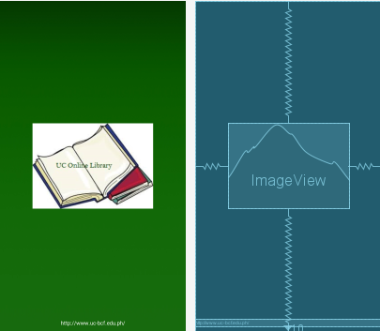

**package** com.example.myapplication;  
  
**import** android.os.Bundle;  
**import** android.widget.ArrayAdapter;  
**import** android.widget.ListView;  
**import** android.widget.SearchView;  
  
**import** java.util.ArrayList;  
  
**import** androidx.appcompat.app.AppCompatActivity;  
  
**public class** Search_List **extends** AppCompatActivity {  
  
 SearchView **mySearchList**;  
 ListView **myList**;  
  
 ArrayList<String> **list**;  
 ArrayAdapter<String> **adapter**;  
  
 @Override  
 **protected void** onCreate(Bundle savedInstanceState){  
 **super**.onCreate(savedInstanceState);  
 setContentView(R.layout.***searchlist***);  
  
 **mySearchList** = (SearchView)findViewById(R.id.***searchView***);  
 **myList** = (ListView)findViewById(R.id.***searchView***);  
  
 **list**= **new** ArrayList<String>();  
  
 **list**.add(**"Juan Tamad"**);  
 **list**.add(**"Jack and The Beanstalk"**);  
 **list**.add(**"Sleeping Beauty"**);  
 **list**.add(**"Snow White"**);  
 **list**.add(**"The Turtle and the Monkey"**);  
  
 **adapter** = **new** ArrayAdapter<>(**this**,android.R.layout.***simple_list_item_1***,**list**);  
 **myList**.setAdapter(**adapter**);  
  
 **mySearchList**.setOnQueryTextListener(**new** SearchView.OnQueryTextListener() {  
 @Override  
 **public boolean** onQueryTextSubmit(String s) {  
 **return false**;  
 }  
  
 @Override  
 **public boolean** onQueryTextChange(String s) {  
  
 **adapter**.getFilter().filter(s);  
 **return false**;  
  
  
 }  
 });  
 }  
}

