# Survey

Survey is open on

Socrative.com

# Message

Please return at 11:55am

# Review

# Whiteboard

# Toolbox

## Stack and Heap

|  |  |  |  |  |  |
| --- | --- | --- | --- | --- | --- |
| Stack Page | |  | Heap | | |
| **Variable Name** | **Value** |  | **Address** | **Value** | **GC** |
|  |  |  |  |  |  |
|  |  |  |  |  |  |
|  |  |  |  |  |  |

Figure Stack (of Stack pages)

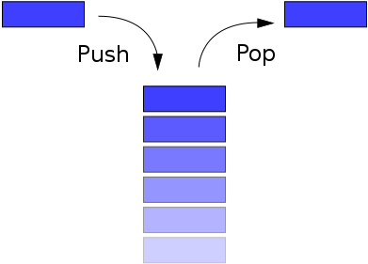

[This Photo](https://en.wikibooks.org/wiki/Data_Structures/Stacks_and_Queues) by Unknown Author is licensed under [CC BY-SA](https://creativecommons.org/licenses/by-sa/3.0/)

## Binary Numbers

|  |  |  |  |  |  |  |  |  |  |  |  |  |  |  |  |  |  |  |  |  |  |  |  |  |  |  |  |  |  |  |  |  |  |  |
| --- | --- | --- | --- | --- | --- | --- | --- | --- | --- | --- | --- | --- | --- | --- | --- | --- | --- | --- | --- | --- | --- | --- | --- | --- | --- | --- | --- | --- | --- | --- | --- | --- | --- | --- |
|  |  |  |  |  |  |  |  |  |  |  |  |  |  |  |  |  |  |  |  |  |  |  |  |  |  |  |  |  |  |  |  |  |  |  |
|  |  |  |  |  |  |  |  |  |  |  |  |  |  |  |  |  |  |  |  |  |  |  |  |  |  |  |  |  |  |  |  |  |  |  |

|  |  |  |  |  |  |  |  |  |  |  |  |  |  |  |  |  |  |  |  |  |  |  |  |  |  |  |  |  |  |  |  |  |  |  |
| --- | --- | --- | --- | --- | --- | --- | --- | --- | --- | --- | --- | --- | --- | --- | --- | --- | --- | --- | --- | --- | --- | --- | --- | --- | --- | --- | --- | --- | --- | --- | --- | --- | --- | --- |
|  |  |  |  |  |  |  |  |  |  |  |  |  |  |  |  |  |  |  |  |  |  |  |  |  |  |  |  |  |  |  |  |  |  |  |
|  |  |  |  |  |  |  |  |  |  |  |  |  |  |  |  |  |  |  |  |  |  |  |  |  |  |  |  |  |  |  |  |  |  |  |

|  |  |  |  |  |  |  |  |
| --- | --- | --- | --- | --- | --- | --- | --- |
|  |  |  |  |  |  |  |  |
|  |  |  |  |  |  |  |  |

|  |  |  |  |  |  |  |  |
| --- | --- | --- | --- | --- | --- | --- | --- |
|  |  |  |  |  |  |  |  |
|  |  |  |  |  |  |  |  |

# To Do

techelevator.zoom.us/my/mmorel