CodeRay User Guide vers 1.0
© Richard Fencel Software
Contents
1. Introduction 2
1.1 Software Requirements 2
1.2 Installation 2
2. Sample Client App with CodeRay 3
2.1 Tree Display 4
2.2 DataGrid Display 9
2.3 Client App Modifications 14
3. Reference 19
4. Known Issues 20
4.1 No Support for FrameworkContentElement 20
4.2 Nested Data Template Problem 20

Introduction
CodeRay is an debugging/documentation utility that shows a WPF application's view-view model architecture in a tree-structured layout and displays in real-time all data binding updates in an accompanying DataGrid.
This capability requires minor changes to the client WPF application. These include the need to make static calls to the CodeRay library when views are created/destroyed or view models are created, as well the setting of XAML databinding “update” flags for properties of interest.
CodeRay will not work with WPF frameworks such as Prism and Caliburn-Micro.

Software Requirements
CodeRay has been certified to run under the following system configuration:
- Windows 7, Windows 8, Windows 8.1
- .NET 4.5

Installation
The downloaded CodeRaySource.zip file when extracted creates a directory called CodeRaySource that has the following subdirectories:
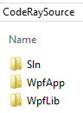

The Sln directory contains all the solutions in the project (there is only one), the WpfApp directory contains all the WPF applications in the project (there is only one), and the WpfLib directly contains all the libraries in the project (there is only one).
The sample client app is “SimpleListBoxWpfApp”. This calls methods in the CodeRay library “CodeRayWpfLib” that invoke and manage the MVVM debugging/documentation popup window. The sample client app and CodeRay library make up the solution CodeRayTestSln.

Sample Client App with CodeRay
This section shows how a sample client app would use CodeRay. The sample client is SimpleListBoxWpfApp and is included in the source code.
When the sample app executes, it displays a simple list of ten employees in a ListBox:

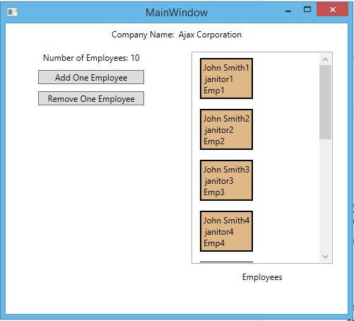
An employee can be added or deleted by pressing the appropriate button. The Number of Employees field will increment or decrement with each button press. You can also edit the occupation field of any employee, e.g. change “janitor2” to “salesman”.
When the sample app executes, it invokes the CodeRay popup window shown below:
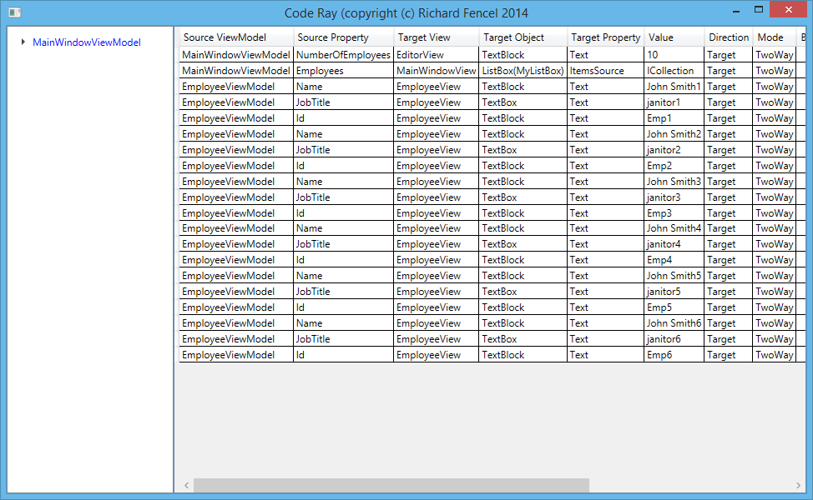
The rest of this section explains the tree and data grid parts of the CodeRay popup.

Tree Display
The CodeRay tree (shown expanded below) displays the MVVM architecture of the client app:
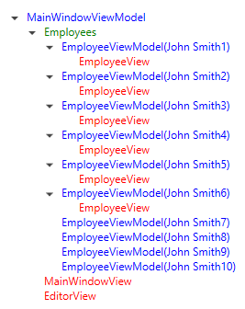
The view models are in blue, the view model collections in green and the views in red. Note that not all of the EmployeeViewModels in this example have a corresponding view. This is because of the “virtualized” nature of the ListBox, i.e. not all the views have been created yet. As you scroll up and down the ListBox, the view models that have views will vary as the corresponding ListViewItems are created and destroyed.
For any view in the tree, you can find its corresponding client window by clicking on the tree item. This causes the client window to be outlined in red. For example:

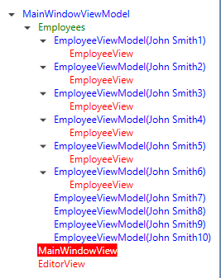
The client app changes to:
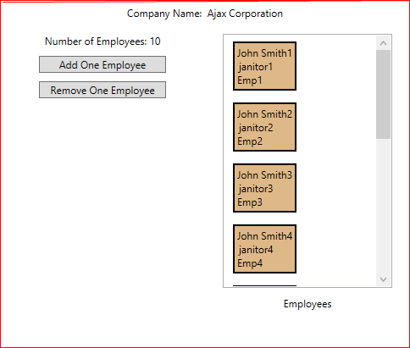
Other examples of view selection:
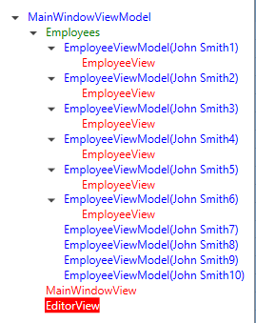

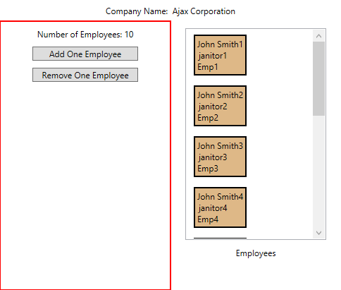
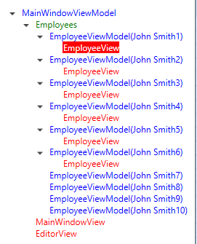
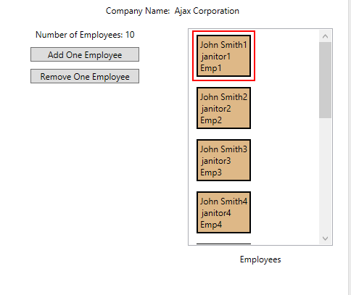

DataGrid Display
The CodeRay datagrid contains all the data binding updates. Shown below are those updates that happened when the ten employees were added at startup.

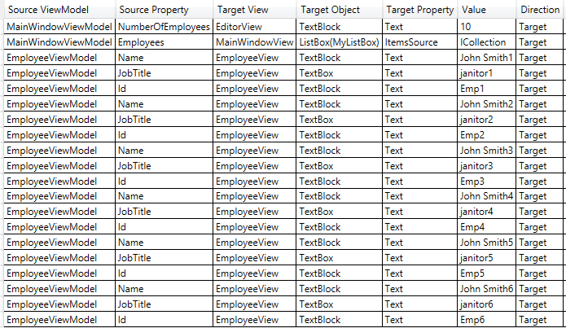
If you click on “Add One Employee” in the client app:
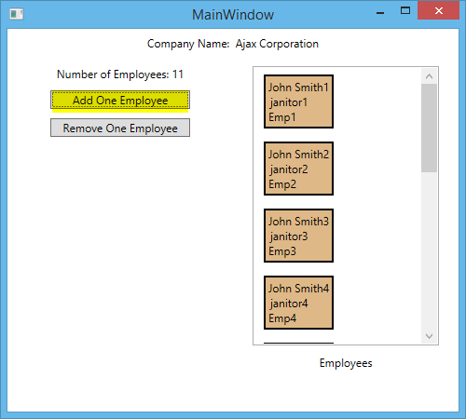
The following data binding update occurs:
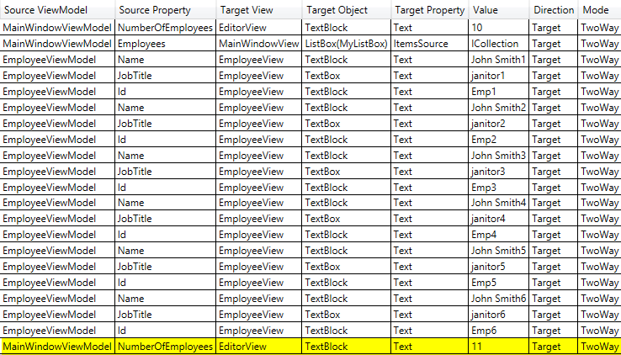
In this case, the field “NumberOfEmployees” was updated. No employee fields were updated because the new ListBoxItem has not yet been created due to the virtualization of the ListBox.
Suppose you edit one of the occupation fields in the client app:
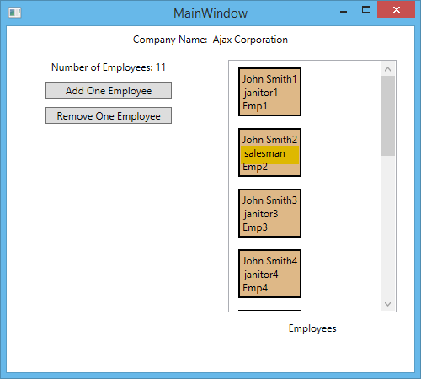
This results in the following update:
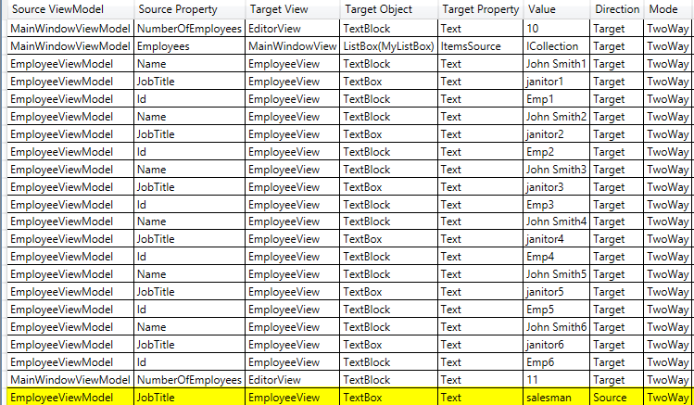
Notice that in this case the Direction column is “Source” because the source property was updated.
It may be of interest to see in the client app the target object that corresponds to a particular databinding update. You can do this by clicking on the update row in the data grid:
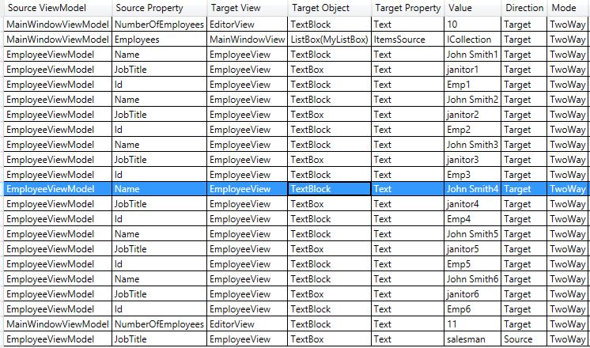
The target object in the client app is now outlined in purple:
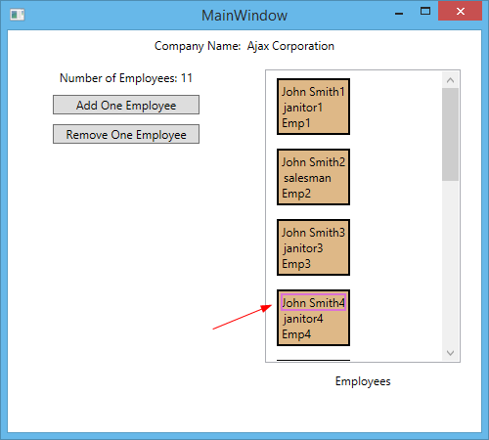
Notes:
(a) The result of this operation is the same whether the update direction is Source or Target, i.e. you will always see the target object outlined in purple.
(b) If you click on an update in the datagrid refers to an object that has subsequently been deleted (e.g. due to virtualization of the ListBox), then you will see an error message “Target object not found”.

Client App Modifications
In order to achieve the above functionality, the following changes were made to the client app:
- In the startup code, add the call to show the CodeRay popup:
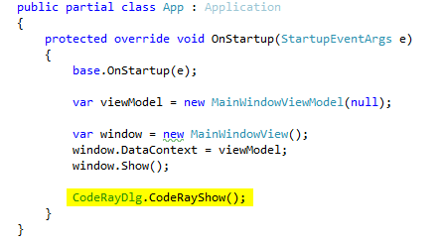
- When the top view is is unloaded, add the code to remove the CodeRay popup:
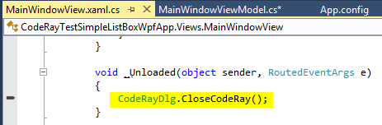
- In each view, add the code to handle the DataContext changed, Unloaded, SourceUpdated, and TargetUpdated events. Note: if the top view, then in the Unloaded handler, call CodeRayDlg.CloseCodeRay() as shown above rather than RemoveElement().
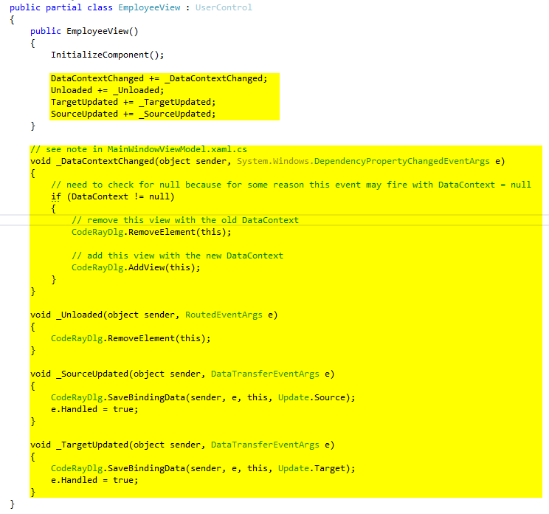
- In the constructor of each view model, insert the code that adds the view model and its view model collections to CodeRay:
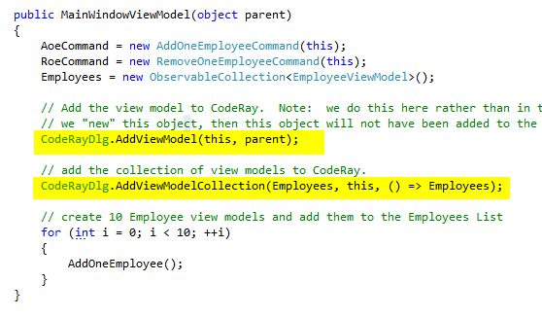
Notes:
(a) The view model collection name is always specified as a lambda expression (e.g. () => Employees) in order to be able to derive its text variable name without using magic strings (e.g. “Employees”).
(b) It is necessary to pass to the constructor of the view model the parent of the view model, i.e. the object where the view model was created (the parent is need by the AddViewModel() and AddViewModelCollection()). If the view model corresponds to the top view, then its parent is null.
(c) It is not necessary to call RemoveElement() when a view model is destroyed (as is done for a view).
- In each view model, for every data binding of interest, set NotifyOnTargetUpdated = True and NotifyOnSourceUpdate = True:
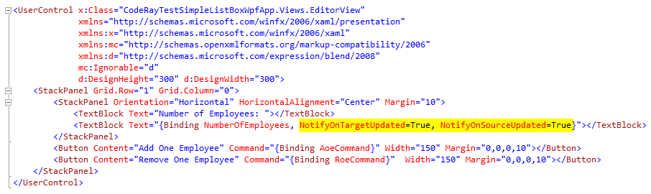

Reference
The following table lists all the static methods in the CodeRay library.

Method | Purpose
AddView() | Adds a view to the CodeRay tree
AddViewModel() | Adds a view model to the CodeRay tree
AddViewModelCollection() | Adds a view model collection to the CodeRay tree
CloseCodeRay() | Closes the CodeRay popup window
CodeRayShow() | Opens the CodeRay popup window
SaveBindingData() | Adds to the CodeRay datagrid a record that describes a data binding update

Known Issues
This section describes known limitations of CodeRay.

No Support for FrameworkContentElement
CodeRay supports only views that are derived from FrameworkElements. No attempt has been made to process or test a view that is derived from FrameworkContentElement. This could probably be added but would require significant rewrite of the view logic.

Nested Data Template Problem
The following code cause GetBindingExpression() to return null in SaveBindingData() even though the data binding update was successful:
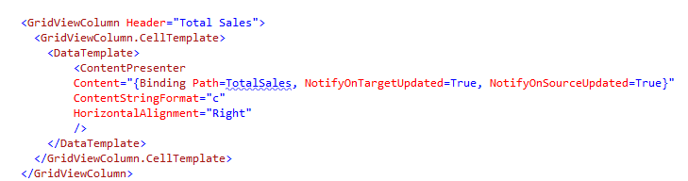

It is not certain why this is the case. It may have something to do with the fact that the DataTemplate is nested inside a CellTemplate. In any case, the following workaround works:
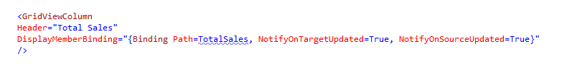
The above code that failed with CodeRay was taken from the Josh Smith MVVM example that can be downloaded from: http://msdn.microsoft.com/en-us/magazine/dd419663.aspx
(due to copyright issues, none of the Josh Smith code is include in this project).

