About your Arduino

Congratulations on getting an Arduino! This document is meant to serve as a quick introduction to Arduinos.

Note: In this case I’m basing the instructions off of the Elegoo Uno R3 Basic Starter Kit.

# Getting Started

An Arduino is a type of electrical component known as a microprocessor. This means that it can be used with other components to form circuits and that it can receive instructions on how it’s supposed to work.

In a way, an Arduino microprocessor or microcontroller is a small form of computer. It has data storage, processing capabilities, and means of providing input and output.

# Board Anatomy

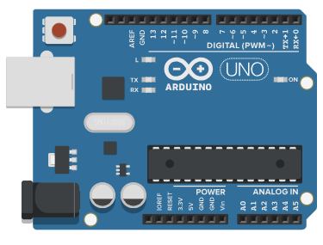

Figure

Your Arduino board should look similar to the board shown above in Figure 1. Take notice of the pins: AREF, GND, 13, 12, ~11, ~10, ~9, 8, 7, ~6, ~5, 4, ~3, 2, TX→1, RX←0, IOREF, RESET, 3.3V, 5V, GND, GND, Vin, A0, A1, A2, A3, A4, and A5. These are your main pins. Please also take note of your two ports on the left side, as well as the red button in the top left corner. These are all the things that you’re likely to need to worry about for these projects.

Your pins can be separated into a few categories: power, digital, analog, and miscellaneous. Each of these has certain purposes and specialties.

The first thing to know about your pins is what is meant by digital and analog. In today’s usage, digital tends to mean electronic and analog tends to mean nonelectric. However, in robotics we use these terms a bit differently. Digital means binary- either on or off, with no in-between state. Digital pins accept values known as HIGH or LOW. Analog pins are different, however. Analog pins can work with a range of values. We tend to represent these values as floating-point (decimal) numbers. Digital and analog pins are useful because they work with certain inputs and outputs. For instance, a button can only be on or off, open or closed. For this reason it makes the most sense to connect it to digital pins. A photoresistor, however, might be used with analog pins because its signal can fall into a certain range.

Power pins are also important to know about. They help provide power from the Arduino that can power different circuits. GND stands for Ground, and is a negative connection. 3.3V is a 3.3-volt power supply, while 5V is a 5-volt supply. A quick internet search states that the Vin pin is a 7-12 voltage supply.

The miscellaneous pins are more esoteric in terms of purpose. The AREF pin, or Analog Reference pin, can be used to provide an external reference for converting analog to digital signals. The IOREF pin, or Input/Output Reference pin, can be used to see what voltage the board operates at. Last but not least, there is the RESET pin, which can be used to restart the Arduino board.

The red button has the same purpose as the RESET pin- it restarts the Arduino board. The silver port at the top left of the board is used to connect the Arduino to a computer for programming or to a power source. The black port at the bottom left of the board is used to power the Arduino.

# What can you do with Arduino?

Arduinos were specifically invented to be versatile and approachable for beginners. They’re useful because they can store and run programs and serve as a tool for implementing software with hardware. Arduinos are often used for many purposes. Here’s a few that I’ve seen:

* Robotics: Arduinos are good at acting as the brain of a robot.
* Power supplies: Arduinos can sometimes be used to divert power within a system.
* Circuitry: circuitry works with Arduino!