PUBLIC SURVEY STATUS REPORT
(95th OPC MEETING)

This report should be returned to the Observing Programmes Office of the European Southern Observatory (opo@eso.org).

ESO PROPOSAL No.: 179.A-2010
TITLE: The VISTA Hemisphere Survey (VHS)
PRINCIPAL INVESTIGATOR: Richard McMahon

- Scientific Aims (brief description)

The aim of the Vista Hemisphere Survey (VHS) is to carry out a wide field near Infra-Red survey, which when combined with other VISTA public surveys will result in coverage of the whole southern celestial hemisphere (~20,000 deg²) to a depth 30 times fainter than 2MASS/DENIS in at least two wavebands (J and K_{s}), with an exposure time of 60 seconds per waveband to produce median 5σ point source (Vega) limits of J = 20.2 and K_{S} = 18.1. In the South Galactic Cap, ~5000 deg² will be imaged deeper with an exposure time of 120 seconds and also including the H band producing median 5σ point limits of: J = 20.6; H = 19.8; K_{s} = 18.5. In this 5000deg² region of sky deep multi-band optical (grizy) imaging data will be provided by the Dark Energy Survey (DES). The remainder of the high galactic latitude (|b|>30°) sky will be imaged in YJHK for 60sec per band to be combined with ugriz waveband observations from the VST ATLAS survey.

The medium term scientific goals of VHS include:
- discovery of the lowest-mass and nearest stars
- deciphering the merger history our own Galaxy via stellar galactic structure
- measurement of large-scale structure of the Universe out to z~1 and measuring the properties of Dark Energy
- discovery of quasars with z>7 for studies of the baryons in the intergalactic medium during the epoch of Reionisation
- discovery of the most luminous quasars in the southern celestial hemisphere at all redshifts as probes of the IGM and the formation of the most massive supermassive black holes in the Universe

In addition the VHS survey will provide essential multi-wavelength support for the ESA Cornerstone missions; XMM-Newton, Planck, Herschel and GAIA.

- Detailed progress report with respect to initial estimate from the Survey Management Plan (including preliminary results, whether published or not).

The report was prepared in November 2014 during ESO Observing Period 94 and covers observations taken up to the end of Period 93 (i.e. end of Sep 2014). The status of CASU processing is visible here:

- http://tinyurl.com/o7k8o9u

This shows that VISTA single band products data taken up to the end of June 2014 was released to VHS at the end of September.

  - Scientific Progress and Outlook

In Figure 1 we show the RA, Dec distribution of OBs for ESO observing periods 84-93 (including Dry Run observations in Period 84) that have been submitted and executed up to the end of Period 93 (Sep 30st 2014). A total of 6258 OBs including 230 OBs from the Dry Run period in Period 84 have been submitted. All the 230 DryRun OBs were completed although some may have to be repeated. 6178 out of 6258 OBs submitted for observing periods 85 to 92 were completed by the end of period 93 (Sep 30th 2014). Each ESO observing period in ESO parlance is a VHS Run with the Dry Run observations that were obtained during period 84 called run A. Period 85 observations are called Run B, Period 86 observations, etc are called Run C; Period 92 = Run I.

Figure 1 show the sky coverage progress for VHS and is generated from the csv status files available via the ESO Portal. Figure 1a shows the VHS status on 2014-10-01 with the Dark Energy Survey April 2012 proposed footprint. Most of the science goals of VHS require optical data from either DES or VST ATLAS.

The official start of the 5 year Dark Energy Survey (DES) was on 31st Aug 2013. DES science verification(SV) observations covering around 300 square degrees were acquired during the period Dec 2012 to Feb 2013. The first observing season ended on 9th Feb 2014 and resulted in around 2000deg² of coverage in the 5 wavebands grizy with an effective exposure of half the final survey exposure per waveband. This is an important milestone for VHS since the combination of VHS with optical data from DES and VST-ATLAS is essential for many of the main science goals of VHS. See Figure 1b for the footprint of the DES observations. The expected final depths DES (5sigma point sources) for DES are 26.5, 26.0, 25.3. 24.7, 23.0 in g, r, i, z and y respectively

VHS survey planning and coordination with the DES collaboration which includes many members of VHS minimised the effect of DES footprint changes by avoiding the scheduling of VHS OBs in regions where the DES footprint was under review. Figure 1b shows the footprint of the DES data acquired during the first observing season up to Feb 9th 2014. The next DES observing season will start in August 2014. Figure 1c shows the VHS overlap with observations of the VST ATLAS survey which is observing in the ugriz wavebands. The VST ATLAS observations are shown upto the end of Feb 2014 and shows the area of sky with at least one VST ATLAS waveband.

Table 1 reports the OBs execution status for each period. Note that OBs submitted in one period are carried over into the next period and hence the observing efficiency in each Period cannot be derived directly from the Table 1. For instance ESO scheduled a smaller amount of time in Period 88 so that the number of carried over OBs was reduced. During the last few periods all submitted OBs have been executed during the relevant period and the number of OBs executed.

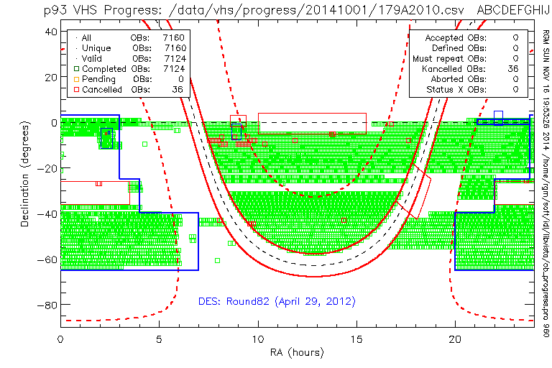
Figure 1a: Sky coverage of the VHS survey in equatorial coordinates based on ESO Portal report tables. The green rectangles show completed OBs. The thin blue lines show the CFHTLS Wide fields. The thick blue lines show the April 2012 Dark Energy Energy Survey footprint (prior to the start of the DES in August 2012).

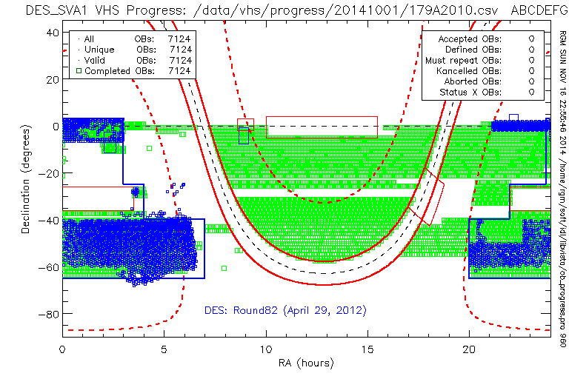
Figure 1b: Sky coverage of the VHS survey in equatorial coordinates based on ESO Portal report tables. The blue small rectangles show the footprint of DES data taken during the first observing season from Aug 31st 2013 to Feb 09 2014 (DES Year 1).

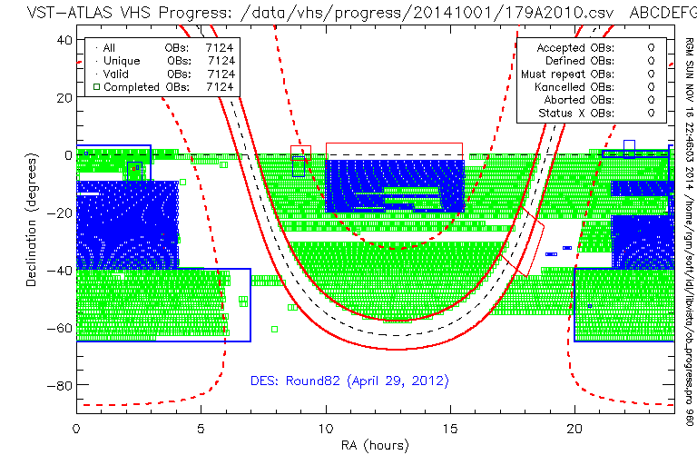
Figure 1c: Sky coverage of the VHS survey in equatorial coordinates based on ESO Portal report tables. The blue small rectangles show the footprint of VST ATLAS taken up to 2014 Mar 1st.

Table 1 VHS OB progress on 2013-10-01
ESO Observing Period | Date Range | Allocated Time  (hrs) | Charged Execution time (hrs) | Submitted OBs | Completed  OBs | Incomplete OBs
P84 (A) | Nov’09-Feb’ 10 | 100 | 99.3 | 230 | 230 | 0
P85 (B) | Apr’10-Sep’10 | 380 | 380.4 | 1088 | 1088 | 0
P86 (C) | Oct’10-Mar’11 | 311 | 311.7 | 850 | 850 | 0
P87 (D) | Apr’11-Sep’11 | 311 | 315.0 | 700 | 700 | 0
P88 (E) | Oct’11-Mar’12 | 158 | 158.7 | 313 | 313 | 0
P89 (F) | Apr’12-Sep’12 | 311 | 313.3 | 723 | 723 | 0
P90 (G) | Oct’12-Mar’13 | 311 | 314.6 | 713 | 713 | 0
P91 (H) | Apr’13-Sep’13 | 311 | 316.2 | 840 | 840 | 0
P92 (I) | Oct’13-Mar’14 | 311 | 315.6 | 801 | 721 | 0
P93 (J) | Apr’14-Sep’14 | 311 | 323.3 | 866 | 866 | 0
Total |  | 2805 | 2849.2 | 7124 | 7124 | 0
Notes: | P84 observations were termed Dry Run.

Observing overhead concerns

We repeat the concerns we have raised in previous reports to the PSP and OPC about the observing overheads. In Table 2 we summarise the OB execution times compared with the OB time on sky and the OB execution times assumed in the VHS SMP.

Table 2: OB overheads
VHS component | OB time  on sky  (seconds) | SMP  (A) | P85  (B) | P86  (C) | P87  (D) | P88  (E) | P89+  (F+)
VHS-DES | 1080 | 1491 | 1809 | 1809 | 2129 | 2129 | 1845
VHS-ATLAS | 720 | 1199 | 1510 | 1510 | 1910 | 1910 | 1649¹
VHS-GPS | 360 | 600 | 829 | 829 | 1005 | 1005 | 1005
Notes: (1) During P89 some ATLAS OBs have execution times of 1910 seconds where they are contiguous with Declination stripes already executed in an earlier period.

The current charging for observing overheads is higher than we assumed in the VHS SMP. VHS has three survey components each with slightly different OB structure with the common theme that each OB produces a tile with a full complement of the wavebands that have to be acquired for a tile.

- VHS-GPS: J and K; 60 seconds per waveband
- VHS-ATLAS: Y, J, H, and K; 60 seconds per waveband
- VHS-DES: J, H and K; 120 seconds per waveband

Each VISTA tile requires 6 sparse filled pawprints. Thus the total on-sky time for the 3 components above are 360, 720 and 1080 seconds respectively.

In our accepted SMP, based on information provided by ESO and the VISTA project we estimated the total elapsed time including overheads as 600, 1199 and 1491 seconds respectively. The execution time charged within P2PP for Period 85 is 829, 1510 and 1809 seconds which is an increase in the observing overheads of 4-5 minutes per OB. We also requested a change to the jitter pattern which should have reduced the overheads but this overhead reduction was not taken into account in P2PP.

In Period 87, the charged execution time per OB increased further to 1005, 1910 and 2129 seconds respectively. Some of this is due to our decision in Period 87 to use AO Priority high to see if this will improve the median seeing that is delivered. This hopefully improved our point source sensitivity although at the expense of increased overheads.

In Period 89, following consultation with the PSP at the last review we changed the observing strategy in order to increase the exposure time in the bluest wavebands in the DES and ATLAS components and removed the H band observations from these OBs. This reduced the execution time per OB for these OBs by 280seconds i.e ~15%. The actual on sky exposure time for future OBs is now:

- VHS-GPS: J (60 seconds) ; K (60 seconds)
- VHS-ATLAS: Y(120 seconds); J (60seconds) , K (60 seconds)
- VHS-DES: J (240 seconds), K (120 seconds)

  - Refereed Publications (accepted or in press)

A survey description publication in a refereed journal associated with the data release of the DR3 band merged catalogue is planned. This has been delayed due to the work on delivery of the Phase 3 products.

The following papers using VHS data have been accepted for publications, have been submitted or at an advanced draft stage. The lack of wide field supporting optical data that is expected from VST and DES has hampered short term science exploitation. The DES survey started it second year in Aug 2014 and the Year 1 data products will soon be released to the DES collaboration which include a number of VHS team members. VST ATLAS is also making good progress. See Figure 1b and 1c.

Accepted papers:

There are currently a total of 13 publications identified by ESO at: http://telbib.eso.org/?programid=179.A-2010

Year | All papers | VHS collaboration | Non-VHS
2012 | 3 | 2 | 1
2013 | 3 | 1 | 2
2014 | 7 | 1 | 6
Total | 13 | 4 | 9

It is pleasing to see exponential rise in the number of non-VHS papers.

In addition to the above papers two significant papers are making progress:

Accepted:

“Joint Optical and Near Infrared Photometry from the Dark Energy Survey and VISTA Hemisphere Survey”, Banerji, M., et al, 2014, MNRAS accepted, 2014arXiv1407.3801B

Advanced drafts:

“The VISTA ZYJHKs Photometric System: Calibration from 2MASS”, Hodgkin, S. et al, 2014, MNRAS in preparation

2.3. Other Publications (e.g. conference proceedings)

McMahon et al, 2013, ESO Messenger, December 2013

- Quality Control and Phase 3. The Phase 3 submission plan should be described here.
3.1 The PI should comment on the quality control and the science validation of the acquired data.

Quality control consists of visual inspection of a subset of image and visual inspection of colour magnitude diagrams from all data. In addition the distribution of astrometric and photometric parameters are inspected. An independent check on the astrometry has been carried out via comparison with 2MASS using the VISTA Science Archive for a subset of the data. An independent check on the photometry has been carried by comparing the VHS Y, J, H and K photometry with the Y, J, H and K photometry from the UKIDSS survey. For examples, see Figures 8-11 and Table 3.

Colour-magnitude and colour-colour plots as shown in Figure 2-4 are being produced for all paw-print and tile bandmerged catalogues. Figure 2 shows examples of version 1.0 VDFS data products that failed our QC. Figure 3 shows the VDFS version 1.1 data products for the same raw data and shows that the version 1.1 products now pass our image classification and photometric QC. Figure 4 shows data from the final VHS OB for Period 85 and Period 86 respectively.
CASU image and catalogue pipeline processing has undergone a series of revision changes as follow:

2010-07-21: Version 1.0

2011-03-01: Version 1.1

2011-05-01: Version 1.2

2013-03-27: Version 1.3

Some of these changes have been the result of the science validation of the VDFS VHS data products. e.g. item 7 in the list below.
Each FITS image and catalogue contains a keyword in the primary header that uniquely identifies the version of the product. This keyword is named CASUVERS and takes a value like the following example:
CASUVERS= 'vircam version 1.3' / CASU Release Version Number

The most recent revisions is version 1.3 which was released on 2013-03-07. The pipeline change log is reported below:
CASU pipeline revision version 1.3 (27/03/2013)
All data have been tagged as version 1.3. Note that nights before 20101101 were still version 1.0 and those before 20110501 were still version 1.1, both sets now include the cumulative changes up to version 1.3. The version 1.3 changes affect all tile catalogues up to 20111231, catalogues after that date are unaffected apart from requiring updating with the latest ESO grades. All processed images are unchanged apart from updated magnitude zero-points. The main catalogue changes are:
- A bug involving how the aperture 2 correction was calculated is now fixed and tile catalogues have now been regrouted to include this.
- Prior to regrouting all the stacked pawprint photometric zero-points were recomputed using the latest version of the photometry software.
- Post regrouting all the tile photometric zero-points have also been updated.
- ESO grades have been updated and they should now agree with those supplied by ESO to the PIs directly. This affects the keywords ESOGRADE and OBSTATUS for all data products. See the ESO Grades page for more information on their values.
- All tile catalogues have been re-grouted taking into account both detector level magnitude zero points variations (tiles before 20101101 did not have those applied) and atmospheric seeing variations.
- Note that WCS coefficients for PV2_3 and PV2_5 were changed from 42.0, -10000.0 pre-20101130 to 44.0, -10300.0 post-20101201. The pre-20101130 astrometry was not updated.
- The internal ZPN->TAN definition bug that affected tile products was fixed August 2012. All products post-2012801 use the corrected ZPN ->TAN transformation. Earlier tile products remain affected at the ~100mas level by this bug. All pawprint products are unaffected.
An astrometric issue at the level of 50milli arc seconds for mosaiced tile images was identified by the VHS team and presented at the ESO Surveys conference in Oct 2012. This has been fixed for tiles image data processed post-20120101. See Figure 11.

Quality control consists of visual inspection of a subset of image and visual inspection of colour magnitude diagrams from all data. In addition the distribution of astrometric and photometric parameters are inspected. An independent check on the astrometry has been carried out via comparison with 2MASS using the VISTA Science Archive for a subset of the data. An independent check on the photometry has been carried by comparing the VHS Y, J, H and K photometry with the Y, J, H and K photometry from the UKIDSS survey.

Colour-magnitude and colour-colour plots as shown in Figure 2-4 are being produced for all paw-print and tile bandmerged catalogues. Figure 2 shows examples of version 1.0 VDFS data products that failed our QC. Figure 3 shows the VDFS version 1.1 data products for the same raw data and shows that the version 1.1 products now pass our image classification and photometric QC. Figure 4 shows data from the final VHS OB for Period 85 and Period 86 respectively.

Image quality
Figure 5 and 6 shows the distributions of the image quality in all wavebands for all VHS observations obtained in Periods 86+87 and Period 91. The plots contain repeat OBs and hence although the median value will be robust, poor quality data will be over represented. Figure 5 shows the measured seeing (FWHM) for stellar objects and Figure 6 shows the image ellipticity distribution. Visual inspection of images with ellipticity > 0.15 is carried out. Some have double images whereas some may still be useable. In Period 86 the ellipticity distribution improved compared with Period 85. The measured image widths are around 0.1arcsecs larger in tiles compared with pawprints. This is under investigation but could to be due astrometric uncertainties in the pawprints and the resampling and interpolation procedure used when combining pawprints images into tiles.

The medians of the pawprint seeing distributions show a wavelength dependence increasing from 0.89 arc seconds in K_{S} to 0.99 arc seconds in J. The ratio is consistent with a Kolmogorov λ^{-1/5} wavelength dependence assuming a effective wavelengths of 2.149μm for K_{S} and 1.254μm for J. The Y band images have median seeing of 0.98 arc seconds. There is some evidence for an improvement in the seeing compated with DR1 which may be due to the use of higher AO priority.

The seeing distributions in J and Y have a significant tail to value that exceed out seeing limit of 1.4”. Figure 7 shows the airmass distribution. This shows a tail above 1.5 airmasses which will contribute to the mediocre seeing tail.

Astrometry
Figure 8 shows the distribution of the World Cooordinate System (WCS) rms astrometric errors derived from 2MASS. The J and K bands have a tail to smaller values compared to Y and H, since there are J and K observations in regions of higher stellar density at lower galactic latitude. Figure 9 shows how the WCS rms is a function of the number of stars used in the fit. This shows the expected correlation between the number of stars and the rms residuals due to better determination of the WCS transformation. There is plateau in distribution in the J and K bands. The origin is under investigation. It could be a feature of sigma clipping of outliers. The higher surface density of 2MASS stars in J and K is due the lower latitude of some of the J and K observations compared with the Y and H observations which are only obtained at galactic latitude; |b| >30º .

Table 3 VHS comparison with VLBI radio reference frame
Survey  (number of sources) | sigma (Statistical) |  | Systematic uncertainty
Survey  (number of sources) | RA | Dec | RA | Dec
VHS (563) | 0.11” | 0.09” | -0.011±0.005” | -0.051±0.004”
SDSS (2308) | 0.05” | 0.05” | 0.006±0.001” | -0.003±0.001”
UKIDSS (599) | 0.10” | 0.09” | -0.031±0.004” | -0.068±0.004”

Figure 10 shows a comparison between VHS positions and the VLBI radio reference frame (http://astrogeo.org/vlbi/solutions/rfc_2012b). The results are summarized in Table 2 and compared with SDSS and UKIDSS. There is a statistically significant systematic error of 0.05 arc seconds in declination. This is consistent with expected proper motions of 2MASS stars (Roser et al, 2010, AJ, 139, 2440) due to the 10 year difference in epoch between 2MASS and VHS. Note this systematic error varies depending on direction in sky due to Solar motion with respect to average 2MASS reference star. Proper motions will be included in a future CASU processing based on UCAC4 or PPMXL (Roser et al, 2010, AJ, 139, 2440)

End to end analysis of Tile level analysis of systematics in astrometry from a comparison with stacked residuals from 2MASS stars is shown in Figure 11.
This astrometric issue at the level of 50milli arc seconds for mosaiced tile images was identified by the VHS team and effected all VISTA survey tiles processed by CASU. This result was presented at the ESO Surveys conference in Oct 2012 and has been fixed for tile image data processed by CASU post-20120101.

Sky brightness
Table 3 shows the measured sky brightness on all VHS tiles for each observing period and Figure 11 shows the cumulative distribution for all VHS observations up to the end of period 91. Note the tail to bright magnitudes that effects 5% of observations.
Note the tail to bright magnitudes that effects ~5% of observations. This is probable due to scattering of moonlight by thin cirrus. Note also the larger scatter in Y, J and H compared with K which is due to the variations in terrestrial airglow that dominates the background in these bands.
The median measured values are 17.08, 15.78, 13.86 and 12.97 for Y, J, H and K respectively. During earlier periods the e.g. period 86 the measured median values were in Y , J and K were a concern and subsequently we used the newly implemented P2PP Twilight observing constraint to avoid Y, J within 30minutes of evening twilight. The values that were assumed based on the VISTA ETC in the VHS SMP were 17.2, 16.0, 14.1 and 13.0.

Table 4: Median Sky Brightness (Vega magnitudes)
Band | SMP | P85 | P86 | P87 | P88(T) | P89(T) | P90(T) | P91 | Up to end of  P91 (incl) | Dispersion  (sigma)  derived  from 90% range
Y | 17.2 | 16.98 | 16.85 | 16.94 | 17.08 | 17.21 | 17.33 | 17.08 | 17.08 | 0.58
J | 16.0 | 15.76 | 15.64 | 15.57 | 15.73 | 15.86 | 15.88 | 15.79 | 15.78 | 0.57
H | 14.1 | 13.86 | 13.67 | 13.73 | 13.85 | 14.08 | - | - | 13.86 | 0.63
Ks | 13.0 | 13.10 | 12.91 | 12.80 | 12.95 | 13.01 | 12.92 | 12.93 | 12.97 | 0.34

Zero-points and atmospheric transparency
Figure 13 zero-point on tiles for all Period 86 VHS observations based on photometric calibration using 2MASS. There is a tail to bright magnitudes and ~10% have relative attenuation >0.2 magnitudes which is outside the ESO THIN constraint. Some of this may be due to the known degradation in the VISTA system throughput due to the degradation of the primary mirror reflectivity. See CASU website for further details.

Limiting magnitudes
Figure 14 and 15 (a,b,c) shows the computed 5sigma point source limiting magnitudes for the 3 VHS survey components for Period 86 and Periods 89-91 which show the improvements in limiting magnitudes in Y and J in VHS-ATLAS and VHS-DES respectively. Note the VHS DES component has exposure times of 120 seconds per band compared to 60 seconds for the other two components (GPS and ATLAS).

Large scale structure and artifacts
Figure 16 shows some the spatially dependent features of the VHS data. In the three panels are show the patial distribution of all objects classified as stars on J and K in the RA range 140 to 250 degrees and Declination -4 to -15. From top:

- All stars with J and K < 18;
- as above stars with J-K>0.9;
- as above but with J band average confidence > 95%.

The top panel shows an area of higher stellar density at the right hand side due to the proximity of the galactic centre. Apart from obvious gaps in the data due to coverage there are tile sized regions of lower surface density. These are due to tile with lower than average limiting magnitudes. The middle panel shows only stellar classified objects with J-K>0.9. There is evidence of tiles where there is an above average number of objects classified as stellar. This is due to poor seeing resulting in galaxies being classified as stellar. There is also a regular periodic pattern due the variable QE performance of part of detector 16 see:

http://casu.ast.cam.ac.uk/surveys-projects/vista/technical/known-issues

The lower panel shows a regular pattern at the edges of each time. This is due to the 50% exposure regions at the edges of each tile.

3.2 The PI should describe here the current status of the Phase 3 submission for her/his survey project and specify how s/he wishes to structure the submission of data products during the year 2015. These plans will be reviewed and iterated with ESO to reach agreement.
PIs should also include any relevant information for the scientific validation of the data products.

Phase 3 submission has made good progress since the PSP review in April 2014. The ESO infrastructure has been put under some strain by the large volume of VHS deliverables (including the redelivery of DR1 and DR2 single band products due to CASU reprocessing to version 1.3) and the Phase 3 ftp site storage disks filled in August. VHS DR3 includes version 1.3 CASU products for VHS observations up to the end of Period 91 (end of Sep 2013). To allow parallel delivery of the single band and multi-band products two Phase 3 collections are used. The single band image and source list data products are being delivered as a separate Phase 3 collection from the band merged multi-wavelength catalogue products. The single band products have failed to be validated and this is under investigation. The band merged catalogues have passed the validation phase.

DR3 (up to Period 91 inclusive; end of Sep 2013)
- 591,537,751 sources
- 5482 band merged tiles (based on 5457 unique OB tiles)

During 2015, we propose to continue with the delivery of the single band products in increments of 1 or more observing periods per batch. All dependencies on legacy IDL software have now been removed and delivery now is based on more sustainable Python scripts.

We are also considering the delivery of some of the lower level pipeline products e.g. the sky subtracted jitter-pairs that are used for each paw-print and sky frames per paw-print.

- Are any changes proposed with respect to the Survey Management Plan in P95 (e.g., in strategy, field coordinates, exposure time and/or other settings)? If yes, please provide a clear and detailed justification.

We request some clear dark time with seeing <1.2 arc seconds to allow guides stars to be acquired in some high galactic latitude fields which currently do not have a guide stars that are useable within our seeing and transparency constraints and bright time since the guider is an optical CCD.

- Observing Plan for Period 95 – for VISTA & VST Public Surveys only.
Please specify which part of the Survey Management Plan (SMP) the survey will focus on in P95 in the 1st column and provide the corresponding details in the table below. In particular, highlight any changes with respect to the SMP for P95, and provide a full justification for these changes in Section 4 above.

SMP Period | Field name/ mean RA | Filter | Time (h) | Seeing | Moon | Transparency | Comments / strategy  (e.g., no. of epochs)
95 | 0hr | Y, J, K | 281 | <1.4 | Any | Thin
95 | 0hr | Y, J, K | 30 | <1.2 | Dark | Clear

- For Public Surveys, VHS, VIKING, VVV, ATLAS, KIDS & VPHAS+:
PIs of the above surveys are requested to review the observations that were assigned a Quality Control grade “D”. Please report what fraction of the D-classified OBs must be repeated to attain their scientific goals and include an assessment of the time required to repeat these OBs.

Phase 3 delivery activities has resulted in a lack of human resources to develop the software to support the review the grade “D” OBs in an efficient manner.

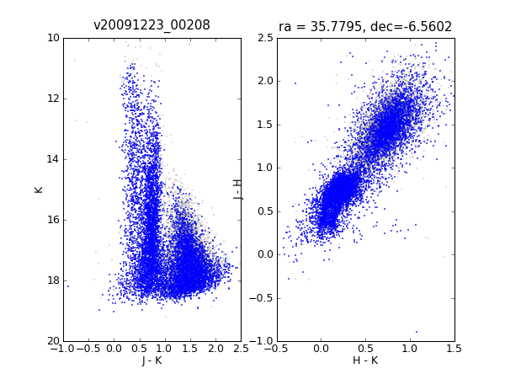
Figure 2(a): Version 1.0 data products showing QC problem with star-galaxy separation. Blue points are starlike objects; Grey points are non-stellar objects.

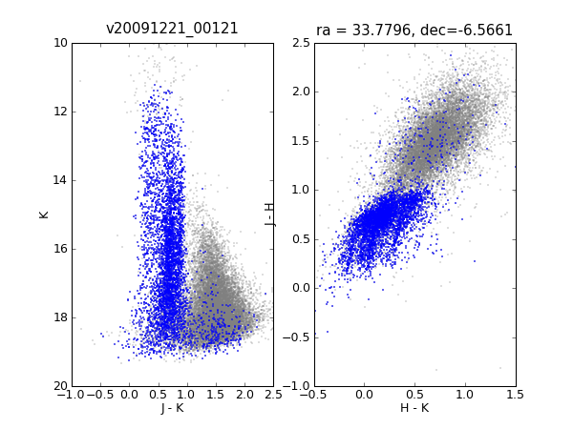
Figure 2(b): Version 1.0 data products showing QC problem with multiple offset stellar loci due to variable seeing causing spatially dependent aperture corrections in different pawprints. This is fixed via the grouting stage of the VDFS pipeline.

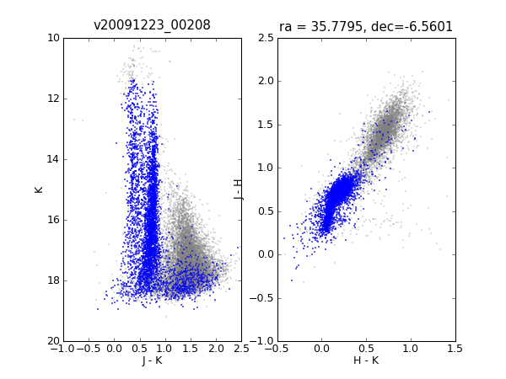
Figure 3(a): Version 1.1 data products for same observations as Figure 2(a) showing the improvement in star-galaxy separation for this OB. Blue points are starlike objects; Grey points are non-stellar objects

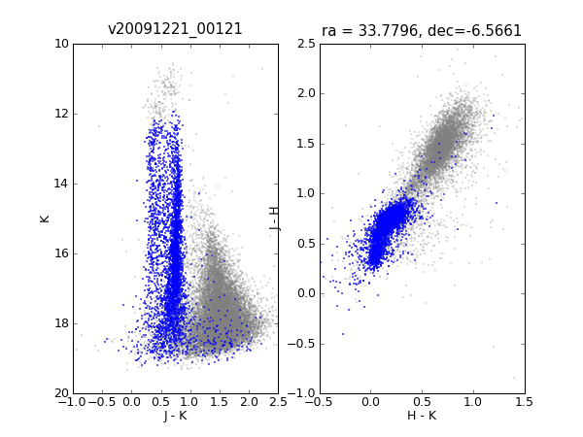
Figure 3(b):
Version 1.1 data products for same observations as Figure 2(b) showing how the pawprint based aperture correction process improved the photometry for a tile. A spatially dependent aperture corrections from different pawprints that contribute to each part of a tile. This is fixed via the grouting stage of the VDFS pipeline.

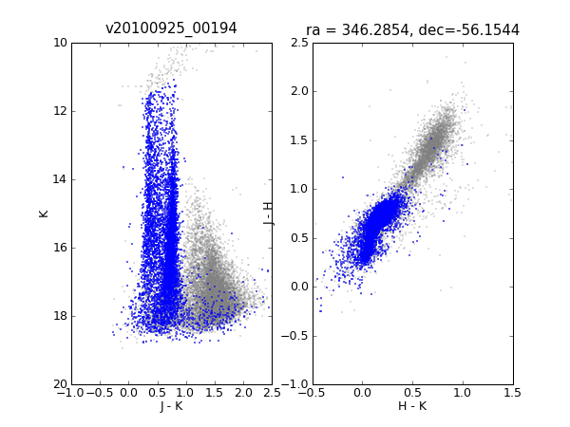
Figure 4(a): Version 1.1 data products for VHS final Period 85 OB acquired on 2010 Sep, 25th. Blue points are starlike objects; Grey points are non-stellar objects

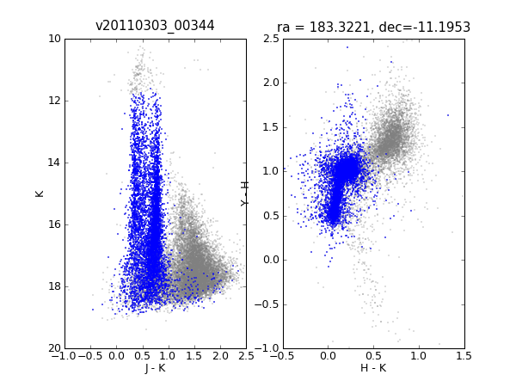
Figure 4(b): Version 1.1 data products for final VHS Period 86 OB acquired on 2011 March, 3rd; Note the right plot is H-K v Y-H whereas in other plots it is H-K v J-H

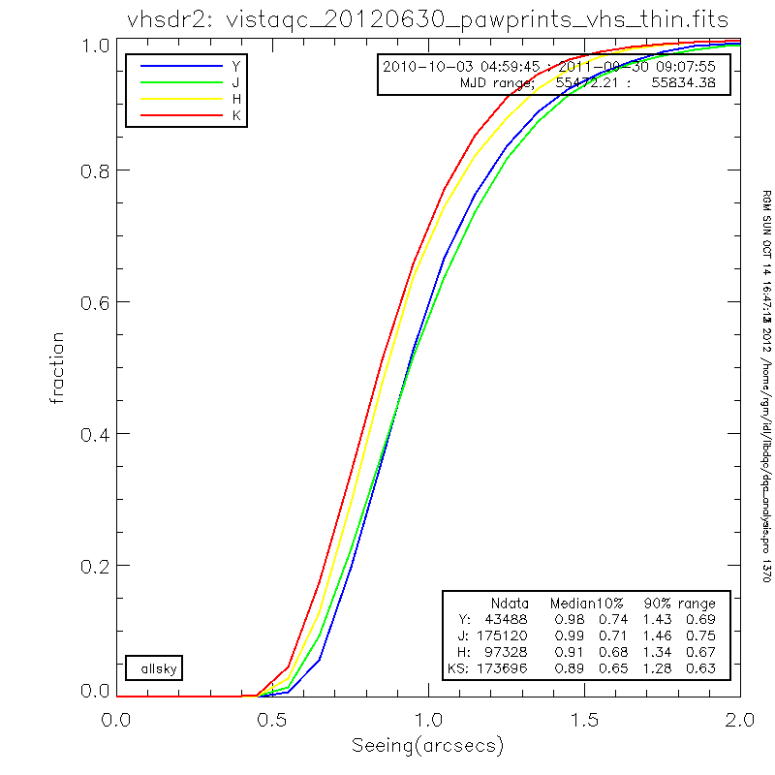
Figure 5a: Measured image seeing (stellar FWHM) on VHS pawprints observed during observing period 86 and 87 including rejected and repeated OBs.

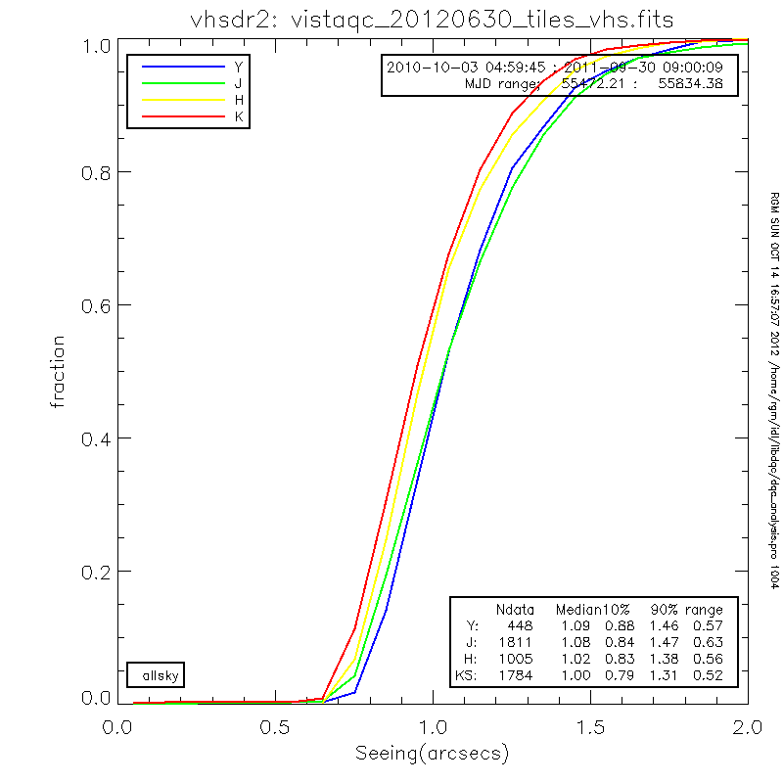
Figure 5b: Measured image seeing (stellar FWHM) on VHS tiles observed during ESO observing period 86 and 87 including rejected and repeated OBs.
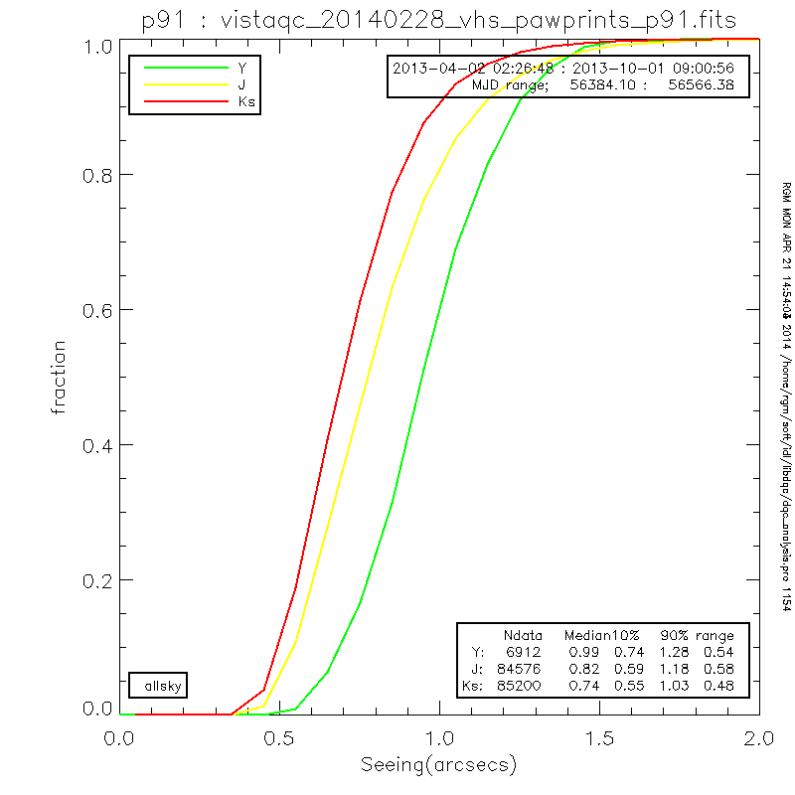
Figure 5c: Measured image seeing (stellar FWHM) on VHS pawprints observed during observing period 91 including rejected and repeated OBs.

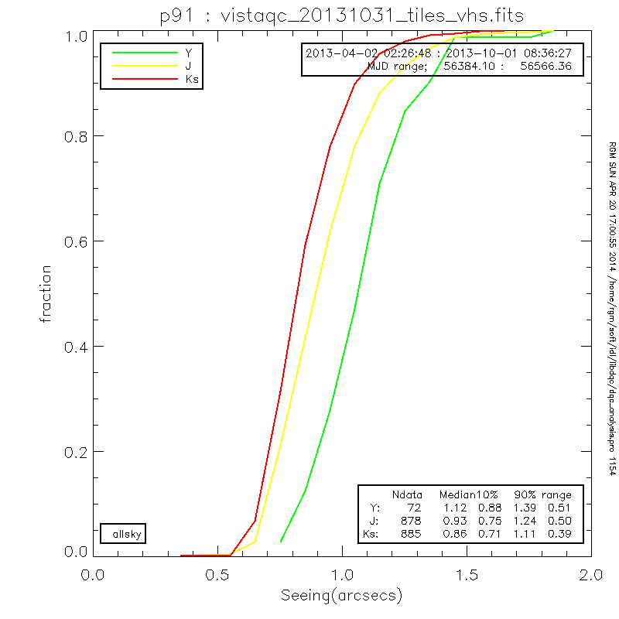
Figure 5d: Measured image seeing (stellar FWHM) on VHS tiles observed during observing period 91 including rejected and repeated OBs.

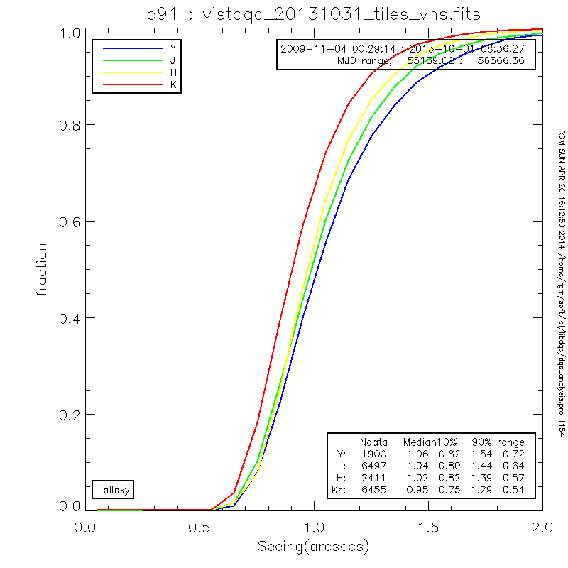
Figure 5e: Measured image seeing (stellar FWHM) on VHS tiles observed up to observing period 91 including rejected and repeated OBs.

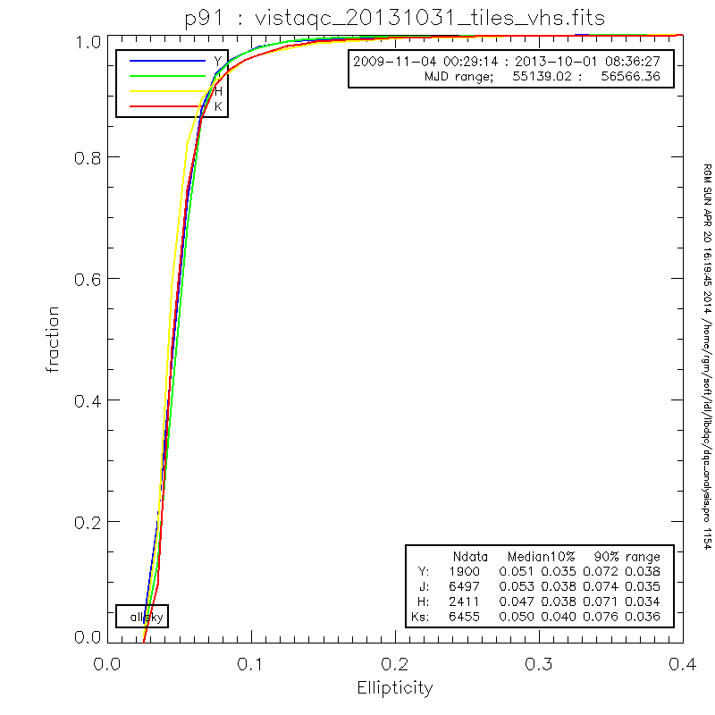
Figure 6: Measured stellar image ellipticity on all VHS tiles observed up to observing period 91 including rejected and repeated OBs.

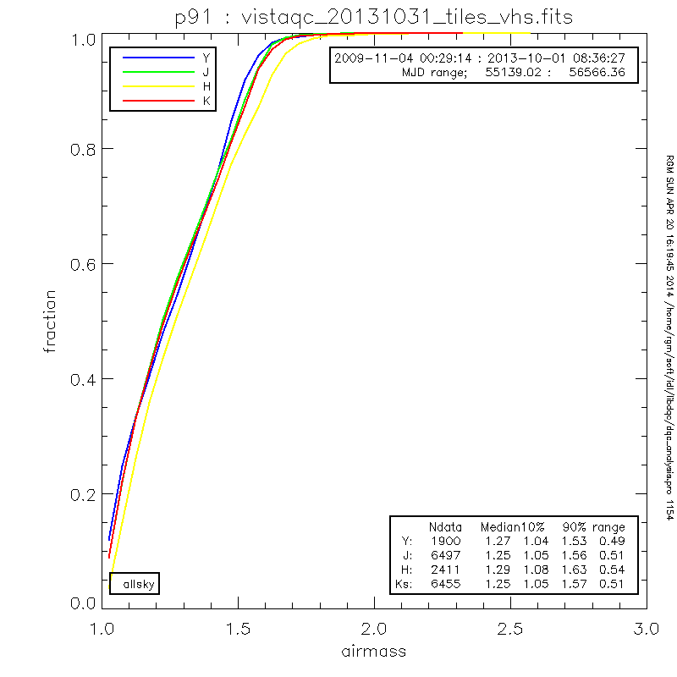
Figure 7: Airmass distribution for all VHS observations upto the end of Period 91 i.e. includes rejected and repeated OBs.
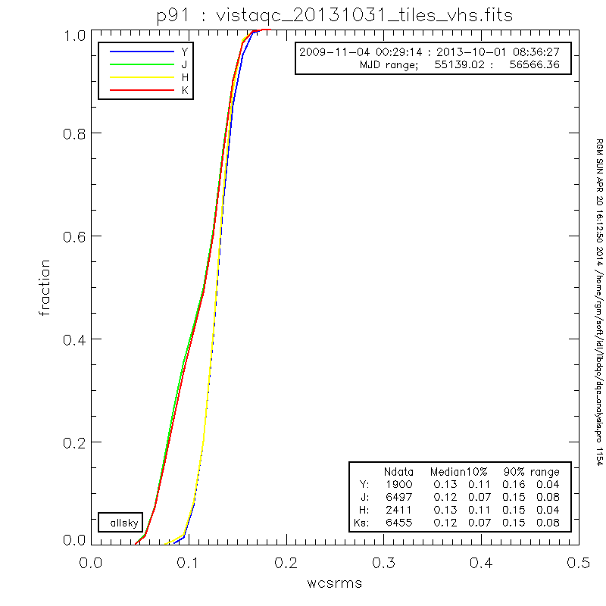
Figure 8: Distribution of the World Cooordinate System(WCS) rms astrometric errors for tiles. The J and K bands have a tail to smaller values compared to Y and H due to larger fraction of fields at low galactic latitude and hence more WCS 2MASS astrometric
calibration stars.

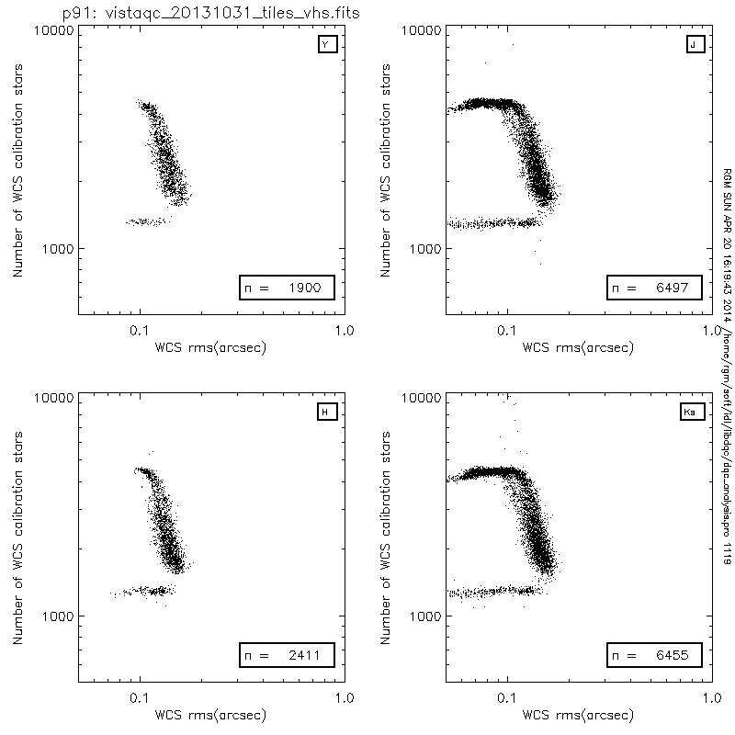
Figure 9: World Cooordinate System(WCS) rms astrometric errors versus number of 2MASS stars used for the WCS fits for tiles. This shows a correlation between the number of stars and the rms residual due expected minimisation. The upper plateau in the distribution in the J and K bands due to upper threshold in number of stars used for the fit which is only reached at low galactic latitude. The horizontal feature at around 1200 stars only appears for data from P84 and P85. This might reflect either a real effect in the released data or could be an issue with the casu DQC database. Data is for all observation up to and including Period 91

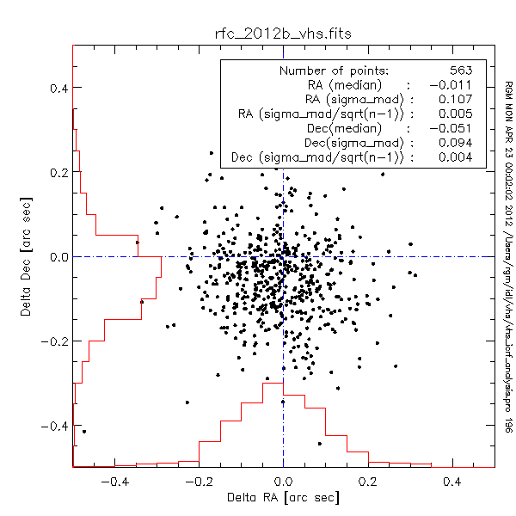
Figure 10: Comparison between VHS positions and the VLBI radio reference frame
(http://astrogeo.org/vlbi/solutions/rfc_2012b).

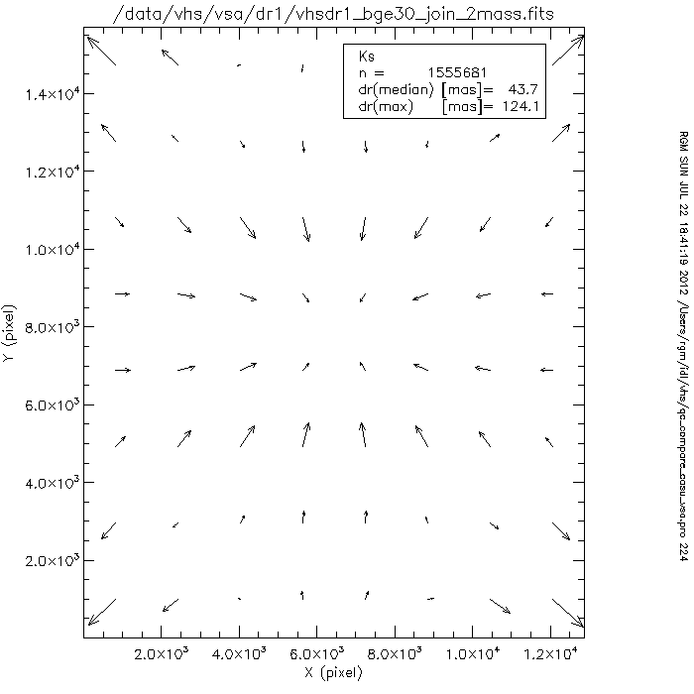
Figure 11: End to end analysis of Tile level analysis of systematics in astrometry from a comparison with stacked residuals from 2MASS stars. This systematic is due to a WCS bug that was fixed for tiles processed after 20120801.

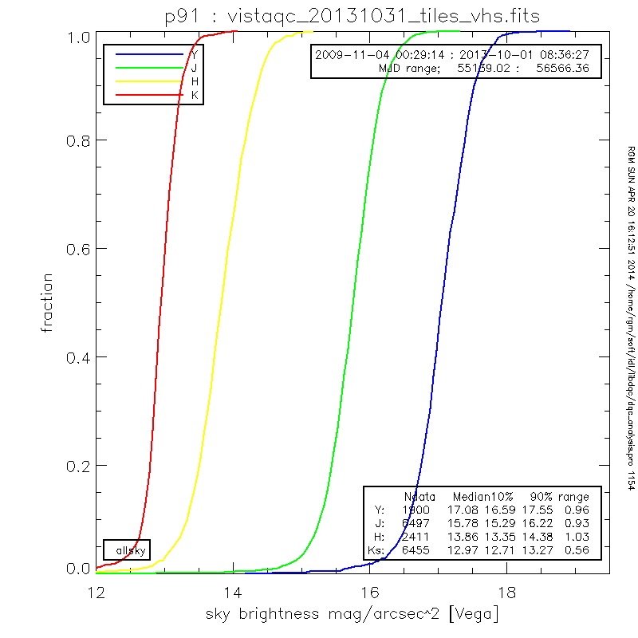
Figure 12: Measured sky brightness seeing on all VHS tiles up to and including period 91 observations. Note the tail to bright magnitudes that effects ~5% of observations. This is probable due to scattering of moonlight by thin cirrus. Note also the larger scatter in Y, J and H compared with K which is due to the variations in terrestrial airglow that dominates the background in these bands.

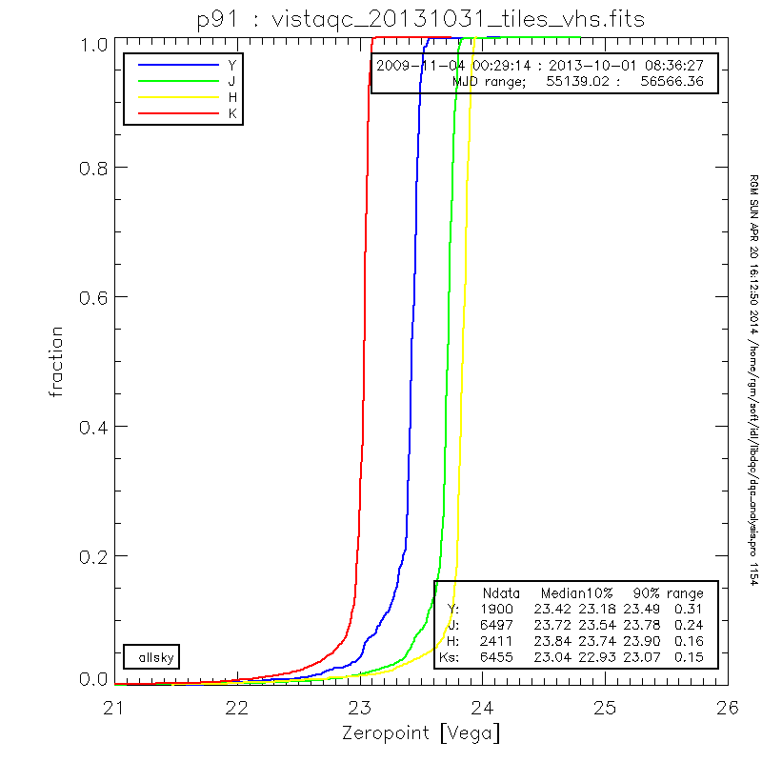
Figure 13: Measured zeropoint on tiles for all VHS observations up to and including Period 91. Note the tail to bright magnitude. 5-10% have attenuation >0.2magnitudes.

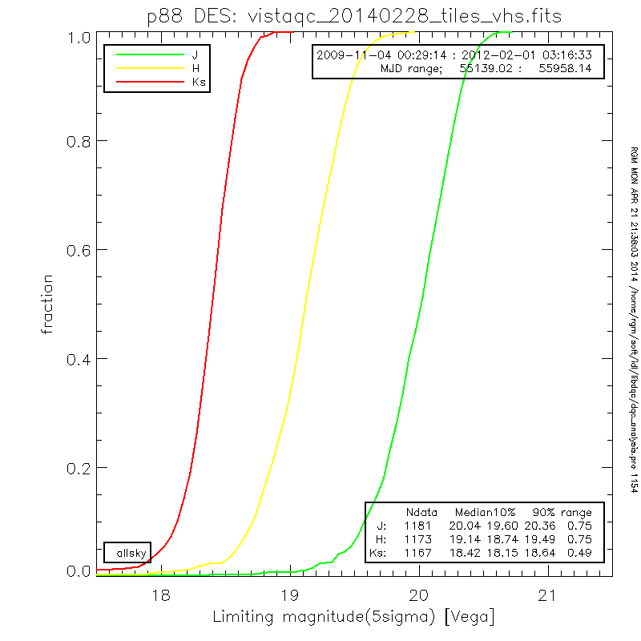
Figure 14(a): Limiting magnitudes for VHS DES component up to and including Period 88 (March 2012)

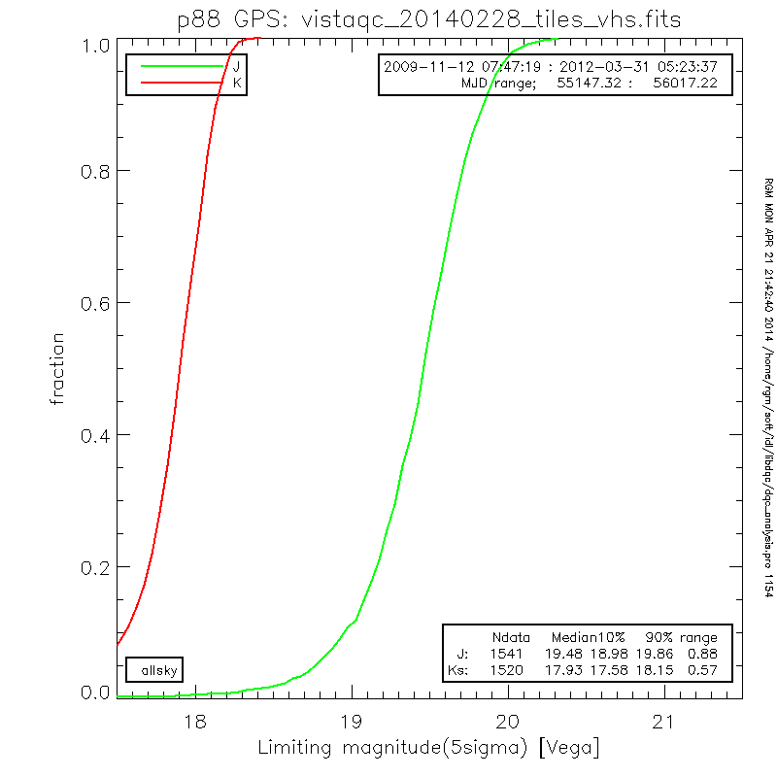
Figure 14(b): Limiting magnitudes for VHS GPS component up to and including Period 88 (March 2012)

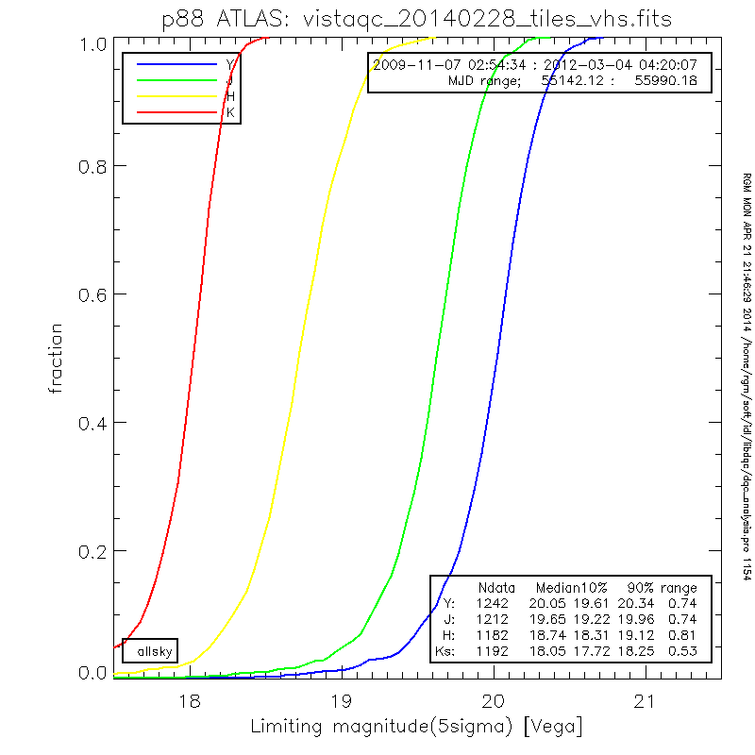
Figure 14c: Limiting magnitudes for VHS ATLAS component up to and including Period 88 (March 2012)

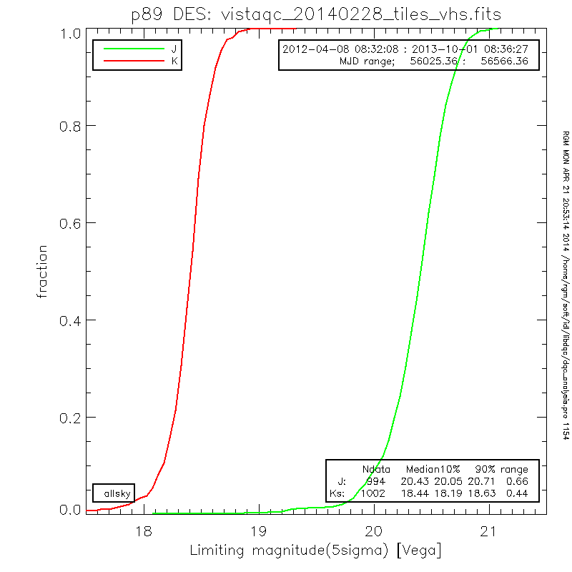
Figure 15(a): Limiting magnitudes for ESO Period 89-91 VHS DES component

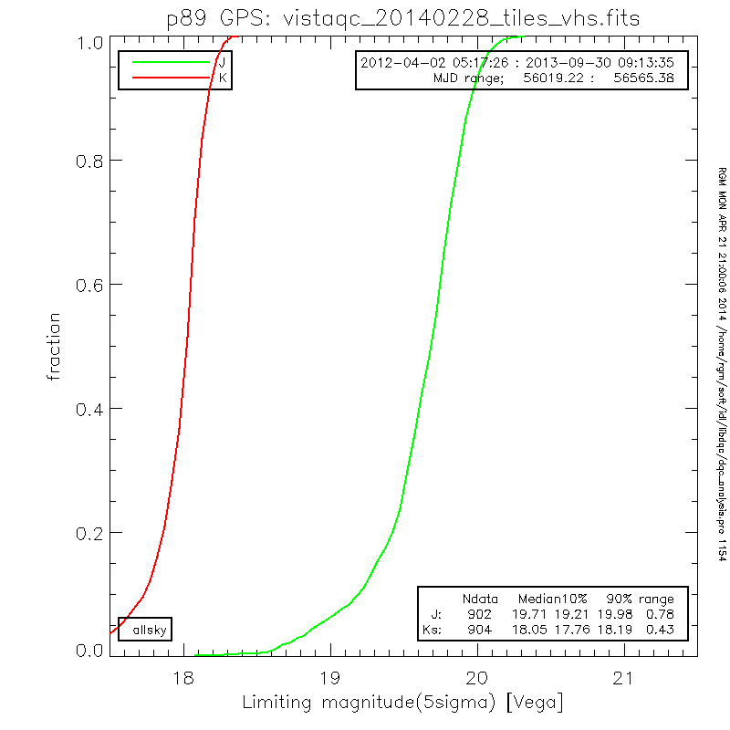
Figure 15(b): Limiting magnitudes for ESO Period 89-91 VHS GPS component

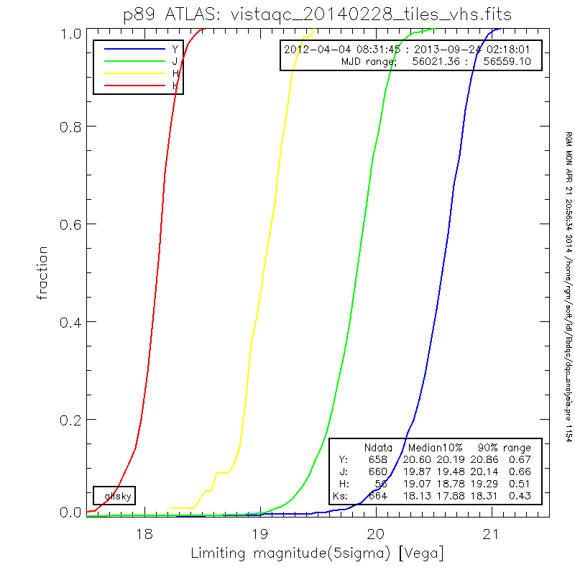
Figure 15c: Limiting magnitudes for ESO Period 89-91 VHS ATLAS component

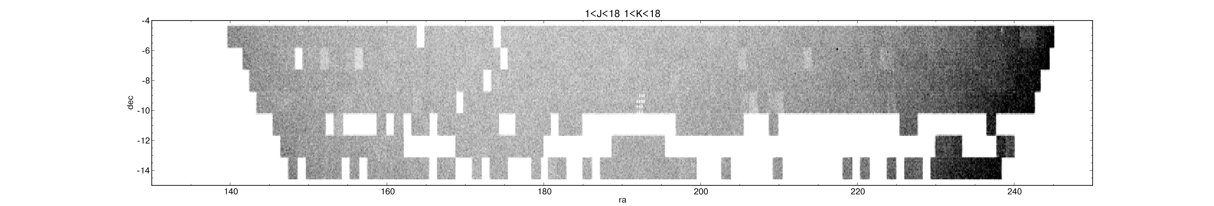
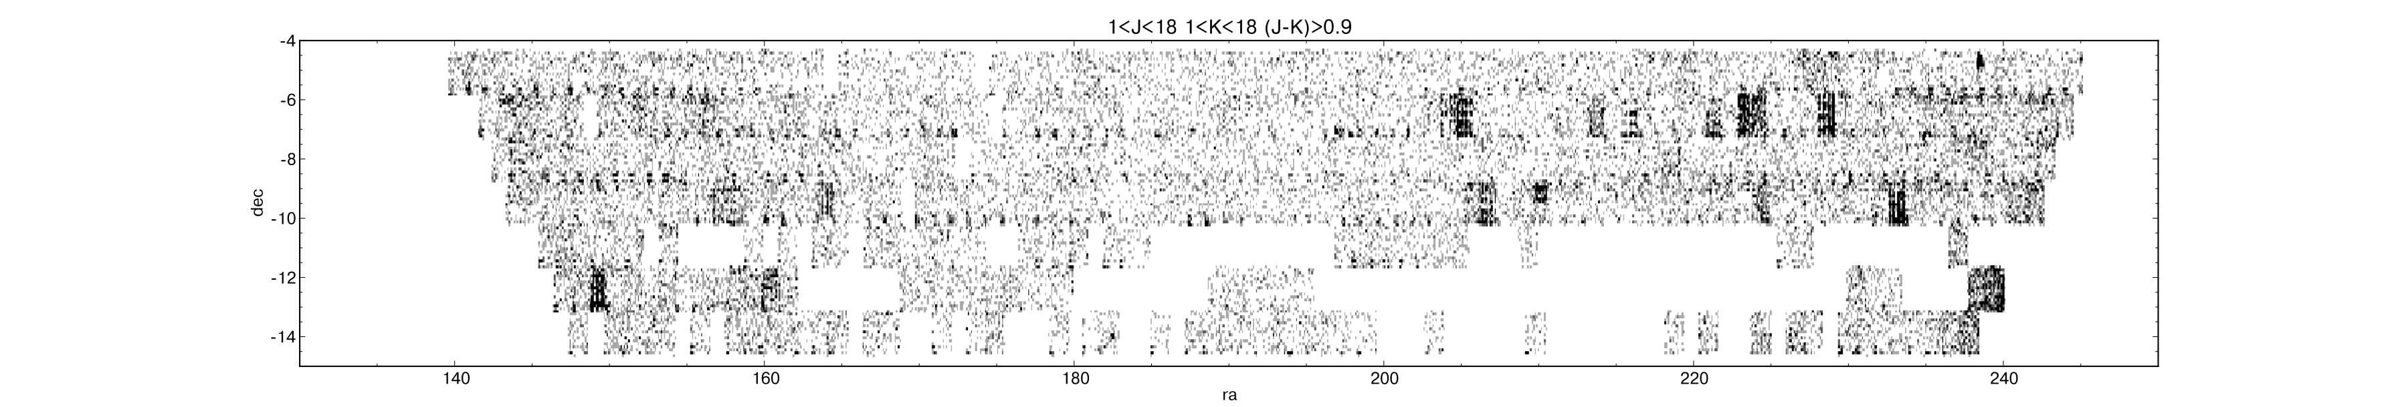
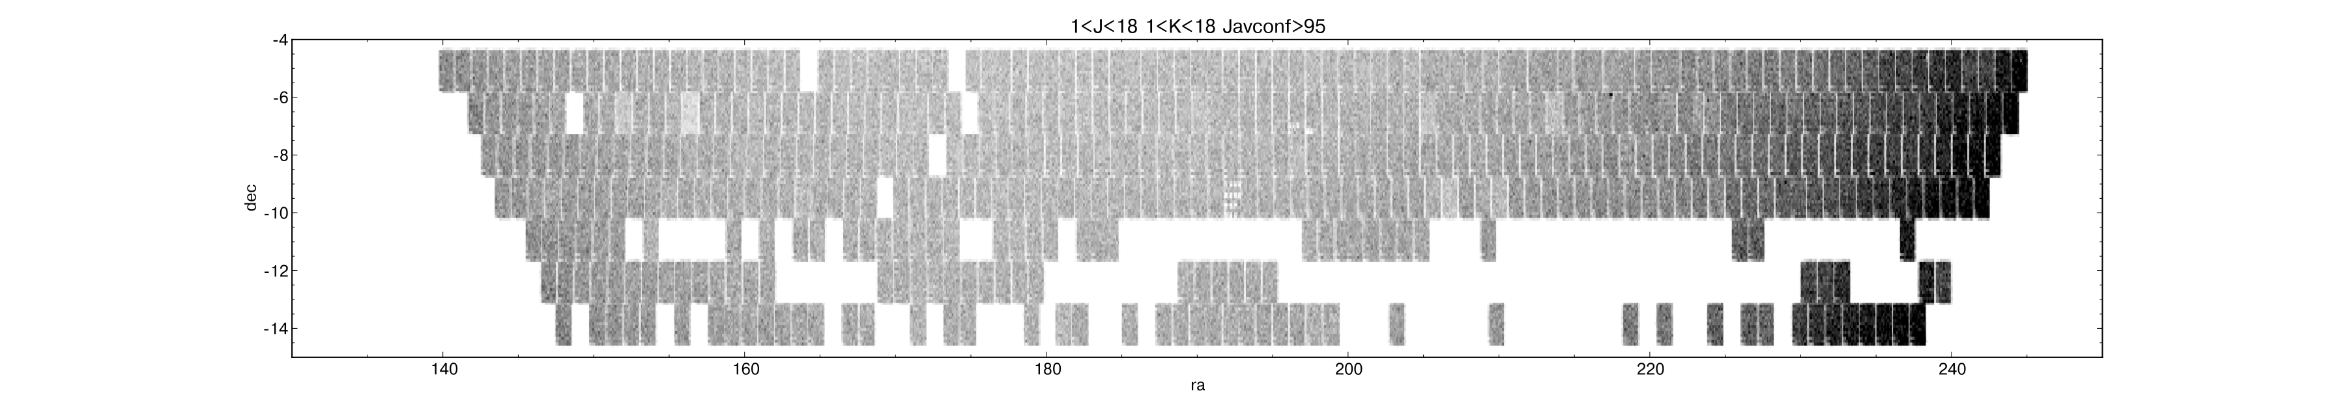
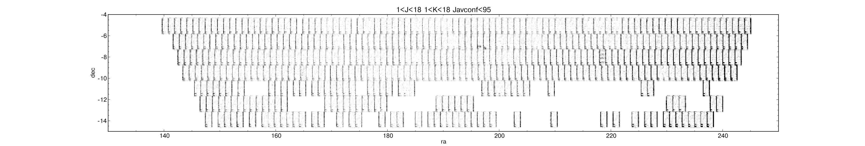
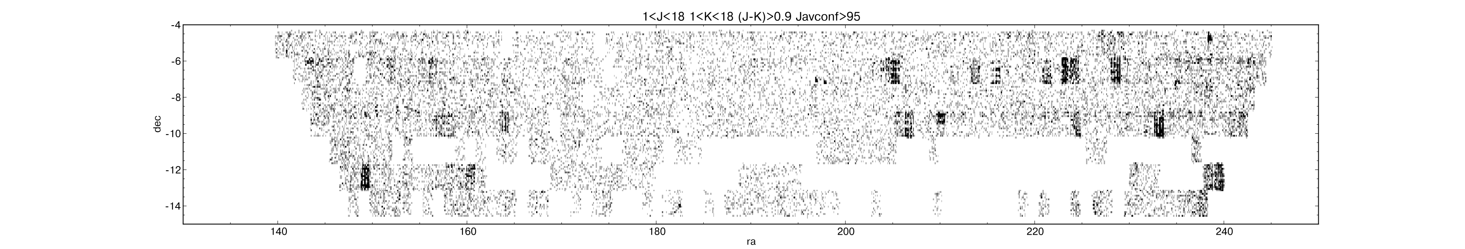
Figure 16: Spatial distribution of all objects classified as stars on J and K in the RA range 140 to 250 degrees and Declination -4 to -15. From top: All stars with J and K < 18; as above stars with J-K>0.9; All stars but with J band average confidence > 95%.;
All stars but with J band average confidence < 95%.; All stars with J and K < 18, J-K>0.9 and J band average confidence > 95%.

