# Lab 4. Task 1- preparation task Template for answers

**Save this document as a .pdf document before submitting.**

*Student names and LiU-IDs: (Max 2 students per group):*

*1. Richard Gotthard Ricgo595*

*2. Marcus Frankelius Marfr808*

*Submission date: 11 december 2020*

*Version (in case you need to re-submit):*

V1

1. **Hough transform**

**1)** H1:

**2)** Your guess:

Vi antar att linjerna är medurs roterade 65 grader från ursprungsposittionen.

**3)** What is the exact angle corresponding to the lines in $Image1a$?

65 grader bör göra linjerna vertikala

**4)** What is the angle of **clockwise** rotation to rotate $Image1a$ to the horizontal level? Use your answer from problem 3.

155 ger horisontella linjer (vi adderar 90 grader).

**5)** Image1a_rotated:

**6)** What is the exact angle corresponding to the straight lines in $Image1b$?

-75 grader får vi fram.

**7)** What is the angle of **counterclockwise** rotation to rotate $Image1b$ to horizontal level? Use your answer from problem 6.

15 grader får linjerna I horisontell linje.

**8)** Image1b_rotated:



**9)** Image1c with noise removed:

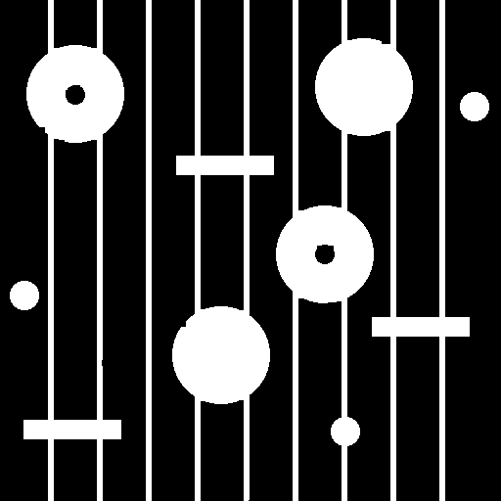

**10)** Image1c_clean (noise and lines removed):

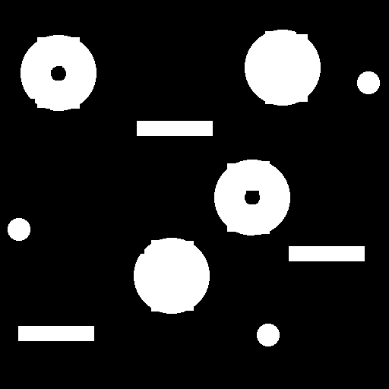

**11)** RGB-image displaying the 3 different classes of objects in different colors:

**12)** Your structuring element: SE = strel(…)

Segmented image with all the grains of rice:

**13)** Labeled image, L, scaled by max value:

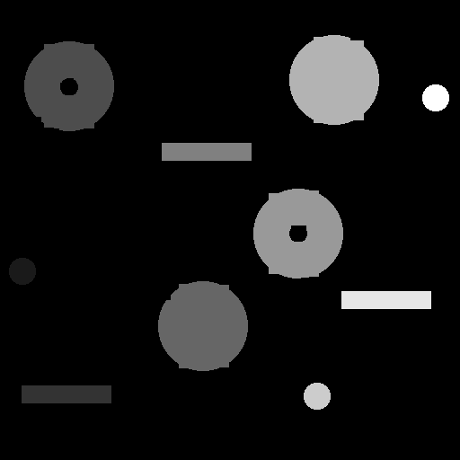

**14)** What are the perimeters for the large objects (having area > 3000 pixels)?

Image containing only the large objects:

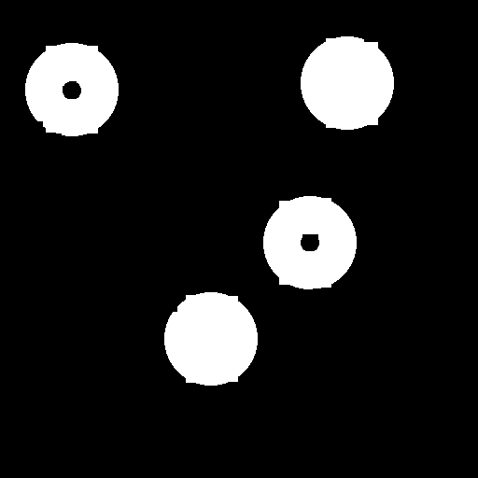

**15)** What is your selected threshold value?

What are the labels of the objects belonging to the class with the smallest perimeter?

Vi får tre objekt med en parameter under 150. Tre stycken mellan 200 och 300. Samt fyra som är över 300.

**16)** What are the labels of the objects belonging to the class with the largest perimeter, and that has no holes?

Image containing only objects having the largest perimeter, without holes:

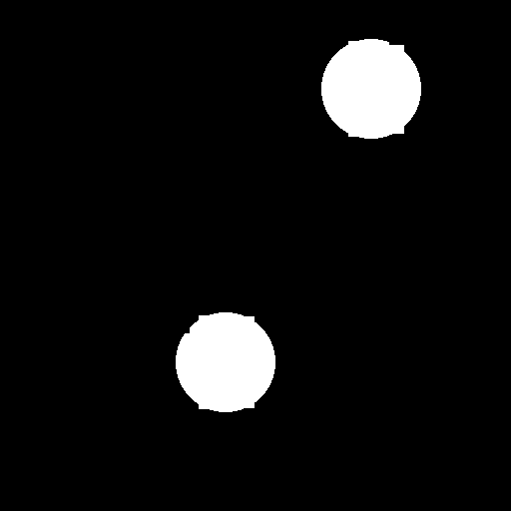

*Don’t forget to save the document as* ***.pdf*** *before submitting!*