1. **Preparing dataset.**

**Step 1:**

**Create a new database bookproject1472935 and use it.**

**Command:**

Create database bookproject1472935;

Use bookproject1472935;

**Screenshot:**

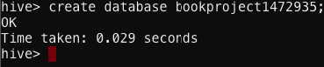

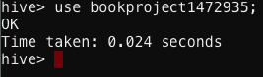

**Step 2:**

**Creating a table and loading to the database just created. (BX-Books.csv)**

**Command:**

CREATE TABLE books1472935 (ISBN STRING, Title STRING, Author STRING, Year_of_Pub STRING, Publisher STRING, Image_URL_S STRING, Image_URL_M STRING, Image_URL_L STRING ) ROW FORMAT SERDE 'org.apache.hadoop.hive.serde2.OpenCSVSerde'

WITH SERDEPROPERTIES (

"separatorChar" = "\;",

"quoteChar" = '\"')

STORED AS TEXTFILE TBLPROPERTIES("skip.header.line.count"="1");

LOAD DATA LOCAL INPATH '/mnt/home/edureka_1472935/Book_Project_Dataset/BX-Books.csv' OVERWRITE INTO TABLE books1472935;

**Screenshot:**

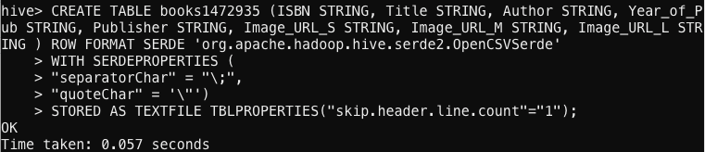

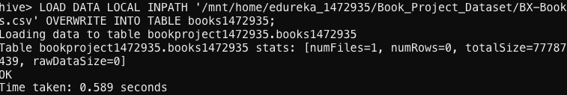

**Step 3:**

**Creating a table and loading to the database just created. (BX-Book-Ratings.csv)**

**Command:**

CREATE TABLE bookratings1472935 (UserID STRING, ISBN STRING, BookRating STRING)

ROW FORMAT SERDE 'org.apache.hadoop.hive.serde2.OpenCSVSerde'

WITH SERDEPROPERTIES (

"separatorChar" = "\;",

"quoteChar" = '\"'

) STORED AS TEXTFILE TBLPROPERTIES("skip.header.line.count"="1");

LOAD DATA LOCAL INPATH '/mnt/home/edureka_1472935/Book_Project_Dataset/BX-Book-Ratings.csv' OVERWRITE INTO TABLE bookratings1472935;

**Screenshots:**

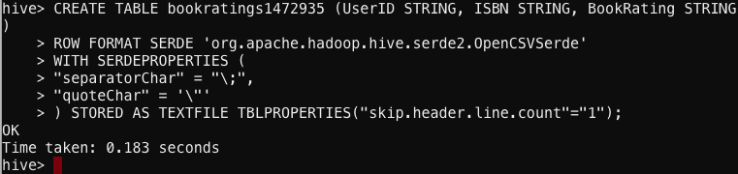

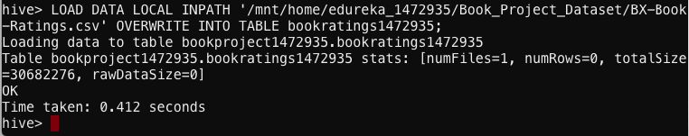

**Solutions for the problem statements:**

1. **A. Find out the frequency of books published each year. (Hint: Use Boooks.csv file for this)**

**Command:**

SELECT Year_of_Pub, count(*) FROM books1472935

GROUP BY Year_of_Pub ORDER BY cast(Year_of_Pub as BIGINT);

**Screenshot:**

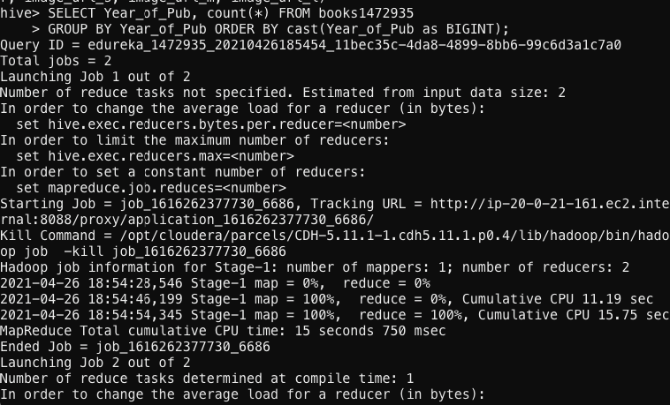

**Results:**

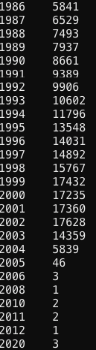

1. **B. Find out in which year maximum number of books were published**

**Command:**

SELECT Year_of_Pub, count(*) as A

FROM books1472935

GROUP BY Year_of_Pub

ORDER BY A DESC

limit 1;

**Screenshot:**

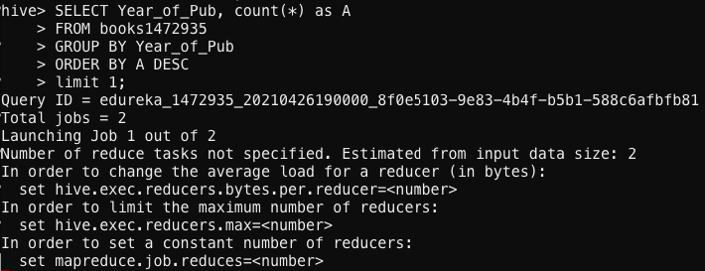

**Results:**

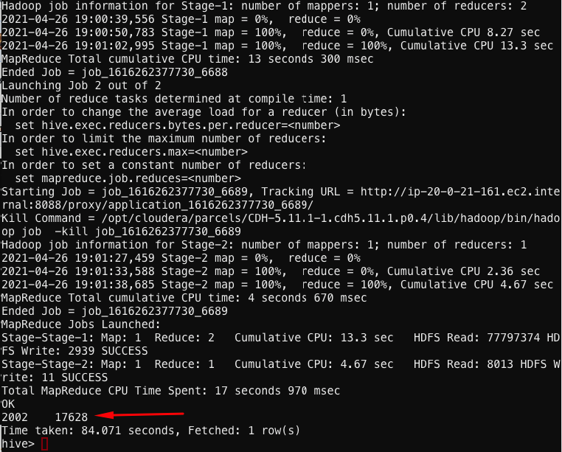

1. **C. Find out how many books were published based on ranking in the year 2002. ( Hint: Use Book.csv and Book-Ratings.csv)**

**Command:**

SELECT count(*) from books1472935

JOIN bookratings1472935 on books1472935.ISBN= bookratings1472935.ISBN

WHERE BookRating ='10' and Year_of_Pub='2002'

GROUP BY Year_of_Pub;

**Screenshots:**

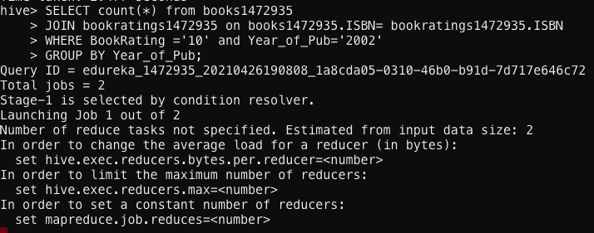

**Results:**

