1. **A. Count number of countries based on landmass.**

**Command:**

country_data = LOAD 'flag.data_dataset.txt' USING PigStorage(',') as (name:chararray, landmass:int, zone:int, area:chararray, population:chararray, lang:int, rel:int, bar:int, stripes:int, col:int, red:int, green:int, blue:int, gold:int, white:int, black:int, orange:int, hue:chararray, circle:int, cross:int, saltire:int, quars:int, suns:int, cres:int, triangle:int, icon:int, animate:int, text:int, left:chararray, right:chararray); grouped_data = GROUP country_data by landmass; count_data = FOREACH grouped_data GENERATE group,COUNT(country_data); DUMP count_data;

**Screenshot:**



**Results:**

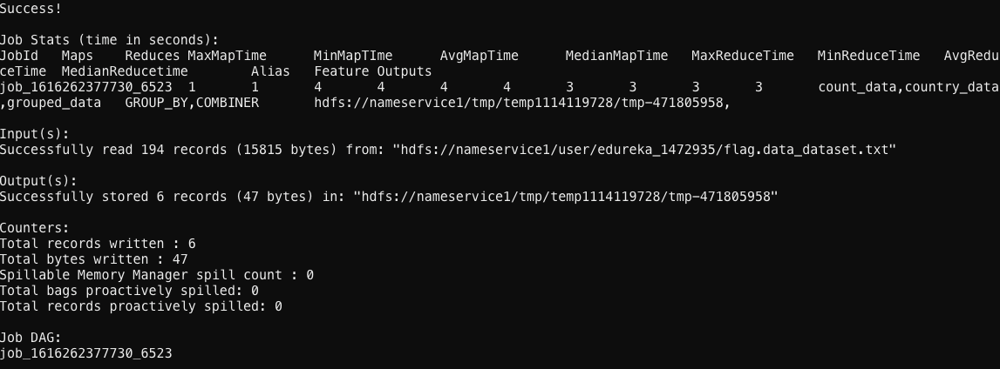

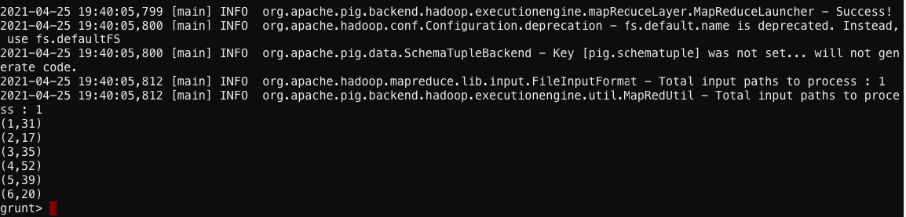

1. **B. Find out top 5 country with Sum of bars and strips in a flag.**

**Command:**

country_data = LOAD 'flag.data_dataset.txt' USING PigStorage(',') as (name:chararray, landmass:int, zone:int, area:chararray, population:chararray, lang:int, rel:int, bar:int, stripes:int, col:int, red:int, green:int, blue:int, gold:int, white:int, black:int, orange:int, hue:chararray, circle:int, cross:int, saltire:int, quars:int, suns:int, cres:int, triangle:int, icon:int, animate:int, text:int, left:chararray, right:chararray); foreach_data = FOREACH country_data GENERATE name,$7+$8; grouped_data = GROUP foreach_data All; bar_data = FOREACH grouped_data {

ord = ORDER foreach_data BY $1 DESC; top = LIMIT ord 5;

GENERATE FLATTEN(top);};

DUMP bar_data;

**Screenshot:**

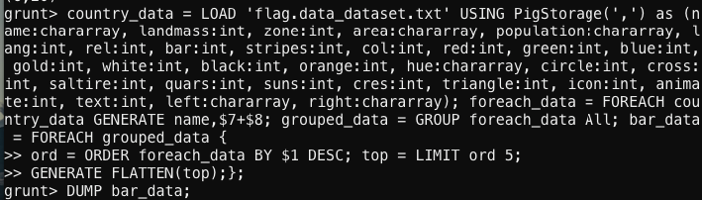

**Results:**

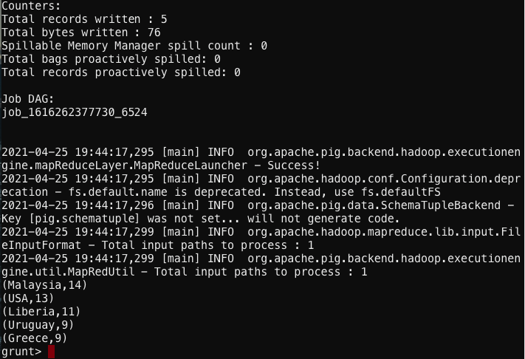

1. **C. Count of countries with icon.**

**Command:**

country_data = LOAD 'flag.data_dataset.txt' USING PigStorage(',') as (name:chararray, landmass:int, zone:int, area:chararray, population:chararray, lang:int, rel:int, bar:int, stripes:int, col:int, red:int, green:int, blue:int, gold:int, white:int, black:int, orange:int, hue:chararray, circle:int, cross:int, saltire:int, quars:int, suns:int, cres:int, triangle:int, icon:int, animate:int, text:int, left:chararray, right:chararray);

filtered_icon_data = FILTER country_data BY icon == 1;

grouped_icon_data = GROUP filtered_icon_data BY icon;

count_icon_data = FOREACH grouped_icon_data GENERATE group, COUNT(filtered_icon_data);

DUMP count_icon_data;

**Screenshots:**

**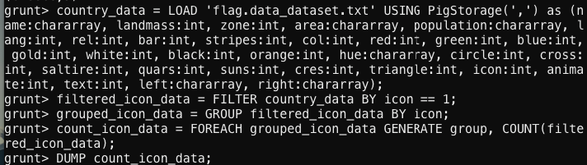  
Results:**

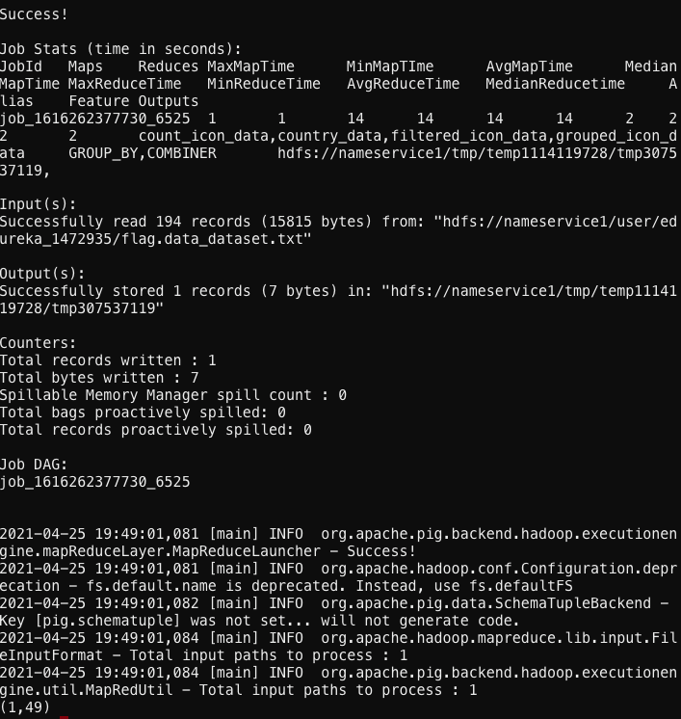

1. **D. Count of countries which have same top left and top right color in flag.**

**Command:**

country_data = LOAD 'flag.data_dataset.txt' USING PigStorage(',') as (name:chararray, landmass:int, zone:int, area:chararray, population:chararray, lang:int, rel:int, bar:int, stripes:int, col:int, red:int, green:int, blue:int, gold:int, white:int, black:int, orange:int, hue:chararray, circle:int, cross:int, saltire:int, quars:int, suns:int, cres:int, triangle:int, icon:int, animate:int, text:int, left:chararray, right:chararray);

filtered_flag_data = FILTER country_data BY $28 == $29;

grouped_flag_data = GROUP filtered_flag_data All;

count_flag_data = FOREACH grouped_flag_data GENERATE group, COUNT(filtered_flag_data);

DUMP count_flag_data;

**Screenshots:**

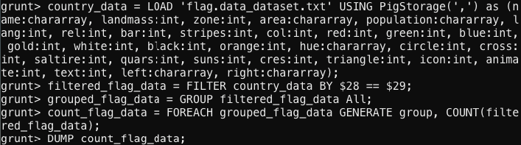

**Results:**

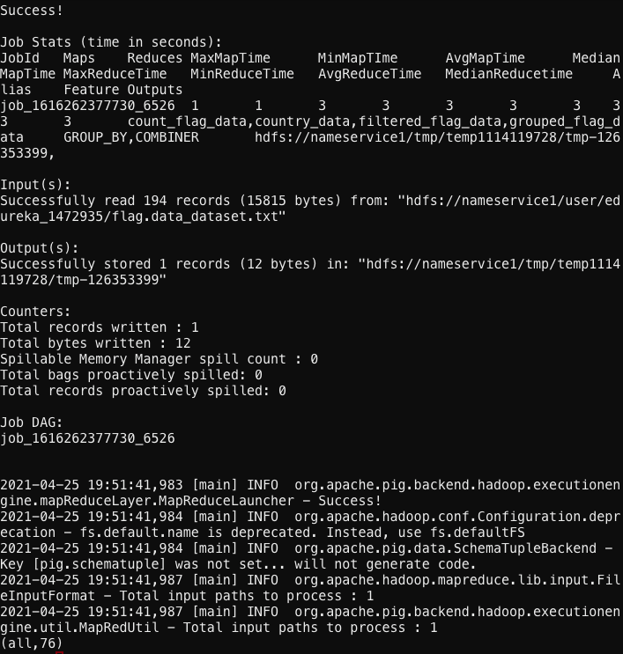

1. **E. Count number of countries based on zone.**

**Command:**

country_data = LOAD 'flag.data_dataset.txt' USING PigStorage(',') as (name:chararray, landmass:int, zone:int, area:chararray, population:chararray, lang:int, rel:int, bar:int, stripes:int, col:int, red:int, green:int, blue:int, gold:int, white:int, black:int, orange:int, hue:chararray, circle:int, cross:int, saltire:int, quars:int, suns:int, cres:int, triangle:int, icon:int, animate:int, text:int, left:chararray, right:chararray);

grouped_zone_data = GROUP country_data by landmass;

count_zone_data = FOREACH grouped_zone_data GENERATE group,COUNT(country_data);

DUMP count_zone_data;

**Screenshot:**

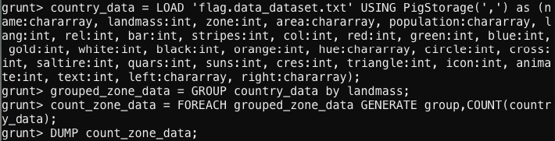

**Results:**

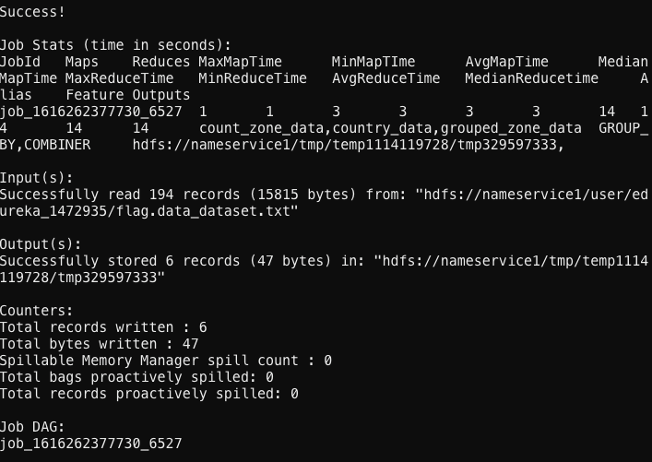

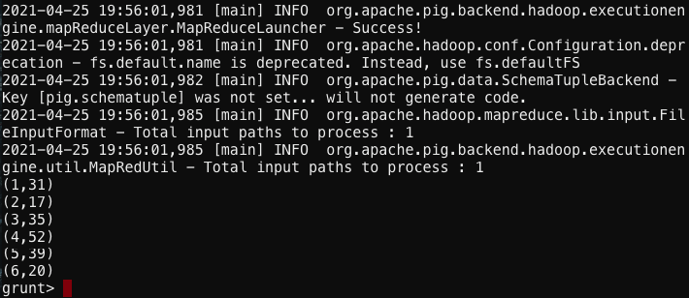

1. **F. Find out largest county in terms of area in NE zone.**

**Command:**

country_data = LOAD 'flag.data_dataset.txt' USING PigStorage(',') as (name:chararray, landmass:int, zone:int, area:int, population:chararray, lang:int, rel:int, bar:int, stripes:int, col:int, red:int, green:int, blue:int, gold:int, white:int, black:int, orange:int, hue:chararray, circle:int, cross:int, saltire:int, quars:int, suns:int, cres:int, triangle:int, icon:int, animate:int, text:int, left:chararray, right:chararray);

filtered_NE_data = FILTER country_data BY zone == 1;

grouped_NE_data = GROUP filtered_NE_data All;

max_area_data = FOREACH grouped_NE_data {

ord = ORDER filtered_NE_data BY $3 DESC;

top = LIMIT ord 1;

GENERATE FLATTEN(top); };

max_area_country = FOREACH max_area_data GENERATE name,area;

DUMP max_area_country;

**Screenshot:**

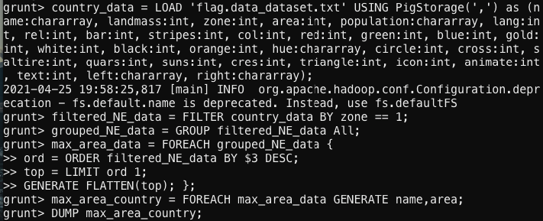

**Results:**

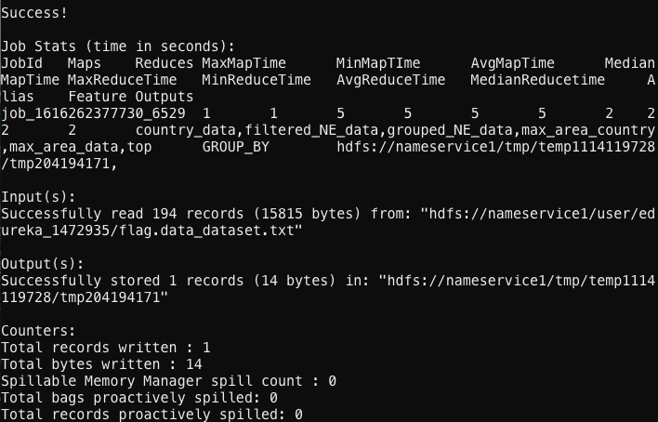

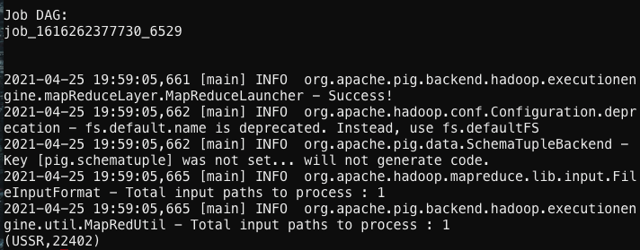

1. **G. Find out least populated country in S. America landmass.**

**Command:**

country_data = LOAD 'flag.data_dataset.txt' USING PigStorage(',') as (name:chararray, landmass:int, zone:int, area:int, population:chararray, lang:int, rel:int, bar:int, stripes:int, col:int, red:int, green:int, blue:int, gold:int, white:int, black:int, orange:int, hue:chararray, circle:int, cross:int, saltire:int, quars:int, suns:int, cres:int, triangle:int, icon:int, animate:int, text:int, left:chararray, right:chararray);

filtered_SA_data = FILTER country_data BY landmass == 2;

grouped_SA_data = GROUP filtered_SA_data All;

min_population_data = FOREACH grouped_SA_data {

ord = ORDER filtered_SA_data BY $4 ASC;

top = LIMIT ord 1;

GENERATE FLATTEN(top); };

min_population_country = FOREACH min_population_data GENERATE name,population;

DUMP min_population_country;

**Screenshot:**

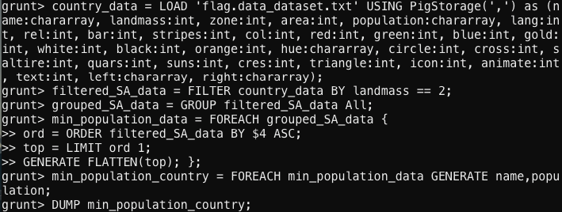

**Results:**

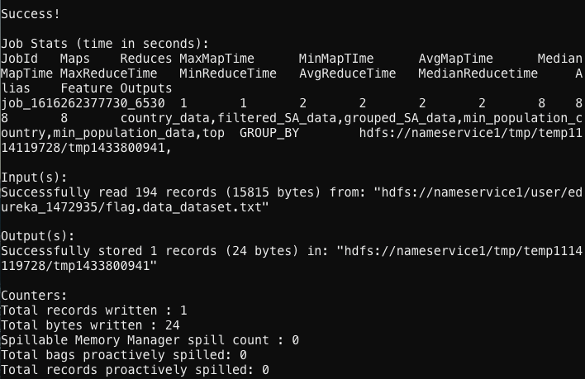

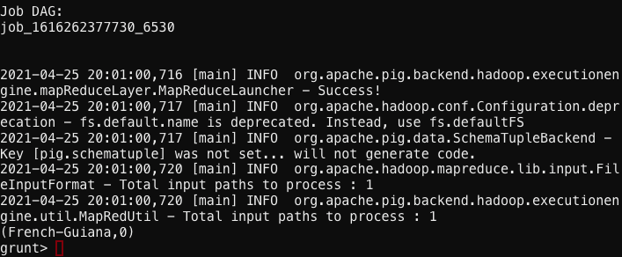

1. **H. Find out largest speaking language among all countries.**

**Command:**

country_data = LOAD 'flag.data_dataset.txt' USING PigStorage(',') as (name:chararray, landmass:int, zone:int, area:chararray, population:chararray, lang:int, rel:int, bar:int, stripes:int, col:int, red:int, green:int, blue:int, gold:int, white:int, black:int, orange:int, hue:chararray, circle:int, cross:int, saltire:int, quars:int, suns:int, cres:int, triangle:int, icon:int, animate:int, text:int, left:chararray, right:chararray);

foreach_data = FOREACH country_data GENERATE name,lang;

grouped_data = GROUP foreach_data BY lang;

count_data = FOREACH grouped_data GENERATE group,(int)COUNT(foreach_data);

grouped_count_data = GROUP count_data All;

max_lang_data = FOREACH grouped_count_data {

ord = ORDER count_data BY $1 DESC;

top = LIMIT ord 1;

GENERATE FLATTEN(top); };

DUMP max_lang_data;

**Screenshot:**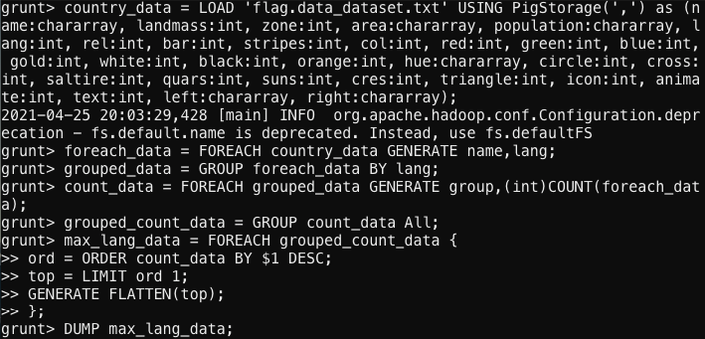

**Results:**

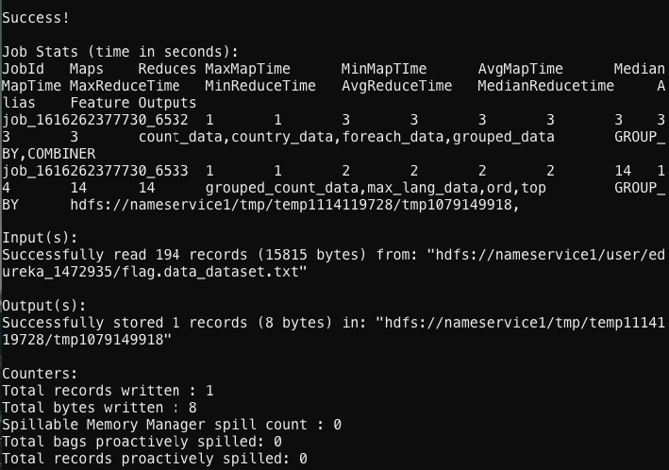

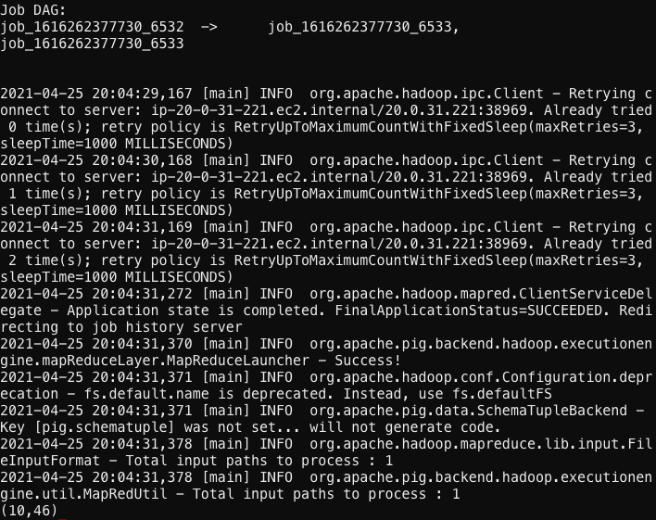

1. **I. Find most common colour among flags from all countries.**

**Command:**

country_data = LOAD 'flag.data_dataset.txt' USING PigStorage(',') as (name:chararray, landmass:int, zone:int, area:chararray, population:chararray, lang:chararray, rel:int, bar:int, stripes:int, col:int, red:int, green:int, blue:int, gold:int, white:int, black:int, orange:int, hue:chararray, circle:int, cross:int, saltire:int, quars:int, suns:int, cres:int, triangle:int, icon:int, animate:int, text:int, left:chararray, right:chararray);

grouped_data = GROUP country_data All;

final_color_data = FOREACH grouped_data GENERATE group,SUM(country_data.$10),SUM(country_data.$11),SUM(country_data.$12),SUM(country_data.$13),SUM(country_data.$14),SUM(country_data.$15),SUM(country_data.$16);

dump final_color_data;

**Screenshot:**

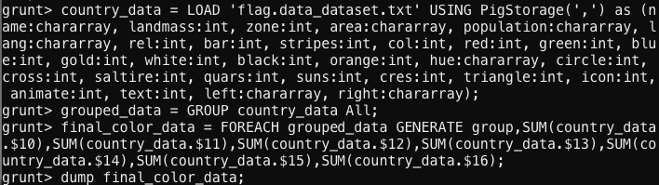

**Results:** 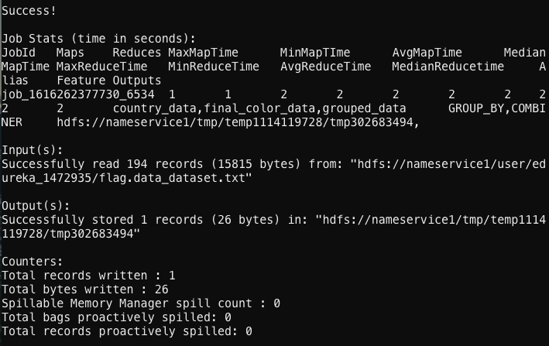

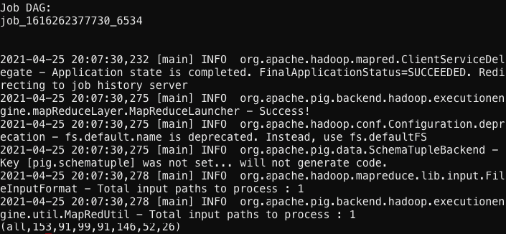

1. **J. Sum of all circles present in all country flags.**

**Command:**

country_data = LOAD 'flag.data_dataset.txt' USING PigStorage(',') as (name:chararray, landmass:int, zone:int, area:chararray, population:chararray, lang:chararray, rel:int, bar:int, stripes:int, col:int, red:int, green:int, blue:int, gold:int, white:int, black:int, orange:int, hue:chararray, circle:int, cross:int, saltire:int, quars:int, suns:int, cres:int, triangle:int, icon:int, animate:int, text:int, left:chararray, right:chararray);

grouped_circle_data = GROUP country_data All;

sum_circle = FOREACH grouped_circle_data GENERATE group,SUM(country_data.circle);

dump sum_circle;

**Screenshot:**

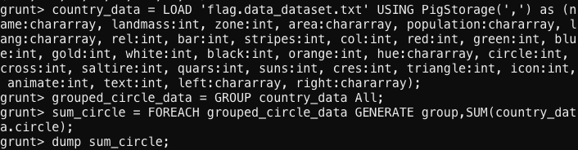

**Results:**

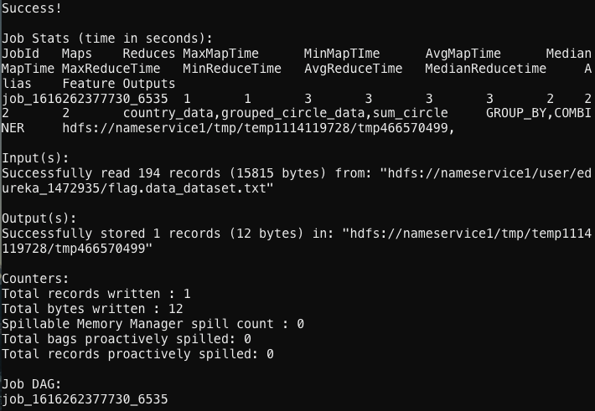

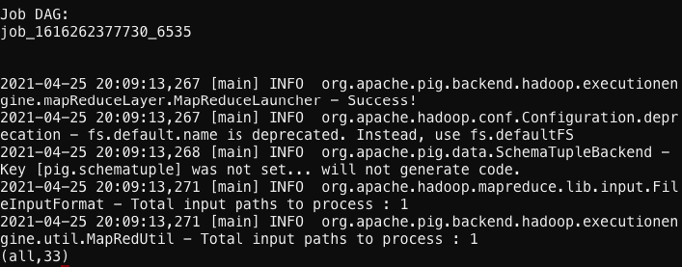

1. **K. Count of countries which have both icon and text in flag.**

**Command:**

country_data = LOAD 'flag.data_dataset.txt' USING PigStorage(',') as (name:chararray, landmass:int, zone:int, area:chararray, population:chararray, lang:int, rel:int, bar:int, stripes:int, col:int, red:int, green:int, blue:int, gold:int, white:int, black:int, orange:int, hue:chararray, circle:int, cross:int, saltire:int, quars:int, suns:int, cres:int, triangle:int, icon:int, animate:int, text:int, left:chararray, right:chararray);

filtered_country_data = FILTER country_data BY ($25 == 1) AND ($27 == 1);

grouped_text_data = GROUP filtered_country_data All;

count_text_data = FOREACH grouped_text_data GENERATE group, COUNT(filtered_country_data);

DUMP count_text_data;

**Screenshot:**

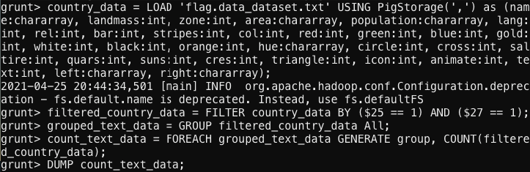

**Results:**



