**Hadoop Airlines Analysis Project with using HIVE**

**Step 1:**

**Creating the new airport table for airports_mod.dat dataset.**

**Command:**

**Create table airport (Airport_ID string, Name string, City string, Country string, IATA_FAA string, ICAO string, Latitude string, Longitude string, Altitude string, Timezone string, DST string, TZ string) row format delimited fields terminated by ‘,’;**

**Screenshot:**

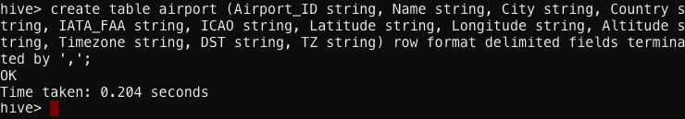

**Step 2:**

**Creating the new final airlines table for Final_airlines dataset.**

**Command:**

**Create table finalairlines(Airline string, Name string, Alias string, IATA string, ICAO string, Callsign string, Country string, Active String) row format delimited fields terminated by ‘,’;**

**Screenshot:**

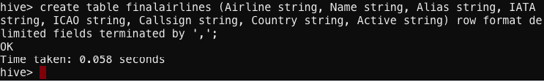

**Step 3:**

**Creating the new route table for routes.dat dataset.**

**Command:**

**Create table route (Airline string, Airline_ID string, Source_Airport string, Source_Airport_ID string, Destination_airport string, Destination_Airport_ID string, Codeshare string, Stops string, Equipment string) row format delimited fields terminated by ‘,’;**

**Screenshot:**

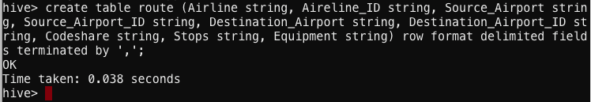

**Step 4:**

**Loading the dataset into airport table.**

**Command:**

**load data local inpath '/mnt/home/edureka_1472935/Airlines_Analysis_Project/airport/airports_mod.dat’ overwrite into table airport;**

**Screenshot:**



**Step 5:**

**Loading the dataset into finalairlines table.**

**Command:**

**load data local inpath '/mnt/home/edureka_1472935/Airlines_Analysis_Project/final_airline/Final_airlines' overwrite into table finalairlines;**

**Screenshot:**

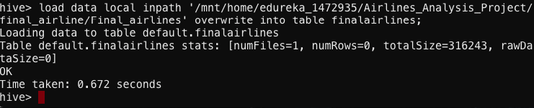

**Step 6:**

**Loading the dataset into route table.**

**Command:**

**load data local inpath '/mnt/home/edureka_1472935/Airlines_Analysis_Project/routes/routes.dat' overwrite into table route;**

**Screenshot:**

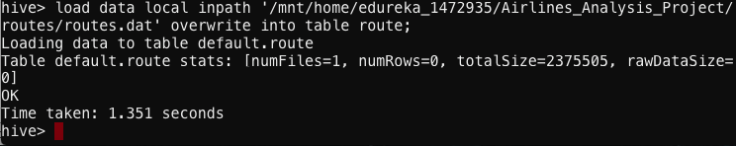

**Solutions:**

**A.Find list of Airports operating in the Country India**

**Command:**

**create table india_airport122 as select * from airport where Country LIKE '%India%';**

**Screenshot:**

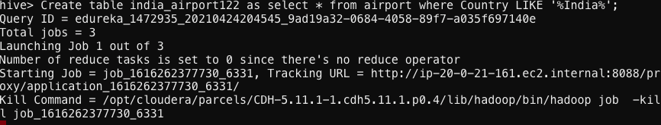

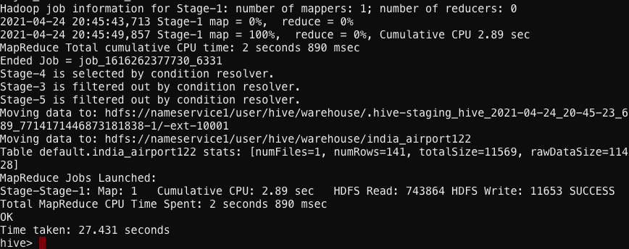

**Command:**

**Select * from india_airport122 limit 10; (to show the first 10 observation since we have a big dataset.)**

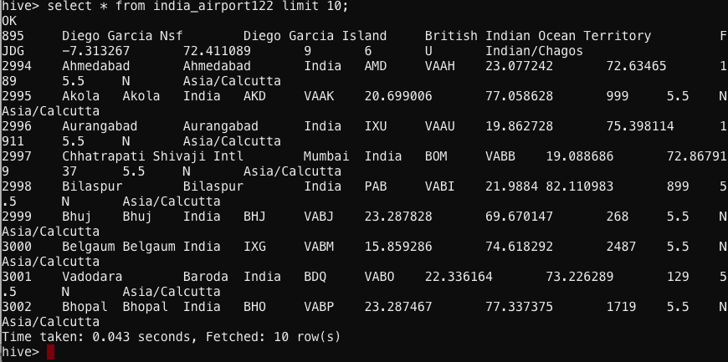

**B. Find the list of Airlines having zero stops**

**Command:**

**Create table stop122 as select * from route where Stops LIKE ‘%0’;**

**Screenshot:**

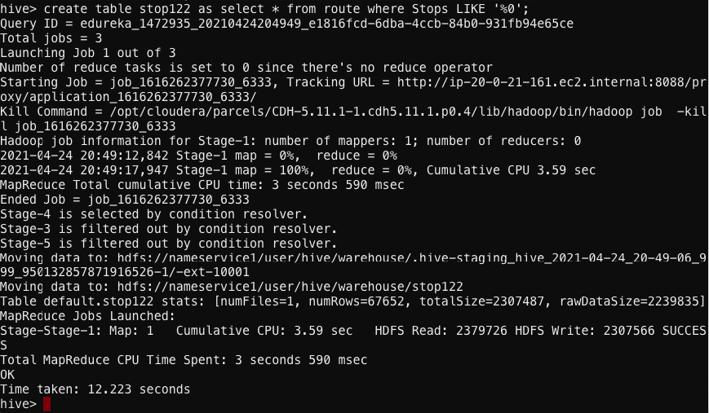

**Samples of 0 stop of the airline in the dataset.**

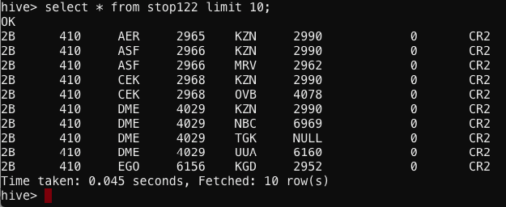

**C.List of Airlines operating with code share**

**Command:**

**Create table codeshare_122 as select * from route where Codeshare LIKE ‘%Y%;**

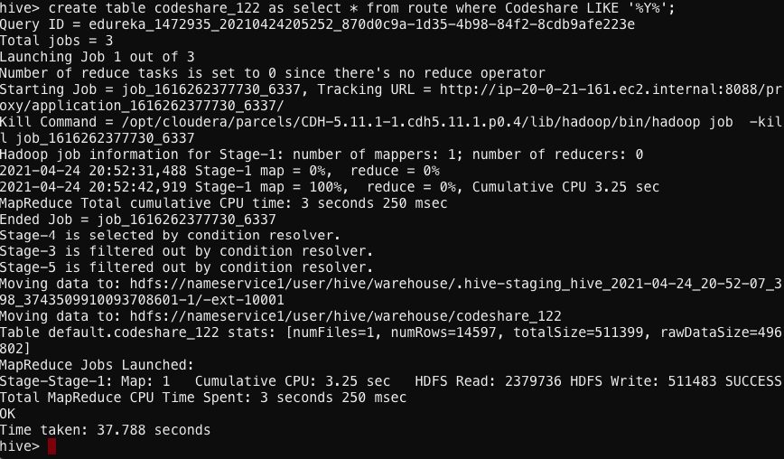

**Examples:**

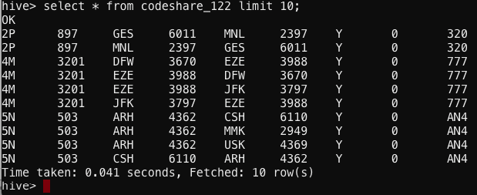

**D.Which country (or) territory having highest Airports**

**Answer is United State of America.**

**Command:**

**select Country,count(*) as cnt from airport group by Country SORT BY cnt DESC;**

**Screenshot:**

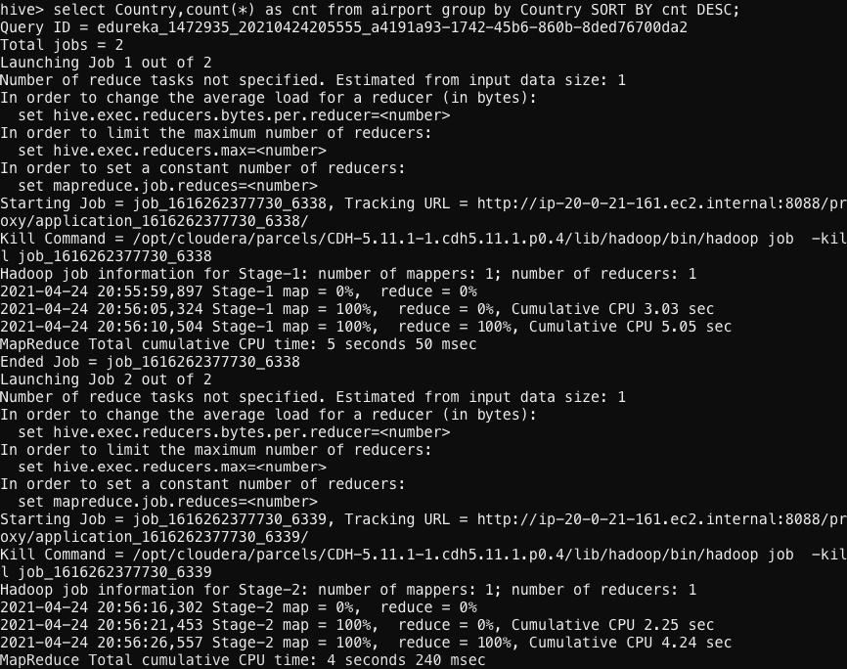

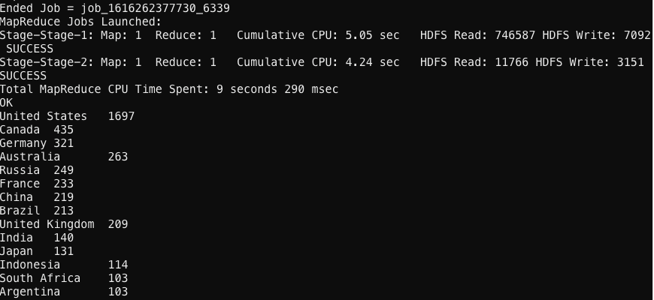

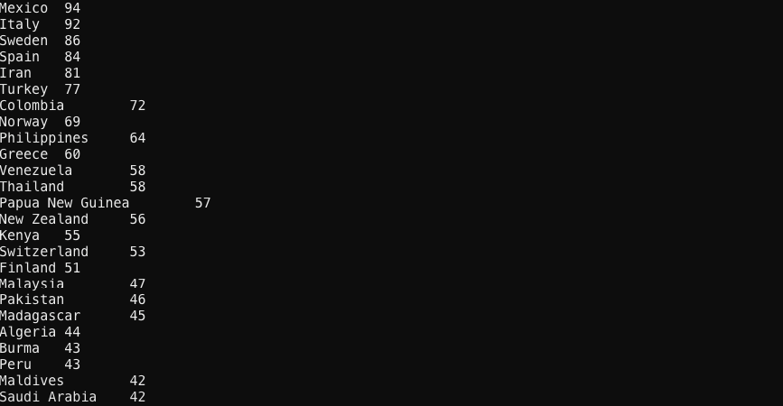

**E.Find the list of Active Airlines in United state**

**Command:**

**select * from finalairlines where Country like '%United States%' AND Active like '%Y%';**

**Screenshot:**

