**Step 1:**

**Loading of dataset into movies relation:**

**Command:**

movies = LOAD 'movies_dataset.txt' USING PigStorage(',') AS (id:int,name:chararray,year:int,rating:double,duration:int);

**Screenshot:**



**Results:**

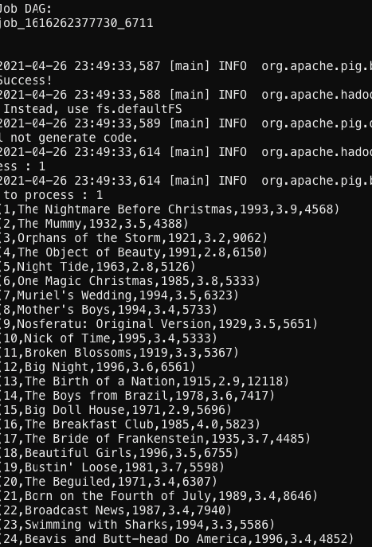

1. **A. Find the number of movies released between 1950 and 1960.**

**Command:**

movies = LOAD 'movies_dataset.txt' USING PigStorage(',') AS (id:int,name:chararray,year:int,rating:double,duration:int);

filtered_movies = FILTER movies BY year > 1949 AND year < 1961;

grouped_movies = GROUP filtered_movies ALL;

counted_movies = FOREACH grouped_movies GENERATE group, COUNT(filtered_movies);

DUMP counted_movies;

**Screenshot:**

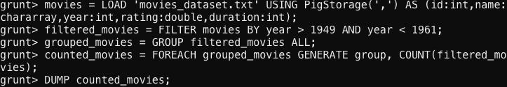

**Results:**

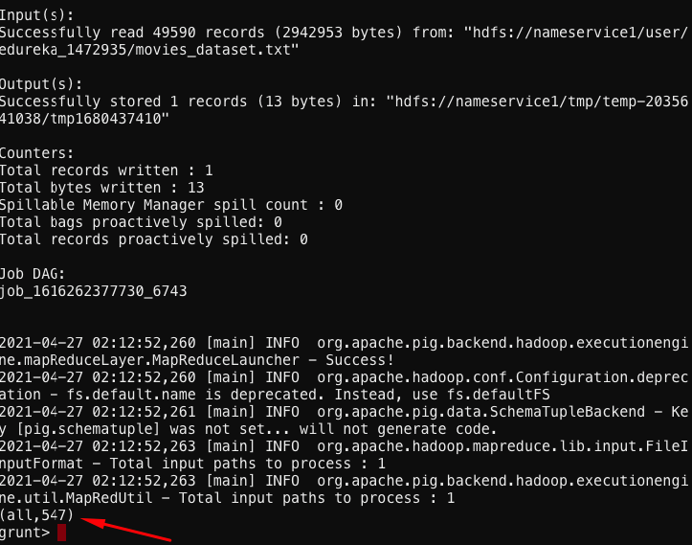

1. **B. Find the number of movies having rating more than 4.**

**Command:**

movies = LOAD 'movies_dataset.txt' USING PigStorage(',') AS (id:int,name:chararray,year:int,rating:double,duration:int);

filtered_movies = FILTER movies BY rating > 4.0;

grouped_movies = GROUP filtered_movies all;

counted_movies = FOREACH grouped_movies GENERATE group, COUNT(filtered_movies);

DUMP counted_movies;

**Screenshot:**

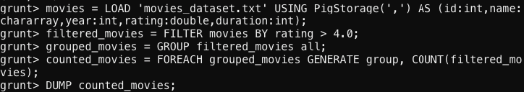

**Result:**

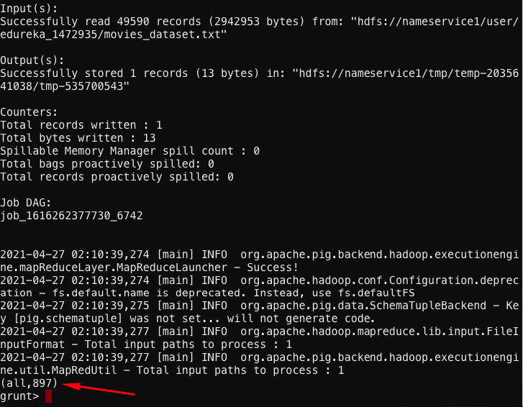

1. **C. Find the movies whose rating are between 3 and 4.**

**Command:**

movies = LOAD 'movies_dataset.txt' USING PigStorage(',') AS (id:int,name:chararray,year:int,rating:double,duration:int);

filtered_movies = FILTER movies BY rating < 4.01 AND rating > 2.99;

DUMP filtered_movies;

**Screenshot:**



**Result:**

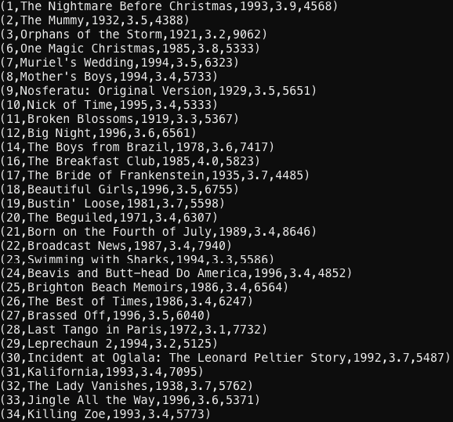

1. **D. Find the number of movies with duration more than 2 hours (7200 second).**

**Command:**

movies = LOAD 'movies_dataset.txt' USING PigStorage(',') AS (id:int,name:chararray,year:int,rating:double,duration:int);

filtered_movies = FILTER movies BY duration > 7200;

grouped_movies = GROUP filtered_movies ALL;

counted_movies = FOREACH grouped_movies GENERATE group, COUNT(filtered_movies);

DUMP counted_movies;

**Screenshot:**

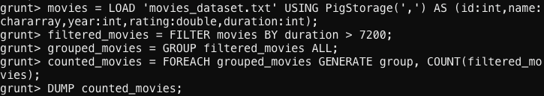

**Result:**

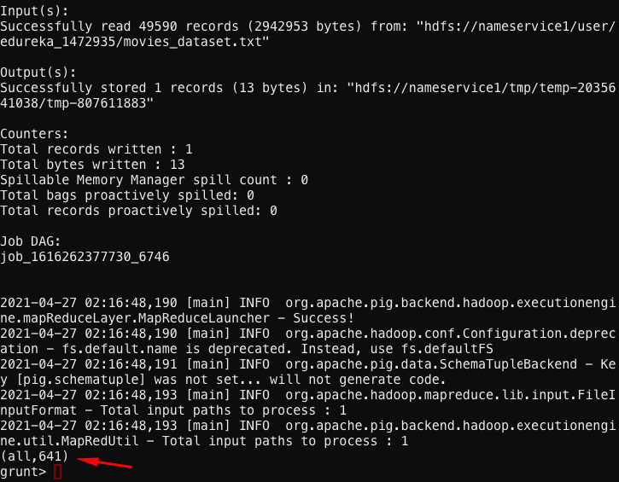

1. **E. Find the list of years and number of movies released each year.**

**Command:**

movies = LOAD 'movies_dataset.txt' USING PigStorage(',') AS (id:int,name:chararray,year:int,rating:double,duration:int);

grouped_movies = GROUP movies BY year;

counted_movies = FOREACH grouped_movies GENERATE group, COUNT(movies.id);

DUMP counted_movies;

**Screenshot:**

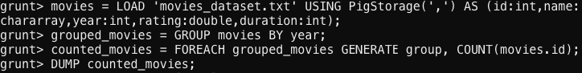

**Result:**

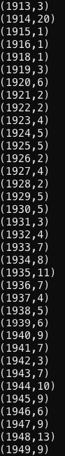 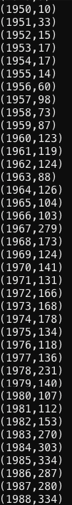 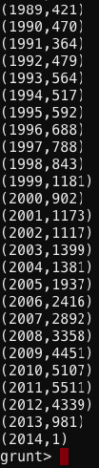

1. **F. Find the total number of movies in the dataset.**

**Command:**

movies = LOAD 'movies_dataset.txt' USING PigStorage(',') AS (id:int,name:chararray,year:int,rating:double,duration:int);

grouped_movies = GROUP movies ALL;

sum_movies = FOREACH grouped_movies GENERATE group, COUNT(movies.id);

DUMP sum_movies;

**Screenshot:**

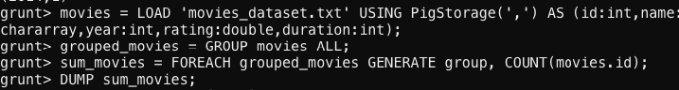

**Result:**

