Southern New Hampshire University

Richard Huang

February 18, 2019

Professor Benaoussar

MIS-350 Final Project and Report

**I. Report for Stakeholders**

**A. Enterprise-level report:**

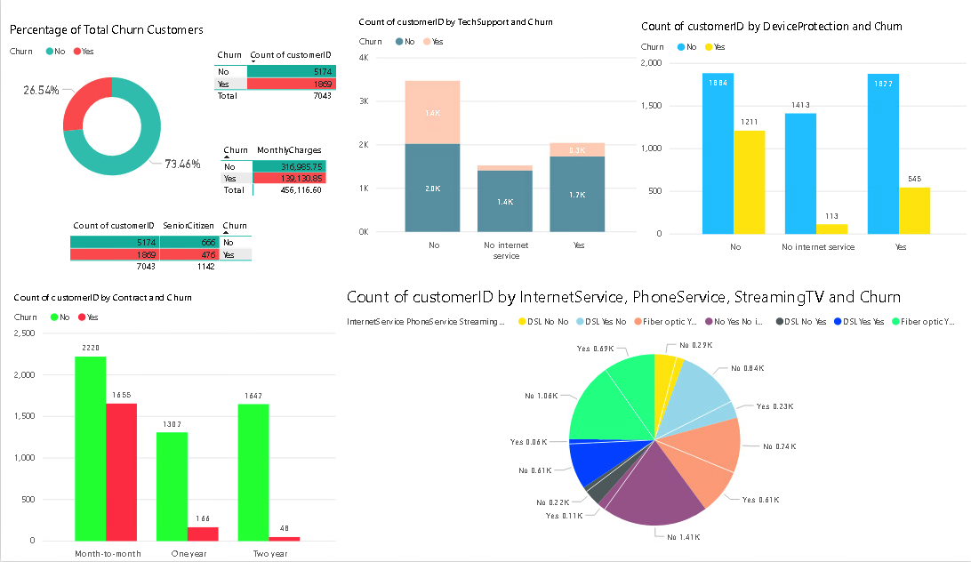

**B. Executive Summary:**

Based on the data I have obtained, I have analyzed ratio and amounts of churn customers in different circumstances and backgrounds. For better answering managements' questions and cooperating with other departments, we would have to find solutions based on the data received. Some of Business questions may occur such as how do we prevent the churn? In what circumstances would the company have a higher churn rate? How much will be the loss in a month?

I had used Power BI tools to import data from *Tele Customer Churn*. I have analyzed the percentages of churn customers compared to the overall customers. I have also compared the churn and non-churn customers with different backgrounds and circumstances. We could find out customers have month-to-month or two years contracts have a higher churn rate. We could compare the churn rate of customers with or without received technical support. We could also figure out whether the device protection can help reduce churn rate. I have also calculated monthly revenue and determined how much we would lose if customers stop using our services. The purposes of this enterprise-level report were to analyze the reasons that customers decided to stop using our services, and we would need to find solutions to prevent the losses. We would also need to utilize marketing campaigns that attract new customers to use our services. With this data analysis, it showed there is about 26.54% of churn rate. Most of churn customers are on a month-to-month contract service, and nearly 50% of the senior customers are churning. There were about 1400 of churn customers that have not received technical support, and nearly 65% of churn customers that have not been covered by device protection.

Based on the data reports, I would look forward to answering and resolving managements' concerns such as: What's the percentage the churn customers compared to overall customers? What are the main reasons that they decided to leave us? What is the total monthly loss? What can we do to prevent revenue losses? Overall, it does seem that senior customers, customers with no tech supports and customers with the month-to-month contract have a higher churn rate. To prevent losses, we would need to provide better technical supports, especially to senior citizens. Marketing teams should utilize campaigns that would attract customers to sign up for two years contract.

**II. Identify the Business Question:**

I have chosen *Tele Customer Churn* as my dataset for the final project. To better solve the business questions listed above, we would need the data such as churn customers, senior customer status, tech supports, contract status, device protection plans, multiple line services, internet services status and monthly revenue.

**III. Making Sense of Data:**

1. The dataset is regarded as ABC company's churn rate that customer leaves the company to its competitors due to various reasons. This data set has included churn status of each customer, the services customers have signed up for, customers' account information, and demographics about the customers. This dataset provided all the backgrounds and circumstances that may cause the customers to leave ABC Company to its competitors. With all the data provided, we would be able to analyze the reasons and answer the questions that stakeholders may have.
2. I would need to use the churn status as the main information, and various circumstances such as senior status, tech support, monthly charges, contract status, device protection, Internet services, and multiple line services. Based on the data received, I would be able to determine the reasons that caused customers leaving us and I would also be able to answer business questions that stakeholders may have.

**IV. Business Intelligence:**

1. Power BI tool allows me easily to import the data into its platform. Power BI can separate different segments with different information, allow us to transform the data into visualization, and provide a professional enterprise-level report for stakeholders.
2. Power BI analysis tool provided professional graphics such as bar chart, pie chart or other data visualization, and it summarized the massive amounts of data and focused on the core elements. It's a great tool to allow non-technical or other area background stakeholders to easily understand the information and influences by the "story" that we have transform from the data.

**VI. Guiding Question:**

1. What's the current churn rate compared with overall? How much will we lose in a month based on the current churn rate? What would be the main elements that caused the customers to leave us? What's the main age group that leaves us?
2. Based on my initial analysis, I have used the compiled and cleaned data to obtain the ratio of churn compared to the overall. I have used the total monthly sales amount to determine the loss, and I also compared different circumstance to determine the main elements that caused the churn. I realized that the senior group was the main age group with higher churn rate.

**VII. Visualizations:**

1. In the visualizations, I have chosen the column charts, table chart, pie charts, and donut charts to display the data that can answer business questions accurately. Donut and pie charts showed and compared the churn rate with overall. The column charts used for comparing different ratios in various circumstances, and the table charts displayed the information such as total monthly fee and account information.
2. I have realized that the donut chart would be best to obtain the ratios compared with the overall. These column charts are great visualization charts when comparing two elements. Table charts allow us to clearly understand the numeric elements. Based on business questions occurred, I believed that theses visualizations would be best suited for conveying information to targeted user audience and across multifunctional teams because they are easy to read and understand.
3. Please see attached pbix file.
4. Please see attached pbix file.
5. This visualization represents monthly revenues; churn rates, and compares churn rates in all circumstances. Based on the dataset provided, I have transformed the data into this visualization and intend to answer business questions that stakeholder might have.

**VII. Actionable Insight:**

Based on my analysis, I would recommend our Marketing department would propose a campaign that can attract customers to sign up the two years contract with us. ABC Company should be able to hire more talent technical supports to meet technical assistance needs, especially for senior citizens. Based on the data visualization, the customers that had obtained technical support from us were least likely to leave our company. That would also reduce customers' efforts and complaints and increase customers' satisfactions. I would also recommend ABC Company to offer free or discount device protection plans for those who have signed up one or two years contract. Based on the high churn rate with fiber optics services, it might possible due to higher monthly price of services. ABC Company should propose to discount the price and offer promotion bundles such as triple bundle service including Internet, TV and Telephone services.