**Task 1: Insert Record to the Person Table**



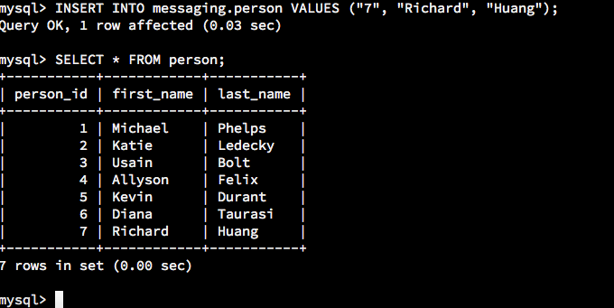

Explanation:

Task one required adding my-self as new record in the person table. First, I used the messaging database by entering the “USE messaging;” command, and I used the INSERT INTO statements to complete the task. The result came out successfully.

**Task 2: Alter the Person Table**

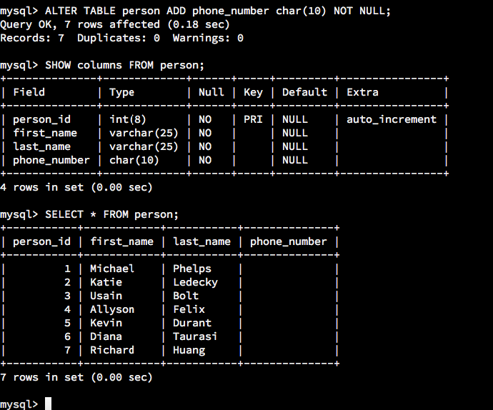

Explanation:

Task two required altering the “person” table with adding a new column. I used ALTER TABLE statement to add a new column and named it “phone_number” with CHAR (10) type and NOT NULL. The result came out successfully.

**Task 3: Update Records in the Person Table**

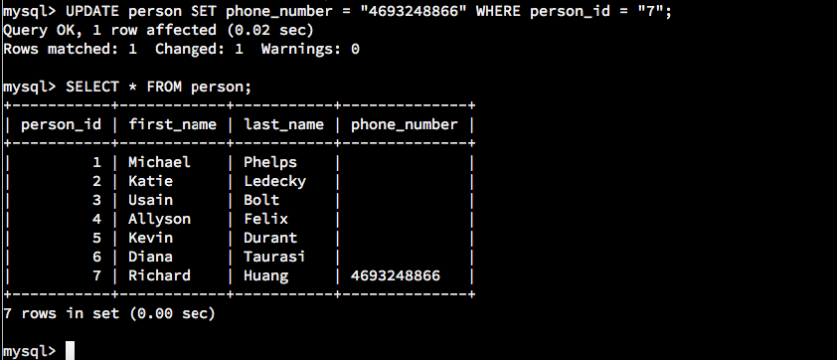

Explanation:

Task three required updating the record on the person table, and I entered UPDATE statement to update the “phone_number” record to add my phone number to the person table. The result came out successfully.

**Task 4: Delete Records from Person Table**

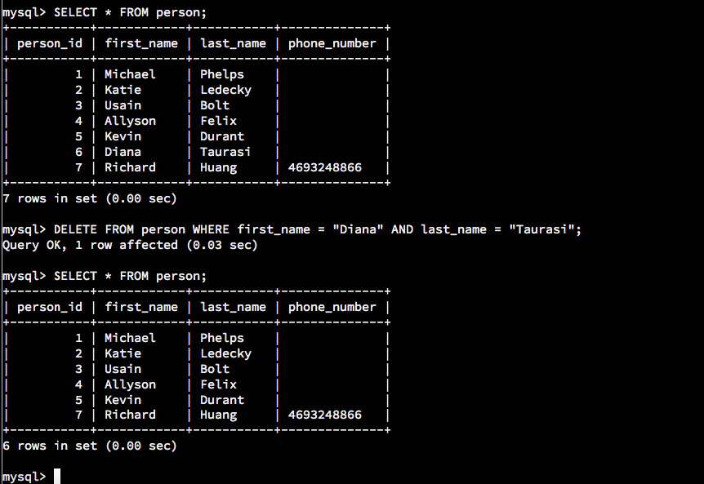

Explanation:

Task four required deleting the record name “Diana Taurasi”, and I entered the DELETE statement where first_name = “Diana” and last_name = “Taurasi”. The result came out successfully, and the record with person_id 6 had deleted.

**Task 5: Alter the Contact List Table**

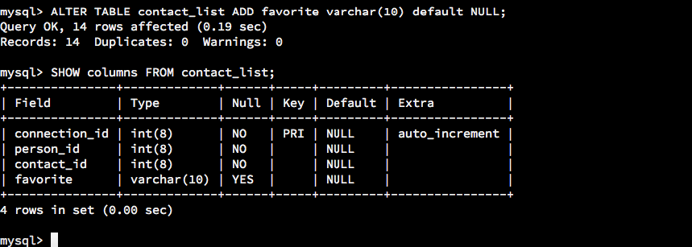

Explanation:

Task five required altering contact list table to add new column name “favorite”, varchar(10) type and NOT REQUIRED. I entered the ALTER TABLE statement with VARCHAR (10) default NULL. The result came out successfully, and favorite column had added with required type and others.

**Task 6: Update Records in the Contact List Table**

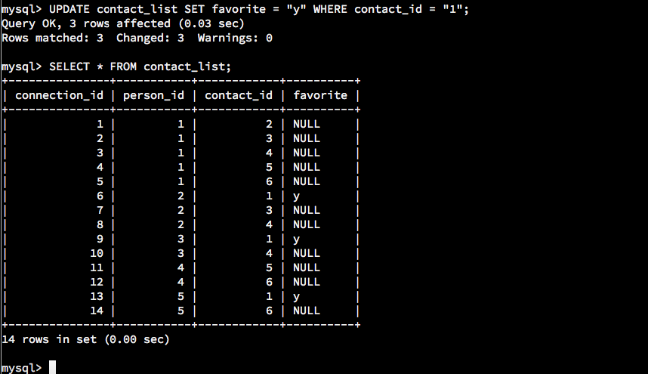

Explanation:

Task six required updating the new “favorite” column on contact list table, and we needed to set the Mr. Michael Phelps (contact_id =1) as favorite contact. I entered the UPDATE statement and set all contact id 1’s favorite column with “y” (yes). The result came out successfully.

**Task 7: Update Records in the Contact List Table**

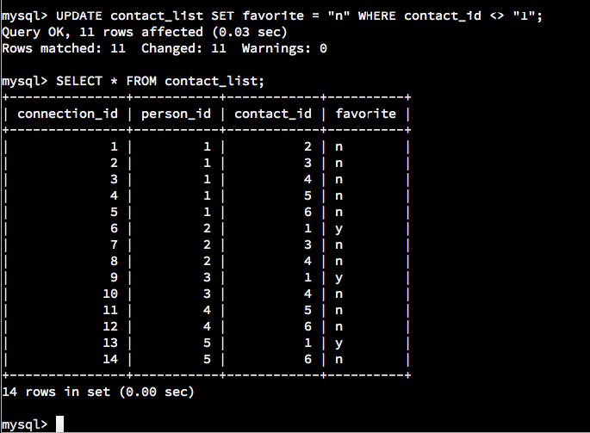

Explanation:

Task seven required us to update remaining records under favorite column, and set other people beside Mr. Michael Phelps (contact_id =1) to not favorite. I entered the UPDATE statement and set “n” (no) to remaining contact ids. The result came out successfully.

**Task 8: Insert Records to Contact List Table**

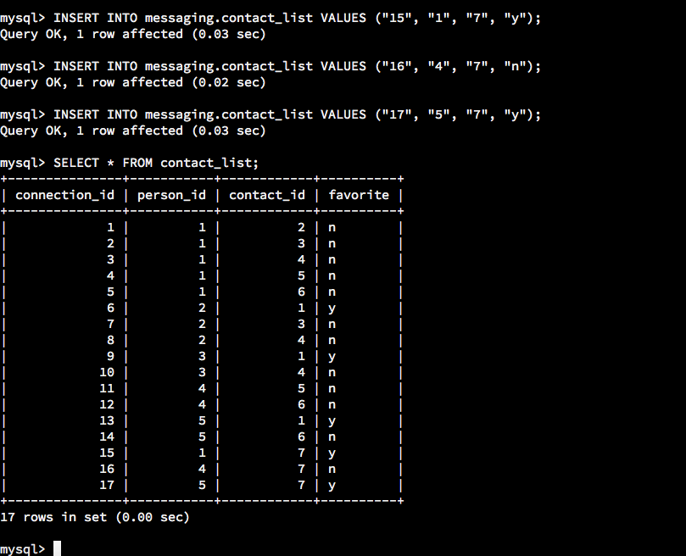

Explanation:

Task eight required us to insert three new records, and add my-self as a new contact in the contact_list table. I entered INSERT statements with connection id 15, 16, and 17, person id 1, 4 and 5. I had provided the values for “favorite” column under my contact id.

**Task 9: Create the Image Table**

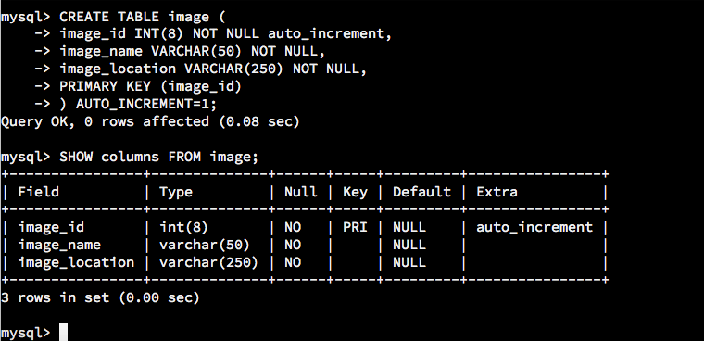

Explanation:

Task nine required us to create a new table name “image” with column data type and constraints. I entered the CREATE TABLE statements with all the requirements on task nine, and set image_id as primary key. The result came out successfully.

**Task 10: Create the Message-Image Intersection Table**

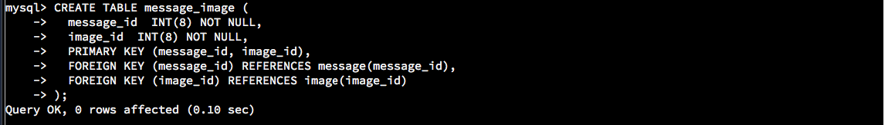

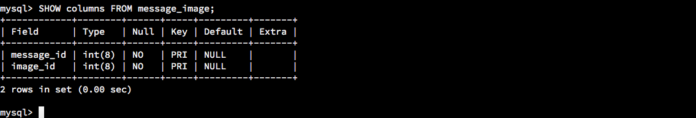

Explanation:

Task ten required creating intersection table named “message_image”, and I used CREATE TABLE statements with assigning PRIMARY KEY AND FOREIGN KEY to each column. The result came out successfully, and the table was created with required specifications.

**Task 11: Insert Records to Image Table  
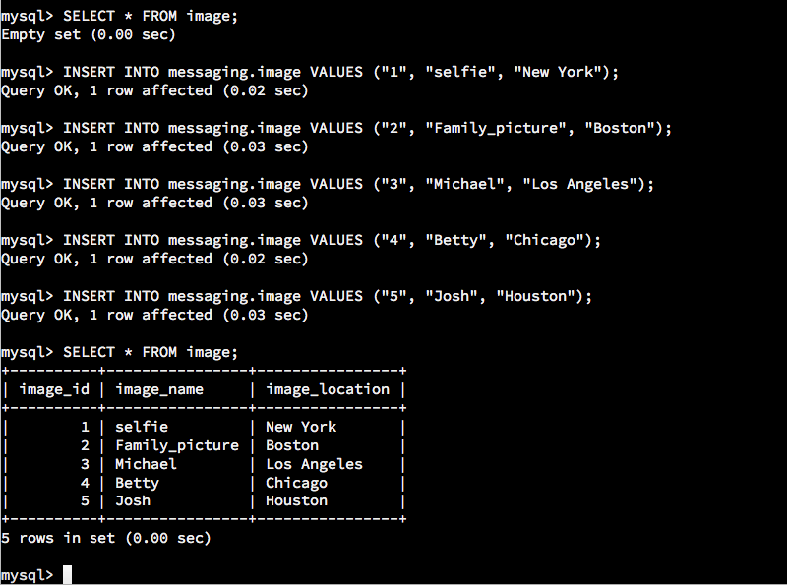**

Explanation:

Task eleven required us to insert 5 new records into the “image” table, and I used INERT INTO statements to add required information and values. The result came out successfully.

**Task 12: Insert Records to Message-Image Table**

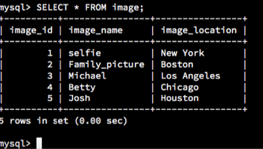

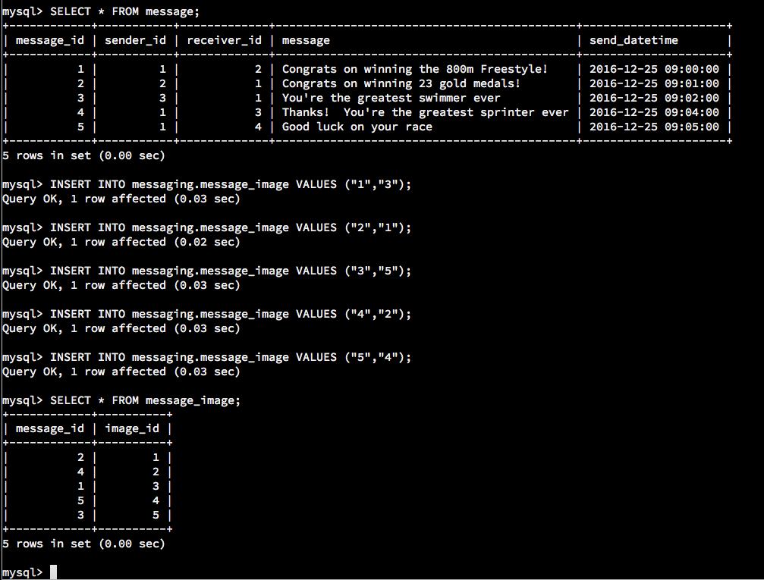

Explanation:

Task twelve required us inserting 5 new records, and added at least one record where at least one of Michael Phelps’ messages includes at least one image. I used INSERT INTO statement and assigned all Mr. Michael Phelps messages with images. The result came out successfully.

**Task 13: Find All of the Messages that Michael Phelps Sent**

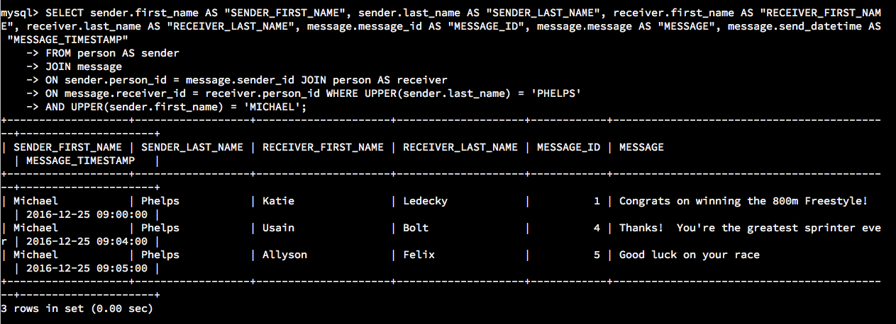

Explanation:

Task thirteen required finding all messages that Mr. Michael Phelps sent, and I used the JOIN statements. These commands joined from “person” table with “message” table with displaying the required names and columns. The result came out successfully.

**Task 14: Find the Number of Messages Sent for Every Person**

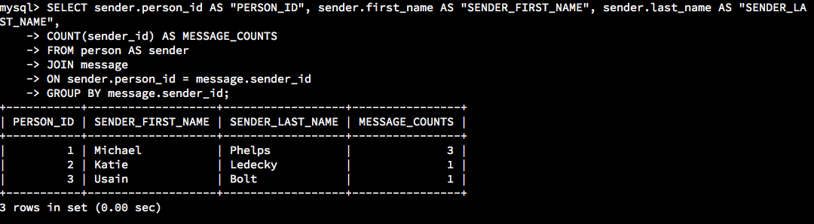

Explanation:

Task fourteen required us to count the message sent, and grouped them by orders. I entered the SELECT, COUNT, JOIN and GROUP BY statements to obtain person id, message counts, and sender’s first and last name. The result came out successfully.

**Task 15: Find All of the Messages that Have At Least One Image Attached Using INNER JOINs**

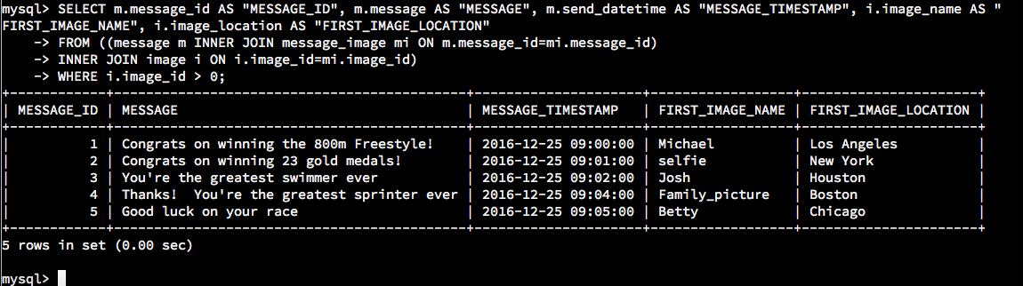

Explanation:

The final task required using INNER JOIN to combine the image table and message table with at least one image attached. I used the INNER JOIN statement to combine all the related tables and showed the required names and columns. The result came out successfully.