# Interim Assignment 5

Implement the next release of your term project, employing a database set up and manipulated—where possible—from your application. If you want to use a database other than Derby as described, please check with your facilitator.

The same instructions as in Assignment 2 applies to this completed Word document, the gray text, the 5 page limit, appendices, JUnit tests, and a ReadMe file.

## 1.1 SUMMARY DESCRIPTION

One- or two-paragraph overall description of your proposed term project. Color red the parts changed from Assignment 4.

This project is an educational tool, titled MusicTrivia, for those looking to test and improve their music theory knowledge. The application, a graphical user interface (GUI), will randomly generate questions from among several question templates ranging from simple to complex with random, appropriate values inserted at key points in the templates so that the user gets practice manipulating the questions with many different value permutations. Some of the concepts tested include major and minor scales, intervals, scale degree names, alto and tenor clefs, and diatonic chords. After the user has selected his or her answer from among multiple options, the application will offer feedback on the correctness of his or her answer.

In addition, the application will keep track of the user’s progress over time on each category of question so that the user can track his or her progress in specific topic areas.

## 1.2 ADDITIONAL REQUIREMENTS (FEATURES) IMPLEMENTED IN THIS RELEASE

Title and one or two sentences per requirement. Don’t repeat requirements implemented for prior assignments unless they are necessary to provide context—in which case, make it clear which are new vs. old.

### 1.2.1 Identify Notes in Seven Note Scales by Position (NEW)

The user will be asked to identify the note located at a specific position in a seven note scale. An example question would be: “What is the third scale degree of B Natural Minor?”

## 1.3 I/O SUPPORTING THE REQUIREMENTS LISTED ABOVE

Provide an example of input / output showing the new features of your application.

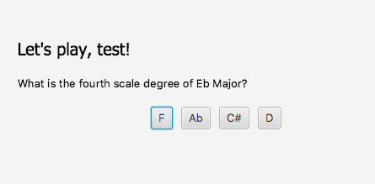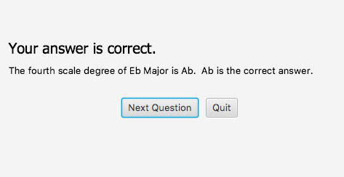

## 1.4 YOUR DIRECTORY

Show a screenshot of your directory. Include all relevant files. This should include JUnit tests.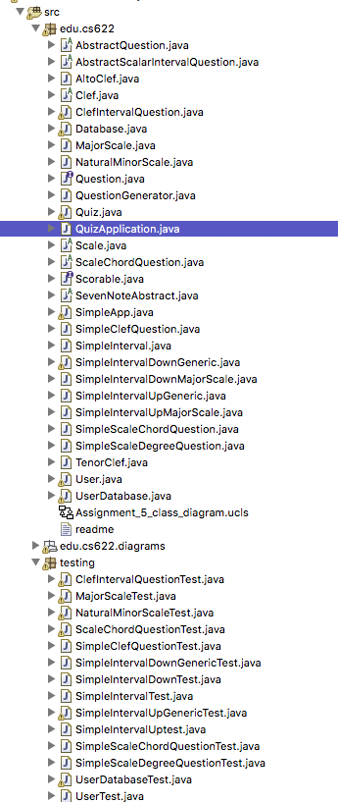

## 1.5 DESIGN

### 1.5.1 Class Model, Use Case, and Sequence Diagram

## Supply a main use case, the class model, and the sequence diagram corresponding to the use case. These should be consistent. Indicate in red where you applied the features listed below.

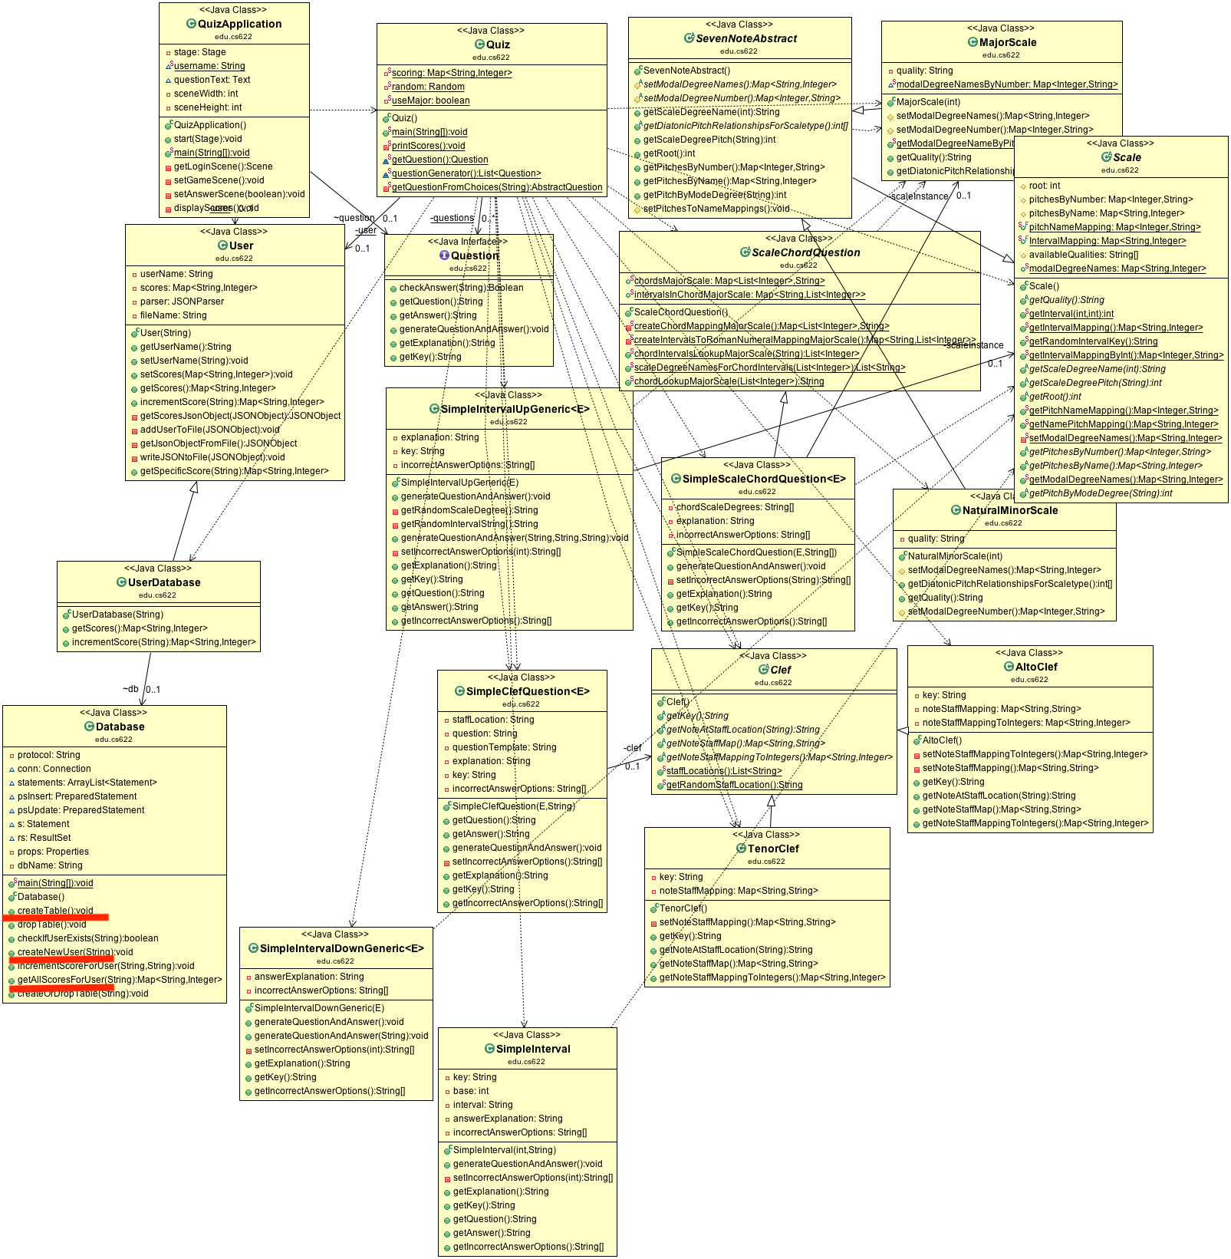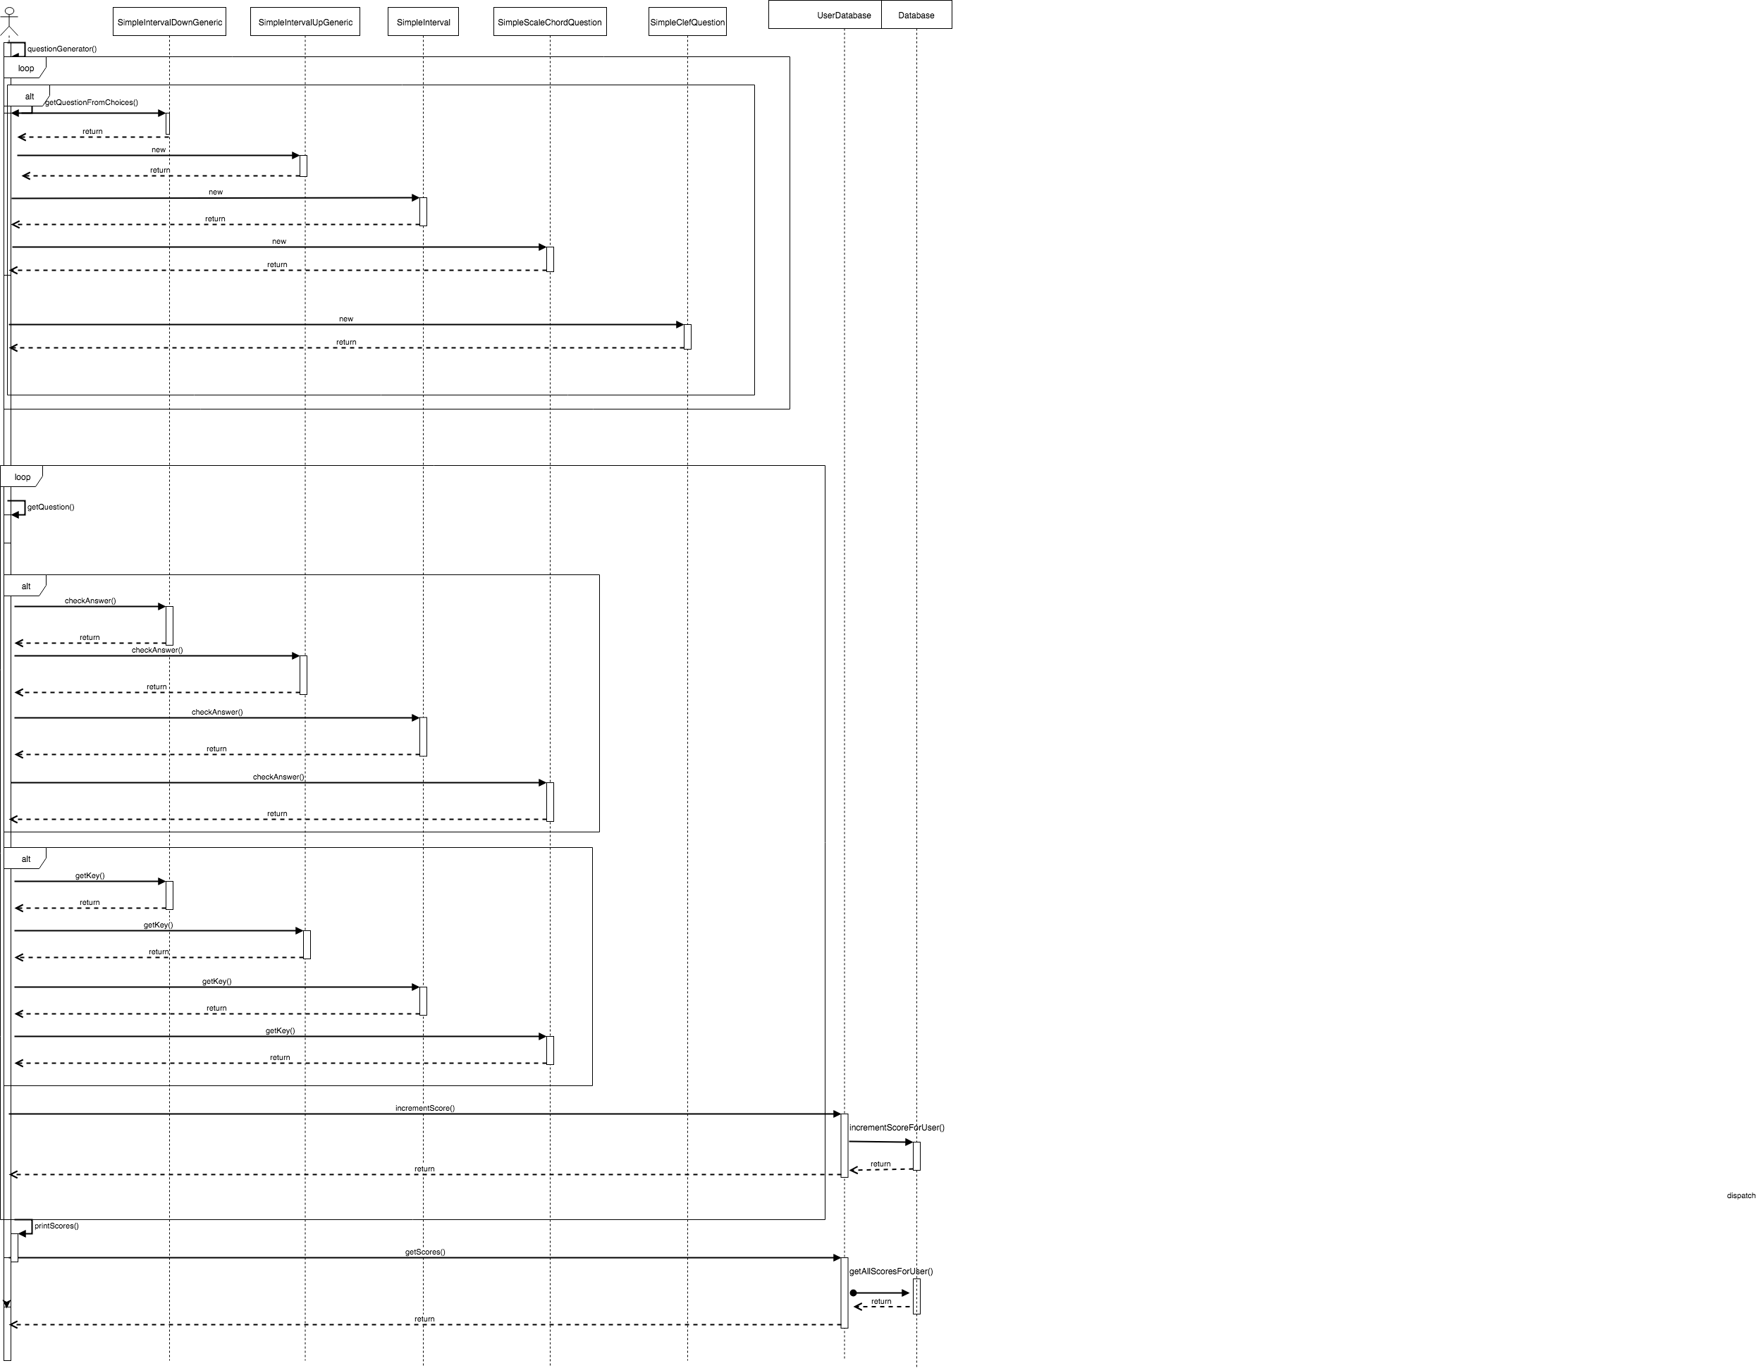

### 1.5.2 Code showing table creation

From edu.cs622.Database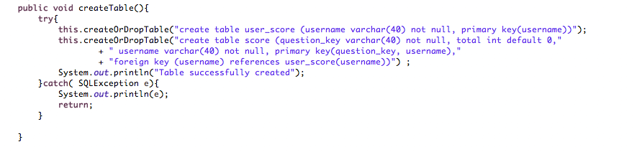

### 1.5.3 Code showing the insertion of data

.From edu.cs622.Database

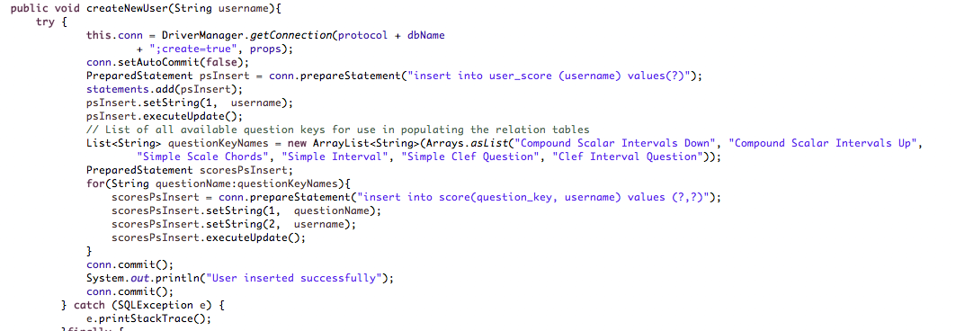

### 1.5.4 Code showing selection of records, and ordering with SQL

from edu.cs622.Database.getAllScoresForUser: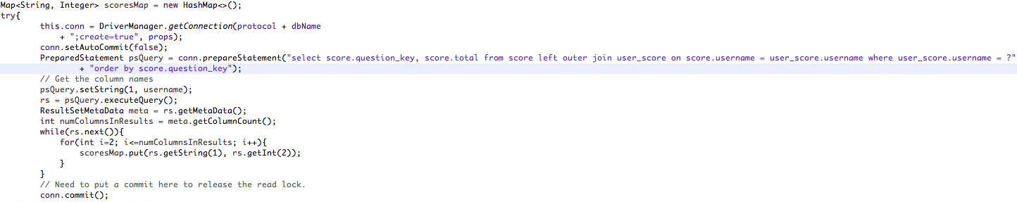

### 1.5.5 Code showing selection involving at least two tables

from edu.cs622.Database.getAllScoresForUser:



## 1.7 YOUR CODE

Unless your facilitator arranges another method, copy your Eclipse project to your file system, zip it, and attach it. Please contact your facilitator in advance if you want to request an exception.

<Your response here>

## 1.8 Instructor’s Evaluation

