Assignment 3
Implement the next release of your term project. You will incorporate generics. (Please see the worked example solution.)
The same instructions as in Assignment 2 applies to this completed Word document, the gray text, the 5 page limit, appendices, JUnit tests, and a ReadMe file.

1.1 SUMMARY DESCRIPTION
One- or two-paragraph overall description of your proposed term project. Color red the parts changed from Assignment 2.
This project is an educational tool, titled MusicTrivia, for those looking to test and improve their music theory knowledge. The application will randomly generate questions from among several question templates ranging from simple to complex with random, appropriate values inserted at key points in the templates so that the user gets practice manipulating the questions with many different value permutations. Some of the concepts tested include major and minor scales, intervals, scale degree names, and diatonic chords. After the user has selected his or her answer from among multiple options, the application will offer feedback on the correctness of his or her answer.
In addition, the application will keep track of the user’s progress over time on each category of question so that the user can track his or her progress in specific topic areas.

1.2 ADDITIONAL REQUIREMENTS (FEATURES) IMPLEMENTED IN THIS RELEASE
Title and one or two sentences per requirement. Don’t repeat requirements implemented for prior assignments unless they are necessary to provide context—in which case, make it clear which are new vs. old.

1.2.1 Questions for Simple Intervals (NEW)
Users are asked questions about intervals above and below a specified pitch. For example, “what is a perfect fourth below G?”

1.2.2 Compound Interval Questions Using Major and Minor Scales ( NEW)
Users are asked multi-part questions about intervals. The material that forms the basis for these questions comes from either major or natural minor scales.

1.2.3 Diatonic Major Scale Chord Questions (NEW)
Users are asked questions that require them to translate multiple scale degree names into the corresponding roman numerals that represent the chord position in the underlying major scale.

1.3 I/O SUPPORTING THE REQUIREMENTS LISTED ABOVE
Provide an example of input / output showing the new features of your application.

I/O for 1.2.1:

I/O for 1.2.2

I/O for 1.2.3

1.4 YOUR DIRECTORY
Show a screenshot of your directory. This should include a parallel directory of JUnit tests—package-by-package, class-by-class, and method-by-method, except for trivial ones.
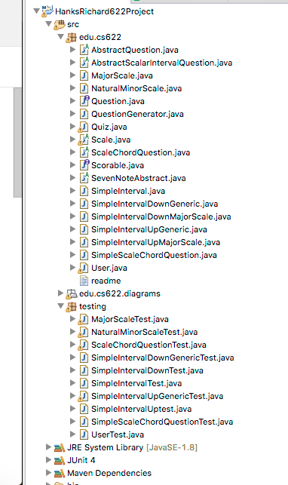

1.5 DESIGN

1.5.1 Class Model, Use Case, and Sequence Diagram

Supply a main use case, the class model, and the sequence diagram corresponding to the use case. These should be consistent. Indicate clearly in your class model where you applied generics. To do this use tools, PowerPoint, or a combine models as in this example (which you are free to cut and paste from). Insert indications in red (as in this example) to show where generics apply (as in the code below).

This is the main use case where the system generates a number of Question subtype instances, gets the username, prints scores, asks questions, checks answers, gives feedback to the user, and prints updated scores after correct answering by the user and at the end of the program.
Sequence Diagram:

Class Model: These are all the classes, base classes, abstract classes, and interfaces involved in this use case.

1.6.1 Class model fragment showing generic class
Explain where and how you applied generic classes in your class model.
I refactored my previous simple interval question classes into generic versions. In the original classes, all of my questions where based on material derived from the MajorScale class. So, for example, my question might read “the fifth scale degree of G Major is…”. Instead, I created two classes, SimpleIntervalDownGeneric and SimpleIntervalUpGeneric, that use <E extends Scale> as the generic dependency. I then created a new class, NaturalMinorScale, that, like MajorScale, derives from Scale. This allows me to use these classes to create many more question permutations because now I can also derive material from NaturalMinorScale in addition to MajorScale. A new form of the question might be something like “the fifth scale degree of G Natural Minor is…”. The use of the bounded generic type allows me to enforce the type of object that can be passed in. In the case of the previous two examples, any class in the Scale hierarchy should work. I also created another class of questions to test diatonic triads. In this class, SimpleScaleChordQuestion<E extends MajorScale>, I use a generic bounded to MajorScale. Since this class specifically uses MajorScale, I am using this class instead of the Scale superclass used in the previous two classes. This allows me to have control over what type of class E (myScaleInstance instance variable) will be. It will also allow me to pull future material in if I were to create new subclasses to MajorScale in the future. One possible example might be modes of the major scale might extend MajorScale.
Class model fragment showing generic classes:

1.6.2 Code (including test code), input (if applicable), and output showing generics
Explain why the use of generics is appropriate here.
I am leveraging generics to allow my question classes to derive their underlying structure from different subclasses of Scale. In my main method, I am using dynamic dispatching to randomly select from between several versions of Question subclasses. For those classes where I use generic types bounded to Scale, I can randomly pass any subclass of Scale to further increase the number of question permutations, with no extra coding. Currently, I have MajorScale and NaturalMinorScale as Scale subclasses which I can pass to SimpleIntervalDownGeneric<E extends Scale> and SimpleIntervalUpGeneric<E extends Scale>. In addition, by bounding to Scale, I have control over what classes can be passed to my class. In this case, only those deriving from Scale will be accepted. I contemplated implementing the Comparable Interface, but I couldn’t think of a proper way to compare two Scale objects, from a music theory perspective.

In this test, testing.SimpleIntervalDownGenericTest, I instantiate two versions of SimpleIntervalDownGeneric<E extends Scale>. Because I am using bound generics for this class, I am able to use two different scale classes/types to derive questions.

In the test for generating the question, I am checking that the formatting includes a reference to the TYPE of scale used at runtime. In this case, this would refer to either Major or Natural Minor.

The code:

The console output showing the above:

I achieve this by calling the getQuality() method dynamically on whatever type of Scale this.scaleInstance refers to at runtime. Inside of SimpleIntervalDownGeneric<E extends Scale>, the code looks like this:

Then, as an example of one of the types of Scale instances I use, here is the getQuality() method from the NaturalMinorScale class:

Inside of MajorScale, getQuality() is:

I use the same technique to in the SimpleIntervalUpGeneric class and the SimpleScaleChordQuestion class to dynamically derive correct values based on the type of scale being used at runtime. If I had more time, I might refactor SimpleScaleChordQuestion<E extends MajorScale> to extend Scale, a superclass of MajorScale. Since the diatonic chords of Major and Minor are different, it would require that I dynamically check for the diatonic chord options for the type of scale at runtime in order to properly formulate the question and derive the answer. I didn’t have time to implement that functionality in this release, so I instead chose to simply derive from MajorScale. Because this question class is bounded to this specific instance of Scale, MajorScale, I can leverage this fact to restrict the caller of this class to only classes which derive from MajorScale. However, bounding to a superclass would give me more question permutations as in the examples of SimpleIntervalUpGeneric and SimpleIntervalDownGeneric.

1.7 YOUR CODE
Unless your facilitator arranges another method, copy your Eclipse project to your file system, zip it, and attach it. Please contact your facilitator in advance if you want to request an exception.
<Your response here>

1.8 Instructor’s Evaluation

