|  |
| --- |
|  |
| Excel Homework: Charting Crowdfunding |
| Excel-Challenge |

|  |
| --- |
| Richard Kim |

1. **Given the provided data, what are three conclusions we can draw about crowdfunding campaigns?**
   * Looking at the data, one can conclude that theater fundraisers are the most popular category. Film & video and Music are in second and third respectively while the Journalism category ranks as the least popular crowdfunding campaign.

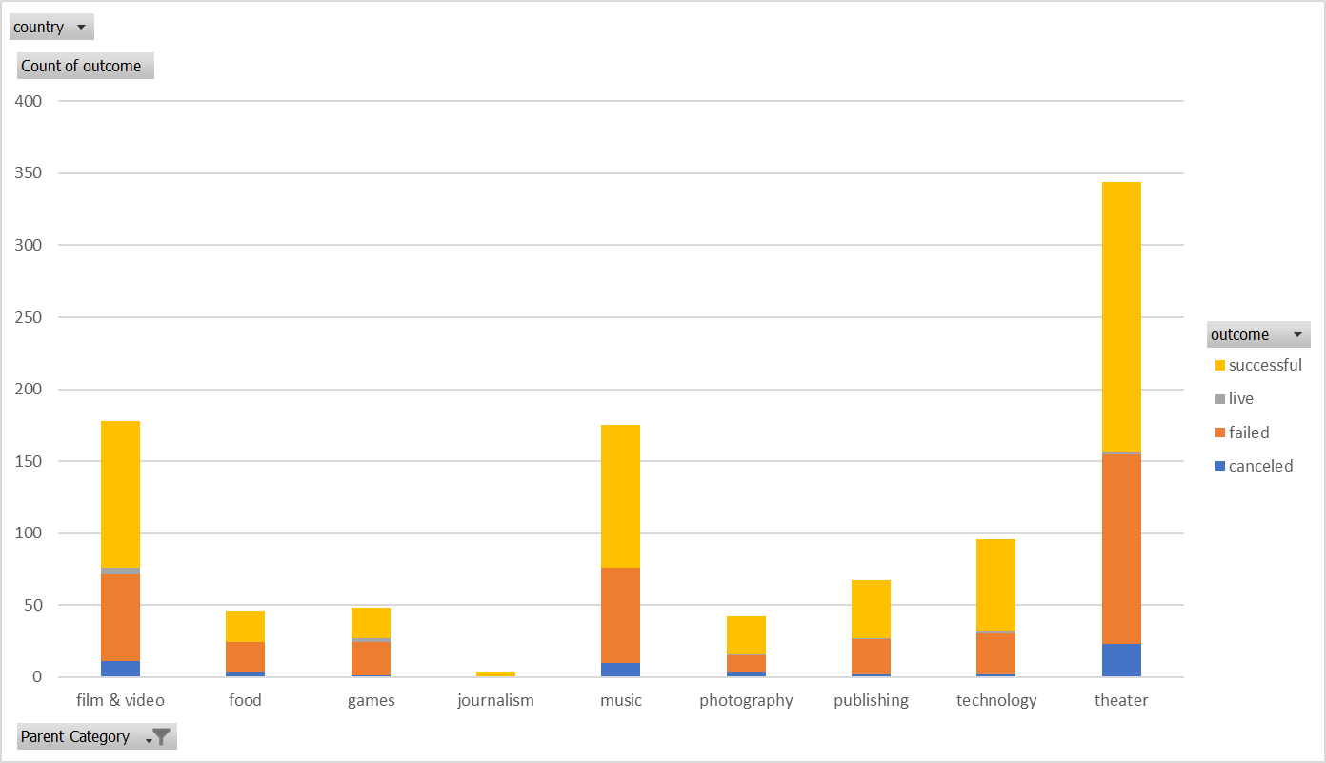

* + When we observe the subcategory data, plays takes the lead in most popular fundraiser with well over 300 total campaigns. Every other subcategory has a total of less than 100 campaigns.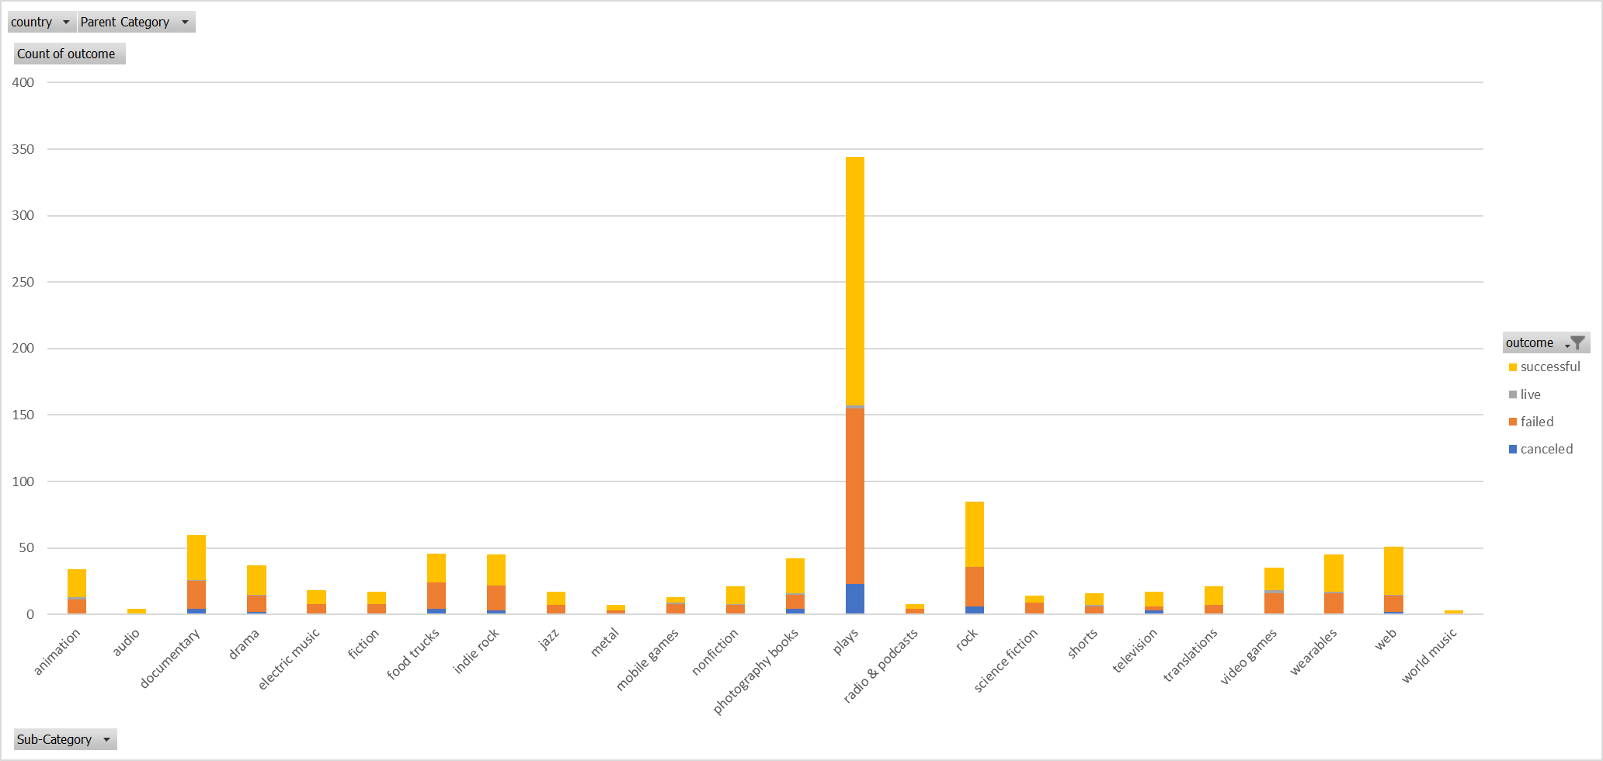
  + Looking at the outcome and months graph, there doesn’t seem to be a strong trend line for the successful, failed, and canceled campaigns. My best guess is that there is no correlation between the month of the fundraiser and the outcome of the fundraiser or that we don’t have enough supporting variables to specify a concrete conclusion.

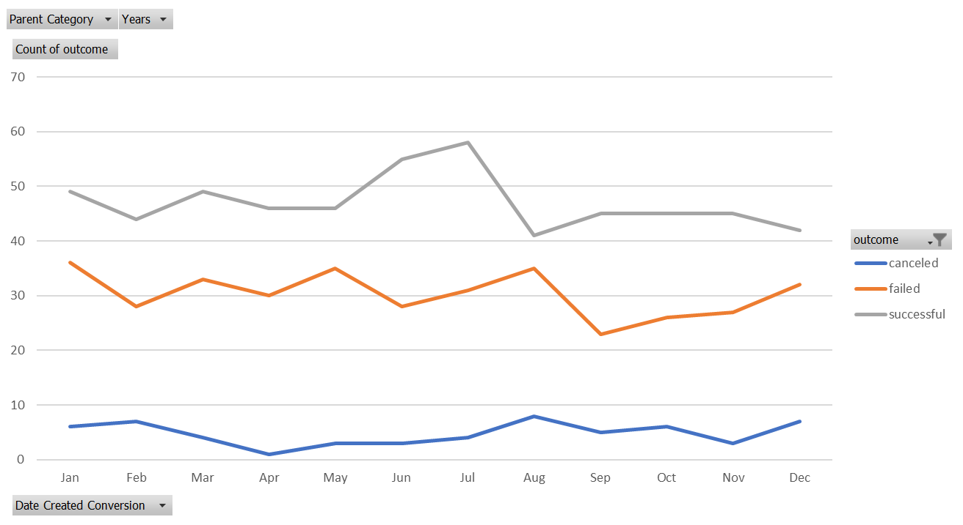

1. **What are some limitations of this dataset?**
   * Some limitations include the unknown variable of population. We can’t be certain if the data we have included in the set is a representative sample size.
   * Another limitation is how we define what success, failed, and canceled. There isn’t a specified metric to evaluate whether the campaign’s success was large or small.
2. **What are some other possible tables and/or graphs that we could create, and what additional value would they provide?**
   * Success rate per country/currency: This graph would show us which countries are more successful with crowdfunding campaigns
   * Relationship between campaign goal and the pledged amount: A graph between the relationship of campaign goal outcome and the pledged amount would tell us if pledging more money would result in a successful campaign.
   * Graph relationship between campaign length and its success rate: This would help show whether shorter or longer campaigns have better or worse success rates.