Parallel Processing Concept
CSCI 4330/6330

Lab0:Unix Environment

1.Go to the
https://jupyterhub.cs.mtsu.edu/azuread/
and open the terminal

Copy l0.c, and create a makefile to run that l0.c

Take a screenshot of the successful execution of the program and add a screenshot here in this docx file.

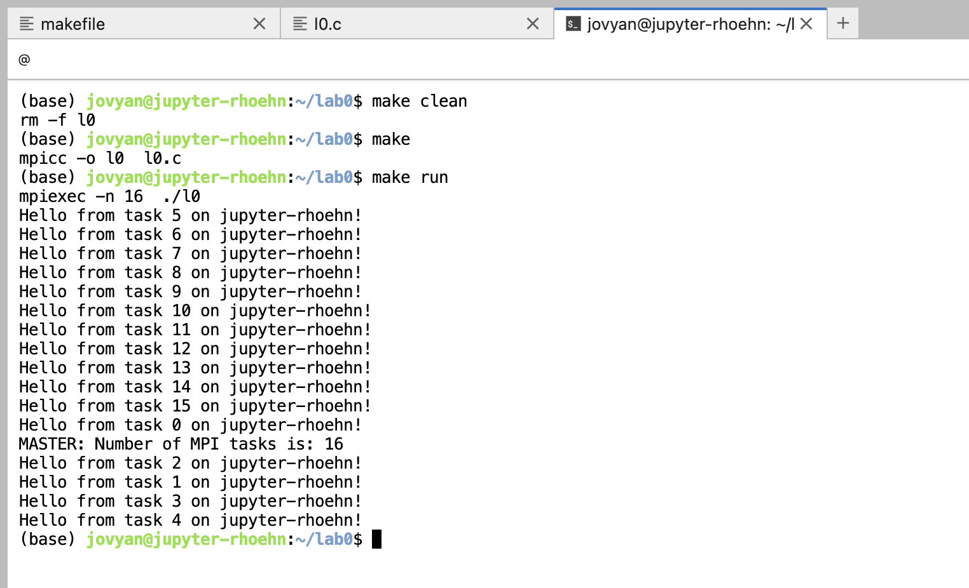

Submission: Please submit a tar file(LastnameFirstname_CSCI6330(Or 43300)Lab0.zip) via D2l containing all of your project files in D2L,including this Lab0.docx file, makefile, .c files that will build the executable program which MUST
be named l0.

To build the project, I will cd to my directory containing your files
and simply type:

rm -rf l0
rm -f *.o
make
make run

The next page shows the details screenshot and steps what I did to run the first program in Jupyterhub environment.
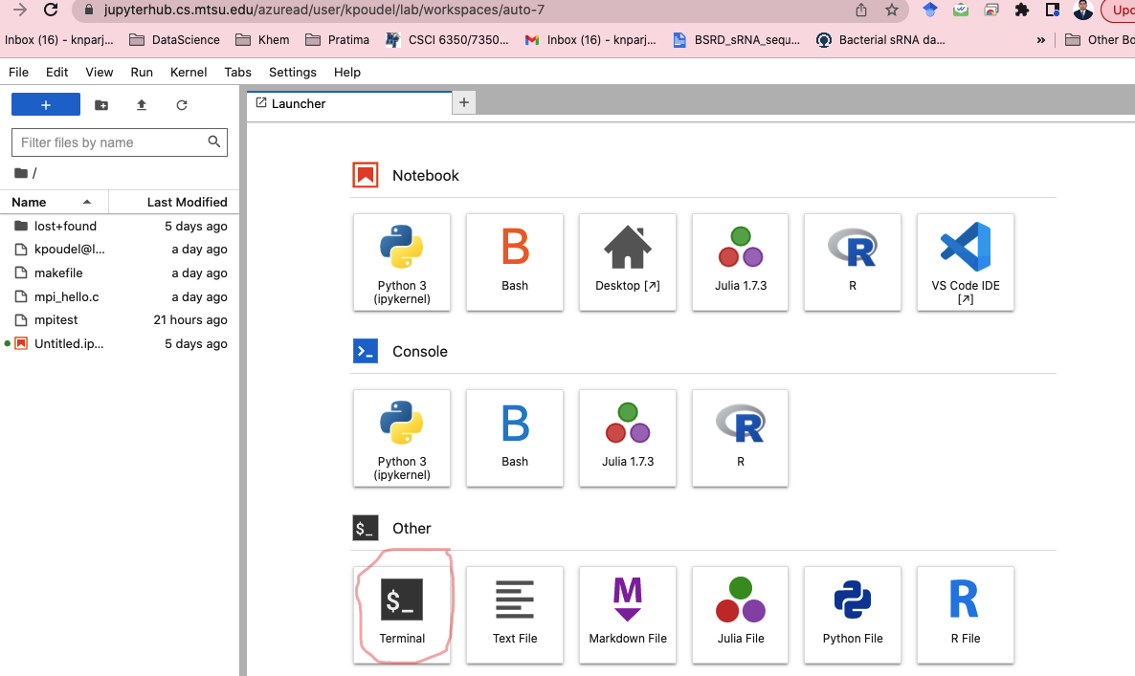

Type
sudo apt-get update
sudo apt-get install openmpi-bin openmpi-common libopenmpi-dev
This will install the openMpi/mpi

Copy l0.c in your home location

mpicc l0.c -o l0

mpiexec -n 12 ./l0

if you want to create a make file , it looks like similar to this

l0: l0.c

mpicc -o l0 l0.c

run:
mpiexec -n 16 ./l0

clean: l0
rm -f l0
make

make run

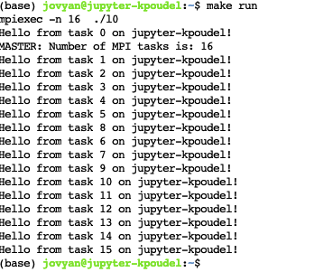

Note:
Build & run (OpenMPI alternative):
mpicc -O2 -o hello_mpi hello_mpi.c
mpirun -np 8 ./hello_mpi

