CRYSTALS Workshop

DISORDER – Tosylate

Data courtesy of Waqar Rauf and John Brown.

SO₃: Disorder

Import data and solve structure

Browse to the folder SO3-disorder, right-click on the folder title and open CRYSTALS

The Guide should start automatically, bit if not, click the red-brown CRYSTALS icon just below the File menu in the top left. The Guide will suggest Run KCCDIN – Click OK.

- Type in the space group with spaces between the operators, e.g. P 1 21/n 1 as listed in the dialogue window.
- The suggested value of Z (4) is OK just press return.
- Enter the crystal dimensions, (0.06 0.07 0.50) each length separated by a space.
- Enter the temperature (150).
- Enter the colour (yellow).
- The command prompt will close automatically.

- In the “Input KCCD data” dialog, click OK to import the data.
- Choose refinement against F-squared.
- In the “Merge equivalent reflections” dialog, click Yes.
- Click OK in the “Merge” dialog.
- When the “Filter reflections” dialog opens, click OK (i.e. set no filters).

The Guide now suggests carrying out an initial analysis of the data – click OK. Various quality indicators can be examined by exploring the different tabs. Details on how to interpret these graphs are available on the Analyse menu under Help. On completion, click Close at the bottom right.

Next, The Guide suggests Run Sir92, click OK. SIR will successfully solve the structure. Click the Quit button at the top left of the window twice to close.

When CRYSTALS asks “Do you want to use the structure from Sir92?” choose Yes.

Already there is evidence for disorder with Sir solving the structure with four carbon atoms bound to the sulphur. Correct the atom types according to the picture below (deleting C(32)) and choose Automatic numbering.

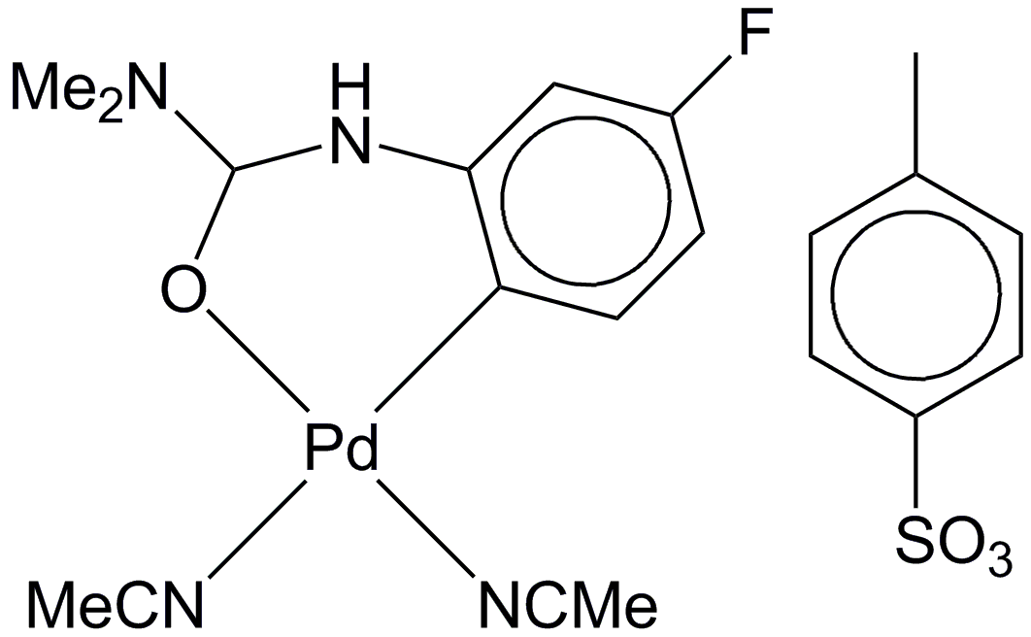

Refinement
The Guide suggests Refine posn and aniso – Click OK to bring up a dialogue box. Make sure “Refine scale, positions and Uijs” is selected and click OK. After a few cycles of refinement, it will become apparent that something is up with the SO₃ group: the adps are elongated, indicating that it is disordered. These will need dealing with.

Splitting the atom
The disordered atoms are O(22), O(23) and O(24). Where there are hydrogen atoms, it is always easiest if the disordered fragment ends before an atom that has no hydrogen atoms bound to it. However, in this case, that isn’t a problem. So, the first step in modelling the disorder is to split the disordered atoms.

Right-click on O(22) and choose Split atom O(22) from the popup menu. The original atom now needs to be deleted. Right-click on it again, and choose Delete O(22). You should now be able to see two isotropic carbon atoms, which will have serial numbers O(221) and O(222). From either hovering over the atom or from the atomic parameters list below the model, you can see that each has as occupancy of 0.5. Repeat this for O(23) and O(24).

Adding Parts
Parts tell CRYSTALS what atoms are bonded together within the disordered fragment and can be assigned using option Allocate Part Nos on the Structure menu. Since we are dealing with a new disordered assembly, click New assembly and OK. Within assembly 1 we need two groups, one for each component of the disorder. So, click New group, and OK. Click on O(220), O(230) and O(240) to add them to this group. Then create a second group and add O(221), O(231) and O(241) to that. Click Close to finish.

Restraints and Constraints
To ensure the structure refines sensibly, it is sensible to add some geometrical restraints at this point. This is easily done by clicking on the curly spring-like squiggle just below the Fourier menu. This will launch a text window, replace the line that says “NO” with the following two lines:

SAME S(21) O(220) O(230) O(240) AND
CONT S(21) O(221) O(231) O(241)

It is wise to initially refine the disordered part isotropically, while leaving the other atoms alone. This can be done by clicking on the interlinked rings below the Structure/Fourier menus. Edit the BLOCK line (remove the X’s and U’S) and add the following to refine the split atoms.:

BLOCK SCALE PART(1001,X’S ,U[ISO]) PART(1002,X’S , U[ISO])
EQUIV PART(1001,OCC) PART(1002,OCC)
WEIGHT -1 PART(1002,OCC)

Refinement should no longer be done with The Guide (if you try it a dialog will open warning you that, “continuing will overwrite any refinement instructions that you may have written”; you don’t want to do this). Hide the Guide. However, click the blue/pink R button below the Fourier/Refinement menus and click OK and this will carry out cycles of refinement without rewriting the constraints.

The disordered components will have separated out slightly. Hover the mouse over an O atom to see its occupancy. Keep clicking the refine button until convergence.

Now try refining the structure with anisotropic displacement parameters. Edit the BLOCK line in the constraint file (accessed using the interlinked rings button again) and add U’S:

BLOCK SCALE X’S U’S
EQUIV PART(1001,OCC) PART(1002,OCC)
WEIGHT -1 PART(1002,OCC)

Control the SO3 adps with restraints. Add the DELU and SIMU lines to the restraint file using the curly spring-like squiggle button:

SAME S(21) O(220) O(230) O(240) AND
CONT S(21) O(221) O(231) O(241)
DELU S(21) O(220) O(230) O(240) AND
CONT S(21) O(221) O(231) O(241)
SIMU S(21) O(220) O(230) O(240) AND
CONT S(21) O(221) O(231) O(241)

Click the blue/pink R button until convergence.

Adding hydrogens
We can add the hydrogen atoms through Structure/Add hydrogen + Fourier menu. Careful examination will show that all the hydrogen atoms on carbon have been added correctly, but there is also a hydrogen atom attached to N(4) so select it. Then check the All H atoms have been found box and click Done.

In order to ensure that the hydrogen positions ride on those for the carbon atoms, some more constraints are required. CRYSTALS has written the instructions – they can be found in the current directory in the file rideh.dat. Open this file with an editor, select and copy all the contents. Open the constraints file (using the interlinked rings button) and paste the rideh.dat instructions between the WEIGHT and END lines, e.g. .

BLOCK SCALE X'S U'S
EQUIV PART(1001,OCC) PART(1002,OCC)
WEIGHT -1 PART(1002,OCC)
RIDE C ( 7,X'S) H( 71,X'S)
RIDE etc etc
RIDE C ( 31,X'S) H( 311,X'S) H( 312,X'S) H( 313,X'S)
END

Now the structure is ready to be refined again using the blue/pink R button as before. The structure should refine successfully, with each atom in a given part having the same occupancy, and both sets of occupancies adding up to unity. The final R-factor will be around 5.4%, but this is the value for all the data. Using Recalculate phases on the Refinement menu will give the R-factor for the 2σ data (just under 3.6%).

