CRYSTALS Workshop

DISORDER - Tony Linden's Compound

C₁₆H₂₂OS: Disorder

Import data and solve structure

From the workshop dialog, choose “11. Zurich (disorder)”.

The Guide should start automatically, bit if not, click the red-brown CRYSTALS icon just below the File menu in the top left. The Guide will suggest Run Kccdin – Click OK.

- Type in the space group with spaces between the operators, e.g. P 1 21/c 1 as listed in the dialogue window.
- The suggested value of Z (4) is OK just press return.
- Enter the crystal dimensions, (0.1 0.2 0.2) each length separated by a space.
- Enter the temperature (210).
- Enter the colour (colourless).
- The command prompt will close automatically.

- In the “Input KCCD data” dialog, click OK to import the data.
- Choose refinement against F-squared.
- In the “Merge equivalent reflections” dialog, click Yes.
- Click OK in the “Merge” dialog.
- When the “Filter reflections” dialog opens, click OK (i.e. set no filters).

The Guide now suggests carrying out an initial analysis of the data – click OK. Various quality indicators can be examined by exploring the different tabs. Details on how to interpret these graphs are available on the Analyse menu under Help. On completion, click Close at the bottom right.

Next, The Guide suggests Run Sir92, click OK. SIR will successfully solve the structure. Click the Quit button at the top left of the window twice to close.

When CRYSTALS asks “Do you want to use the structure from Sir92?” choose Yes.

The structure is correct, so click Done and choose Automatic numbering.
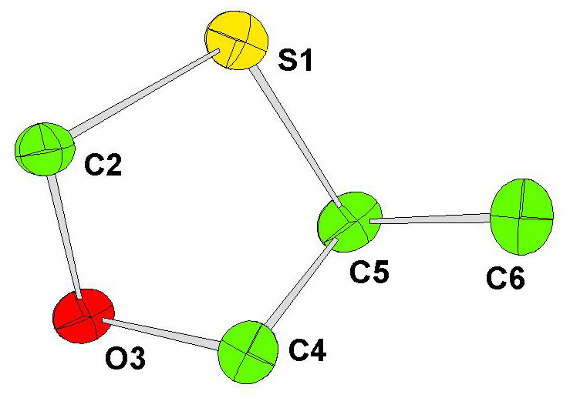

The numbering generally looks as in the diagram (plus other atoms). If your molecule has different numbers for C4,C5, & C6, change the instructions below accordingly.

Refinement
The Guide suggests Refine posn and aniso – Click OK to bring up a dialogue box. Make sure “Refine scale, positions and Uijs” is selected and click OK. After a few cycles of refinement, it will become apparent that something is up with one of the carbon atoms: the adp is elongated, indicating that it is disordered. The R-factor (bottom right) is about 13%.

The Guide proposes to Check extinction – Click OK. This shows a plot of Fo vs Fc; flattening out at high values could be an indications of extinction, but there is no evidence of that here, so click Do not. The text window gives an error message, “CRYSTALS cannot guide you further with this analysis. Please consult a professional crystallographer”, so the disorder will have to be modelled before we can procede.

Splitting the atom
In this case, it can be seen that C(5) is the most prolate, but there is also evidence of vibration in the adjacent atoms.. Dealing with hydrogen atoms is always easiest if the disordered fragment ends before an atom that has no hydrogen atoms bound to it. In this case, that leaves C(4), C(5) and C(6) to deal with. The first step in modelling the disorder is to split the disordered atoms.

Right-click on it and choose Split atom C(4) from the popup menu. The original atom now needs to be deleted. Right-click on it again, and choose Delete C(4). You should now be able to see two isotropic carbon atoms, which will have serial numbers C(40) and C(41). From the atomic parameters list below the model, you can see that each has as occupancy of 0.5. Repeat this for C(5) and C(6). The next part will be easier if the atoms are in sequential order. To ensure this, type
#EDIT
SORT SERIAL
END

From here, it would be relatively straight-forward to edit the constraints (List 12) and refine the disordered structure. However, problems will arise when hydrogen atoms are added. By using parts, it is possible to simplify the constraints to overcome these problems.

Adding Parts
Parts tell CRYSTALS what atoms are bonded together within the disordered fragment and can be assigned using option Allocate Part Nos on the Structure menu. Look at the C(5) C(60)/C(61) bond lengths. Since we are dealing with a new disordered assembly, click New assembly and OK. Within assembly 1 we need two groups, one for each component of the disorder. So, click New group, and OK. Click on the atoms which form a sensible fragment – probably C(40), C(50) and either C(60) or C(61). Then create a second group with the remaining split atoms. Click Close to finish.

Restraints and Constraints
To ensure the structure refines sensibly, it is sensible to add some geometrical restraints at this point. This is easily done by clicking on the curly spring-like squiggle just below the Fourier menu. This will launch a text window, replace the line that says “NO” with the following two lines:
SAME O(3) C(40) C(50) C(60) S(1) AND
CONT O(3) C(41) C(51) C(61) S(1)

Note that PARTs are not used because this would imply restraining the Hatoms later on.
It is also wise to refine the structure as isotropic and constrain the ADPs of the disordered component. This can similarly be done by clicking on the interlinked rings below the Structure/Fourier menus. Replace the BLOCK line with the following:
BLOCK SCALE X’S U[ISO]
EQUIV PART(1001,U[ISO]) PART(1002,U[ISO])

Refinement can no longer be done with The Guide (if you try it a dialog will open warning you that, “continuing will overwrite any refinement instructions that you may have written”; you don’t want to do this). However, click the blue/pink R button below the Fourier/Refinement menus and click OK and this will carry out cycles of refinement without rewriting the constraints.

The disordered components will have separated out slightly, but C(40) and C(41) are quite close together suggesting free anisotropic refinement may be unstable and the occupancy of the disordered components may not be equal.

So, add the following lines to the restraint file using the curly spring-like squiggle button:
DELU 0.01 O(3) C(40) C(50) C(60) S(1) AND
CONT O(3) C(41) C(51) C(61) S(1)
SIMU 0.01 O(3) C(40) C(50) C(60) S(1) AND
CONT O(3) C(41) C(51) C(61) S(1)

Replace the BLOCK and EQUIV lines in the constraint file (accessed using the interlinked rings button) with:
BLOCK SCALE X’S U’S
EQUIV PART(1001,OCC) PART(1002,OCC)
WEIGHT -1 PART(1002,OCC)

Refine again the blue/pink R button as before. The R-factor is now 12.3% and the occupancy of the disordered components are approximately 65:35.

Adding hydrogens
Because we have set up the part numbers, we can add the hydrogen atoms through The Guide by selecting the Add hydrogen option from the drop-down menu and clicking OK. Careful examination will show that all the hydrogen atoms have been added correctly, so check the All H atoms have been found button and click Done.

The correct part numbers are propagated from the parent carbon to the hydrogen atoms, so the occupancies are all taken care of. However, in order to ensure that the hydrogen positions ride on those for the carbon atoms, some more constraints are required. CRYSTALS has written the instructions – they can be found in:
C:\Wincrys\demo\disorder\rideh.dat

Copy the contents of this file into the constraints file (using the interlinked rings button) between the WEIGHT and END lines.

Now the structure is ready to be refined again using the blue/pink R button as before. The structure should refine successfully, with each atom in a given part having the same occupancy, and both sets of occupancies adding up to unity. The final R-factor will be around 9.6%, but this is the value for all the data. Using Recalculate phases on the Refinement menu will give the R-factor for the 2σ data (just under 6%).

