CRYSTALS workshops

Booklet 4 – “special shapes!”

David Watkin and Richard Cooper
University of Oxford
richard.cooper@chemical-crystallography.ox.ac.uk

Disorder and diffuse electron Density 0
Creating a 'RING' 2
Visualise the electron density 2
ZnGaPO with a Disorderly Guest 2

Disorder and diffuse electron Density
This example works with data measured for a material containing a highly mobile pentamethyl cyclopentane residue. The molecule can be modelled with anisotropic displacement parameters, but these need to be controlled by the application of similarity restraints. An alternative strategy is to include electron density distributed around an annulus.
This structure is tedious to solve, so to save time, three .DSC files have been prepared for the refinement of the Cp*.

ISO.DSC The Cp* group is refined with isotropic dps.
ANISO.DSC The Cp* group is refined with adps
RING.DSC The Cp* group is refined with a mixture of isotropic adps and electron density distributed on rings.

Choose “Ru structure (Disorder)” from the list of workshop structures, and click "Open workshop structure".
From the file menu select “Open datafile” and from the dialog, choose "NEWISO.DSC".
On the CRYSTALS command line, type:
\SFLS
REFINE
END

Note the R factor and the number of parameters making up the Cp* group.
From the file menu, select “Open datafile” and from the dialog, choose "NEWANISO.DSC" file.
Perform one cycle of refinement, note the R factor and the number of parameters being used. Now carry out an analysis of the thermal parameters

\GEOMETRY
ATOM C(1) UNTIL C(15)
AXES
EXECUTE Note that the outer atoms (C11-15) have massive major axes.
ATOM C(1) UNTIL C(15)
TLS
EXECUTE Note the principal libration of 251 degrees² and the very large R factor.
END

From the file menu select “Open datafile” and from the dialog, choose "NEWRING.DSC" and perform one cycle of refinement.

Note that the R factor is a bit higher than for the aniso refinement, but there are also fewer parameters. To see how this sort of refinement is set up, type:

\SUMMARY LIST 5 HIGH
END
\SUMMARY LIST 12
END

Occ Uiso
C 1 0.46-0.138-0.104-0.300 1 0.056 0.000 0.000 0.00 0.00 0.00 1.000 0
C 2 0.46-0.121-0.202-0.194 1 0.056 0.000 0.000 0.00 0.00 0.00 1.000 0
C 3 0.46-0.182-0.188-0.108 1 0.056 0.000 0.000 0.00 0.00 0.00 1.000 0
C 4 0.46-0.249-0.064-0.166 1 0.056 0.000 0.000 0.00 0.00 0.00 1.000 0
C 5 0.46-0.218-0.016-0.276 1 0.056 0.000 0.000 0.00 0.00 0.00 1.000 0
C 11 0.44-0.100-0.080-0.443 1 0.100 0.000 0.000 0.00 0.00 0.00 1.000 0
C 12 0.44-0.015-0.323-0.158 1 0.100 0.000 0.000 0.00 0.00 0.00 1.000 0
C 13 0.44-0.191-0.273 0.037 1 0.100 0.000 0.000 0.00 0.00 0.00 1.000 0
C 14 0.44-0.334-0.006-0.077 1 0.100 0.000 0.000 0.00 0.00 0.00 1.000 0
C 15 0.44-0.270 0.127-0.371 1 0.100 0.000 0.000 0.00 0.00 0.00 1.000 0
. . .
Occ Uiso Size
C 100 2.69-0.177-0.115-0.203 4 0.033 1.317 0.701 0.27 0.00 0.00 1.000 0
C 200 2.78-0.179-0.117-0.211 4 0.047 2.758-1.070 0.27 0.00 0.00 1.000 0

#LIST 12
FULL
CONT C(1,X'S) UNTIL C(15) refine x,y,z of the 10 C atoms
EQUIV C(1,U[ISO]) UNTIL C(5) refine a single idp for the inner atoms
EQUIV C(11,U[ISO]) UNTIL C(15) refine a single idp for the outer atoms
CONT C(100,X'S,U[ISO],DECLINATION, SIZE, AZIMUTH) refine the inner ring
CONT C(200,X'S,U[ISO],DECLINATION, SIZE, AZIMUTH) refine the outer ring
EQUIV C(1,OCC) UNTIL C(5) C(100,OCC) refine a single occupation parameter for the inner atoms and ring
EQUIV C(11,OCC) UNTIL C(15) C(200,OCC) the same for the outer atoms and ring
WEIGHT -5 C(100,OCC) C(200,OCC) See below
END
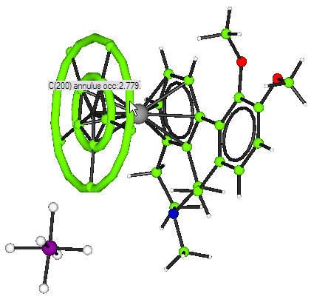
In the parameter listing, note that the inner and outer atoms each have a single occupancy (about 0.5) and Uiso. The 'atoms' C100 and C200 are the 'rings'. Each ring could contain up to 5 carbon atoms, so its occupation factor would be 5.0. However, the same volume is also being shared with five normal atoms. These were given starting occupancies of 0.5, so that the ring starting occupancy was 5.0-(5*0.5)=2.5. During refinement, for every shift, δ, in a carbon atom occupancy, there has to be a shift of -5δ in the corresponding ring occupancy.

Creating a 'RING'

Return to the first file: NEWISO.DSC. (File->Open Datafile).
We will create a ring from the inner and outer atoms, and then delete the atoms altogether and refine the ring at full occupancy.
\EDIT
RING 100 C(1) UNTIL C(5)
RING 200 C(11) UNTIL C(15)
RENAME QR(100) C(100) QR(200) C(200)
DELETE C(1) UNTIL C(15)
LIST HIGH
END

Create refinement directives and do some least squares.
\LIST 12
FULL C(100,X'S,U[ISO],SIZE,DECLINATION,AZIMUTH) UNTIL C(200)
END

As this is a non-routine refinement, the GUIDE isn’t much use. Instead, type:
\SCRIPT SIXCYCLE
to carry out the cycles of refinement.

Visualise the electron density
Select three or more atoms in the Cp* ring, right click one of the selections and choose “Slant Fourier map”. Using Michal Husak’s MCE you should be able to see the ‘lumpy’ annulus of electron density.

ZnGaPO with a Disorderly Guest

This example structure (Andrew Cowley and Ann Chippindale) is a material containing a highly disordered cyclo-pentane molecule on a special position! It can be modelled very tediously with several part occupied cyclo-pentane molecules. An alternative strategy is to include electron density distributed around a spherical shell.
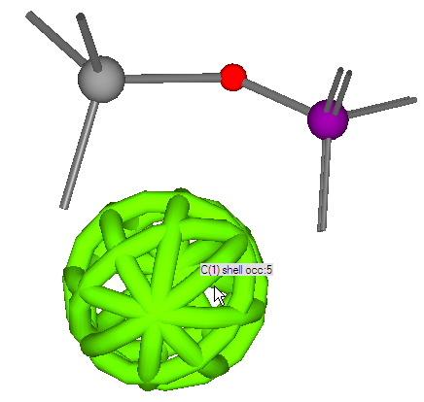
From the workshop dialog, choose “ZnGaPO (disorder)”.
Andrew has prepared all the data as a giant command macro. To read in the structure and the data type:
#USE ZNGAPO.DAT
Note that the ‘shell’ is represented graphically with holes in – that is so you can see through to the inside, there aren’t really gaps.
Note that the Ga site should really be a disordered Ga and Zn, but this makes little difference to the refinement.
Visualise the whole structure, by running Cameron and choosing the Complete packing option.
Unfortunately, Cameron cannot display the spherical shell, but you do see an atom C1 at it’s centre.

View down the a, b and c axes.
The disordered cyclopentane, represented here by C1, is at the centre of the framework’s cavity.

