CRYSTALS workshops

Twinning

Simon Parsons and Richard Cooper
University of Oxford
richard.cooper@chemical-crystallography.ox.ac.uk

B₁₀F₁₂: Merohedral Twin

Summary information
This data for this crystal structure was collected in Edinburgh.

The cell is tetragonal with a=b=6.412, c=27.551. The space group is I 4₁/a.

From the workshop dialog, choose B10F12 Twin.
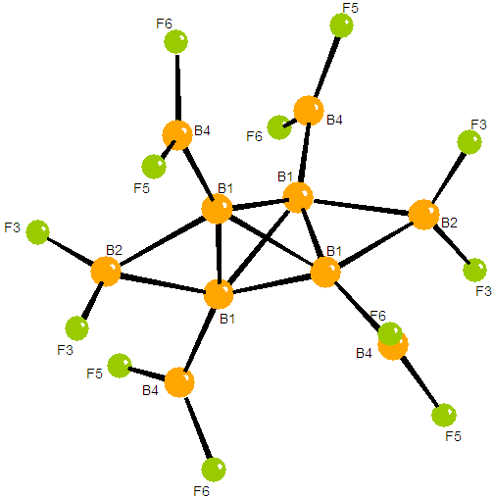
Using the GUIDE import the SHELX hibflq.ins file.
Remember that the space group is I 41/a.

Using the GUIDE import the SHELX reflection file, hibflq.hkl.

Solve the structure in Sir 92 and read the results back into CRYSTALS.

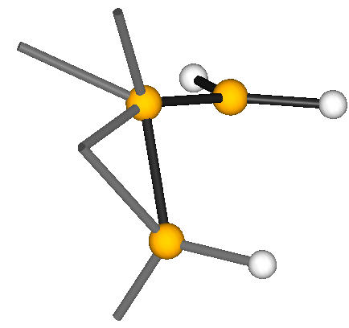
The structure is on a special position in the space group, so the model is only about one-quarter of the molecule. It will look something like the picture on the right.

Proceed with the refinement.
You will find that it fails to refine to a decent R-factor. (22% is about the best you can do with isotropic refinement – this is a common problem with twins – they will solve, but not refine.)

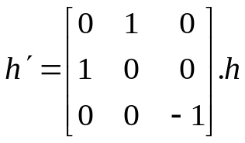
The twin law
a
b
ROTAX/ANALYSE will identify several alternative correct twin laws. However it is instructive to work out and input the twin law by hand. The most common type of twinning in tetragonal systems is a 180° rotation about the [110] direction (i.e. the diagonal across the a-b unit cell face) which transforms the indices as shown. Once the twin law is identified, this type of twinning is easily treated in CRYSTALS.

Twinned Refinement: Easy
Guided treatment of two-component twins is implemented in the CRYSTALS GUI:
Choose Tools -> Input Twinned Data from the menus.

The number of matrices is 2, of which the first is the identity.
Twin Law 1, the identity, must always be present. Click New Twin Law and then update the elements in the matrix box.
0 1 0 1 0 0 0 0 -1
Click Apply Twin Laws and continue.
Restart the Guide (hide it first if it is still open), and carry on with the refinement.

The R-factor should drop immediately to below 7%, and at the end of the guided refinement should end up below 2.5%

