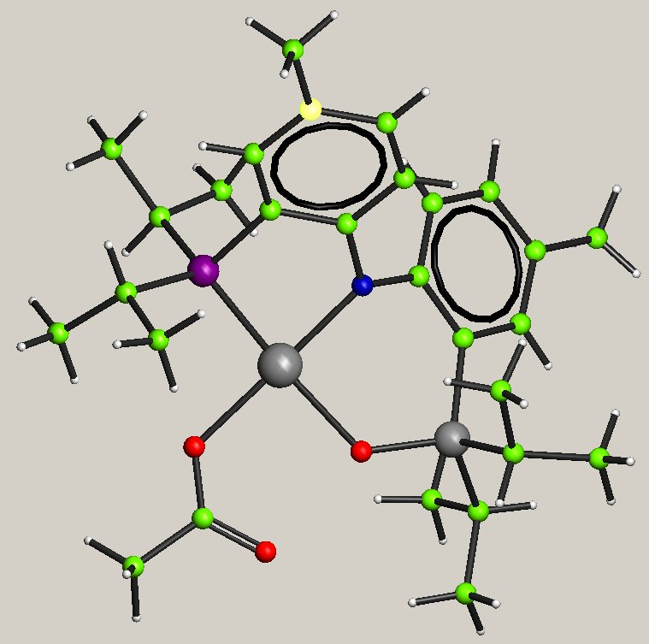
Non-merohedral Twin.

Data provided by Bruce Foxman, Brandeis University.

Bruce provided an hkl4 reflection file containing reflections without any indication of twinning. The structure solves but R remains at about 16%.
The Fo-Fc plot is typical of twinned data, but ROTAX fails to find a twin law.

Bruce then provided an hkl5 file obtained with the following twin law:

-1 0 0
-.007 -1 -.222
0.063 -.001 1

Open CRYSTALS, start the Guide.

Import shelx.ins. This contains the basic information plus the current structure in SHELX format. CRYSTALS does most of the necessary reformatting. Read in the hkl4.hkl file
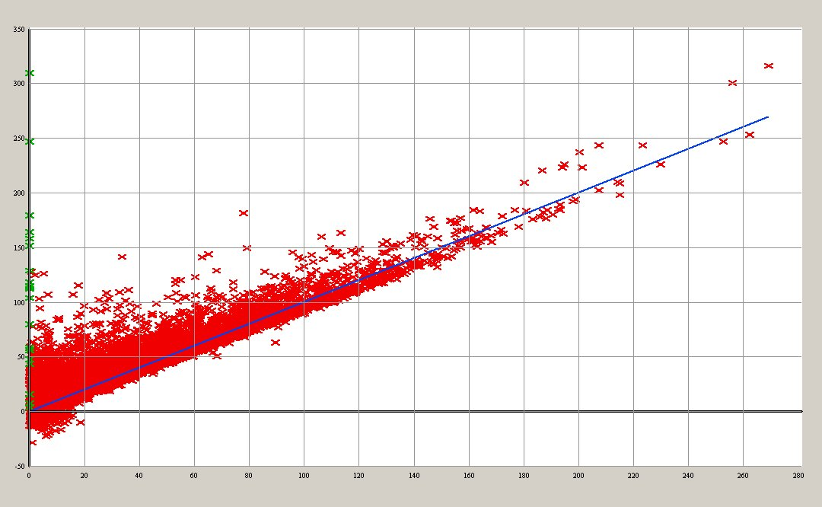
Do aniso refinement - the Rfactor sticks at about 16%. Look at the Fo/Fc plot.

The spread of points above the main distribution is often characteristic of twinning. Try ROTAX. It should not find a suitable twin law, so cancel it.

On the menu X-ray Data, choose Import hklf5 file. Browse for shelx5.hkl. Tick import new twin law.

You will be prompted for the number of twin laws, in this case 2, the unit law plus the one Bruce provided. Input the second law. On the guide click aniso refinement. Note that twin element refinement is automatically set.

Compute the new overall scale factor. Either select Refinement/Calculate Scale Factor from the Menu or type on he command line

#sfls
scale
end

You can now either do several cycles of refinement using The Guide or, perhaps safer, first do a few cycles refining only the overall scale factor and the twin element scales.

#list 12
block scale
sumfix element scales
end
#sfls
refine
refine
end

