CRYSTALS Workshop

DISORDER – Sugar
Example provided by Sarah Jenkinson and George Fleet

Disordered Methoxy Group

Import data and solve structure

Browse to the folder Sugar-disorder, right-click on the folder title and open CRYSTALS

The Guide should start automatically, bit if not, click the red-brown CRYSTALS icon just below the File menu in the top left. The Guide will suggest Import SHELX Data – Click OK.

- Choose refinement against F-squared.
- Crystals will ask you to input the RES or INS data, so browse for the file sugar.ins. CRYSTALS will suggest the space group P 21/c, which is correct, so Click OK.
- CRYSTALS will then ask you to input the reflection data – Click OK.
- Since this is centrosymmetric, CRYSTALS suggests you merge the Friedel pairs; Click Yes.
- When the “Filter reflections” dialog opens, click OK (i.e. use a low angle, sinθ/λ cut-off).

The Guide now suggests carrying out an initial analysis of the data – click OK. Various quality indicators can be examined by exploring the different tabs. Details on how to interpret these graphs are available on the Analyse menu under Help. On completion, click Close at the bottom right.

Next, The Guide suggests Run Sir92, click OK. SIR will successfully solve the structure. Click the Quit button at the top left of the window twice to close.

When CRYSTALS asks “Do you want to use the structure from Sir92?” choose Yes.

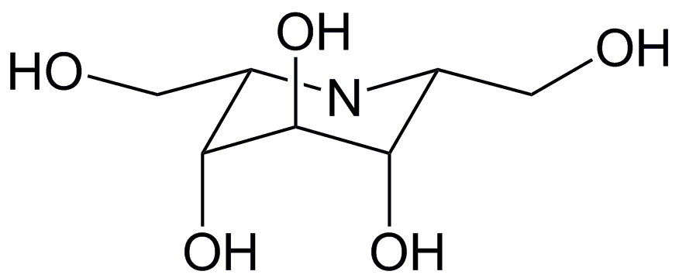
Already there is evidence of potential problems since the atom types don’t match the prediction (below) and there is an extra atom. Correct the atom types (deleting C(14)) and choose Automatic numbering.

Refinement
The Guide suggests Refine posn and iso – Click OK to bring up a dialogue box. Make sure “Refine scale, positions and Uiso” is selected and click OK. After a few cycles of refinement, it will become apparent that something wrong with one CH₂OH group: the adps are enlarged. From the drop-down menu, select Refine posn and aniso and click OK. The ADPs are now very elongated indicating that it is disordered. The R-factor is over 18% – This will need dealing with.

Splitting the atom
The disordered atoms are C(12) and O(13) (although C(5) looks slightly prolate too). Where there are hydrogen atoms, it is always easiest if the disordered fragment ends before an atom that has no hydrogen atoms bound to it. However, in this case, that isn’t a realistic option and the most sensible place to end “the disorder” is at the junction with the ring. So, the first step in modelling the disorder is to split the disordered atoms.

Right-click on C(12) and choose Split atom C(12) from the context menu. The original atom now needs to be deleted. Right-click on it again, and choose Delete C(12). You should now be able to see two isotropic carbon atoms, which will have serial numbers C(121) and C(122). From either hovering over the atom or from the atomic parameters list below the model, you can see that each has as occupancy of 0.5. Repeat this for O(13).

Adding Parts
Parts tell CRYSTALS what atoms are bonded together within the disordered fragment and can be assigned using option Allocate Part Nos on the Structure menu. Since we are dealing with a new disordered assembly, click New assembly and OK. Within assembly 1 we need two groups, one for each component of the disorder. So, click New group, and OK. Click on C(120) and O(130) to add them to this group. Then create a second group and add C(121) and O(131) to that. Click Close to finish.

Restraints and Constraints
To ensure the structure refines sensibly, it is sensible to add some geometrical restraints at this point. This is easily done by clicking on the curly spring-like squiggle just below the Fourier menu. This will launch a text window, replace the line that says “NO” with the following two lines:

DIST 1.53, 0.01 = C(5) TO C(120), C(5) TO C(121)
DIST 1.44, 0.01 = C(121) TO O(131), C(121) TO O(131)

It is also wise to refine the structure as isotropic which can easily be done using The Guide, by selecting Refine position and iso from the drop-down menu and clicking OK.

It is clear at this point that one group consists of a large carbon ADP with a small oxygen ADP while for the second group they are the other way round. This suggests that the fragments are not equally occupied and the atoms are paired up incorrectly. To fix this, right-click on the smaller O(131), choose Edit from the context menu and change the serial number to 130 and the group number to 1, then click Apply changes. Do the same to the enlarged O(130) and change its serial number to 131 and its group number to 2. Then using The Guide, select Refine position and iso and click OK.

The occupancies now need to be refined. This can similarly be done by clicking on the interlinked rings below the Structure/Fourier menus. After the BLOCK line add the following:

EQUIV PART(1001,OCC) PART(1002,OCC)
WEIGHT -1 PART(1002,OCC)

Refinement can no longer be done with The Guide (if you try it a dialogue will open warning you that, “continuing will overwrite any refinement instructions that you may have written”; you don’t want to do this). However, click the blue/pink R button below the Fourier/Refinement menus and click OK and this will carry out cycles of refinement without rewriting the constraints.

You can try refining the structure with anisotropic displacement parameters, but restraints are advisable. So, add the following lines to the restraint file using the curly spring-like squiggle button:

DELU 0.01 C(5) C(120) O(130) AND
CONT C(5) C(120) O(130)
SIMU 0.01 C(5) C(120) O(130) AND
CONT C(5) C(120) O(130)

Replace the BLOCK lines in the constraint file (accessed using the interlinked rings button again) with:

BLOCK X’S U’S

Refine again with the blue/pink R button as before. The R-factor is now 9.3% and the occupancy of the disordered components are approximately 62:38.

Adding hydrogens
Because we have set up the part numbers, we can add the hydrogen atoms through The Guide by selecting the Add hydrogen option from the drop-down menu and clicking OK. In addition to the hydrogen atoms CRYSTALS has located bound to the carbon atoms there are also hydrogen atoms visible for the nitrogen and the oxygen atoms. Select these so that they are added to the model.

The hydrogen atoms for the disorder are only partly visible at this time, but have been added geometrically where possible (i.e. on the alkyl carbon atoms). Since the two disordered components are close together, it is largely a matter of personal taste whether you prefer the model to have two hydrogen atoms on C(5), or one, therefore CRYSTALS does not do it by default. You can either choose to use one at this point, or add them separately (below). Once you are happy, click Done.

If you wish to include two separate hydrogen atoms, you can now Right-click on C(5) and choose Add hydrogens to C(12) from the context menu. Select the SP3, 1H option and click Next, then click N(4), C(6) and C(120) in turn. Repeat to add the second hydrogen atom using the atoms N(4), C(6) and C(121). Note how close together the atoms are. The correct part numbers are propagated from the parent carbon to the hydrogen atoms, so the occupancies are all taken care of.

Hydrogen atoms cannot be added to the OH groups in the same way, because the positions cannot be calculated purely geometrically. However, they are visible in the difference map. Under the Fourier menu, select Difference and click OK then click Transfer. This will bring up a plot of the strongest peaks. Switching to the Model tab, will show where they are on in the structure and the strongest two are next to the disordered oxygen atoms.

Right-click on Q(1) and choose Change type … H from the context menu. Do the same for Q3. Click the box that says Delete remaining peaks on exit and click Exit. Because these hydrogen atoms have been added via the difference map, the part numbers, occupancies and serial numbers will need to be corrected. These can be done in many different ways, but the easiest is probably to right-click on the atom in question and choose Edit. Use the same occupancy, assembly and part numbers as the parent oxygen atoms. Crystals will correct the numbering itself using the Renumber hydrogen tool on the Structure menu.

Refining the hydrogen positions and displacements can be done using The Guide; select Add hydrogen from the drop-down menu and click OK and No. Careful examination should show that all the hydrogen atoms have now been added correctly, so check the All H atoms have been found button and click Done.

In order to ensure that the hydrogen positions ride on those for the carbon atoms, some more constraints are required. These can be added manually, but that is very slow. It is best to create the riding constraints using the Setup directives and constraints option on the Refine menu, clicking Continue to overwrite the old instructions and OK.

The occupancy refinement can be included in the final refinements, by clicking on the interlinked rings below the Structure/Fourier menus and adding the following after the BLOCK command:

EQUIV PART(1001,OCC) PART(1002,OCC)
WEIGHT -1 PART(1002,OCC)

Now the structure is ready to be refined again using the blue/pink R button as before. The structure should refine successfully, with each atom in a given part having the same occupancy, and both sets of occupancies adding up to unity. The final R-factor will be around 5.3%, but this is the value for all the data. Using Recalculate phases on the Refinement menu will give the R-factor for the 2σ data (just over 4%).

