CRYSTALS workshop

Crystallographic Editors

Structure Manipulation in CRYSTALS and Cameron

Background

Summary
Manipulation of the model is generally not a problem for small or well behaved structures, but it can become time consuming for large or ill-behaved structures. Manipulation of the model (i.e. the atomic coordinates, LIST 5) may be required for two different reasons:

Changing parameter values
This might simply be changing an atom type, or site occupancy, or it might mean shifting whole groups of coordinates to 'regularise' a fragment.

Reorganising the list of atoms
The list might need to be re-organised so that atoms in different fragments are collected together, or so that the most interesting atoms are at the top of the list. These rearrangements are usually concerned with preparing the structure for publication, but careful ordering and numbering can also simplify some tasks.

Strategies
CRYSTALS has a large number of facilities for manipulating the model.

1. Text editors
This can be a very convenient way for changing a few individual parameters

Atom identifiers eg C7 to C17
A few parameter values, eg occupation factors

It is inconvenient for making many related changes.

2. Graphical editors
These are especially useful for making broad qualitative changes to a structure.

Deleting spurious atoms/peaks
Renaming a few atoms
Deleting spatially related groups of atoms
Re-organising a structure within the unit cell

CRYSTALS contains two integrated graphical utilities.
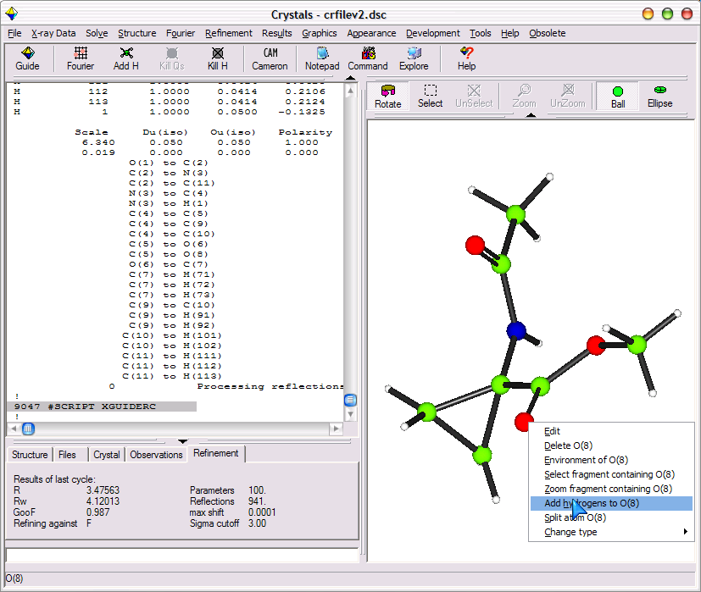
The Model Window
This is generally visible throughout a structure analysis. It provides quick access to the most commonly used editing features.
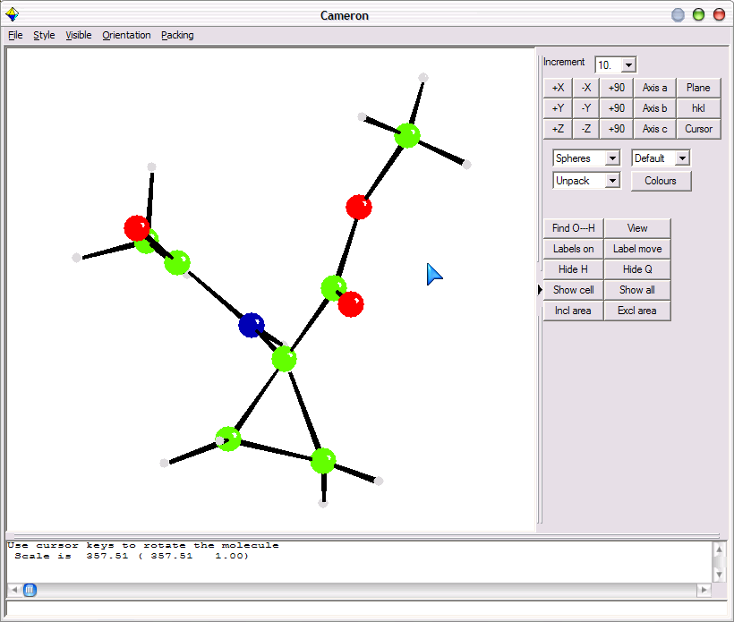

CAMERON
This is a complete visualisation and modelling utility, mainly intended for the interpretation stage of an analysis, but sometimes useful during the development of difficult structures.

3. Crystallographic editors
A crystallographic editor can be used to apply 'crystallographic' operations to one or a group of atoms:
Apply an origin shift or transformation, re-organise the atom list, make conditional changes to the atom list, operate on groups of parameters, eg:

DELETE C(12) UNTIL LAST. Deletes all atoms from C12 until end of list
SPLIT 10 N(14) Splits N14 into N140 and N141
CENTROID 100 C(23) UNTIL C(28) Creates a pseudo-atom QC100 at the centroid of the listed atoms.
SHIFT x y z ALL Shifts the atomic coordinates of all the atoms by x,y and z
SELECT U[ISO] LT 0.08 Selects (keeps) only those atoms with Uiso less
than 0.08
TYPECHANGE U[ISO] GE .04 C All atoms with Uiso >= 0.04 are changed to carbon.
SORT SERIAL Sort the atoms in order of increasing serial number
SORT C N O Sorts the atoms into the order C,N,O followed by other atoms alphabetically.
RESET OCC 1.0 ALL
RESET U[ISO] 0.03 O(1) O(3) N(5)
RESET TYPE C O(2) O(13) The individual atoms, e.g. O(3), can be specified by clicking in the model window.
PERTURB .02 FIRST(X) UNTIL LAST Apply random shifts (mean=0.0, esd 0.02A) to all the x -coordinates.
RING 100 C(1) UNTIL C(5) Replace the 5 atoms by a single annular scattering factor.

4. Tailored Utilities
These perform complex calculations on groups of atoms and can be used as both diagnostic operations and as structure modifiers.

For example:
Molecule assembly, TLS analysis. geometric comparison, planarity analysis, Fourier refinement, hydrogen placement, eg:

Molecule Assembly
Applications exist for assembling atoms into molecules, for collecting peaks into an existing molecule, for re-ordering the list of atoms, and for re-numbering the atoms.

\COLLECT
SELECT TYPE=ALL
END
Collects all atoms into molecular fragments. The order of the atom list is not changed.

\REGROUP
SEL TYPE=ALL SEQUENCE=YES
END
Assembles molecular fragments, moving the atoms in the atom list, and giving them sequential numbers.

\PEAK 10 5
SELECT TYPE=PEAK
END
Takes the peaks from a Fourier map and eliminates those coincident with existing atoms

Planarity
Least squares refinement proceeds best from a good starting model. The 'PLANE' directive, which is normally used to compute best planes and the deviations from then, can also be used to flatten a group and so improve the model.

\GEOMETRY
ATOM C(1) UNTIL C(12)
PLANE
REPLACE C(1) UNTIL C(13)
END

Note that C13 was not included in the first atom list - one might imagine it was poorly located away from the best plane.

Geometry Regularisation
The REGULARISE instruction can be used to compare a molecular fragment with another fragment or a standard geometry. It can also be used to regularise on fragment on the basis of another, or to fill in missing atoms.

\REGULARISE REPLACE
GROUP 7
ATOM P(1) F(1) UNTIL F(6)
OCTAHEDRON 1.58 1.58 1.58
END

TLS Analysis
The TLS calculation is normally used as a diagnostic tool or to adjust bonds for librational motion. It can also be used to homogenise the adps.

\GEOMETRY
ATOM C(1) UNTIL C(6)
TLS
REPLACE C(1) UNTIL C(7)
END

Structure Manipulation.

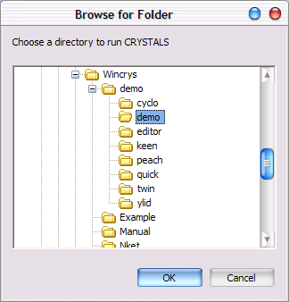
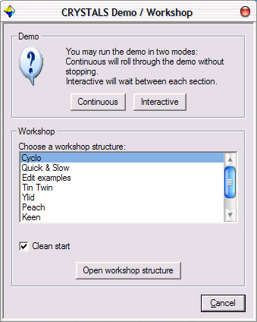
Double click on the CRYSTALS icon on the desktop, the "Browse for Folder" dialog will be displayed. The selected directory should already be demo, if it isn't then browse to find it: c:\wincrys\demo\demo, highlight it and then click OK
CRYSTALS will start, and the demo / workshop dialog will open automatically.
Choose Edit examples from the list of workshop structures and click "Open workshop structure".

To bring this dialog back at any point either close and restart CRYSTALS, or choose " Workshop/Demo" from the "Help" menu.

Simple Examples

Text Editors
Text editors provide a very convenient way for changing a few individual parameters, but are inconvenient for making many related changes.

Let’s say we want to change C1, C2, C4, C6 into O, and C3 to N, using a text editor:
Type the following command into CRYSTALS,
\USE WORK1.DAT

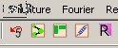
Select the button to “Manually Edit Parameters” from the toolbar and make the changes.

Save the file and exit notepad to read the model back into CRYSTALS.

Graphical Editors
For larger problems, text editing is tedious. The model window provides a continuous view of the structure, and also gives graphical access to some editing and evaluation tools.
This next example is an organic acid.
Input the demonstration file by typing:
\USE WORK2.DAT
The model window will show the structure.
The text window shows that the atom numbers are not sorted. They can easily be sorted in CRYSTALS
Type the following commands into CRYSTALS:
\EDIT
SORT SERIAL
END
The parameter pane below the model will show the new numbering, or hover the cursor over any atom to show its name.
Right-clicking on an atom will enable you to change the atomic types.
Change the acid group to oxygens.

Crystallographic Manipulations

CRYSTALS can often sort out the numbering for you:
Re-input the acid structure:
\USE WORK2.DAT

Start by moving the atom (C(10)) that you want to be numbered '1' to the top of the atom list.
\EDIT
MOVE C(10)
END

You will see C(10) move to the top of the list in the parameter pane. Now issue
\REGROUP
SELECT TYPE=ALL SEQUENCE=YES GROUP=YES
END
Look at the parameter pane again. C19 and C20 can easily be changed to O in the model window.

Or you can sort the numbering out for yourself:
Re-input the original structure.
\USE WORK2.DAT
Then choose “Structure” -> “Renumber atoms” from the menus.

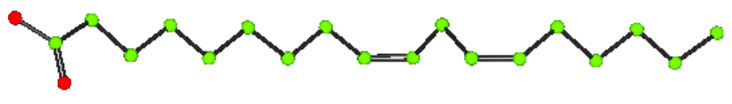
Click each atom in turn and they will be numbered from 1-20 in the order you click on them.
Then click Done.

Adding Hydrogen Atoms
To finish off the model, add hydrogen atoms:
Select “Add Hydrogens Geometrically” from the “Structure” menu.
The acid hydrogen will not be added automatically.
Use Cameron to look at the completed structure.

Advanced Examples

Working with a Z'=4 structure
The next demonstration file is from a structure with 4 molecules in the asymmetric unit. The original coordinate list contains all the atoms or peaks in a unique half of the cell. Type:
\USE WORK3.DAT
CRYSTALS can assemble the atoms into molecules:
On the Structure menu, select ‘Collect atoms by Symmetry’ and collect all the atoms together.
When there is only one molecule in the cell, this is often all that is necessary. For Z'>1 structures, or extended lattice structures, a more hands-on approach is required. This can be done through Cameron.
The idea here is to move the four individual molecules so that they can be seen and worked with more easily. We colour the four molecules differently, use the space group symmetry to pack the structure and then choose one molecule of each colour to form our new model, such that the molecules are not all on top of each other.
Click Cameron on the toolbar and then type and click:
COLOUR FRAG <click an atom> RED VIEW
(<click an atom> from one molecule with the mouse)
Repeat the command above selecting an atom from each of the other molecules and a different colour. Permitted colour names are:
BLACK BLUE CYAN GREEN GREY LBLUE LGREEN LGREY LRED MAGENTA ORANGE PINK PURPLE RED WHITE YELLOW
You should now have 4 differently coloured molecules.
Change the pull-down listbox on the right, which currently says "Unpack", to "Complete".
This will create a mass of related molecules.
Use the “AXIS” buttons to get different views of the structure.
The view along the c-axis separates the molecules into layers.

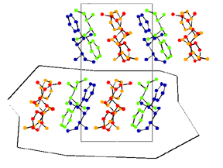
Use the “Incl Area” button to enclose one layer of molecules, then do “+90” about the x axis to look onto the layer.
Identify four molecules (one of each colour) that you wish to keep. Then type:
EXCLUDE ALL INCLUDE FRAG aa bb cc dd VIEW
(where aa etc are single atoms selected from each fragment).
The EXCLUDE and INCLUDE must be on the same line.
Cameron can now be closed and the altered structure read back into CRYSTALS.

The GUI can now help with the re-naming of the Q peaks to real atoms:
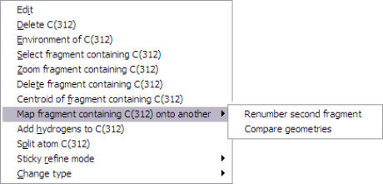
- Right-click on an atom in the molecule that is numbered correctly.
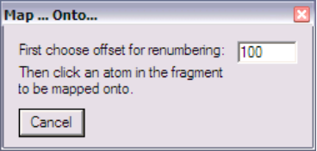
- Choose “Map fragment containing C(n) onto another” -> “Renumber second fragment”.

- Enter a serial offset (e.g. 100).
- Click one atom in the molecule that is to be renumbered.
Provided that your molecule contains no internal non-crystallographic symmetry, the second molecule will be assigned the same elements and an offset serial number from the first.

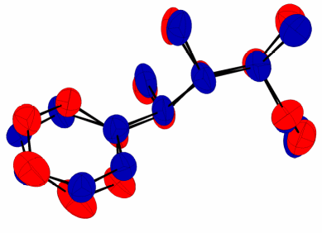
The related “Compare geometries” menu option displays the two fragments overlapped using a least squares fit. It gives a qualitative idea of the differences between the two molecules. (Quantitative answers are in the text output.)
If trying this, when in Cameron, type
OBEY regular.oby
to colour the fragments by number.
Don’t pack the structure, and don’t save the changes after exiting Cameron. The structure you see is in an orthogonal unit cell defined by the best plane system of the molecule.

Origin Shifts and Changing Space Group
Sometimes a structure which is actually in a centrosymmetric space group will not solve by direct methods in that space group. A common trick is to remove the centre of symmetry and use a less symmetric space group (e.g. P-1 becomes P1, or P2₁/c becomes P2₁). Once the structure is solved, it must be transformed to the real space group.
The file WORK4.DAT contains an example of this. The true space group is P 1 2₁/n 1, but the structure has been solved in P 1 2₁ 1. This yields twice as many atoms due to the absence of the centre of symmetry.
The task is to find the centre of symmetry and place this at a suitable point (e.g. ½,½,½), removing the excess atoms.
Type \USE WORK4.DAT then use Cameron to view the structure.
The atom numbering is arbitary ( “Labels on”), as is the location in the cell (“Show Cell”).
Input the proper space group:
\SPACE (NB. Young people may prefer the
SYMBOL P 1 21/N 1 menu item “X-ray data”->
END “Input/Edit Space Group”!)
Output a summary of the space group operators in the text window:
\SUMMARY LIST 2
END
Force a redisplay of the structure (it hasn’t noticed that the space group has changed):
\BONDCALC FORCE
END
It looks chaotic because the centre is not properly located – hence lots of incorrect bonds to symmetry related atoms. CRYSTALS can find the centroid for you. By subtracting it’s coordinates from all atoms, you can apply the necessary origin shifts.
Right-click any atom in the model window, and select 'Centroid of fragment containing' from the drop-down menu.
A 'QC' atom will appear at the centroid, and its coordinates can be seen in the text window.
You will need to type in the negated x y and z coordinates of the centroid.
\EDIT
SHIFT -x -y -z ALL (where x, y, z are the coordinates of QC(1))
EXECUTE
SHIFT .5 .5 .5 ALL
EXECUTE
SELECT TYPE NE QC (get rid of the QC (centroid) atom)
END
You will see that the two molecules overlap quite well. The PEAK command (usually used for operating on the results of Fourier peak searches, LIST 10) can be used to tidy up the structure.
\PEAK 5 5
SELECT TYPE=AVERAGE
END
\COLLECT
END

