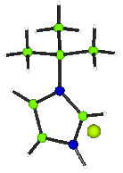
CRYSTALS workshops

“twins”
Simon Parsons and Richard Cooper

Keen (C₇H₁₃ClN₂): Pseudo-merohdral twin

Summary
This data for this material were collected by on a Nonius KappaCCD diffractometer with Mo Kα radiation.

Expected Formula C₇ H₁₃ Cl N₂. Temperature 150K
Monoclinic b unique

- The structure was solved with 2 molecules in the asymmetric unit in P2₁ but failed to refine to an R-factor below 30%.
- Using the systematic weaknesses as a guide, it was postulated that the sample was a poor quality in P 2₁/c. The structure again solved in this space group, but failed to refine below 20%.
- Finally, it was recognised that the material was twinned. The R factor fell to below 3%, with all the hydrogen atoms showing in a difference map.

First Attempt (for your information only):
Importing and solving using the space group P 2₁ gives a reasonable structure with two independent molecules, but it fails to refine.
SIR92 leaves a diagnostic file in the working folder. CAMERON can also be used to get a global view of the structure.

Tools at your disposal:
You could open SIR92.lis. Type: $notepad sir92.lis
The volume per atom looks OK, there is no translational pseudo-symmetry, but all the statistics point strongly to acentric. This is unusual (but not impossible) for a synthetic material.
You could use CAMERON to look along the b axis at a ‘complete’ packing diagram. The two independent molecules might be related by a c glide. To do this you would:

Click Cameron on the toolbar. Change selection from Unpack to Complete. Click the button Axis b. Close Cameron window. Do not apply changes made in Cameron.

Second Attempt (for you to try):
If you have tried the First Attempt, navigate to the Keen folder and delete the crfilev2.dsc file. Import the data (keen.ins, keen.hkl), trying space group P 1 2₁/c 1. Follow the same steps as for the other structures, but take note of the statistics for the systematic absences, and for the merging R factor.
The structure should solve in Sir 92. Delete the spurious C peaks, but be careful not to delete the Cl anion!
You will find that it still fails to refine to a decent R-factor.

Diagnosis:
Scroll backup up the text page until you find the reflection input section.

- The mean value for the systematic absences is unusually high (it is almost always greater than zero).
- R_{int} is good, especially for the medium and strong reflections.
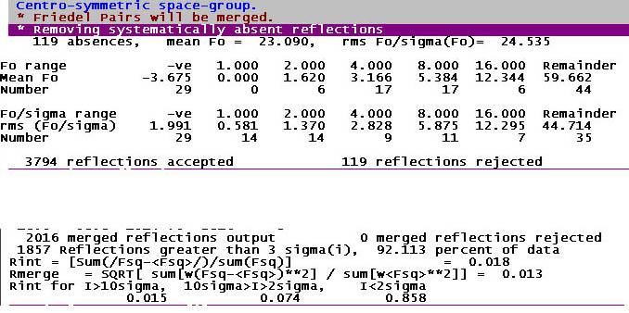
- Look at the systematic absences plot

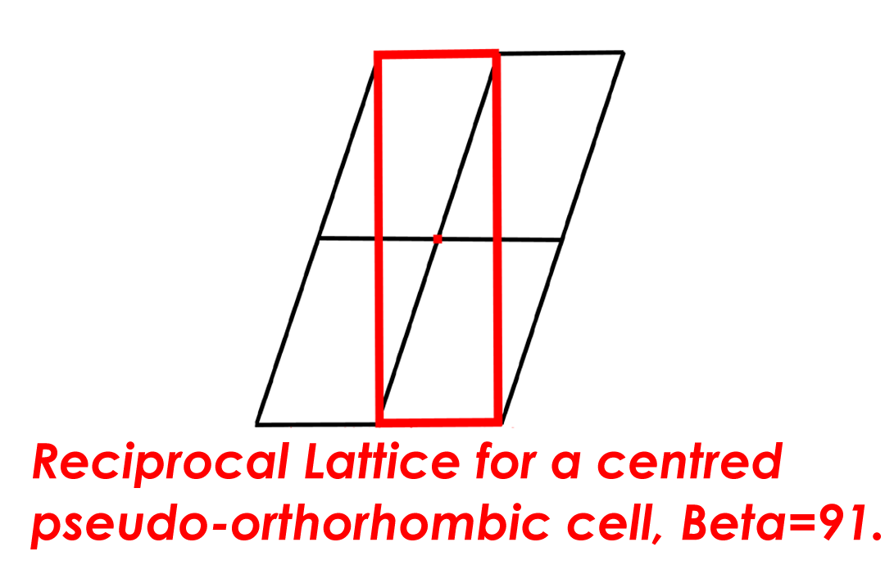
Start worrying about the crystal being twinned. A scale drawing of the reciprocal lattice shows the possibility of a pseudo-orthorhombic super-cell (in red).
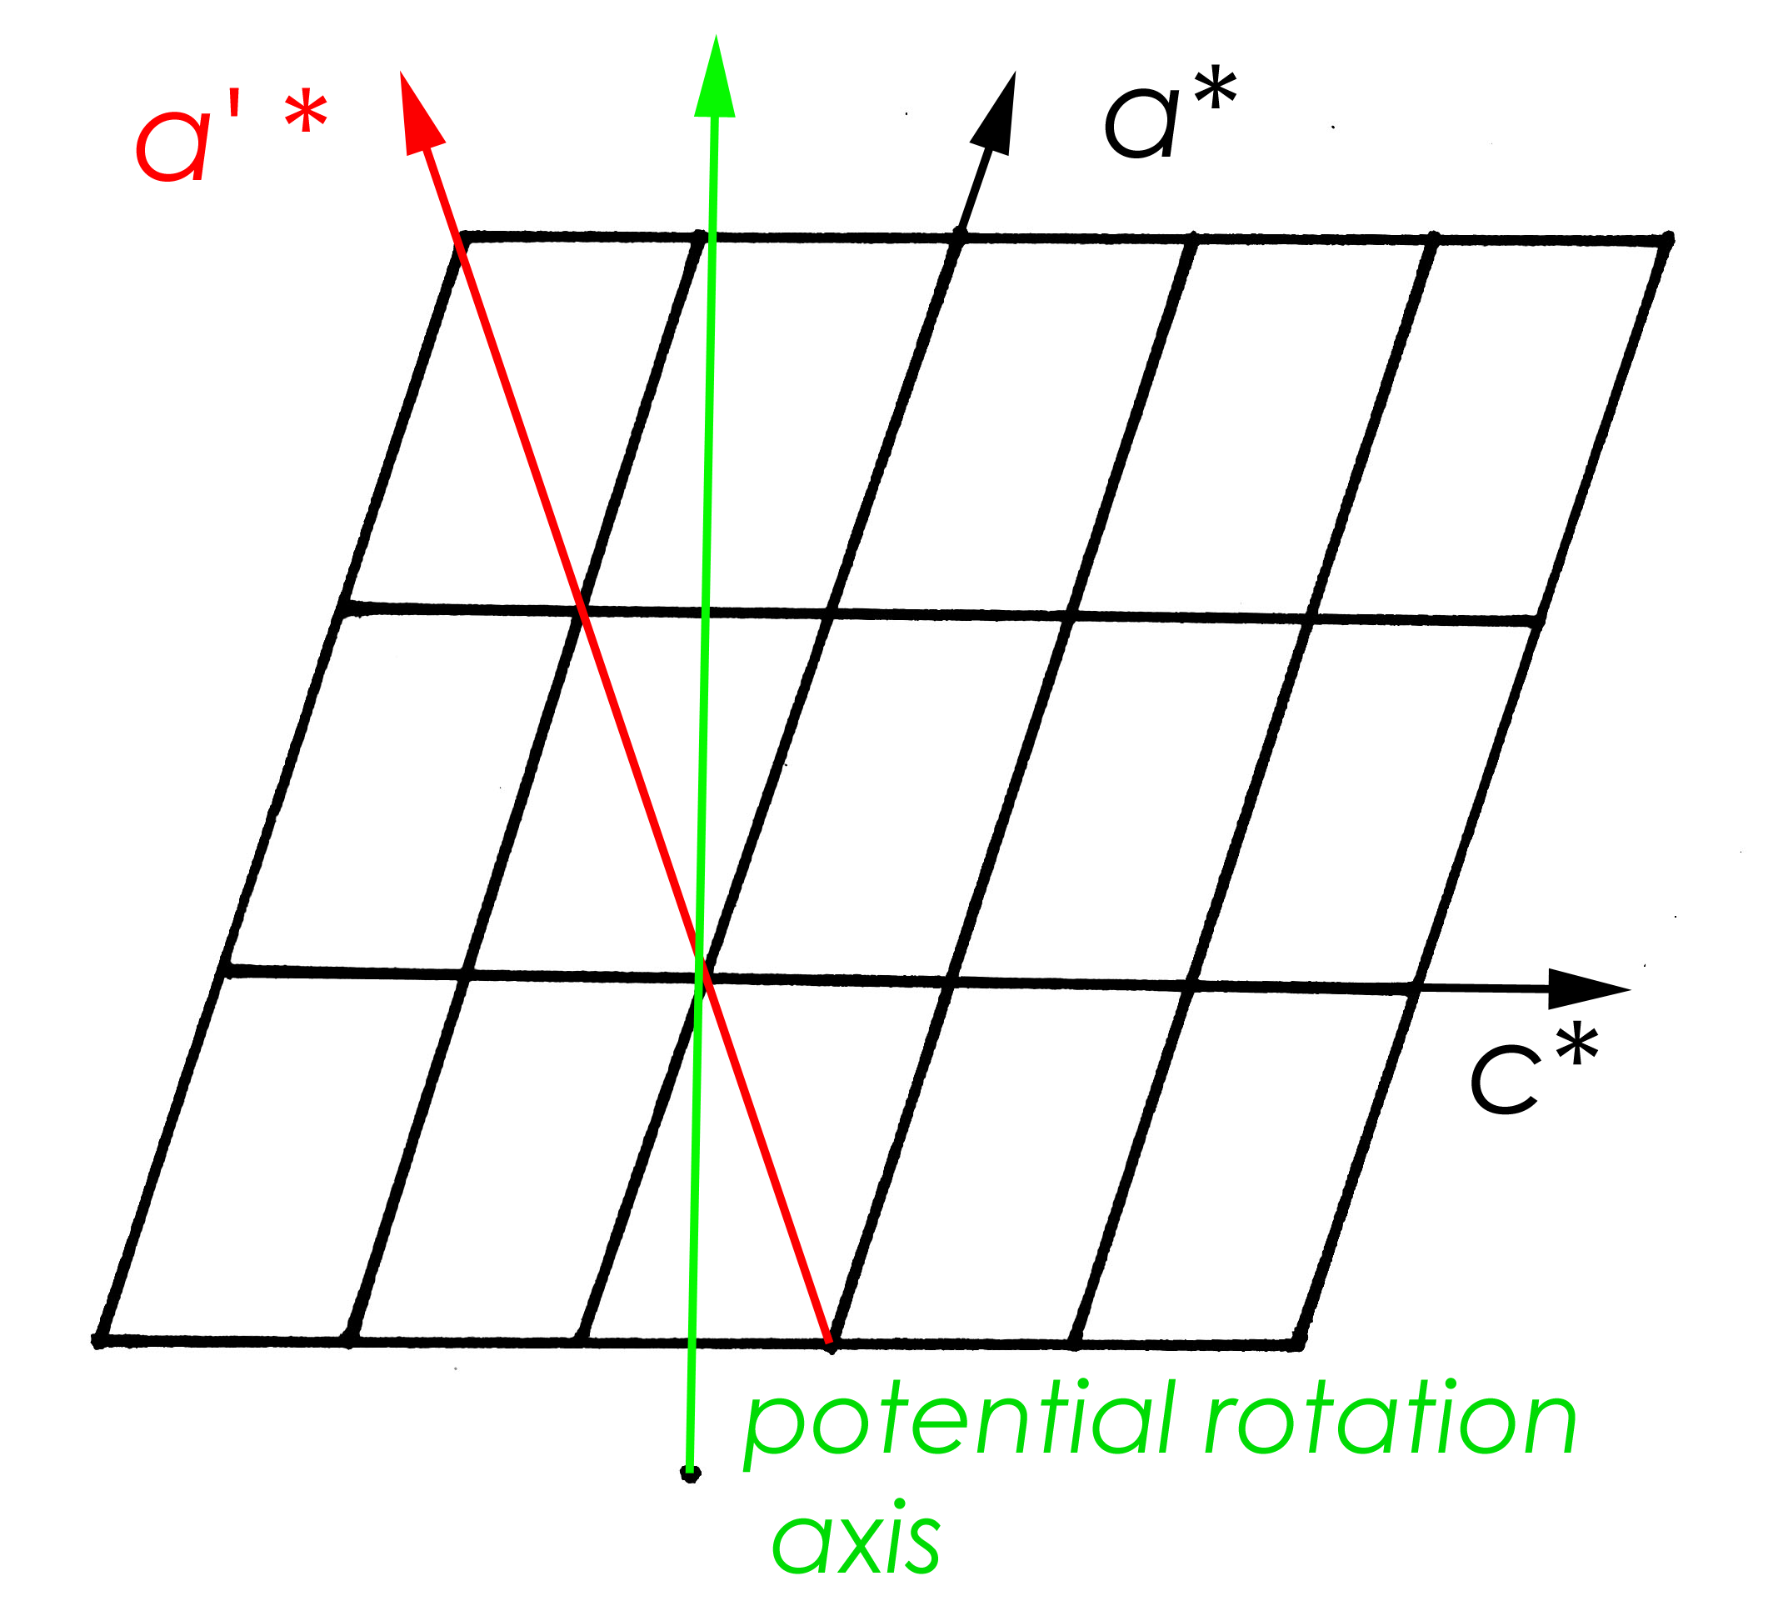

The pseudo-orthorhombic super lattice means that twinning is possible by rotation about either c* or a.

Rotation of the whole lattice about either axis does not result in exact overlap of reciprocal lattice points - this type of twining is termed pseudo-merohedral (TLQS) twinning. However, the almost orthorhombic β angle of 91.13 degrees means that in practice both lattices overlap, so that every observation contains contributions from both twin domains.
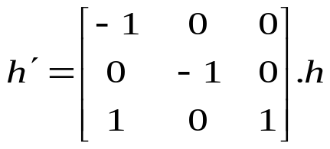
This type of twinning is easily treated in CRYSTALS – once the twin law is identified. From the diagram we propose a rotation of 180 degrees about c*, which transforms the indices as:

ROTAX will do this for you.

Twinned Refinement: Easy
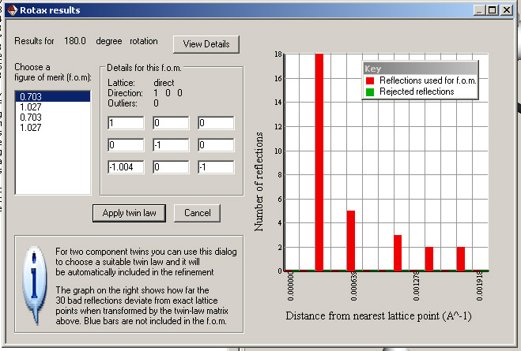
Guided treatment of two-component merohedral and pseudo-merohedral twins is implemented in the CRYSTALS GUI: Choose
GUIDE > Analyse > Rotax Analysis > ROTAX

Select a low “fom” twin law and apply it.
Use the GUIDE to set up a refinement. Note that the twin elements are now automatically included.

The R-factor should drop very quickly, and at the end of the guided refinement should end up below 3%

