CRYSTALS Workshop

Advanced uses of CRYSTALS

Which Space Group?

CRYSTALS Workshop 1
Advanced uses of CRYSTALS 1
Which Space Group? 1
Background Information for Simon Llewellyn’s compound 1
Getting Started: 1
Structure Solution 2
Structure Development 3
Getting A New Start 3
Amusements 4

Richard Cooper, David Watkin, Simon Parsons, Anna Collins & Stefan Pantos.

Data kindly provided by Ann Chippindale, Andrew Cowley, Tony Linden, Simon Parsons & Sofia Pascu.

Llewellyn’s compound

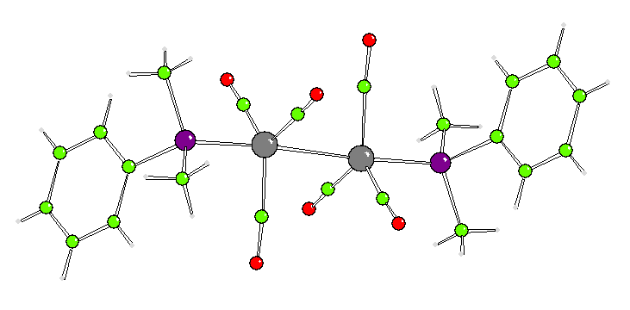

Background Information for Simon Llewellyn’s compound
This material was prepared by Simon Llewellyn, working with Malcolm Green in Oxford. It was submitted to Andrew Cowley for routine X-ray analysis. The material was in the form of small dark-red crystalline fragments. The data were collected on a Nonius Kccd diffractometer at 150K. The expected molecular formula was C22 H22 Co2 O6 P2. The unit cell was triclinic with a volume of 615Å³. Since the material was not expected to be chiral and the cell could contain one molecule, a good starting hypothesis is that the space group is P‾1 with half a molecule in the asymmetric unit.

Getting Started:
Navigate to the folder LLEWELLYN.

In this example, we will mix use of the GUIDE with manual use of more advanced features. We start by reading in a pre-prepared text file (arc811.ccf – one of Andrew’s start up files, rather like a SHELX .ins file). The reflections are in the corresponding arc811.hkl file. Use a text editor to view the .ccf file, but take care not to accidentally change anything.

Lines beginning ‘# ‘ (hash followed by a space) are comments. The upper triangular matrix near the top of the file is the cell parameter error covariance matrix. The experimental information near the bottom is not needed for any calculations, but will be inserted into the final cif.

Start CRYSTALS by right-clicking the folder icon on the top bar of the folder window, and select ‘Open CRYSTALS Here’. On the tabs near the bottom left, select ‘Files’, and then ‘Use file’.
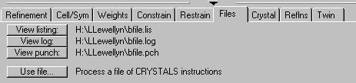

Use the browser to find arc811.ccf, and open it. This will cause CRYSTALS to read the .ccf file, which in its turn will read in the hkl file.

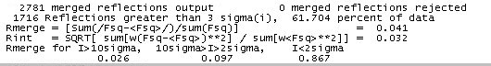

Note that 62% of the data has I>3σ(I), and the Rmerge is 3% for the strong data, 10% for the medium data, and 87% for the weak. The small crystal has yielded weak data. Click the ‘Refinement’ tab on the summary information so that you can watch what happens later.

Structure Solution

On the menu bar choose Solve and then SIR92 in default mode. When SIR finishes, click Quit twice to close down SIR, and import the result into CRYSTALS. You should see a diagram with some recognisable features in it. Drag the cursor across the diagram to rotate it. Click Done to accept the model as it is. Choose a numbering option – probably Automatic.

On the menu bar, choose Refinement, Setup Directives & Constraints, then Refine Scale, positions and Uiso. Accept this and then return to Refinement and choose Refine.

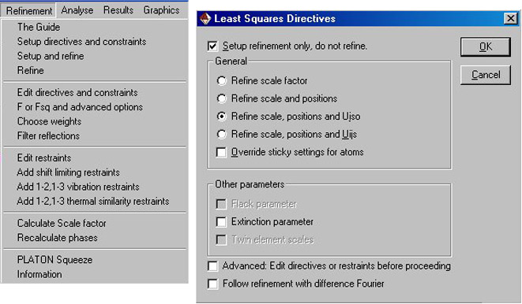

The refinement will stop after one cycle because it is not converging. Go to Refine again and uncheck the ‘Stop cycling’ box. Crystals will now (by default) perform 5 cycles of least squares. You can try some more. The ‘max shift’ on the Refinement tab will tend to zero, and the R factor stop reducing, showing convergence to an unsatisfactory minimum. The structure is not solved.

There are now a number of options.
- Try alternative strategies in SIR, or try SHELXS
- Try Fourier refinement
- Try a lower symmetry space group.

Alternative 1 from the SIR92 menu actually solves this structure, but is not very educational.

Structure Development

Try Fourier refinement. From the menu bar select Refinement, then The Guide. In the drop down menu scroll up to ‘Fourier Refinement’ and start this. You will be asked a question about rejecting atoms. In the input bar, type NO. Wait until you are shown an image of the new peaks (pink Q atoms) together with the existing structure. This is some kind of superimposed ghost image of the structure. Click Done to return to the main CRYSTALS window.
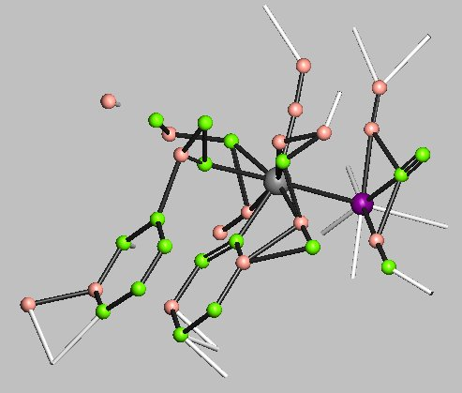
On the Tool bar, select Analyse then Fo vs Fc and Normal Probability Plots. Note the very wide scatter in the Fo-Fc plot, and the non-linearity of the Normal Probability plot.

In fact, the heavy atoms are displaced from their real positions, and this structure cannot be developed properly. It is in a stable false minimum.

Getting A New Start

Option 3 is to reduce the symmetry. This allows the Direct methods more flexibility, and is a useful trick. Click the Cell/Sym tab at the bottom of the screen. Use Set Space Group to change the space group to P 1. Use Set Formula to enter the cell contents (C 22 H 22 Co 2 O 6 P 2). Make sure that each part of the formula is separated from any other part by at least one space. When the formula updates correctly, choose Solve from the menu bar. This time the structure will look much better. Import it into CRYSTALS, and in the manipulation window, ensure that the atoms have the correct types. You may see that one atom is missing. Click Done to accept the changes. The Guide should still be open (if not, open it by clicking the CRYSTALS icon 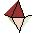). Do some refinement, then select Fourier refinement. The missing atom should appear in pink. Change it to carbon, and click Done. There in no point doing more Fourier refinement since we can now see the whole structure. Accept the Guide’s proposals about refinement, and about adding hydrogen atoms. In the manipulation window, note that there is a pink atom from the difference map near almost every white atom positioned geometrically. There may be some white atoms missing. At the bottom of this window is the Advanced option of restrained refinement of the hydrogens. Accept this. Now continue refinement (and possibly looking for missing H atoms) until convergence. Usually, this model does not converge, with the maximum shift going up and down. In the model window, the adps and some bond lengths can be seen oscillating.

Select ‘CAM’ from the tool bar (short for CAMERON, the full functioned graphics module in CRYSTALS). Go to the unpack drop-down, and select centroid. View the structure down each axis. There does appear to be a centre of molecular symmetry. If the structure really is centric in P‾1, the P1 refinement will be very unstable, leading to poor bond lengths and weird adps – the situation we have here. Close CAMERON rejecting changes.

Avoiding being ‘Marshed’. We need to place the molecular centre of symmetry on a crystallographic centre. In the input bar, type the following lines, using the mouse to select the two Co and P atoms in your structure, in any order. Their names may be different from the example below. The shifts –x,-y,-z are those needed to make the coordinates of the centroid zero.

#edit
centroid 100 p(1) p(2) co(1) co(2)
execute
shift –x –y –z all
(note that x,y z are the coordinates of your centroid)
execute
shift .5 .5 .5 all
execute
del qc(100)
execute
end

Use the Cell/Sym tab to change the space group back to P‾1, and to reset the cell contents to C22 etc.

On the main menu bar, click Appearance, Model, Update Model. Additional white bonds should appear in the model. These are symmetry-generated bonds. We need to remove ½ of the model. Atoms can simply be deleted in the GUI, but better would be to replace atoms by their symmetry averaged position.

In the input bar, type

#peak 5 5
select type=average
end
#collect
end

On the main menu bar, select Structure, Renumber, then Add Hydrogens + Fourier. Check the box to delete the existing hydrogens, and to do restrained refinement.

Finish off by doing aniso refinement with riding hydrogens, check for extinction, optimise weights and finally refining to death.

Amusements

Amuse yourselves by swapping from F to F² refinement, by setting different filtering thresholds and by trying different weighting schemes (on the Refinement menu). Once you have a model you like, look at the bond lengths. In the input bar type:

#distance
e.s.d yes
end

The phenyl distances should have s.u.s <.01 Now look at the effects of libration. In the input bar type:

#release printer
#aniso
atom (click P and the atoms in the phenyl ring)
tls
distance
end

Go to the Files tab, and look at the corrected and uncorrected distances in the listing file.

