CRYSTALS workshops

Jo Peach's Crystal

Peach - Summary information
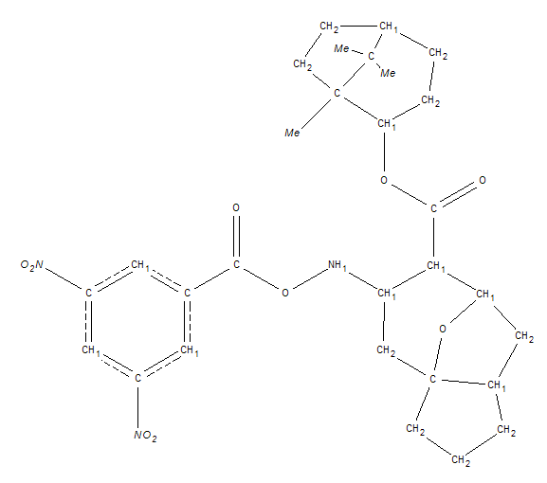
The data set for this crystal structure was collected for Dr Jo Peach in Oxford.

The cell is orthorhombic with a=6.415, b=19.871, c=21.298. The data collection used Copper radiation.
Once again the space group is P 2₁ 2₁ 2₁

Using the GUIDE import the SHELX peach.ins file.
Remember that the space group is P 21 21 21.

Using the GUIDE import the SHELX reflection file, peach.hkl.

Solve the structure in Sir 92 and read the results back into CRYSTALS.

Correct any wrongly typed hetero atoms by reference to the diagram above. (usually just the NO₂ groups)

Proceed with the refinement. (Switch to “Ellipse” view to check the results are reasonable).

Add Hydrogen atoms to the structure. Does the auto-refinement seem to have worked?

Continue the refinement - look at the thermal ellipses - they indicate the quality of the structure.

Continue the refinement. Check extinction.
Continue the refinement. Optimise the weights.
Finish the refinement. Validate your results and produce a CIF ready for publication.

To close CRYSTALS choose Exit Crystals from the File menu.
Alternatively, to get back to the workshop starting point, choose Demo from the Help menu.

