Tin Twin: Non-merohedral twin

Simon Parsons and Richard Cooper

Chemical formula Me₃SnH, Space group triclinic P -1

Data input
- choose the workshop structure: "Tin Twin"
- the input file is called me3snh.ins
- the reflection file is called me3snh.hkl

Twin suspicions
Look at the initial analyses dialog and note that:
- The merging-R remains around 5% even for "reliable" data.
- The Wilson plot looks okay for an organometallic structure.
- The N(Z) plot looks weird.
- The |E²-1| value (below the N(Z) plot) is a bit low (should be around 0.9 – though it is a heavy atom structure)

Structure Solution by Patterson methods
The structure will not solve by direct methods (probably because of the errors in some Fobs caused by the other twin component).
Click the Hide button on the GUIDE.
From the Fourier menu, click Others. From this Others sub-menu, click Fo-Patterson
When the Fourier dialog appears, just accept all the default settings and click OK.
On the next dialog click Transfer and select No Refinement.
On the next dialog (peak results), just click Exit.
Seven peaks are found. The highest peak Q(1) is at the origin (as you would expect in a Patterson). The co-ordinates of the next highest peak, Q(2), is a vector between two tin atoms.
In P -1, this will be the vector between a Sn at -x,-y,-z and x,y,z
Q(2) is therefore currently at 2x,2y,2z. - thus, we need to move it.

Type the following to reject the other peaks, half the co-ordinates and rename the peak to tin.
\EDIT
KEEP Q(2)
MULTIPLY 0.5 X
MULTIPLY 0.5 Y
MULTIPLY 0.5 Z
RENAME Q(2) SN(1)
END

Now we just need the methyl groups:
From the Fourier menu, click F-Obs.
Accept all the defaults and click OK.
Four new peaks will be found. Transfer them to the model, do not do Fourier refinement, and then delete the spurious one (ie not attached to the tin).
Rename the three peaks to carbon using the menu.

Refinement
Now open the GUIDE again. (Click the button on the toolbar).
It should recommend refinement of positions and Uiso
Carry out this refinement
The GUIDE should now recommend anisotropic refinement.
Carry out this refinement.
The R-factor is now ~7%. But, look at the ellipses!
Click Ellipse in the toolbar above the model window.
What now? We already suspect that it might be a twin, so let's check:

ROTAX: Find the twin law
Hide the GUIDE again.

From the "Analyse" menu, choose "Rotax analysis/twins >", then "ROTAX".
The Rotax dialog defaults to searching for twin laws involving 180 degree rotations with a "figure of merit" less than 5.
Click OK.
ROTAX is a brute force procedure which tries thousands of possible twin-laws (all rotations about direct and reciprocal lattice directions). For each twin-law tested, ROTAX takes your 30 worst fitting reflections where Fo > Fc and analyses how close they fall to an integer lattice point when operated on by the proposed twin law. (If overlap is very close, this accounts for the unexpected extra intensity in Fo, if you have a twin).
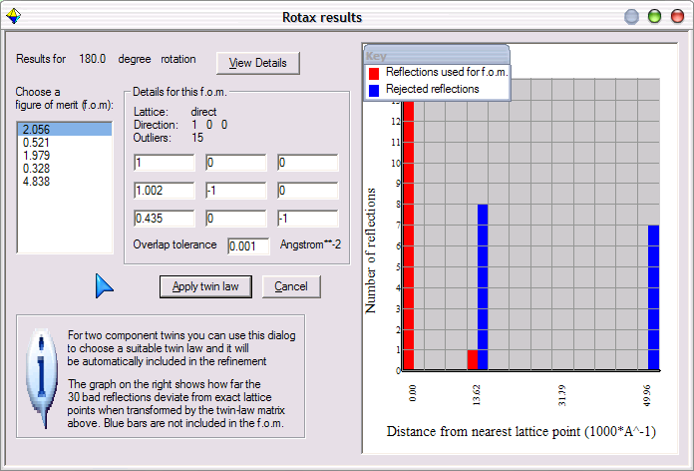
Each twin law tested is assigned a figure-of-merit based upon how far the 30 transformed reflections fall from lattice points. (i.e. the lower the f.o.m., the better).
NB. ROTAX sometimes reports figures-of-merit of zero. It treats all lattices as triclinic, so these results are due to two-fold rotations which are either part of the Laue symmetry of the crystal or potential merohedral twin laws. As overlap is total and exact in either case, the fom becomes zero.

Click on the lowest figure of merit in the list.
ROTAX displays the twin-law in the 3X3 matrix on the right.
The graph on the right just shows how close each of the 30 bad reflections comes to an integer lattice point. Blue bars show points that have been rejected (up to half the points may be rejected) to lower the f.o.m.
Now click "Apply Twin Law".
You are given an option to view list 6 (the reflections) to ensure that the twinned reflections have been identified correctly. As expected, the twin flags (last but one column) only flag reflections with h=even as being affected by the second component of the twin. (The twin law has a 1/2 in it).

Open the GUIDE again.
Make sure "Refine position and aniso" is selected. Click OK

Carry out refinement and follow the GUIDE to the end, noting that:
When it comes to adding hydrogen, the geometric positioning will fail because it wasn't designed with Sn-C bonds in mind.
You will have to add H's manually.
Right-click a carbon atom, and choose Add Hydrogens to C(n).
Follow the instructions to add 3 sp3 hydrogens to each.

Once these are added, choose Add Hydrogen in the GUIDE, and find the last H atom in a Fourier map, bonded to the Sn.

Right-click to change it into a H.
Check the All H atoms found box and click Continue.

The refinement should proceed to publication without any hitches, except that the program will warn you about residual peaks in the difference map before producing a CIF. Ignore it.

