CRYSTALS workshops

Twinning

Simon Parsons and Richard Cooper
University of Oxford
richard.cooper@chemical-crystallography.ox.ac.uk

AS19A2: Non-merohedral Twin

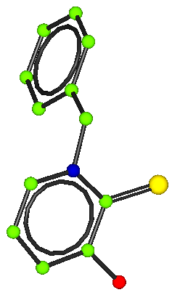
Summary information
This crystal was synthesised by Andrew Smith and the data was collected by Simon Parsons in Edinburgh.

The cell is monoclinic P 21/n

Instructions
From the workshop dialog, choose AS19A2 Twin.

Using the GUIDE import the SHELX as19a2.ins file.
Remember that the space group is P 21/n.

Using the GUIDE import the SHELX reflection file, as19a2.hkl.

Solve the structure in Sir 92 and read the results back into CRYSTALS.

Sir92 will place the N incorrectly. Use the dialog to correct the atom types.

The structure won’t refine very well (it will stick at R>14%)

Use ROTAX to find the twin law (hint: it’s the one with the lowest figure-of-merit). And then complete the refinement.

The R factor will fall to about 11%. Use the toolbar item Analyse to see the Fo-Fc plot. There is a very strong reflection not lying on the plot. You might decide to omit it (by right-clicking on it)

