CRYSTALS workshops

YLID

This simple molecule has achieved cult status far beyond it's humble expectations, due to its use by most diffractometer manufacturers as a standard test crystal.

Navigate to the folder "ylid", right-click on the folder icon (top left) and select "Open CRYSTALS here". When CRYSTALS opens, click on the crystal icon on the toolbar (left corner of the third row down). The Guide will open to guide you through the analysis.

Ylid - Summary information

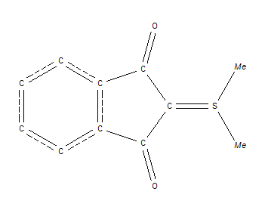
The cell is orthorhombic with a=5.9541, b=9.0263, c=18.3688.
The space group is P 2₁ 2₁ 2₁
The sample crystal was carefully ground to a sphere (why?) with a diameter of 0.2mm.

Using the GUIDE import the SHELX ylid.ins file. Choose refinement against Fsquared.

Using the GUIDE import the SHELX reflection file, ylid.hkl.
(Note that the presence of the heavier sulphur atom changes the default “Merge Friedel” recommendation.) Remember that you still choose “Yes” to merge the other equivalent reflections.

In the "Initial Analysis" look at the Completeness, Systematic Absences and Wilson Plot tabs. Make a note about anything you think might be good, bad or just interesting.

Solve the structure in Sir 92 and read the results back into CRYSTALS. Hover the mouse over the sulphur, oxygen and some other atoms. Write down what rule you think might be being used to allocate atom numbers. Close the viewer and then select automatic numbering. Comment on the new atom numbering. Are you surprised by the methyl group positions? make a note of the R-factor (bottom left of the screen).

Proceed with the refinement, noting the change in the R-factor.

Add Hydrogen atoms to the structure.
Note that while CRYSTALS has failed to add H to the methyl groups attached to the sulphur atom, they are visible (pink atoms) in the Fourier difference map.
Change the six Fourier peaks corresponding to H positions into H atoms.
Ignore the other pink atoms - with one exception they are near geometrically predicted positions. Click the "All H atoms have been found box" and then Done.

Continue the refinement, note the R-factor.

Check extinction.
For this sample an extinction correction looks appropriate (see the information box at the top of the window), so add one into the refinement.
Continue the refinement. Optimise the weights.
Choose the Auto-statistical scheme. In the graph the red bars are the un-weighted residual (Fo²-Fc²)², the green bars show the effect of the weights in evening out the contributions to the refinement

Finish the refinement but in the check box include "Refine H atom positions" and "Treat H atoms as above except restrain H-CNO bonds".

Validate your results and produce a CIF ready for publication. On the same drop-down select the "Distance" option and ask for hydrogen atoms to be included.

Estimate the average C-C, C-O, C-S and C-H distances and comment on them.

