Cloudera Enterprise Data Hub – Data Rationalization Agenda

* Enterprise Data Hub Overview
* Demonstration
* Summary
* Additional Q&A

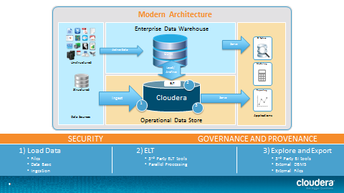

Demo phases

1. Load the data
2. Transform the data - ETL
3. Query the data - Interactive SQL
4. Explore the data - Faceted Search
5. Security - Authentication and Authorization
6. Governance - Audit, Lineage, and Discover
7. Export to EDH