Desktop Application Story

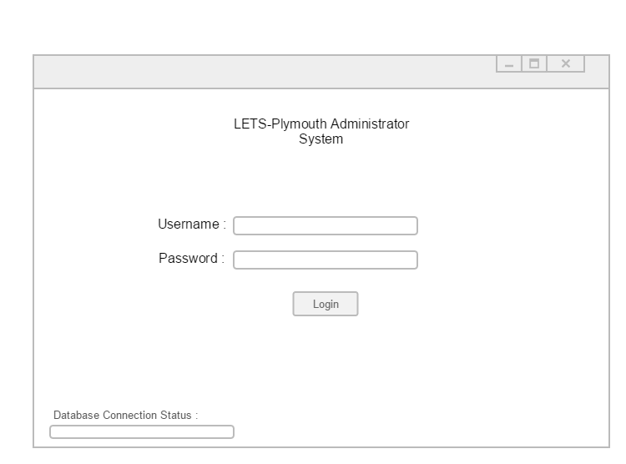

This is a design of the basic layout of the login page for the system. The connection status will let them know whether or not they can access the system. Once the user has logged in they will be presented a dialog screen confirming or rejecting their login attempt.

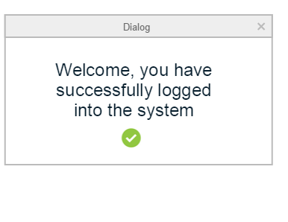

Above is an example of a successful login attempt, an unsuccessful login attempt will result in an explanation to the error and allow them to re attempt the login.

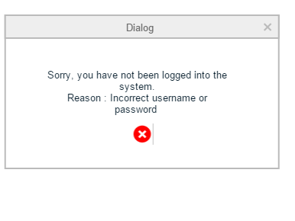

Example of incorrect login.

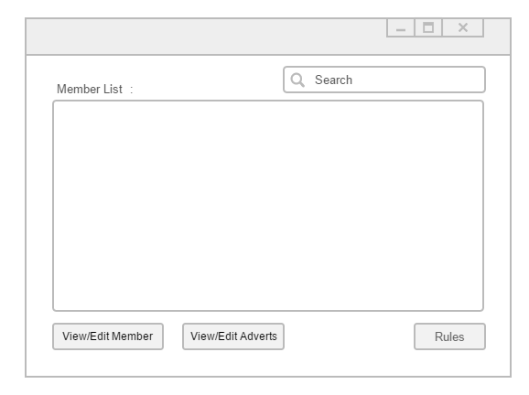

A successfully logged in system will result in the above window being shown. A list of members will be shown, this will also allow them to be selected. Once a selection has been made the admin will be able to view/edit the member and their adverts. A list of the rules can also be viewed and edited from this window. An admin may also search for a member or any of their details.

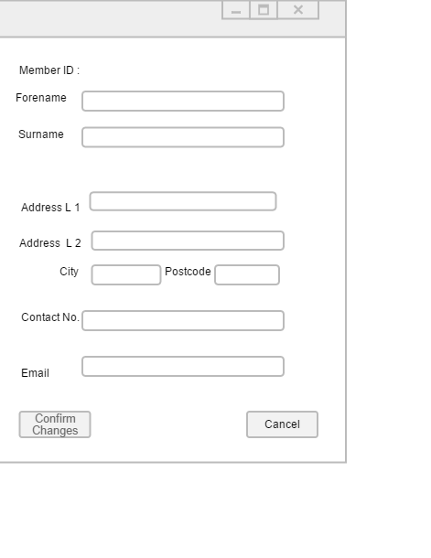

If the admin would like to edit or view a member they will be welcomed by the above page. From here they can view the details of the member and also be able to edit them. A confirmation will have to be clicked to agree to any changes, if no changes wish to be made the admin can cancel the form.

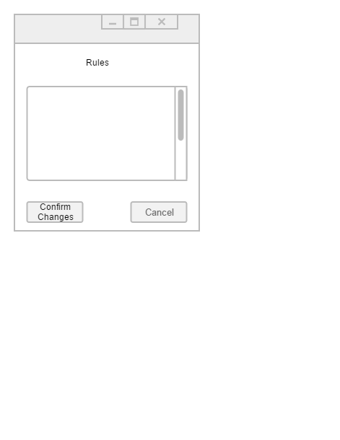

If the admin selects to view the rules they will be presented with a text view of the rules which they can edit and amend changes to.

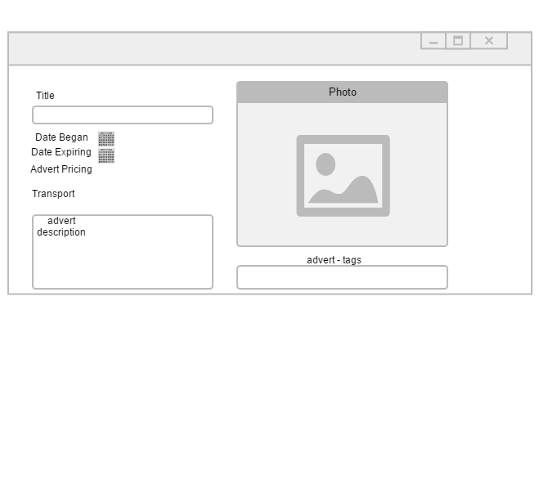

Above is an example of the advert page. The title, date the advert began, date the advert expires and pricing can be viewed. As well as this so can the pricing, transport option, description and the tags for the advert. The image shall also be shown.