|  |
| --- |
| Plymouth University |
| PRCSA: Initial Planning Document |
| PRCS205 Group Coursework |
|  |
| **Philip Edwards, Richard Imms, Nathaniel Ovington, Brian Viviers & Dominic Youel** |
| **January 2015** |

|  |
| --- |
|  |

# Contents

|  |  |
| --- | --- |
| 1. Team Description and Tools | 1 |
| 1.1 Team Description | **1** |
| 1.2 Bitbucket Account Details | **1** |
| 1.3 Pivotal Tracker Account Details | **1** |
| 2. User Requirements | **2** |
| 2.1 Requirements – Desktop Application | **2** |
| 2.2 Requirements – Web Application | **3** |
| 2.3 Requirements – Android Application | **4** |
| 3. Initial Requirements Analysis and Design | **5** |
| 3.1 Use Case – The Desktop Application | **5** |
| 3.2 Use Case – The Web Application | **6** |
| 3.3 Use Case – The Android Application | **7** |
| 4. Management Plan | **8** |
| 4.1 Schedule of Meetings | **8** |
| 4.2 Methods of Communication | **8** |
| 4.3 Gantt Chart | **9** |
| 5. Risk Analysis | **10** |
| 5.1 Grading Criteria | **10** |
| 5.2 Risk Analysis – Technology | **10** |
| 5.3 Risk Analysis – Planning | **11** |
| 5.4 Risk Analysis – Requirements | **12** |
| 5.5 Risk Analysis – Team | **12** |

# 1. Team Description and Tools

This section will give details on the team, their roles and contact details. To follow will be details on the tools used for project management.

## 1.1 Team Description

### Philip Edwards

**Roles:** Interface Design Leader, Software Engineering, Mobile Development Leader.

**Scrum Role:** Team Member

Student Number: 381831

[philip.edwards@students.plymouth.ac.uk](mailto:philip.edwards@students.plymouth.ac.uk)

Contact Number: 07772639129

### Richard Imms

**Roles:** Project Manager, Security Leader, Database Leader.

**Scrum Role:** Scrum Master

**Student Number:** 10405604

**Email:** [richard.imms@students.plymouth.ac.uk](mailto:richard.imms@students.plymouth.ac.uk)

**Contact Number:** 07525952051

### Nathaniel Ovington

**Roles:** **[Continued Absence – no roles delegated]**

**Scrum Role:** Team Member

**Student Number:** 10427507

**Email:** [nathaniel.ovington@students.plymouth.ac.uk](mailto:nathaniel.ovington@students.plymouth.ac.uk)

**Contact Number:** 07972175650

### Brian Viviers

**Roles:** Product Owner , Web Development Leader, Software Engineering

**Scrum Role:** Team Member

**Student Number:** 10253311

**Email:** [brian.viviers@students.plymouth.ac.uk](mailto:brian.viviers@students.plymouth.ac.uk)

**Contact Number:** 07725708780

### Dominic Youel

**Roles:** Team Administrator, HCI Manager, Software Engineering.

**Scrum Role:** Scrum team member

**Student Number:** 10061144

**Email:** [dominic.youel@students.plymouth.ac.uk](mailto:dominic.youel@students.plymouth.ac.uk)

**Contact Number:** 07902807390

## 1.2 Bitbucket Account Details

Repository Name: PRCSA

Homepage*: <https://bitbucket.org/DominicY/prcsa/overview>

## 1.3 Pivotal Tracker Account Details

Project Name: PRCSA

Homepage*: <https://www.pivotaltracker.com/n/projects/1253584>

*This has been blocked to non-members. The module leader should have read-only access.

# 2. User Requirements

To follow are three tables showing the user requirements, organised under the application they relate to. Please see table 1 for an explanation of the priority level shown in tables 2-4. Please note the time estimate is rounded to the closest working day. These figures were found by each team member making an estimate and then taking the average.

|  |  |
| --- | --- |
| Priority | Colour |
| Required |  |
| High |  |
| Low |  |
| Stretch |  |

Table 1: Showing the levels of importance in the User Requirements tables.

## 2.1 Requirements – Desktop Application

|  |  |  |  |  |  |
| --- | --- | --- | --- | --- | --- |
| No. | **User Requirement** | **Description** | **Use Case** | **Priority** | **Time Estimate** |
| 1 | View user information | View a specific user's information | Maintain user records | 1 | 2 |
| 2 | Log in/out | Log in or out of the system | Login, Logout | 1 | 2 |
| 3 | View list of active ads/requests | View a complete list of active adds/requests | View reports | 1 | 3 |
| 4 | View list of completed ads/requests | View a complete list of completed ads/request | View reports | 1 | 2 |
| 5 | View reports/stats | View various reports about the state of the system | View reports | 1 | 2 |
| 6 | Search for users | Search for a specific user - name/accNo./email | Search for members | 2 | 2 |
| 7 | Search for ads/requests | Search for a specific ad/request | Search for Adverts | 2 | 2 |
| 8 | Edit user information | Edit user information on request | Maintain user records, Maintain contact details | 2 | 3 |
| 9 | Edit active ads/requests | Edit currently active ads/requests | Maintain user records | 2 | 3 |
| 10 | Maintain user profiles | Update/edit a user's profile | Maintain user records, Maintain contact details | 3 | 2 |
| 11 | Remove ads | Remove ads - user request/broken rules | Maintain user records | 3 | 2 |
| 12 | Maintain forum | Enforce forum rules/remove posts | Stretch goal | 4 | 3 |
| 13 | Contact users | Contact a user('s) using the internal system/email | Contact visitors/members | 4 | 3 |

Table 2: User requirements for the Desktop Java Application

## 2.2 Requirements – Web Application

|  |  |  |  |  |  |
| --- | --- | --- | --- | --- | --- |
| No. | **User Requirement** | **Description** | **Use case** | **Priority** | **Time**  **Estimate** |
| 1 | Register | Register with the system | Register | 1 | 2 |
| 2 | Log in/out | Log in or out of the system | Login, Logout | 1 | 1 |
| 3 | Submit adverts | Post adverts to the system | Create an Advert | 1 | 3 |
| 4 | Browse adverts/requests | View a list of active adverts or requests | Search/Browse adverts | 1 | 3 |
| 5 | Submit requests | Post requests to the system | Create an Advert | 1 | 2 |
| 6 | Respond to ads/requests | Begin the negotiation - Finalise the negotiation | View an Advert | 1 | 3 |
| 7 | View account information | View an overview of your account | View account balance | 2 | 1 |
| 8 | View transaction history | View a complete list of your transaction | View transaction history | 2 | 2 |
| 9 | Search for ads/requests | Search for a specific add/category/keyword | Search/Browse adverts | 2 | 2 |
| 10 | Rate completed transactions | Rate a transaction once it has been completed | Respond to Advert | 2 | 1 |
| 11 | Update/edit their profile | Edit information on a profile such as location | Manage account details | 2 | 2 |
| 12 | Filter displayed ads/requests | Filter the ads and requests to be displayed | Search/Browse adverts | 3 | 2 |
| 13 | Bookmark adverts/requests | Save/bookmark adverts and requests | View Advert | 3 | 2 |
| 14 | Edit existing Adverts | Update one of their own adverts | Edit existing advert | 3 | 2 |
| 15 | Contact the company | Contact the company using the internal system | Contact admin | 3 | 2 |
| 16 | View company info | View details about the company | View rules? | 3 | 1 |
| 17 | Access the forum | Be able to browse the user/support forum | Stretch goal | 4 | 3 |
| 18 | Post to the forum | Be able to add posts to the forum | Stretch goal | 5 | 3 |

Table 3: User Requirements for the Webpage

## 2.3 Requirements – Android Application

|  |  |  |  |  |  |
| --- | --- | --- | --- | --- | --- |
| No. | **User Requirement** | **Description** | **Use Case** | **Priority** | **Time Estimate** |
| 1 | Register | Register with the system | Register | 1 | 2 |
| 2 | Log in/out | Log in or out of the system | Login, Logout | 1 | 2 |
| 3 | Submit adverts | Post adverts to the system | Create an Advert | 1 | 3 |
| 4 | Submit requests | Post requests to the system | Create an Advert | 1 | 2 |
| 5 | Browse adverts/requests | View a list of active adverts or requests | Search/Browse adverts | 1 | 3 |
| 6 | Respond to ads/requests | Begin the negotiation - Finalise the negotiation | View an Advert | 1 | 3 |
| 7 | View account information | View an overview of your account | View account balance | 2 | 2 |
| 8 | View transaction history | View a complete list of your transaction | View transaction history | 2 | 2 |
| 9 | Rate completed transactions | Rate a transaction once it has been completed | Respond to Advert | 2 | 2 |
| 10 | Search for ads/requests | Search for a specific add/category/keyword | Search/Browse adverts | 2 | 4 |
| 11 | Filter displayed adds/requests | Filter the ads and requests to be displayed | Search/Browse adverts | 3 | 2 |
| 12 | Edit existing Adverts | Update one of their own adverts | Edit existing advert | 3 | 2 |
| 13 | Receive updates on transactions | Receive notifications in the taskbar | Stretch goal | 4 | 3 |
| 14 | Change notification settings | Change the settings for the notifications | Stretch goal | 5 | 3 |

Table 4: User Requirements for the Android Mobile Application

# 3. Initial Requirements Analysis and Design

Presented in figures 1-3 are use case diagrams for the whole system. Two use cases will be demonstrated with a design level sequence diagram, state machines and a class diagram. These additional diagrams will be presented in the final report.

## 3.1 Use Case - The Desktop Application

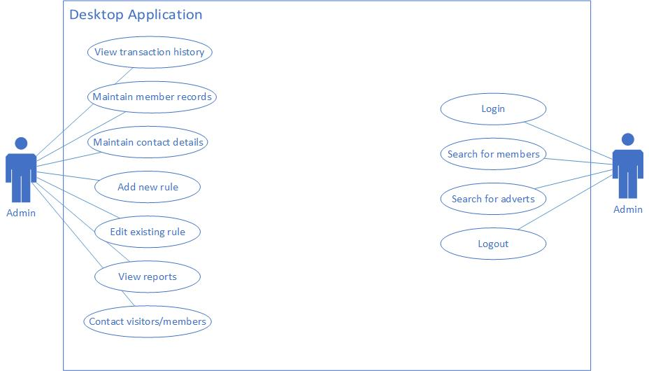

Figure 1: The use case diagram for the Desktop Application

## 3.2 Use Case - The Web Application

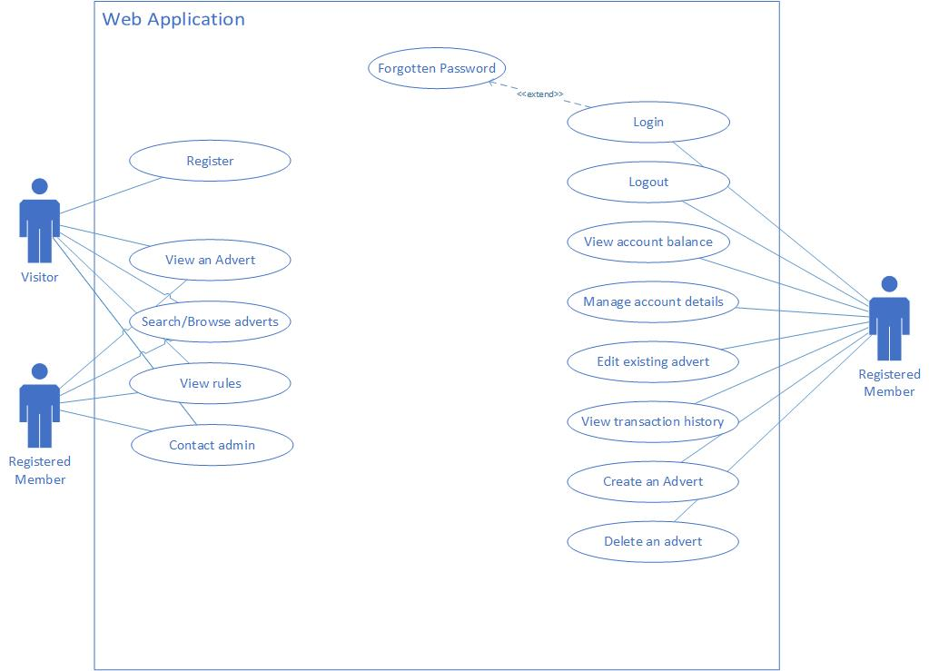

Figure 2: The use case diagram for the Web Application

## 3.3 Use Case - The Android Application

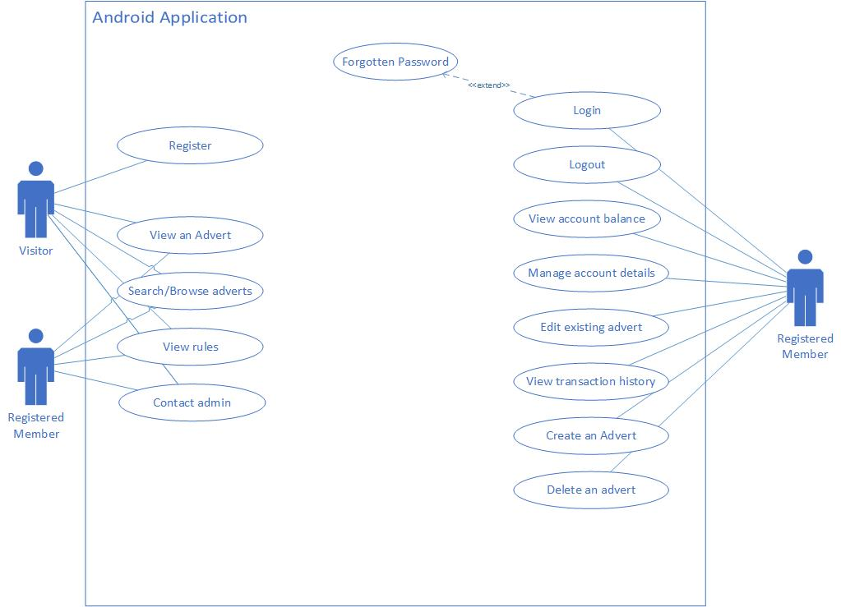

Figure 3: The use case diagram for the Android Application

# 4. Management Plan

This section details how the team will be managed and which tools will be used to facilitate this process. A Gantt chart has been included in section 4.3.

## 4.1 Schedule of Meetings

Meetings will be held in available suites of the University Babbage building, dependant on which rooms are available. Minutes will be maintained for each meeting and uploaded to the repository as text documents. Table 5 shows the agreed meeting time for each day of the working week. This is subject to timetable changes – the team will follow the same university timetable wherever possible. Members will be given the opportunity to reschedule a meeting on any given day and the rest of the group will try to accommodate. This minimises the chance of meetings being missed by individual members and the group as a whole.

|  |  |
| --- | --- |
| Day | **Time** |
| Monday | 13:00 – 13:45 |
| Tuesday | 16:00 – 17:00 |
| Wednesday | 13:00 – 14:00 |
| Thursday | 14:00 – 15:00 |
| Friday | 13:00 – 14:00 |

Table 5: The agreed meeting times

## 4.2 Methods of Communication

Pivotal Tracker will be used to help with project management, allowing team members to see which tasks are yet to be started, currently in progress or completed. Individual tasks or user stories will be ordered by their importance in the backlog, while larger stories with more than one dependency from the backlog (for example: “Completion of the web page”) will be kept in the Icebox. In this way, keeping track of individual user stories and larger deliverables can be easily achieved. Dates of task commencement, completion and overall progress can easily be tracked in this tool. Further to this, it facilitates the production of burn-up and burn-down charts, which are both deliverables for the project.

Bitbucket will be used as the group’s method of file sharing and version control. This will enable the team to contribute their elements of the project by adding it to the shared project folder. Benefits of using Bitbucket include a unification of workflow, avoiding code conflicts or overwriting others’ work. It also provides a history of information about the status of the project. To aid the team, a “readme” file has been included, showing details of how to use the most common git commands, dates for major submissions and team contact details. This is viewable on the repository homepage.

To allow for members to communicate any issues or contribute any ideas or extensions to the project, email, mobile phones and text messaging will be used. Email is the preferred option, unless an issue requires more immediate attention. Microsoft’s Outlook group service has been adopted, enabling the team to easily converse, share files and use a shared calendar. In this way, contacting the whole group can be reduced to a couple clicks on a webpage.

## 4.3 Gantt Chart

## 

# 5. Risk Analysis

The risk analysis has been separated into four tables, organised into four categories. These can be found in tables 8 – 11. The numeric scales used for these risk analyses are defined in table 7.

## 5.1 Risk Analysis – Grading criteria

|  |  |  |
| --- | --- | --- |
| Probability Factor | **Severity** | **Risk (Probability * Severity)** |
| 3 - Probable– High Risk | 3- Critical | 6-9 |
| 2 - Possible – Medium Risk | 2- Serious | 4 |
| 1 - Unlikely – Low Risk | 1 - Minor | 1-3 |

Table 7: The ranking system adopted for the risk analysis in Tables 8-11

## 5.2 Risk Analysis – Technology

|  |  |  |  |  |
| --- | --- | --- | --- | --- |
| Risk Factor | **Probab-ility** | **Severity** | **Risk Factor** | **Controls in Place/Action to be taken** |
| Difficulty integrating work | 2 | 3 | 6 | Plan and research to ensure all used software integrates and works together. |
| Failure of tool(s) | 1 | 3 | 3 | Have back-up and use the resources available. The university has a number of computing suites and each member has their home hardware. |
| Overriding work | 1 | 3 | 3 | Use bit-bucket to allow us to revert to previous versions. Bit-bucket also allows for tracking to enable the team to find out where errors occurred. |
| Inadequate online-help and documentation | 1 | 2 | 2 | Prior research to ensure that the software used has proper documentation and user base. |
| Development tools are not ready by the desired time | 1 | 3 | 3 | Choose appropriate technology, to comply with a previous risk the development tools should have a strong user base. |
| Software too difficult to use (end user) | 1 | 2 | 2 | Enforce correct HCI principles. Run cognitive walkthroughs and usability studies to ensure the product is usable and meets user’s needs. |
| Information security risks | 2 | 3 | 6 | Employ correct security measures on repositories and other software tools. Some methods to consider: Strong password, do not share the password, do not use the software on an untrusted system. |

Table 8: The risk analysis under the technology category

## 5.3 Risk Analysis – Planning

|  |  |  |  |  |
| --- | --- | --- | --- | --- |
| Risk Factor | **Probab-**  **ility** | **Severity** | **Risk Factor** | **Controls in Place/Action to be taken** |
| Poor Estimations | 2 | 2 | 4 | Use ranged estimates as they are more realistic and allow for pressure to be taken off team members. |
| Project Size | 2 | 2 | 4 | Decompose the project into smaller phases. |
| Project Scope (Define/Non-Defined) | 2 | 1 | 2 | Created a detailed scenario. Early prototyping. |
| Target date is changed | 1 | 3 | 3 |  |
| Facilities not available | 2 | 2 | 4 | Ensure that rooms are available and take advantage of the many suites available within the University. |
| Facilities are inadequate | 1 | 2 | 2 | Ensure that every member has the needed software installed on their own machine. This means in the scenario of inadequate facilities we are still prepared. |
| Client insists on new requirements | 1 | 3 | 3 | Early on discussions with client to go through the requirements and sign off that all the requirements have been specified. |
| Late delivery | 2 | 3 | 6 | Correctly plan the project and estimate a realistic schedule. |
| Poorly monitored project progress | 1 | 3 | 3 | Use Pivotal Tracker and ensure all members of the team are trained using it. Remind team members to set up Pivotal Tracker notifications. |
| Ineffective communication | 1 | 3 | 3 | Maintain weekly SCRUM meetings. Set up regular means of contact such as emails and telephone calls. |
| Unidentified dependencies | 1 | 3 | 3 | Go through the system requirements/initial design documents as a team (at least 3 members) to ensure that each member agrees with what is needed. |

Table 9: The risk analysis under the planning category

## 5.4 Risk Analysis – Requirements

|  |  |  |  |  |
| --- | --- | --- | --- | --- |
| Risk Factor | **Probab-**  **ility** | **Severity** | **Risk Factor** | **Controls in Place/Action to be taken** |
| Ambiguous Requirements | 2 | 2 | 4 | Break down requirements into chunks and confirm with the rest of the team that they make sense and each member understands what is needed of that particular requirement. |
| Requirements change | 1 | 3 | 3 | Meet or contact client (University staff member) and confirm with client that requirements are correct. |
| Development of the wrong software functions | 1 | 3 | 3 | Query existing LETS products to see if the function is available there and confirm with client over the functions of the applications. |
| Incorrect system requirements | 1 | 3 | 3 | Having progress meetings with the client to ensure that the requirements are correct. |
| Failure to acknowledge all requirements | 2 | 3 | 6 | Once requirement list has been created have a meeting with the client to discuss the purposed requirements to confirm they are correct. |

Table 10: The risk analysis under the requirements category

## 5.5 Risk Analysis – Team

|  |  |  |  |  |
| --- | --- | --- | --- | --- |
| Risk Factor | **Probab-**  **ility** | **Severity** | **Risk Factor** | **Controls in Place/Action to be taken** |
| Insufficient team knowledge/skillset (correct combination of team members) | 2 | 2 | 4 | Additional training and using resources to gain knowledge(libraries, staff members and internet) |
| Loss of team member | 2 | 3 | 6 | Talk to client (Module leader) to let them know the situation and delegate the tasks to other members of the team. |
| Lack of motivation | 1 | 3 | 3 | Meet with the team and discuss motivation with them, pinpoint the cause of the motivation issue and resolve this. |
| Team members don’t work well together | 1 | 3 | 3 | Hold daily meetings and SCRUMS to get the team members to know each other better and find a common ground. |
| Key members only available part time | 2 | 2 | 4 | Ensure the team is kept up to date with the current progress of the project and their particular role within the project. |

Table 11: The risk analysis under the team category