# Proposal

This project will aim to develop *Dogfight*, a game loosely based on the classic arcade game *Asteroids* (Atari Corporation, 1979).

In *Asteroids*, the player controls a small 2-Dimensional spaceship around an arena from a bird’s-eye view. The player can control the ship by accelerating, steering and shooting. The arena also contains multiple asteroids (of varying size), that move around the screen, which the player must avoid and shoot to gain points. Once shot, the bigger asteroids split into smaller asteroids that move in different directions, which must be also be destroyed. The gamealso occasionally generates flying saucers that circle the player and shoot in their direction. These UFOs can also be shot down for a larger amount of points.

The goal of *Asteroids* is to shoot as many asteroids/flying saucers as possible, in order to gain the most amount of points, before losing 3 lives. Lives are lost when the ship crashes into an enemy object or shot by a flying saucer. The arena in the original games also has repeating boundaries, meaning that if the player or an asteroid passed over the edge of the screen, they would be teleported on the other side of the screen (mirrored across the x and y axes).

The original *Asteroids* also aimed to simulate space-flight physics through the spaceship’s acceleration. If a player accelerated the ship in one direction (*x*) and turned the ship into a new direction (*y*), the player would continue to move in the *x* direction for an extended period of time. By applying acceleration in the *y* direction, the player can reduce the force moving in the *x* direction in favour of *y*.

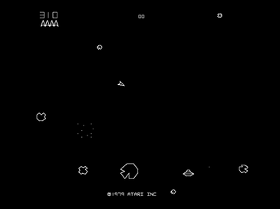

Figure 1 Layout of Asteroids (Atari Corporation, 1979)

*Dogfight* will have some major adaptions to this. First, rather than the player seeing the arena from a bird’s-eye view, the ship will be controlled through a third-person view in a 3D landscape (similar to a car in most popular racing games or an aircraft in a flight simulator). The player’s view of the spaceship will be positioned slightly behind and above, and will change depending on the direction that the ship is pointing.

Furthermore, though *Dogfight* will have similar controls to the original *Asteroids* game (turn left, turn right and accelerate), the spaceship’s handling will be modelled more realistically for the physics of space. In *Asteroids*, if the acceleration is reduced, the ship will eventually stop moving. However, as space is a vacuum, any force that is exerted and unchallenged (such as the thrust of a spaceship) will continue going indefinitely. *Dogfight* will aim to simulate this physical principle in a more accurate manner to *Asteroids*.

In terms of design, *Dogfight* will incorporate a retro aesthetic, similar to early 3-Dimensional videogames (circa. 1990s) made for Consoles such as the Atari Jaguar and Sony PlayStation. This aesthetic usually includes very straight edged, polygonal graphics popular with older games.

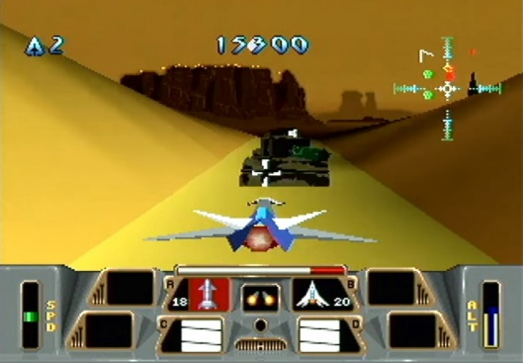

Figure Battlemorph (Atari Corporation, 1995), released for the Atari Jaguar, is a good example of the desired aesthetic for this game

Due to time constraints, *Dogfight* will only incorporate the player’s spaceship and asteroids. Meaning that the enemy UFOs and open borders will not be incorporated.

# Justification for Proposal

## Mastery

The largest argument for *Dogfight* (and by definition, *Asteroids*)being an enjoyable game is that, like many arcade-style games, it is designed to be mastered.

## Nostalgia

## Fantasy

# Technical Feasibility

# Bibliography

Atari Corporation, 1979. *Asteroids,* Sunnyvale, CA: Atari Corporation.

Atari Corporation, 1995. *Battlemorph,* Sunnyvale: Atari Corporation.

Batcho, K., 2017. *The psychological benefits – and trappings – of nostalgia.* [Online]   
Available at: https://theconversation.com/the-psychological-benefits-and-trappings-of-nostalgia-77766  
[Accessed 05 January 2019].

Burgun, K., 2013. *Game Design Theory: A New Philosophy for Understanding Games.* 1st ed. Boca Raton: CRC Press.

Koster, R., 2013. *Theory of Fun for Game Design.* 2nd ed. Sebastopol, CA: O'Reilly Media.