# Proposal

This project will aim to develop *Dogfight*, a game loosely based on the classic arcade game *Asteroids* (Atari Corporation, 1979).

In *Asteroids*, the player controls a small 2-Dimensional spaceship around an arena from a bird’s-eye view. The player can control the ship by accelerating, steering and shooting. The arena also contains multiple asteroids (of varying size), that move around the screen, which the player must avoid and shoot to gain points. Once shot, the bigger asteroids split into smaller asteroids that move in different directions, which must be also be destroyed. The gamealso occasionally generates flying saucers that circle the player and shoot in their direction. These UFOs can also be shot down for a larger amount of points.

The goal of *Asteroids* is to shoot as many asteroids/flying saucers as possible, in order to gain the most amount of points, before losing 3 lives. Lives are lost when the ship crashes into an enemy object or shot by a flying saucer. The arena in the original games also has repeating boundaries, meaning that if the player or an asteroid passed over the edge of the screen, they would be teleported on the other side of the screen (mirrored across the x and y axes).

The original *Asteroids* also aimed to simulate space-flight physics through the spaceship’s acceleration. If a player accelerated the ship in one direction (*x*) and turned the ship into a new direction (*y*), the player would continue to move in the *x* direction for an extended period of time. By applying acceleration in the *y* direction, the player can reduce the force moving in the *x* direction in favour of *y*.

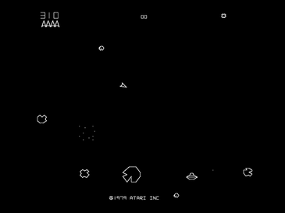

Figure Layout of Asteroids (Atari Corporation, 1979)

*Dogfight* will have some major adaptions to this. First, rather than the player seeing the arena from a bird’s-eye view, the ship will be controlled through a third-person view in a 3D landscape (similar to a car in most popular racing games or an aircraft in a flight simulator). The player’s view of the spaceship will be positioned slightly behind and above, and will change depending on the direction that the ship is pointing.

Furthermore, though *Dogfight* will have similar controls to the original *Asteroids* game (turn left, turn right and accelerate), the spaceship’s handling will be modelled more realistically for the physics of space. In *Asteroids*, if the acceleration is reduced, the ship will eventually stop moving. However, as space is a vacuum, any force that is exerted and unchallenged (such as the thrust of a spaceship) will continue going indefinitely. *Dogfight* will aim to simulate this physical principle in a more accurate manner to *Asteroids*.

In terms of design, *Dogfight* will incorporate a retro aesthetic, similar to early 3-Dimensional videogames (circa. 1990s) made for Consoles such as the Atari Jaguar and Sony PlayStation. This aesthetic usually includes very straight edged, polygonal graphics popular with older games.

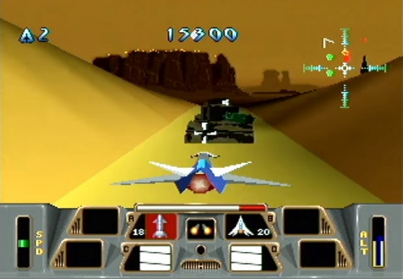

Figure 2 Battlemorph (Atari Corporation, 1995), released for the Atari Jaguar, is a good example of the desired aesthetic for this game

Due to time constraints, *Dogfight* will only incorporate the player’s spaceship and asteroids. Meaning that the enemy UFOs will not be incorporated into the games design at this point in time.

# Justification for Proposal

## Mastery

The most pressing argument for *Dogfight* (and by definition, *Asteroids*)being an enjoyable game is that it is designed to be mastered.

Like many arcade games of the 70s, 80s and 90s, there will be no ‘Ending-Point’ to *Dogfight*, and the game will be able to play indefinitely until the user loses.

In Raph Koster’s book *Theory of Fun for Game Design*, he discusses the importance of mastery in gameplay, saying ‘with games, learning is the drug, but you’ll only play it until you master the pattern.’ (Koster, 2013) By this statement, Koster was indicating a key point of what makes games fun, the idea of pattern-matching. Psychologically speaking, when players successfully match a pattern in a game (which could be anything as varied as a movement of an enemy or the predictability of a physics component), their brain is flooded with endorphins that are then responsible for an improved mood or a feeling of happiness (Koster, 2013). Koster infers that the production of this hormone is what causes activities to be fun, which therefore means that pattern-matching in games are bound to make a game more fun.

Through *Dogfight’s* design, users will have to learn several patterns to fully master the game. First, the motion of the spaceship. As mentioned in the initial proposal, this game will aim to realistically model the actions of forces and physics in space, mainly through the thrust and controls of the player’s spaceship. This physical principle can at times be harder to control than more linear systems of movement (such as those in a racing game). For example, if the acceleration of the ship is activated for too long, players may find it difficult to slow down (e.g. will have to turn 180 degrees and thrust in the opposite direction). Because of these more challenging dynamics, players may find their learning curve to mastery to be fairly steep. Tactics that may have worked for other games, such as moving faster to avoid more obstacles, will not be as viable in this game. For the case of *Dogfight*, the user can be caught up more pressing Risk/Reward scenarios that they will need to learn in order to last longer in the game, meaning that more effort will be needed to fully master the game.

This new format of control could potentially open up new dimensions of thinking and play for the players, meaning that new control patterns will need to be learnt. Leading to a stronger sense of pattern-learning and pattern-matching and therefore a greater sense of fun.

Furthermore, the conservation of force that will be simulated in the game will also be a fairly unique experience to even an experienced gamer. As mentioned earlier, most games that involve operating vehicles (even ones set in space) do not incorporate this law of conserved momentum. Because of this, most players (of all skill types) will be unfamiliar with the correct method of control (and therefore the pattern of gameplay) to correctly and effectively play the game. This would then equate to more time playing the game to learn the control pattern and having more fun while playing (caused by a larger release of endorphins due to the bigger challenge).

On a separate account, like many other arcade games, a player’s level of attainment on *Dogfight* will be measured through a scoring system (which increases depending on the number of asteroids shot). This application of score-keeping could instil a player with a feeling of personal improvement and attainment. This is again supported by Kosta who wrote "Physical challenges alone aren't fun. The feeling of triumph when you break a personal record is." (Koster, 2013) this thought process can also be applied to videogames. Whenever a player achieves a new highscore or unlocks a new part of a game, they are often filled with a sense of achievement which in turn leads to an improved mood or feeling of happiness. By applying this process to *Dogfight* through its scoring system, players will be provided with this same feeling, increasing the feelings of fun and enjoyment while playing this game.

## Nostalgia

As a brief comment, the aesthetic design of *Dogfight* (modelled around 3D games from the 90s) could cause a sense of nostalgia in the player.

In “*theconversation.com”* ‘s article regarding nostalgia, Krystine Batcho wrote ‘in the face of instability, our mind will reach for our positive memories of the past, which tend to be more crystallized’ (Batcho, 2017) From this quote, Batcho is implying that when experiencing nostalgic feelings, people are more likely to remember positive memories of the past than negative. By taking this fact into effect with *Dogfight*: if a player, who had experienced gaming as a child in the late 80s and early 90s (as many children did), was exposed to a nostalgic stimulus through this game’s design, the player will be able to ‘momentarily relive good times’ (Batcho, 2017). This would again lead to a further release of endorphins, increasing the feeling of happiness and serenity while playing. Making the overall experience of the game more fun.

# Technical Feasibility

This project will use the OpenFrameworks (OF) Graphics library and the ODE Physics engine to develop this solution.

In order to correctly display and manipulate the necessary entities for this game, every object instantiated will have a corresponding ODE body (complete with ODE ‘Geoms’ for collision detection) and OF shape (for graphical display). In some cases, this will also include a collada model (for more complex shapes) loaded in through Open Frameworks.

*Dogfight* will also need to handle several cases of collisions (e.g. asteroids hitting the ship) between the objects instantiated. For this, ODE’s Collision and contact resolution system will be used. By using ODE’s callback function to handle all collision checks, collisions should be able to be processed in a timely manner.

# Bibliography

Atari Corporation, 1979. *Asteroids,* Sunnyvale, CA: Atari Corporation.

Atari Corporation, 1995. *Battlemorph,* Sunnyvale: Atari Corporation.

Batcho, K., 2017. *The psychological benefits – and trappings – of nostalgia.* [Online]   
Available at: https://theconversation.com/the-psychological-benefits-and-trappings-of-nostalgia-77766  
[Accessed 05 January 2019].

Burgun, K., 2013. *Game Design Theory: A New Philosophy for Understanding Games.* 1st ed. Boca Raton: CRC Press.

Koster, R., 2013. *Theory of Fun for Game Design.* 2nd ed. Sebastopol, CA: O'Reilly Media.