DATA ENGINEERING CAPSTONE PROJECT
Problem Statement #03
Ride-Hailing Surge Analytics
Project Proposal: Problem Statement, Scope, Architecture, Tools and Implementation Approach
Submitted by
Bharadwaj Boyapati
Khuraijam Richard
Moirangthem Erudite
Implementation language: Python (PySpark)
September 2026

Table of Contents
1. Executive Overview 3
2. Problem Statement 3
2.1 Business Context 3
2.2 Core Problem Statement 3
2.3 Why This Matters 3
3. Objectives 3
4. Key Performance Indicators and SLAs 4
5. Project Scope 4
5.1 In Scope 4
5.2 Out of Scope 5
5.3 Assumptions and Constraints 5
6. Technology Stack 5
6.1 Tools by Layer (as specified) 5
6.2 Python Implementation Mapping 6
7. System Architecture 7
7.1 Layer 1 — Ingestion 7
7.2 Layer 2 — Speed & Batch Engine 7
7.3 Layer 3 — Storage & Lakehouse 7
7.4 Layer 4 — Orchestration & AI 8
8. Data Sources 8
9. Detailed Module Design and Process 8
9.1 Ingestion and Streaming 8
9.2 Processing and Cleansing 9
9.3 Surge Multiplier Logic 10
9.4 Storage and Data Modelling 11
9.5 Cloud and Lakehouse Stack 12
9.6 Orchestration and Workflow (Airflow) 13
9.7 Analytics and AI Integration 13
10. Live Stream and Replay Hybrid Design 14
11. Reliability and Failure Drills 14
12. Measurable Outcomes and Acceptance 15
13. Implementation Plan 15
13.1 Phases 15
13.2 Proposed Work Split 16
13.3 Repository Structure 16
14. Deliverables 16
15. Risks and Mitigations 17
16. Conclusion 17

1. Executive Overview
This document describes the plan for our capstone project, Ride-Hailing Surge Analytics. It covers the problem we are solving, the scope, the end-to-end architecture, the tools we will use, and the step-by-step process we will follow to build, test and demonstrate the system.
The project builds a near-real-time data platform for an urban cab aggregator. The platform ingests trip requests, driver GPS pings and live weather, computes the demand-to-supply ratio for every city zone every 60 seconds, and recommends a surge multiplier for each zone. Alongside the real-time path, a batch and lakehouse path stores history, feeds dashboards, trains a 30-minute demand forecast model and powers a GenAI operations assistant.
All tools listed in the problem statement are retained exactly as specified. The only change is the programming language: every custom component (Kafka producer, Spark jobs, Airflow DAGs, ML and GenAI code) will be written in Python instead of Scala. Section 6.2 maps each specified item to its Python implementation.

2. Problem Statement

2.1 Business Context
An urban cab aggregator experiences driver shortages and high rider wait times during peak hours, because demand and supply are not balanced dynamically across city zones. When a zone has many requests and few available drivers, riders wait longer or cancel, while drivers in quieter zones sit idle. Without timely, zone-level visibility, pricing and driver positioning cannot react fast enough.

2.2 Core Problem Statement
Build a near-real-time streaming pipeline ingesting trip requests, driver GPS pings, and weather data to compute zone-level demand/supply ratios every 60 seconds and recommend optimal surge multipliers.

2.3 Why This Matters
- Riders: shorter waits, because surge pricing draws drivers into under-supplied zones.
- Drivers: higher utilisation and earnings, because they are guided to zones with demand.
- Platform: more completed trips, fewer cancellations, and lower cloud analytics cost through efficient storage.
- Operations team: a live view of every zone and a natural-language assistant to ask questions about the business.

3. Objectives
- Ingest historical data (trips, drivers, riders, city zones) from MySQL in batch, and live events (trip requests, driver GPS pings, weather) through Kafka.
- Compute zone-level demand, supply and demand/supply ratio on a 5-minute sliding window that moves every 1 minute, and publish a surge multiplier per zone every 60 seconds.
- Store the current surge multipliers in HBase for low-latency lookup, and store history in a Hive star schema and a Databricks Delta Medallion lakehouse.
- Store analytical data as partitioned Parquet on S3, catalogued in Glue, so Athena queries scan at least 70% less data than the raw format.
- Orchestrate batch work with Airflow: an hourly zone aggregation DAG and a daily driver incentive payout DAG with automated email reports.
- Build a demand forecasting model (Linear Regression / Random Forest) that predicts 30-minute forward demand per zone with R² ≥ 0.70.
- Deliver Power BI dashboards and a GenAI Ops assistant that answers questions by querying Gold tables through tool calls.
- Prove reliability through three failure drills: broker kill, Spark restart and record-count reconciliation.

4. Key Performance Indicators and SLAs
These targets are taken directly from the problem statement. Section 12 describes how each one will be measured.
Metric Type | Key Performance Indicator | Target | Business Impact
Business | Average Rider ETA | < 4.5 minutes | Improves rider satisfaction and retention
Business | Driver Utilisation Rate | ≥ 78% | Maximises driver earnings and platform revenue
Operational | Surge Multiplier Refresh | Every 60 seconds | Dynamically balances zone supply/demand
Technical SLA | Athena Scan Cost Reduction | ≥ 70% cost drop | Optimises cloud analytics query cost
Model SLA | Demand Forecast Model | R² ≥ 0.70 | Accurately predicts 30-min forward demand

5. Project Scope

5.1 In Scope
- Batch ingestion of historical trips, drivers, riders and city zones from MySQL using Sqoop into the HDFS raw landing zone.
- A hybrid live + replay Kafka feed: CityBikes API (supply proxy), Open-Meteo (live weather) and NYC TLC trip records replayed as trip requests, plus a driver GPS ping simulator.
- Spark Core batch analysis of historical trips (peak hours and cancellation reasons using pair RDDs).
- Spark Structured Streaming surge engine with 5-minute windows, 1-minute slide, deduplication and a join with live weather.
- HBase table of surge multipliers keyed by zone_id#minute; Hive star schema partitioned by city and date.
- S3 Parquet storage with Glue Data Catalog and Athena; Databricks Medallion (Bronze/Silver/Gold) with Delta Live Tables quality expectations.
- Airflow master DAG, hourly zone aggregation DAG and daily driver incentive payout DAG with email reports.
- Power BI dashboards: live zone heat map, driver utilisation gauge and revenue/km trends.
- Demand forecasting model (Linear Regression and Random Forest) and a GenAI Ops assistant using tool calls over Gold tables.
- Failure drills (broker kill, Spark restart, reconciliation) and a final demo.

5.2 Out of Scope
- A rider or driver mobile app, real payments, or real dispatch/matching of drivers to riders.
- Production-grade security hardening (SSO, network isolation, secrets vaults beyond environment variables).
- Multi-region deployment and autoscaling of the Kafka and Hadoop clusters.
- Real personal data: all driver and rider identities are synthetic.

5.3 Assumptions and Constraints
- City and zones: New York City is used as the reference city because the NYC TLC trip data, taxi zone map (263 zones) and Citi Bike stations all cover it. Zone = TLC LocationID.
- Supply signal: Driver supply comes from a Python driver GPS simulator (synthetic fleet), with CityBikes dock availability as the supply proxy specified in the problem statement.
- Driver identities: Public TLC data has no driver IDs, so drivers and riders are generated with the Faker library and assigned to historical trips.
- Infrastructure: Open-source components run locally in Docker Compose; S3, Glue and Athena use the AWS Free Tier; Databricks uses the Databricks Free Edition. A laptop with at least 16 GB RAM is needed to run the full stack.
- Data volume: One or two months of NYC high-volume for-hire vehicle (HVFHV) records are enough to train the model and demonstrate the partitioning benefit.

6. Technology Stack

6.1 Tools by Layer (as specified)
Layer | Tool (as in problem statement) | Role in this project
Source | MySQL | Operational database holding trips, drivers, riders and city_zones
Ingestion | Apache Sqoop | Batch import of MySQL tables into HDFS
Ingestion | Apache Kafka (3 brokers) | Live event bus for trip requests, GPS pings and weather
Ingestion | HDFS | Raw landing zone for batch imports and archived stream data
Processing | Spark Core | Batch analysis of historical trips with pair RDDs
Processing | Spark Structured Streaming | Windowed demand/supply aggregation and surge calculation
Storage | Apache HBase | Low-latency key-value store for current surge multipliers
Storage | Apache Hive | Star schema data warehouse partitioned by city and date
Cloud | Amazon S3 + AWS Glue Data Catalog + Amazon Athena | Parquet data lake, metadata catalog and serverless SQL
Lakehouse | Databricks + Delta Lake + Delta Live Tables | Bronze/Silver/Gold Medallion with quality expectations
Orchestration | Apache Airflow | Master, hourly zone aggregation and daily payout DAGs
BI | Power BI / Tableau | Heat map, utilisation gauge, revenue/km trends
ML | Linear Regression / Random Forest | 30-minute forward demand forecast per zone
GenAI | LLM-based Ops assistant with tool calls | Natural-language questions answered from Gold tables
External data | CityBikes API, Open-Meteo API, NYC TLC trip records | Live supply proxy, live weather, replayed trip requests

6.2 Python Implementation Mapping
The problem statement names Scala for the custom producer. We will implement every custom component in Python while keeping the same tools and behaviour:
Specified item | Python implementation | Library / API
Custom Scala Kafka producer | Python producers for trip requests, GPS pings and weather | confluent-kafka, requests, pandas/pyarrow
Spark Core pair RDDs | PySpark RDD API: map → (key, value), reduceByKey, sortBy | pyspark (RDD)
reduceByKeyAndWindow (5-min window, 1-min slide) | Structured Streaming groupBy(window(event_time, "5 minutes", "1 minute"), zone_id) | pyspark.sql.functions.window
HBase writes | Writes from Spark foreachBatch through the HBase Thrift server | happybase
Hive star schema | HiveQL DDL + PySpark with enableHiveSupport() | pyspark.sql, HiveServer2
Sqoop import | Sqoop CLI commands triggered from Airflow | Airflow BashOperator
S3 / Glue / Athena | Upload, crawler runs and query benchmarking | boto3, awswrangler
Delta Live Tables | Python DLT pipeline with @dlt.table and @dlt.expect_or_drop | dlt (Databricks)
Airflow DAGs | Python DAG files | apache-airflow
Demand forecast model | Linear Regression and Random Forest regressors, tracked in MLflow | scikit-learn, mlflow
GenAI Ops assistant | LLM with tool/function calling and a chat UI | LLM SDK, databricks-sql-connector, streamlit

Note: reduceByKeyAndWindow is a function that belongs to Spark's older DStream API, not to Structured Streaming. PySpark Structured Streaming achieves exactly the same result, a 5-minute window sliding every 1 minute per key, with groupBy(window(...), key). We use the Structured Streaming form because it supports watermarks, exactly-once checkpointing and Kafka offsets natively, which the failure drills depend on.

7. System Architecture
The platform follows the four-layer architecture in the problem statement (Figure 03.1), with the data sources shown as an additional column on the left for clarity.
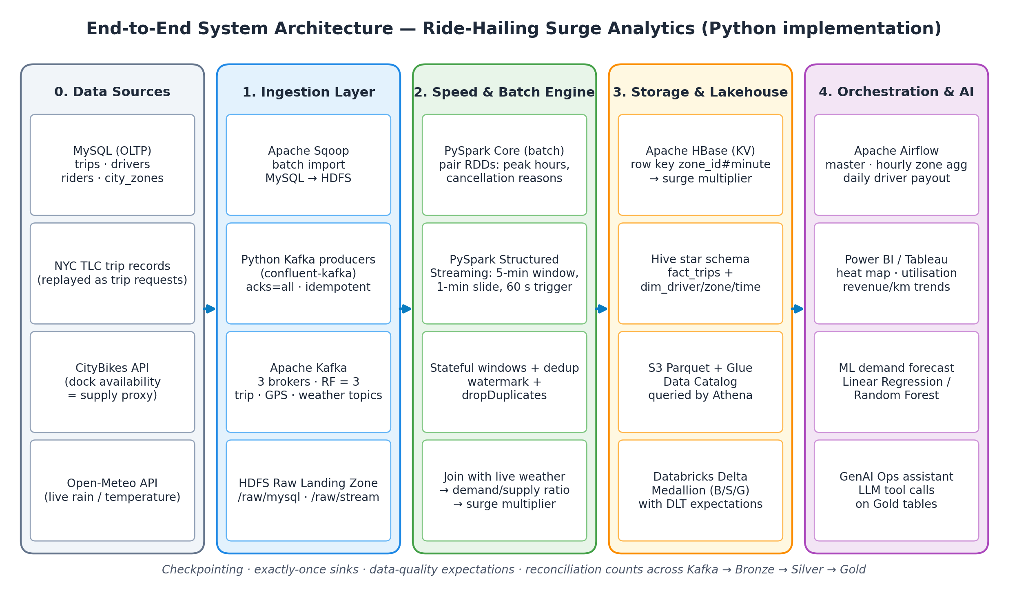
Figure 1: End-to-end architecture — data sources, ingestion, speed & batch engine, storage & lakehouse, orchestration & AI

7.1 Layer 1 — Ingestion
- MySQL (Sqoop batch): historical trips, drivers, riders and city zones are imported nightly into HDFS as Parquet.
- Kafka (live API feed): Python producers publish trip requests, driver GPS pings and weather to a 3-broker Kafka cluster.
- HDFS raw landing zone: immutable copy of every batch import and of the raw stream, used for replays and reconciliation.

7.2 Layer 2 — Speed & Batch Engine
- Spark Structured Streaming (speed layer) computes demand, supply and surge per zone every 60 seconds.
- Spark Core cleansing job (batch layer) cleans historical data and analyses peak hours and cancellation reasons.
- Stateful windows & dedup use watermarks and event IDs so late or repeated events are handled correctly.

7.3 Layer 3 — Storage & Lakehouse
- HBase serves the latest surge multiplier per zone with millisecond reads.
- Databricks Delta (Bronze/Silver/Gold) holds the curated lakehouse with quality rules.
- Hive star schema and S3 Parquet + Glue + Athena provide the warehouse and low-cost SQL analytics.

7.4 Layer 4 — Orchestration & AI
- Airflow master DAG schedules and chains all batch work.
- Power BI / Tableau dashboards visualise zones, utilisation and revenue.
- ML models and GenAI agent forecast demand and answer operational questions.

8. Data Sources
Source | Type | Key fields | Used for
MySQL trips | Batch (Sqoop) | trip_id, driver_id, rider_id, pickup/dropoff zone, request/pickup/dropoff time, distance, fare, status, cancel_reason | History, star schema, model training
MySQL drivers, riders | Batch (Sqoop) | id, name (synthetic), vehicle_type, joined_date, home_city, rating | Dimensions, incentive payouts
MySQL city_zones | Batch (Sqoop) | zone_id (TLC LocationID), zone_name, borough, service_zone, centroid | Zone dimension, mapping GPS to zones
NYC TLC HVFHV trip records | Replay → Kafka | request_datetime, pickup_datetime, PULocationID, DOLocationID, trip_miles, base_passenger_fare | Trip request stream (demand) and seed data for MySQL
Driver GPS simulator | Live → Kafka | driver_id, lat, lon, status (available / on_trip), ts | Supply stream and utilisation
CityBikes API (citi-bike-nyc) | Live → Kafka | station id, lat, lon, free_bikes, empty_slots, timestamp | Supply proxy per zone
Open-Meteo API | Live → Kafka | temperature_2m, precipitation, rain, weather_code | Weather adjustment to surge and forecast feature

Seed data flow: TLC Parquet files are loaded into MySQL by a Python script (pandas + SQLAlchemy), with synthetic driver and rider IDs attached. This gives Sqoop a realistic operational source to import from, as the problem statement requires.

9. Detailed Module Design and Process

9.1 Ingestion and Streaming

Batch: Sqoop import from MySQL
Each MySQL table is imported into the HDFS raw zone as Parquet. Trips are imported incrementally on last_modified so reruns do not duplicate data. Airflow triggers the commands.
sqoop import --connect jdbc:mysql://mysql:3306/ridehail \
--username etl --password-file /secrets/mysql.pwd \
--table trips --target-dir /raw/mysql/trips \
--as-parquetfile --incremental lastmodified \
--check-column last_modified --merge-key trip_id -m 4

Streaming: Kafka topics
Topic | Producer | Key | Partitions / RF | Rate
trip_requests | TLC replay producer | zone_id | 6 / 3 | Replayed at configurable speed (e.g. 1× – 60×)
driver_gps_pings | GPS simulator + CityBikes poller | zone_id | 6 / 3 | Every 15–30 s per driver; CityBikes every 60 s
weather | Open-Meteo poller | city | 1 / 3 | Every 60 s
surge_updates | Streaming job (output) | zone_id | 6 / 3 | Every 60 s

Producer reliability settings: acks=all, enable.idempotence=true, and topic min.insync.replicas=2. With 3 brokers and replication factor 3, one broker can fail with no data loss (Drill 1). Every event carries a unique event_id and an event_time for deduplication and windowing.
from confluent_kafka import Producer
import json

producer = Producer({
"bootstrap.servers": "kafka1:9092,kafka2:9092,kafka3:9092",
"acks": "all",
"enable.idempotence": True,
})

def send_trip_request(row):
event = {
"event_id": row.event_id,
"event_time": row.request_datetime.isoformat(),
"zone_id": int(row.PULocationID),
"dropoff_zone_id": int(row.DOLocationID),
}
producer.produce("trip_requests", key=str(event["zone_id"]),
value=json.dumps(event))
producer.poll(0)

9.2 Processing and Cleansing

Spark Core batch analysis (pair RDDs)
The Spark Core job reads historical trips from HDFS, removes invalid records (null zones, negative fares, drop-off before pick-up), and produces two analyses using pair RDDs:
- Peak hours: (hour_of_day, 1) pairs reduced with reduceByKey to find the busiest hours per zone and day type.
- Cancellation reasons: (cancel_reason, 1) pairs reduced and sorted to rank the causes of cancellations by zone and hour.
trips = sc.textFile("hdfs:///raw/mysql/trips_csv").map(parse).filter(is_valid)
peak_hours = (trips.map(lambda t: (t.pickup_ts.hour, 1))
.reduceByKey(lambda a, b: a + b)
.sortBy(lambda kv: -kv[1]))
cancel_reasons = (trips.filter(lambda t: t.status == "CANCELLED")
.map(lambda t: (t.cancel_reason, 1))
.reduceByKey(lambda a, b: a + b))

Spark Structured Streaming surge engine
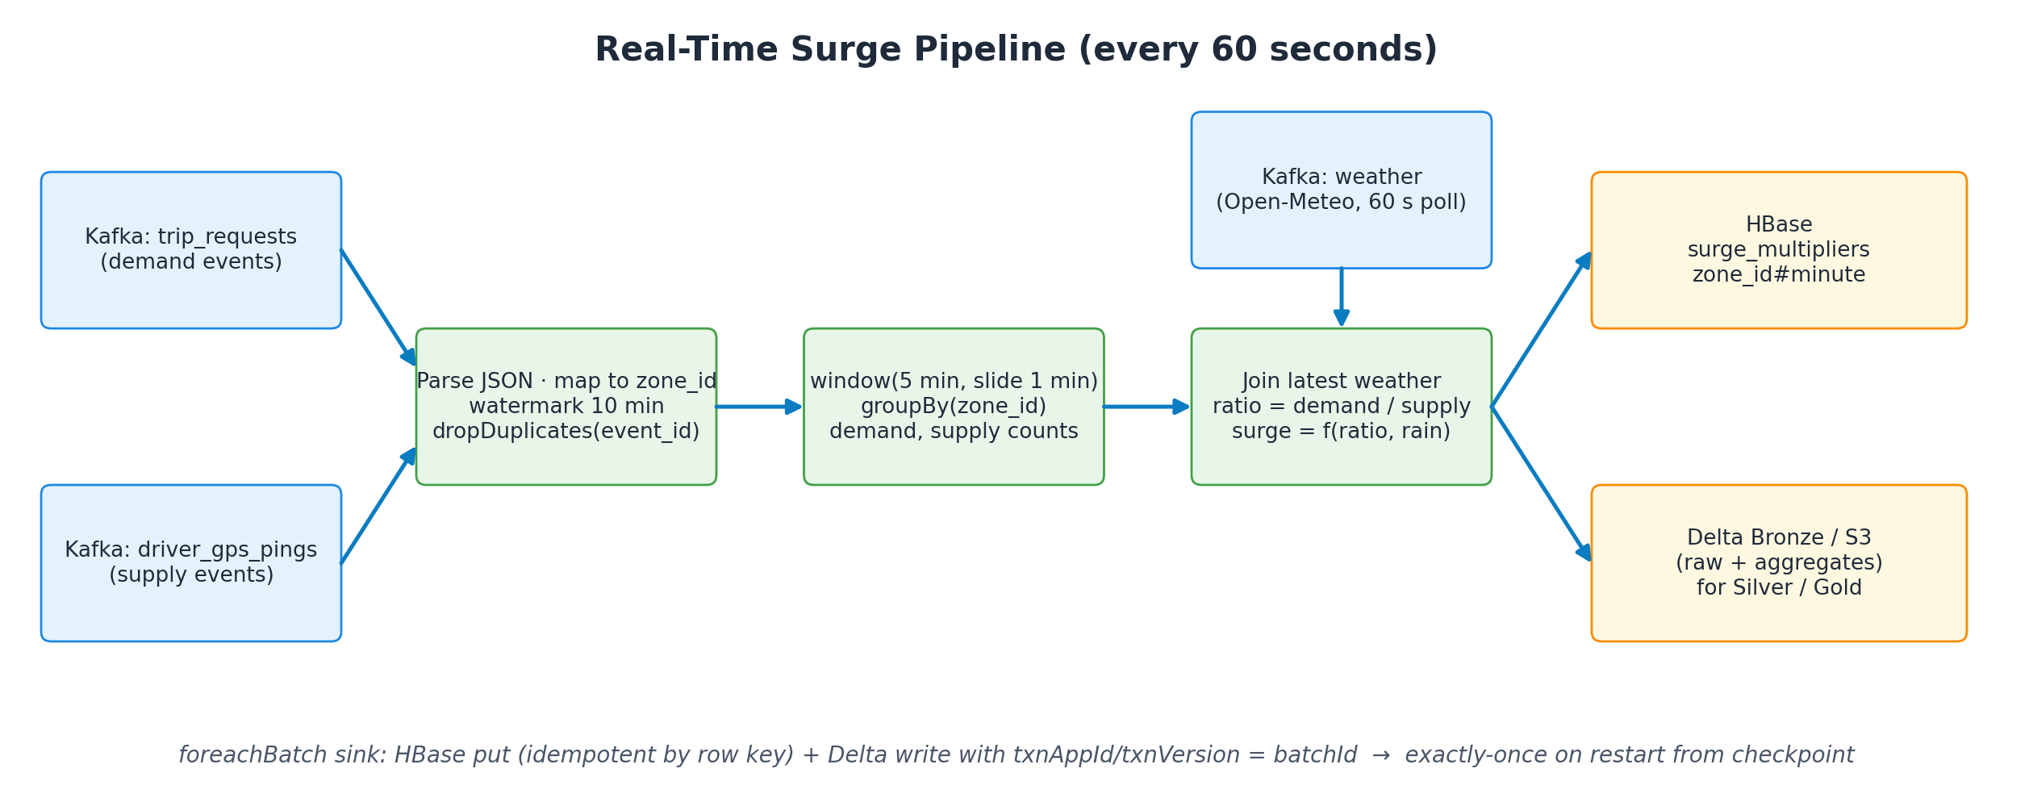
Figure 2: Real-time surge pipeline, refreshed every 60 seconds
- Read trip_requests and driver_gps_pings from Kafka; parse JSON; map GPS coordinates to a zone_id (point-in-polygon on the TLC zone shapes, pre-computed for CityBikes stations).
- Apply a 10-minute watermark on event_time and dropDuplicates on event_id.
- Aggregate on a 5-minute window sliding every 1 minute per zone: demand = count of trip requests; supply = distinct available drivers + CityBikes supply proxy.
- Join each window with the latest weather reading for the city (rain, temperature).
- Compute ratio = demand / max(supply, 1) and the surge multiplier (Section 9.3).
- Every 60 seconds (trigger(processingTime="60 seconds")), write results with foreachBatch to HBase, the surge_updates topic and the Delta Bronze layer.
from pyspark.sql import functions as F

demand = (requests.withWatermark("event_time", "10 minutes")
.dropDuplicates(["event_id", "event_time"])
.groupBy(F.window("event_time", "5 minutes", "1 minute"), "zone_id")
.agg(F.count("*").alias("demand")))

query = (zone_surge.writeStream
.foreachBatch(write_to_hbase_and_delta)
.option("checkpointLocation", "hdfs:///checkpoints/surge")
.trigger(processingTime="60 seconds")
.outputMode("update").start())

9.3 Surge Multiplier Logic
The first version uses a transparent rule-based policy so results can be explained and tuned. The demand forecast can later be added as an input.
Demand / supply ratio | Base multiplier
< 1.0 | 1.0× (no surge)
1.0 – 1.5 | 1.2×
1.5 – 2.0 | 1.5×
2.0 – 3.0 | 2.0×
> 3.0 | 2.5×

- Weather adjustment: +0.2× when rain ≥ 2.5 mm/h; +0.1× when temperature is below 5 °C or above 35 °C.
- Cap and smoothing: final multiplier is capped at 3.0×, and can change by at most ±0.3× per minute to avoid flickering prices.
- These thresholds are starting values and will be tuned against the ETA and utilisation KPIs using the replayed data.

9.4 Storage and Data Modelling

HBase — current surge multipliers
Item | Design
Table | surge_multipliers
Row key | zone_id#minute, e.g. 132#202609291145 (zone ID zero-padded to 3 digits so keys sort correctly)
Column family s | multiplier, demand, supply, ratio, rain_mm, temp_c, updated_at
Access pattern | Latest value for a zone = prefix scan on zone_id# in reverse; history of a zone for the last hour = range scan
Retention | TTL of 7 days; long-term history lives in Delta and Hive

Hive star schema
The warehouse uses one fact table and three dimensions, stored as Parquet and partitioned by city and date as specified.
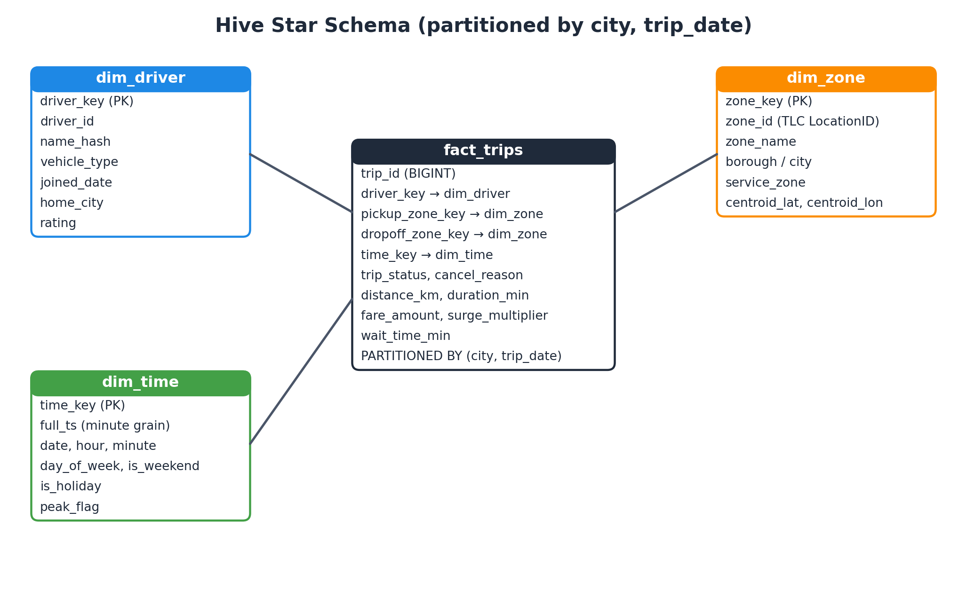
Figure 3: Hive star schema — fact_trips with dim_driver, dim_zone and dim_time
CREATE EXTERNAL TABLE fact_trips (
trip_id BIGINT, driver_key INT, pickup_zone_key INT, dropoff_zone_key INT,
time_key BIGINT, trip_status STRING, cancel_reason STRING,
distance_km DOUBLE, duration_min DOUBLE, fare_amount DOUBLE,
surge_multiplier DOUBLE, wait_time_min DOUBLE)
PARTITIONED BY (city STRING, trip_date DATE)
STORED AS PARQUET LOCATION 'hdfs:///warehouse/fact_trips';

9.5 Cloud and Lakehouse Stack

S3 Parquet + Glue Data Catalog + Athena
- Curated tables are written to S3 as Snappy-compressed Parquet under s3://<bucket>/curated/<table>/city=<city>/trip_date=<date>/.
- A Glue crawler (run by Airflow) registers tables and new partitions in the Glue Data Catalog.
- Athena queries the catalogued tables. Queries filter on city and trip_date, so Athena reads only the needed partitions and columns.

Databricks Medallion with Delta Live Tables
Layer | Content | Quality rules
Bronze | Raw events and batch extracts as received (Auto Loader from S3 landing) | None — full fidelity for replay and audit
Silver | Cleaned, deduplicated, typed and zone-mapped trips, pings and weather | Valid GPS coordinates; fare > 0; non-null zone_id; pickup after request
Gold | zone_minute_surge, zone_hourly_kpis, driver_daily_utilisation, revenue_per_km, demand_forecast | Aggregates reconcile with Silver counts

import dlt
from pyspark.sql import functions as F

@dlt.table(comment="Cleaned trip requests")
@dlt.expect_or_drop("valid_gps",
"lat BETWEEN 40.4 AND 41.0 AND lon BETWEEN -74.3 AND -73.6")
@dlt.expect_or_drop("positive_fare", "fare_amount > 0")
def silver_trips():
return dlt.read_stream("bronze_trips").dropDuplicates(["event_id"])
Rows that fail an expectation are dropped and counted in the DLT event log. These counts feed the reconciliation drill. (Databricks now also calls DLT *Lakeflow Declarative Pipelines*; the Python dlt API is the same.)

9.6 Orchestration and Workflow (Airflow)
DAG | Schedule | Tasks
master_batch_dag | Daily 00:30 | Sqoop import (4 tables) → Spark Core cleansing job → load Hive partitions → sync to S3 → run Glue crawler → trigger downstream DAGs
hourly_zone_aggregation | Every hour | Wait for Silver data → aggregate trips, demand, supply, surge, ETA and revenue per zone-hour → write Gold zone_hourly_kpis → data-quality check → refresh Athena partitions
daily_driver_incentive_payout | Daily 01:00 | Compute per-driver trips, online hours, utilisation and revenue → apply incentive rules → write Gold driver_payouts → build HTML/CSV report → send email (EmailOperator)

Illustrative incentive rule: a driver with utilisation ≥ 78% and at least 12 completed trips in a day earns a bonus; drivers who accept trips in surge zones earn an extra per-trip amount. Failures in any DAG trigger an alert email with retries configured (retries=2).

9.7 Analytics and AI Integration

Power BI dashboards
- Live heat map by city zone: surge multiplier and demand/supply ratio on the NYC taxi zone map (shape map visual), with page auto-refresh through DirectQuery on the Gold tables.
- Driver utilisation gauge: current and daily utilisation against the 78% target.
- Revenue/km trends: by zone, hour and weather condition; plus average rider ETA against the 4.5-minute target.
Power BI connects to the Databricks Gold tables (Databricks connector) and to Athena (ODBC). Tableau can use the same sources.

Demand forecasting model
- Target: number of trip requests in a zone in the next 30 minutes.
- Features: zone_id, hour, day of week, weekend/holiday flag, demand lags (30 min, 60 min, same time yesterday and last week), rolling averages, rain and temperature.
- Models: Linear Regression as the baseline and Random Forest Regressor as the main model (scikit-learn), tracked in MLflow.
- Validation: time-based train/test split (no shuffling), reporting R², MAE and RMSE. Acceptance: R² ≥ 0.70 on the held-out period.
- Serving: batch scoring every 30 minutes into Gold demand_forecast, shown on the dashboard and available to the GenAI assistant.

GenAI Ops assistant
A Python chat assistant (Streamlit UI) lets the operations team ask questions such as "Which five zones have the highest surge right now?" or "What was driver utilisation in Midtown yesterday?". The LLM does not write free SQL; it calls a fixed set of read-only tools:
Tool | What it returns
get_current_surge(zone) | Latest multiplier, demand, supply and weather for a zone
top_zones(metric, n) | Top N zones by surge, demand or wait time
driver_utilisation(date, zone) | Utilisation and trips for a date and optional zone
demand_forecast(zone) | Next 30-minute forecast with the recent actuals
kpi_summary(date) | ETA, utilisation, revenue/km and surge statistics for a day

Each tool runs a parameterised query against the Gold tables using databricks-sql-connector, so the assistant only reads curated data and cannot modify it.

10. Live Stream and Replay Hybrid Design
To keep events flowing 24/7 and still support historical backfills, the Kafka producers combine live APIs with replayed history, as specified in the problem statement:
Feed | Mode | How it works
CityBikes API | Live | Polls the Citi Bike NYC network every 60 s; each station's available bikes are mapped to its taxi zone and published as the supply proxy
Open-Meteo | Live | Polls current rain and temperature for New York every 60 s (no API key needed)
NYC TLC trip records | Replay | Reads a month of HVFHV Parquet, re-stamps each request with the current time (keeping original gaps) and publishes it as a live trip request; speed-up factor is configurable
Driver GPS simulator | Live (synthetic) | Moves a synthetic fleet between zones, marking drivers available or on_trip as replayed trips are matched
Backfill | Replay | The same replay producer can re-publish any historical date range to rebuild Bronze/Silver/Gold after a fix

11. Reliability and Failure Drills
Drill | Procedure | Pass criterion
1. Broker kill | While producers run, stop 1 of 3 Kafka brokers (docker stop kafka2) for 5 minutes, then restart it | Zero data loss: produced count = consumed count; surge refresh continues
2. Spark restart | Kill the streaming job mid-batch and restart it with the same checkpoint location | Job resumes from the committed offsets; no duplicate or missing rows in HBase or Delta (exactly-once)
3. Reconciliation | Compare record counts for one time range across Kafka offsets, Bronze, Silver and Gold | Counts match after accounting for rows dropped by DLT expectations and dedup

How exactly-once is achieved: Kafka offsets are stored in the Spark checkpoint. HBase writes are idempotent because the row key zone_id#minute is deterministic, so a replayed batch overwrites the same cells. Delta writes inside foreachBatch use txnAppId and txnVersion = batch_id, so Delta skips a batch it has already committed.
A Python reconciliation script produces a report per run: Kafka count (end offset − start offset), Bronze count, Silver count + dropped (from the DLT event log) + duplicates, and Gold aggregate totals.

12. Measurable Outcomes and Acceptance
Outcome | How it will be measured | Target
Surge refresh | Timestamp gap between consecutive updated_at values per zone in HBase | Every 60 s
Average rider ETA | request → pickup time from trip data (and simulated dispatch in live mode), averaged per zone-hour | < 4.5 min
Driver utilisation | on-trip minutes ÷ online minutes, from GPS ping status | ≥ 78%
Athena scan cost | Bytes scanned for 5 benchmark queries on raw CSV vs partitioned Parquet; reduction = 1 − Parquet ÷ CSV | ≥ 70% drop
Forecast accuracy | R² on the held-out time period | R² ≥ 0.70
Fault tolerance | Results of the three drills in Section 11 | All pass

13. Implementation Plan

13.1 Phases
Week | Phase | Main activities | Output
1 | Setup & data | Docker Compose stack (MySQL, Kafka ×3, Hadoop/HDFS, Hive, HBase, Spark, Airflow); AWS and Databricks accounts; download TLC data and zone map; seed MySQL | Running environment, seeded MySQL
2 | Batch ingestion | Sqoop imports to HDFS; Spark Core cleansing and pair-RDD analysis | Raw zone, peak-hour and cancellation reports
3 | Streaming ingestion | Python producers (TLC replay, GPS simulator, CityBikes, Open-Meteo); topics with RF=3 | Continuous events in Kafka
4 | Surge engine | Structured Streaming windows, dedup, weather join, surge logic, HBase + Delta sinks, checkpointing | Surge per zone every 60 s
5 | Warehouse & cloud | Hive star schema; S3 Parquet; Glue crawler; Athena benchmark; Databricks DLT Bronze/Silver/Gold | Star schema, lakehouse, cost report
6 | Orchestration | Airflow master, hourly aggregation and daily payout DAGs with email | Scheduled pipelines and reports
7 | Analytics & AI | Power BI dashboards; forecast model training and scoring; GenAI assistant | Dashboards, model (R² ≥ 0.70), assistant
8 | Testing & demo | Failure drills, reconciliation, KPI measurement, documentation, final presentation | Drill report, final report, demo

13.2 Proposed Work Split
Each member owns one layer end to end; all three work together on integration, testing and the demo. The team may adjust this split.
Member | Primary ownership
Bharadwaj Boyapati | Ingestion and speed layer: MySQL seeding, Sqoop, Kafka cluster and Python producers, Structured Streaming surge engine
Khuraijam Richard | Storage and lakehouse: Spark Core batch job, HBase, Hive star schema, S3/Glue/Athena, Databricks DLT, reconciliation
Moirangthem Erudite | Orchestration and AI: Airflow DAGs and email reports, Power BI dashboards, demand forecast model, GenAI Ops assistant

13.3 Repository Structure
ride-hailing-surge-analytics/
├── docker/ # docker-compose.yml, service configs
├── data/ # seed scripts, TLC samples, zone shapefile
├── ingestion/
│ ├── sqoop/ # import commands
│ └── producers/ # tlc_replay, gps_simulator, citybikes, weather
├── processing/
│ ├── batch/ # spark_core_trips.py (pair RDDs)
│ └── streaming/ # surge_stream.py, surge_rules.py, sinks.py
├── storage/ # hbase_schema.py, hive_ddl.sql
├── lakehouse/ # dlt_pipeline, s3_sync, athena_benchmark
├── airflow/dags/ # master_batch, hourly_zone_agg, daily_payout
├── ml/ # features.py, train.py, score.py
├── genai/ # tools.py, assistant_app.py
├── dashboards/ # Power BI .pbix
├── tests/ # unit tests, drills/, reconciliation.py
└── docs/

14. Deliverables
- Source code repository with the structure above and a README describing setup and run steps.
- Docker Compose environment for all open-source components.
- Working streaming pipeline producing surge multipliers every 60 seconds, stored in HBase and Delta.
- Hive star schema, S3/Glue/Athena tables and a Databricks DLT Medallion pipeline.
- Three Airflow DAGs with an automated daily email report.
- Power BI dashboard file (.pbix) with heat map, utilisation gauge and revenue/km trends.
- Trained demand forecast model with evaluation report (R², MAE, RMSE) and MLflow run.
- GenAI Ops assistant with its tool definitions.
- Test report covering the three failure drills, reconciliation and KPI results.
- Final project report and demo presentation.

15. Risks and Mitigations
Risk | Impact | Mitigation
Laptop cannot run every service at once | Slow or crashing stack | Run in profiles (ingestion, streaming, batch); single-node HDFS/HBase; limit Spark memory
Apache Sqoop is retired (moved to the Apache Attic in 2021) | Setup issues on new Hadoop versions | Use a pinned Sqoop 1.4.7 + Hadoop image; keep a Spark JDBC import script as backup
Cloud free-tier limits | Unexpected cost | Small data samples, S3 lifecycle rules, AWS budget alert, Athena workgroup scan limit
DLT or connector features differ on the free Databricks tier | Pipeline cannot run as designed | Verify early in week 1; fall back to plain Delta streaming jobs with the same checks
Forecast R² below 0.70 | Model SLA missed | Add lag and weather features, tune Random Forest, aggregate sparse zones
External API downtime | Gaps in live feed | Retry with backoff; replay producer keeps the stream going

16. Conclusion
This project delivers a complete, working data platform for dynamic surge pricing: batch and streaming ingestion, a real-time surge engine refreshed every 60 seconds, a warehouse and lakehouse for history, scheduled pipelines, dashboards, a demand forecast and a GenAI assistant. It uses every tool named in the problem statement, implemented in Python, and it will be judged against clear, measurable targets and three failure drills that prove the pipeline is reliable.

