**Assignment #13**

**Objective**

Introduction to Bioinformatics software installation

**Due**

Monday 4/23 at 9am. Please submit to your GitHub repository the BASH script that the tutorial instructs you to create in the Exercises section.

**Tasks**

Please read Chapter 6 of the online book “A Primer for Computational Biology”, by Shawn T O’Neil. You can find the link here: <http://library.open.oregonstate.edu/computationalbiology/chapter/installing-bioinformatics-software/>.

This book explains how to install software on a stand-alone UNIX machine. However, Kamiak is a shared resource with a bit different configuration. Therefore, pleas read through the following notes before continuing.

***Note***:

1. Be sure to use an **idev** session on Kamiak to perform this assignment. We do not want to compile software on the Kamiak head nodes.
2. In the first section the author instructs you to click the “Alternative Download Options” link on the HMMER website, but the website has changed. Click the “**archived older versions**” link instead. Also, the HMMER site has stopped offering Linux binaries, so you won’t see those listed as the text describes.
3. The author asks you to download the Drosophila genome data but gives an outdated release version. Instead use the release here: <ftp://ftp.flybase.net/releases/FB2019_02/dmel_r6.27>
4. The author assumes that you are working in your home directory. Remember you have limited space in your home directory.
   1. Install software on Kamiak in your working directory in **/data/hort503/{user}/software,** where {user} is your user name on Kamiak.
   2. Therefore, anywhere you see **$HOME/local** in the text you will need to substitute that for **/data/hort503/{user}/software**
   3. Because you are installing software into a non-expected directory (such as /usr/local/bin) then you will not be able to run **HMMER** or **muscle** just by typing their names. Remember, software must be in the **$PATH** environment variable. Since we are not showing you how to install software into Kamiaks module system, you will have to provide the full path to these software: **muscle**, **hmmbuild** and **hmmsearch**.
5. Also, the author will suggest you download into your home directory referenced using the $HOME environment variable. Instead, download into a new folder in your working directory. A good solution may be: **/data/hort503/{user}/src.**
6. The author shows you how to transfer files to Kamiak using SSH and gives the example using a Firefox browser extension. If you do not use Firefox, then instead download FileZilla (<https://filezilla-project.org/>). FileZilla is easy enough to figure out. You will need to provide your login credentials similar to how the following screenshot shows:

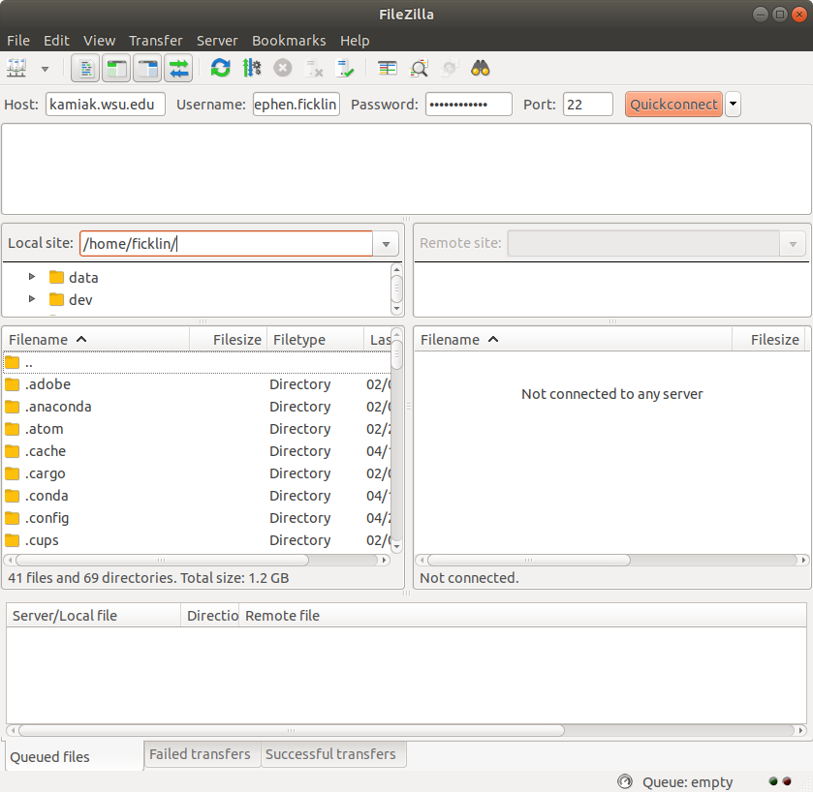

***Help*:**

1. Remember you can use these programs to look at file contents:  
   **cat**: prints the entire contents of a file to the screen  
   **head**: prints the first 10 lines of the file (you can increase this with the -n option)  
   **tail**: prints the last 10 lines of the file (you can increase this with the -n option)  
   **less**: prints the file to the screen but lets you scroll using the arrow keys throughout the file (type the letter`q` to exit).

Complete the installation of HMMER and muscle as described in the document and follow the exercises throughout the Chapter. Turn in your BASH script used for running the tool on your GitHub repository.

<http://eddylab.org/software/hmmer/hmmer-3.2.tar.gz>

<https://www.drive5.com/muscle/downloads3.8.31/muscle3.8.31_i86linux64.tar.gz>