 | ALPHA SCHOOL OF MUSIC - SEMESTER PILOT  Alpha Rhythm  Implementation, customization and deployment guide  Practice. Purpose. Progress.

BRANDED BUILD This refresh uses the supplied Alpha Boys' School artwork throughout the app and adopts its crimson, cream and deep-ink palette. The same artwork is used as the installed home-screen icon.

1. What has been built
Alpha Rhythm is a mobile-first semester companion for the current 25-student cohort. It is designed to make daily discipline visible without turning student development into a competition or a surveillance exercise.
- Daily "My 3" deliverables so each student identifies three concrete outcomes for the day.
- Configurable targets for music practice, reading/study, mindfulness or meditation, and exercise/movement.
- Morning intention plus a short evening close-out and an optional private reflection.
- Semester goals, a seven-day consistency view, streak tracking and semester totals.
- Weekly student check-in plus a mentor-ready summary that excludes private daily reflections.
- CSV export and JSON backup/restore for student-owned records.
- No leaderboard: the focus is self-accountability, preparation and consistent personal progress.

2. Core design principle
The app should feel like a personal training companion for musicians: quick to use, easy to understand, and directly connected to the habits that make rehearsals, coursework, performances and professional growth go better.
PILOT FIRST The present build is intentionally local-first. It lets Alpha test the behaviour and coaching model before deciding whether a central staff dashboard is actually needed.

STUDENT EXPERIENCE

3. What the student sees
The visual system now follows the supplied Alpha identity. Crimson carries the primary actions and progress cues; cream creates the background and card system; the Alpha artwork appears in the sticky header and onboarding.
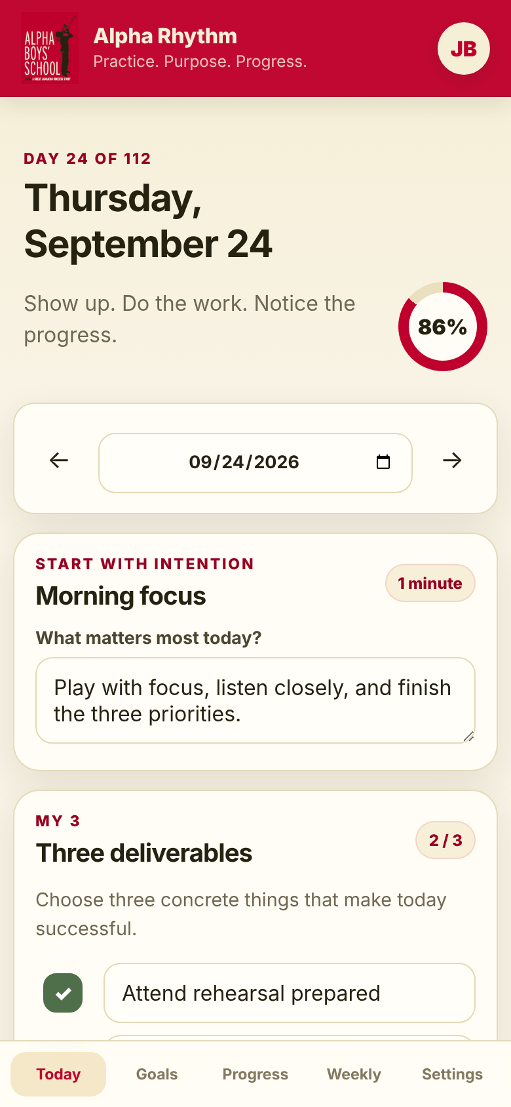  Today view | 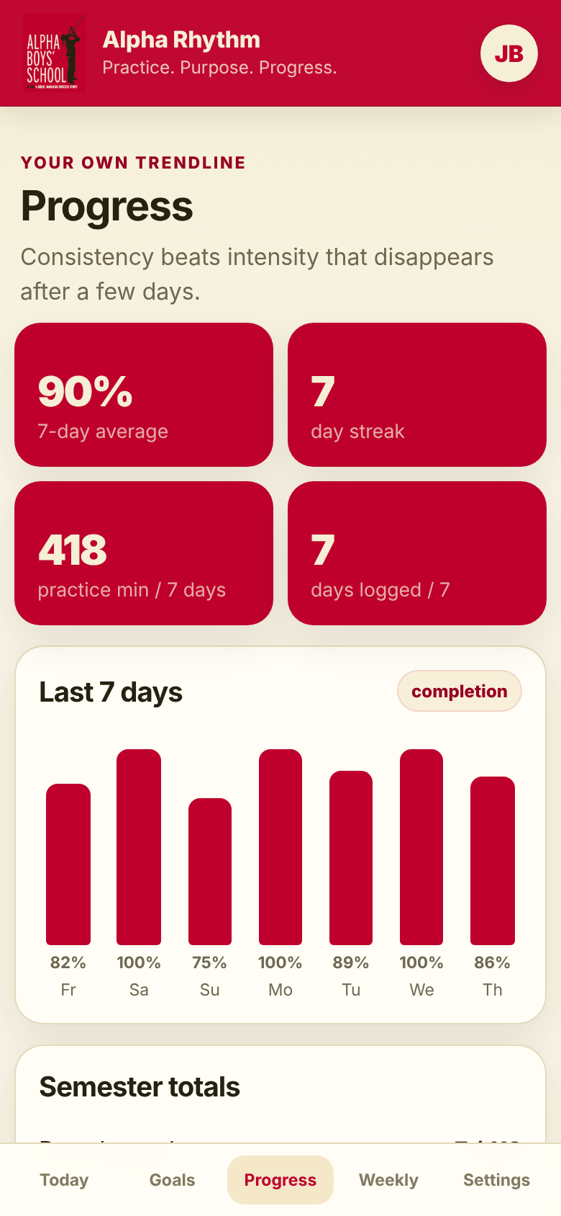  Progress view

Moment | Student action | Why it matters
Morning | Set intention + My 3 | Turns a broad day into three visible commitments.
During day | Log practice, reading, reflection and movement | Makes consistency measurable without public comparison.

PRIVACY BY DEFAULT The weekly mentor summary reports consistency and activity totals but leaves private daily reflections out. That boundary can be changed only after Alpha decides the rules.
FROM FILES TO PHONES

4. Fastest way for Steve to test it
1. Open Alpha_Rhythm_Standalone.html on a laptop or desktop for the quickest visual preview.
2. Use the onboarding screen, enter a test student, and try Today, Goals, Progress, Weekly and Settings.
3. For phone testing and installation, publish the web folder to an HTTPS host such as GitHub Pages.

5. Publish with GitHub Pages
1. Create a GitHub repository, for example alpha-rhythm.
2. Upload the contents of the web folder to the repository root.
3. Open Settings -> Pages -> Build and deployment -> Deploy from a branch.
4. Choose main and / (root), then save.
5. Share the HTTPS link GitHub provides with the pilot students.

6. Save to the phone home screen
iPhone / iPad  Open the published link in Safari -> Share -> Add to Home Screen -> Add. | Android  Open the published link in Chrome -> Install app or Add to Home screen.


Installed icon: a copy of the supplied Alpha logo

7. Customize programme rules
Most programme settings are in web/config.js. Staff can change the semester length, default daily targets and the habit list without redesigning the interface.
Setting | Current pilot default | Where to change it
Semester length | 16 weeks | program.defaultWeeks
Practice | 60 min | defaultTargets.practice
Reading/study | 20 min | defaultTargets.reading
Mindfulness | 10 min | defaultTargets.mindfulness
Exercise/movement | 30 min | defaultTargets.exercise

25-STUDENT COHORT

8. Recommended pilot rhythm
- Days 1-3 - Steve plus 2-3 students test the app and identify wording or friction that needs to change.
- Week 1 launch - a 20-minute cohort orientation; every student creates a profile and at least one semester goal.
- Daily - students plan, practice and log. The app itself should take only a few minutes outside the activity.
- Weekly - students generate the mentor summary. Faculty coach patterns and recovery, not isolated misses.
- Weeks 3-4 - remove anything that feels like administrative weight and refine the targets to match actual Alpha expectations.
- Mid-semester - decide whether a secure central faculty dashboard adds enough value to justify collecting data centrally.

9. Data and privacy in this pilot
- Each student's data lives in that student's browser/device using local storage; there is no central database or account system.
- Private daily reflections are excluded from mentor summaries.
- CSV exports exclude private reflections unless the student explicitly turns that option on.
- JSON backups contain the full personal record and should be treated as private.
- If Alpha later centralizes accounts/reporting, access, retention, consent and safeguarding rules should be defined before the technical build.

10. Phase 2 - only after Alpha decides the rules
- Student login and secure cloud sync across devices.
- Mentor dashboard showing completion patterns and missed check-ins, not private journal text.
- Programme-level views for the 25-person cohort without public ranking.
- Faculty-set assignments, rehearsals, repertoire goals and performance milestones.
- Notifications and scheduled weekly check-ins.
- Optional integration with Alpha systems where useful and permitted.

NEXT INPUT Use the Staff Input Note in this package to gather Alpha's five programme decisions. Those answers should drive the next build rather than adding features by assumption.

