Real-Time Intrusion Detection and Security Monitoring Lab Using Suricata, Wazuh, Active Directory, FortiGate, and VMware ESXi
Richard Mpango Akilimali | INCS 615 Advanced Network and Internet Security | Option 2: Project Demo
Abstract— This project implements a real-time intrusion detection and security monitoring lab using Suricata, Wazuh, Windows Server 2022 Active Directory, FortiGate 60D, Kali Linux, Windows 11, and VMware ESXi. The objective is to demonstrate how a network intrusion detection sensor, endpoint agents, firewall logs, and a SIEM dashboard can be combined to improve visibility in a small enterprise-style environment. Suricata was deployed as a network IDS sensor and Wazuh was used to centralize events and display alerts. Safe test traffic was generated from Kali Linux, and Suricata successfully detected Nmap reconnaissance activity. Windows authentication monitoring and FortiGate syslog forwarding were also validated.
Keywords— Wazuh, Suricata, intrusion detection, SIEM, Active Directory, FortiGate, VMware ESXi, Nmap.
I. Introduction
Intrusion detection and centralized security monitoring are important components of network defense. In this implementation, open-source and enterprise-style tools were combined in a controlled lab to detect suspicious activity and collect endpoint security events. The project follows Option 2 because it demonstrates a working implementation rather than only a research paper.
II. Lab Architecture
The lab used a flat 192.168.5.0/24 network. FortiGate 60D provided firewall, gateway, DHCP, and traffic logging functions. VMware ESXi hosted the Wazuh server, Windows Server 2022 Active Directory, Suricata sensor, and Kali Linux test VM. A Windows 11 laptop acted as a client endpoint. Wazuh collected IDS alerts from Suricata and authentication activity from Windows endpoints.
Component | Role | IP Address
FortiGate 60D | Firewall, gateway, DHCP, traffic logging | 192.168.5.1
Wazuh Server | SIEM and alert monitoring | 192.168.5.3
VMware ESXi | Hypervisor hosting all virtual machines | 192.168.5.4
Windows Server 2022 Active Directory | Domain Controller, DNS, Windows event source | 192.168.5.5
Suricata Sensor | Network intrusion detection | 192.168.5.9
Kali Linux / Test VM | Safe traffic generation and testing | 192.168.5.18
Laptop running Windows 11 Professional | Client | 192.168.5.8
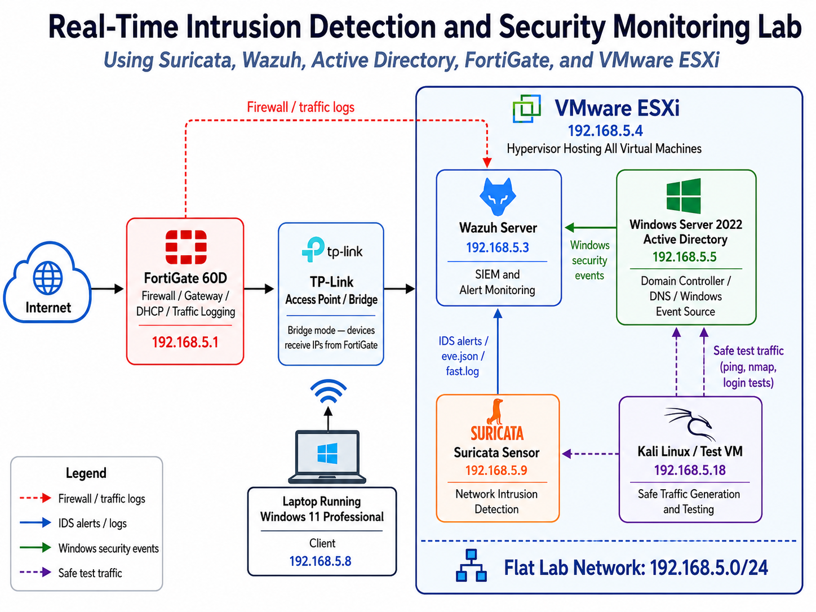
Fig. 1. Lab architecture showing FortiGate, VMware ESXi, Wazuh, Suricata, Windows Server Active Directory, Kali Linux, and Windows 11 client.
III. Implementation
The Wazuh agent was installed on the Suricata sensor and configured to monitor Suricata EVE JSON output. The agent forwarded IDS events to the Wazuh manager. The Wazuh dashboard confirmed that the Suricata sensor was active as agent 007. Windows agents were also active on Windows Server 2022 and Windows 11 endpoints, which allowed authentication success and failure events to be displayed in Wazuh.
Key Wazuh agent configuration on Suricata:
<localfile>
<log_format>json</log_format>
<location>/var/log/suricata/eve.json</location>
</localfile>
Safe test traffic script used for validation:
TARGET=${1:-192.168.5.9}
ping -c 4 $TARGET
nmap -sV $TARGET
IV. Detection Scenarios
Scenario | Source | Result
Nmap reconnaissance | Kali 192.168.5.18 | Suricata alert in Wazuh
Windows authentication | AD 192.168.5.5 | Success/failure visible
FortiGate syslog | FortiGate 192.168.5.1 | UDP/514 traffic received by Wazuh
V. Results and Evidence
The primary validation test was a safe Nmap service scan from Kali Linux (192.168.5.18) to the Suricata sensor (192.168.5.9). Suricata detected this activity as "ET SCAN Possible Nmap User-Agent Observed," and Wazuh displayed the alert under the Suricata sensor. This confirms the full detection path: Kali test traffic, Suricata IDS alert generation, Wazuh agent forwarding, and Wazuh dashboard visualization.
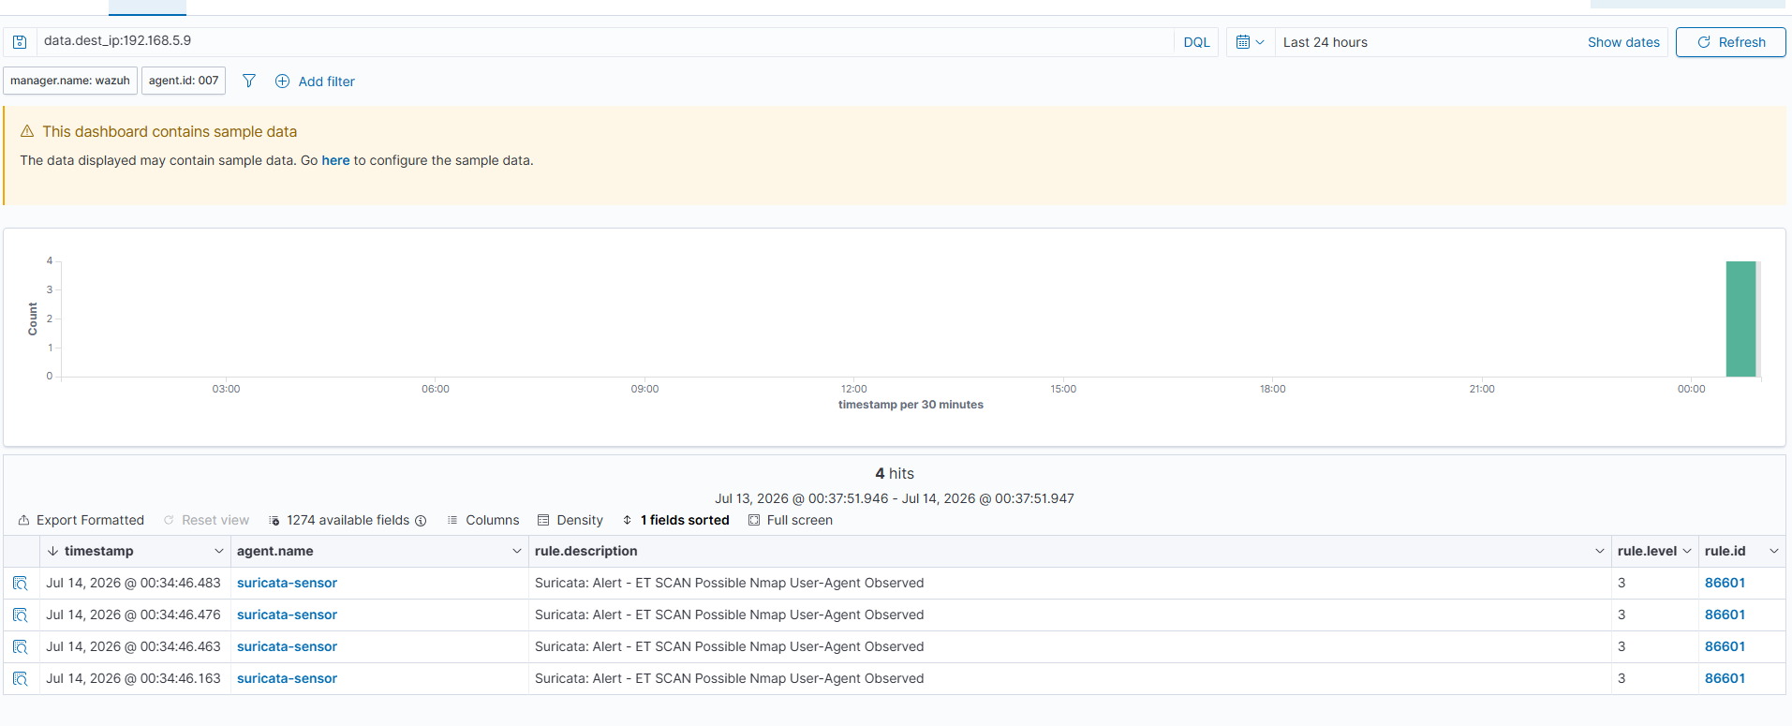
Fig. 2. Wazuh Threat Hunting dashboard showing the Suricata Nmap alert generated by Kali Linux test traffic.
Windows authentication monitoring was validated using the Windows Server 2022 endpoint. The Wazuh dashboard showed both authentication failures and authentication successes. This proves that endpoint authentication activity was being collected and displayed centrally.
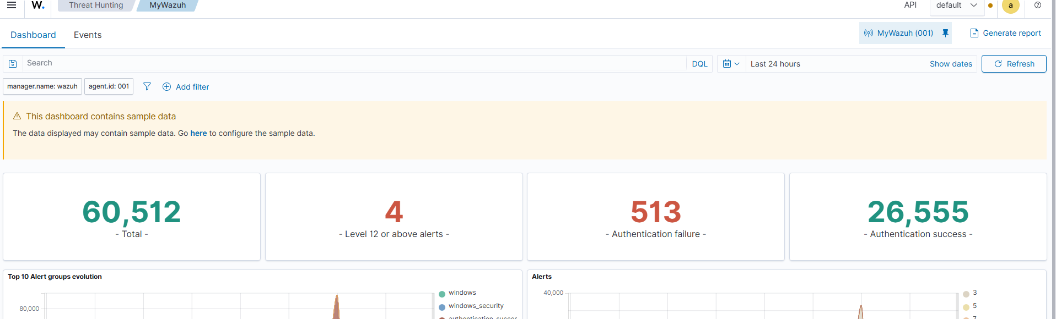
Fig. 3. Wazuh dashboard showing Windows authentication success and failure events.
VI. FortiGate Syslog Validation
FortiGate was configured to forward syslog events to Wazuh on UDP port 514. On the Wazuh manager, wazuh-remoted was confirmed listening on 0.0.0.0:514, and tcpdump confirmed that FortiGate traffic from 192.168.5.1 was reaching Wazuh. This validates the firewall log forwarding path, even though FortiGate appears as a syslog source rather than as a Wazuh endpoint.
FortiGate syslog configuration:
config log syslogd setting
set status enable
set server "192.168.5.3"
set port 514
set mode udp
set facility local7
end
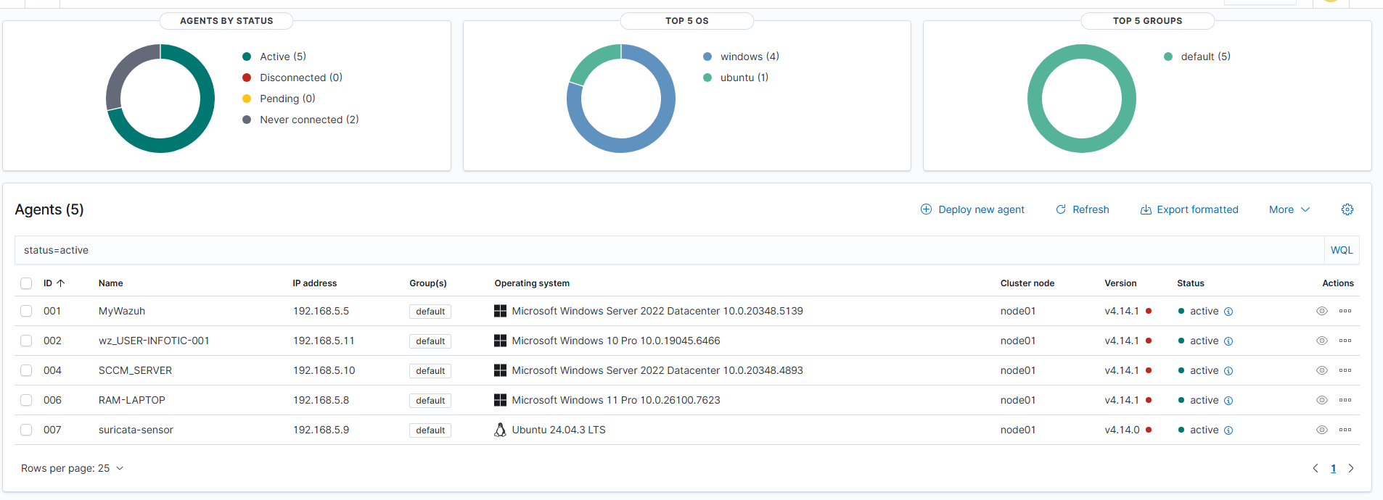
Fig. 4. Wazuh endpoint inventory showing active Windows and Ubuntu agents.
VII. Limitations
The lab used a flat network instead of VLAN segmentation, which limits visibility into some east-west traffic unless the IDS sensor directly observes the traffic. Testing was limited to authorized lab activity such as ping, Nmap, Windows authentication events, and firewall syslog validation. No malware or unauthorized external scanning was used.
VIII. Conclusion
The project successfully demonstrated a working real-time intrusion detection and monitoring environment. The lab detected Nmap reconnaissance using Suricata and Wazuh, collected Windows authentication events from an Active Directory endpoint, and validated FortiGate syslog forwarding to Wazuh. The result shows how network IDS, endpoint monitoring, firewall logging, and SIEM visibility can be combined in a small enterprise-style security lab.
References
[1] Wazuh Documentation, "Network IDS integration - Suricata," Wazuh, 2026.
[2] OISF, "EVE JSON Output and Format," Suricata Documentation, 2026.
[3] Wazuh Documentation, "Wazuh agent and Threat Hunting dashboard," Wazuh, 2026.
[4] Fortinet, "config log syslogd setting," FortiGate/FortiOS CLI Reference, 2026.

