Biological robustness is defined as the adaptability of a biological system to buffer and maintain its phenotype despite changes to the system. Environmental changes such as acidity, oxygen availability, temperature, or available nutrient levels induce changes in cellular pathways because of feedback control for the biological system to maintain homeostasis. This helps the biological system adapt and survive in different conditions.

Biological fragility refers to the opposite of robustness. Biological systems can be fragile despite the built-in redundancies and feedback pathways that respond and maintain cellular function when perturbed. A single point mutation can cause gene knockout or altered protein function. Damage to a critical gene such as p53, which plays a key role in the control of cell division as part of a response to DNA damage, can result in detrimental consequences [5].

Biological robustness is integral to survival and evolution. An example of biological robustness would be the built-in redundancies in biological systems. This built-in redundancy is found in many forms within the biological system, such as multiple copies of genes or organs (diploidy in cells and two kidneys as organs in humans). This redundancy allows for the maintained functionality of the cell or biological system in the event of catastrophic failure of one of the genes from genetic mutation, inherited genetic defect or failure of one kidney. Point mutations on DNA can cause a change in transcribed mRNA, which results in a potential change in the codon. Biological robustness is demonstrated with the redundancy provided by the genetic code where there are 64 possible codon combinations for nucleotides in mRNA, of which only 61 code for 20 amino acids and 3 for stop codons. The genetic code redundancy helps to provide a certain degree of protection for the cell against detrimental mutations that would otherwise cause the protein to be translated with the wrong amino acid leading to error in folding and function or premature termination of the peptide resulting in non-functional protein. However, environmental stressors affect selection of codon usage with decreased mutational robustness of traits less critical to survival at for the environment, biological systems that are extremely robust in one area for enhance survival in an environment (for example, for survival in high temperature environment) are usually balanced in another area that with extreme fragility [1, 3].

Often when systems that contribute to biological robustness fail to compensate, biological homeostasis is broken. Biological fragility usually presents in the form of disease. For example, cancer happens when aberrant cells divide uncontrollably and escape from immune surveillance of the host biological system. This usually happens when there are multiple points of failure that breaks the robustness of the biological system such as:

* Failure of cellular DNA repair mechanisms to identify and correct the mutation that drives the cancer cell to proliferate.
* Failure of host cell mechanisms to identify abnormal conditions and go into apoptosis.
* Failure of immune cells to detect and kill the aberrant cells.

While unavoidable, it is possible to take precautions against disease arising from biological system fragility such as cancer, by early detection through screening and intervention by treatment. Driver mutations that drive aberrant pathways resulting in uncontrolled cell division could be addressed using inhibitors of the aberrant pathway. Immune cell evasion by cancer cells could be addressed by blocking the relevant receptors such as PD-L1. [4]

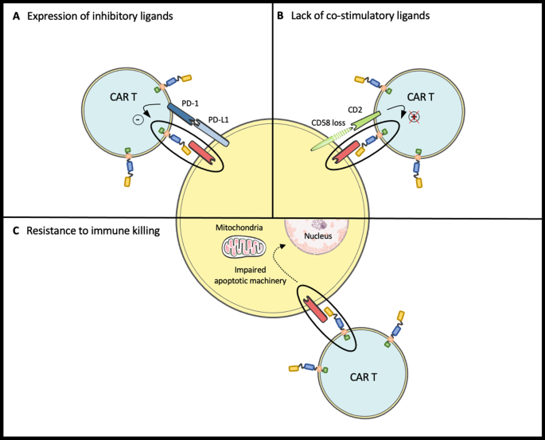

[4]

But addressing these conditions separately often does not control the disease, as cancer is often heterogeneous and the robustness of biological systems in cancer cells would often compensate for the loss in blocked pathways by diverting resources to another pathway necessary for its survival. As such, it is necessary to consider the entire biological system.

**Reference**

[1] Radványi, Á., Kun, Á. Phylogenetic analysis of mutational robustness based on codon usage supports that the standard genetic code does not prefer extreme environments. *Sci Rep* **11**, 10963 (2021).

[4] Lemoine, J., Ruella, M. & Houot, R. Born to survive: how cancer cells resist CAR T cell therapy. *J Hematol Oncol* **14**, 199 (2021).

[5] Chène, P. Inhibiting the p53–MDM2 interaction: an important target for cancer therapy. *Nat Rev Cancer***3**, 102–109 (2003).

[3] Kitano, H. Biological robustness. *Nat Rev Genet* **5**, 826–837 (2004).